Possible Defibrillator Sites at Kensington Gardens and Fen Park

Kensington Gardens
After meeting with Bob Breakspear and the new tenants (Sharon and Cheryl) at the Café, it was agreed that most appropriate place for the installation of a defibrillator would be to the right of the café. This would be on a brick column on the park keepers building where there is a mains power supply.

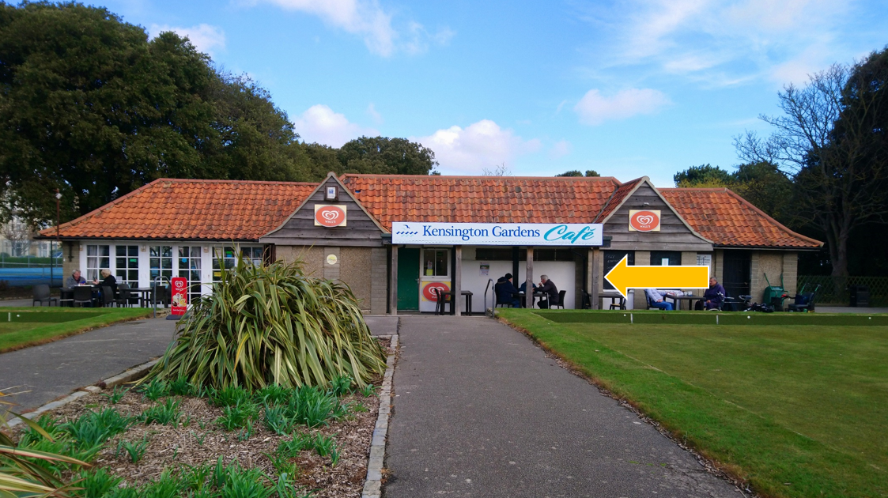

Below is a photo of what the defibrillator may look like if it was installed here. The defibrillator may be 20mm wider than the brick column, but it would still be adequate for installation here.

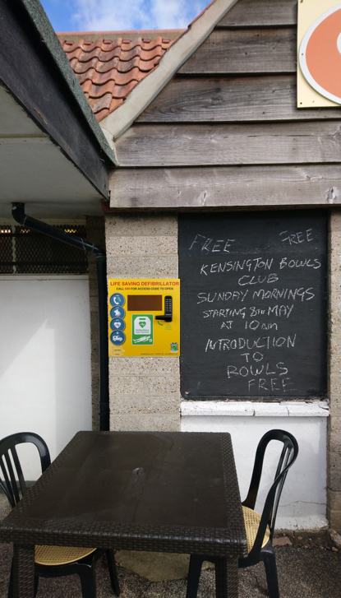

Fen Park
The options at Fen Park are limited due to the lack of building infrastructure in the park. This defibrillator will be a unit that has its own power supply/battery.
One option is securing a defibrillator to the CCTV post. Below is an image of how this may look.
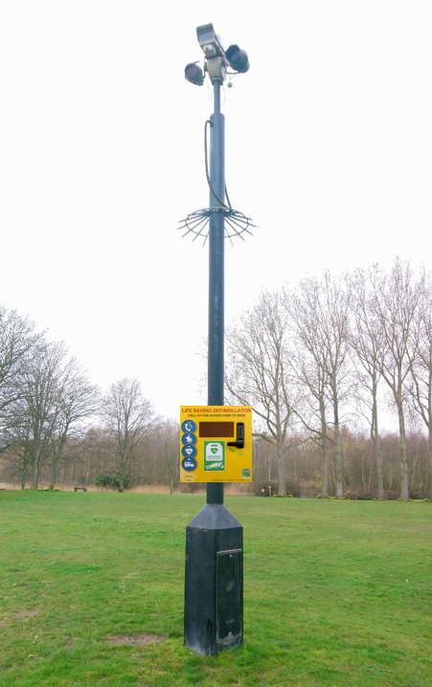

Another option is to have a free standing, twin post construction with a wooden backboard to install the defibrillator on.
Friends of Fen Park are due to have an information board installed on Russel’s Walk, the entrance to the park from the junction of Martin’s Avenue and Southwell Road. Installation of the defibrillator could be in conjunction with this, the image below is just to give an idea of what it may look like in this area.

