Planning notes 7/9/2021

DC/21/3992/FUL 61 Stubbs Wood
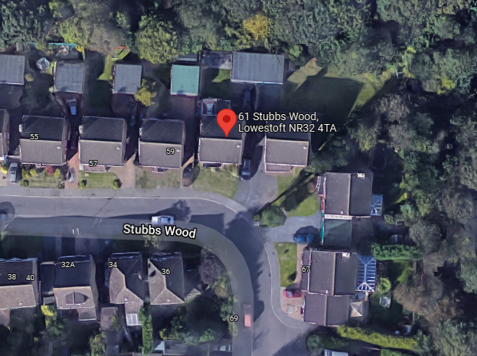
Proposed single storey kitchen and utility room extension.
DC/21/3992/FUL | 01/09/2021 | Consultee Responses | Arboriculture and Landscape
DC/21/3992/FUL | 31/08/2021 | Info Sheet | INFO
DC/21/3992/FUL | 26/08/2021 | Plans | 1645/1 | Existing and proposed
DC/21/3992/FUL | 25/08/2021 | Application Form & Certificate

DC/21/3845/FUL 10 West Side Close
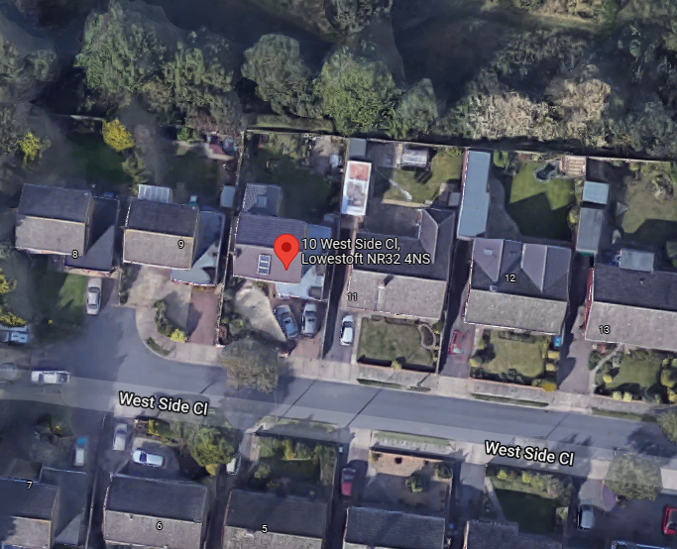
Construction of a two storey extension to front of property
DC/21/3845/FUL | 23/08/2021 | Consultee Responses | East Suffolk Landscape Team
DC/21/3845/FUL | 19/08/2021 | Info Sheet | INFO
DC/21/3845/FUL | 12/08/2021 | Application Form & Certificate
DC/21/3845/FUL | 12/08/2021 | Existing Block / Layout Plan | 189.02
DC/21/3845/FUL | 12/08/2021 | Existing Elevations | 189.05 | Front & Side
DC/21/3845/FUL | 12/08/2021 | Existing Elevations | 189.06 | Rear & Side
DC/21/3845/FUL | 12/08/2021 | Existing Floor Plans | 189.03 | Ground Floor
DC/21/3845/FUL | 12/08/2021 | Existing Floor Plans | 189.04 | First Floor
DC/21/3845/FUL | 12/08/2021 | Proposed Block / Layout Plan | 189.07
DC/21/3845/FUL | 12/08/2021 | Proposed Elevations | 189.10 | Front & Side
DC/21/3845/FUL | 12/08/2021 | Proposed Elevations | 189.11 | Rear & Side
DC/21/3845/FUL | 12/08/2021 | Proposed Floor Plan | 189.08 | Ground Floor
DC/21/3845/FUL | 12/08/2021 | Proposed Floor Plan | 189.09 | First Floor Plan
DC/21/3845/FUL | 12/08/2021 | Site / Location Plan | 189.01

DC/21/3858/FUL 8 Lowry Way
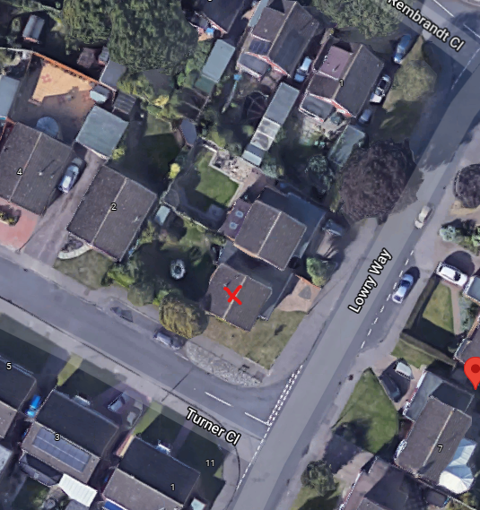
To relocate fence to the boundary of our property and in line with the front of the house. Fence will be 1.8m high
DC/21/3858/FUL | 31/08/2021 | Consultee Responses | SCC Highways
DC/21/3858/FUL | 18/08/2021 | Existing Block / Layout Plan | Existing Fence Line
DC/21/3858/FUL | 18/08/2021 | Photographs | Fence Details
DC/21/3858/FUL | 18/08/2021 | Proposed Block / Layout Plan | Proposed Fence Line
DC/21/3858/FUL | 13/08/2021 | Application Form & Certificate
DC/21/3858/FUL | 13/08/2021 | Photographs | Site Photos
DC/21/3858/FUL | 13/08/2021 | Photographs | Site Photos
DC/21/3858/FUL | 13/08/2021 | Photographs | Site Photos
DC/21/3858/FUL | 13/08/2021 | Photographs | Site Photos
DC/21/3858/FUL | 13/08/2021 | Photographs | Site Photos
DC/21/3858/FUL | 13/08/2021 | Photographs | Site Photos
DC/21/3858/FUL | 13/08/2021 | Photographs | Site Photos
DC/21/3858/FUL | 13/08/2021 | Photographs | Site Photos
DC/21/3858/FUL | 13/08/2021 | Photographs | Site Photos
DC/21/3858/FUL | 13/08/2021 | Photographs | Site Photos
DC/21/3858/FUL | 13/08/2021 | Photographs | Site Photos
DC/21/3858/FUL | 13/08/2021 | Proposed Block / Layout Plan
DC/21/3858/FUL | 13/08/2021 | Site / Location Plan

DC/21/3807/FUL 53 Harrington Avenue
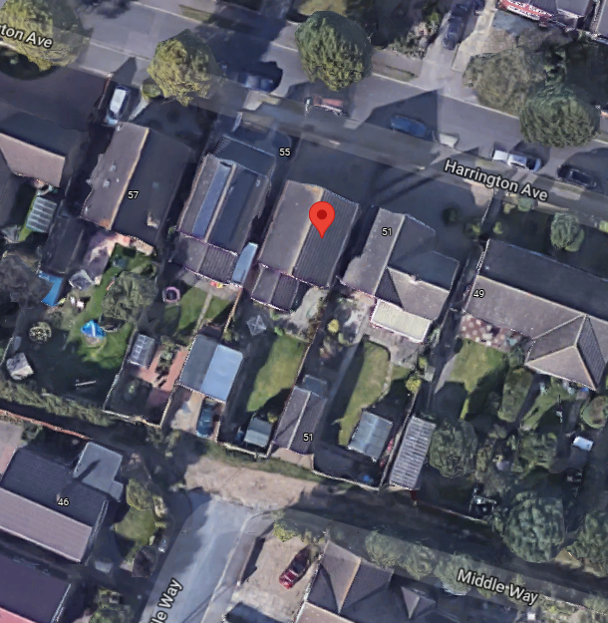
Demolish existing rear extension and build two storey extension at rear
DC/21/3807/FUL | 17/08/2021 | Info Sheet | INFO
DC/21/3807/FUL | 10/08/2021 | Application Form & Certificate | Application form
DC/21/3807/FUL | 10/08/2021 | Plans | Existing & Proposed plans

DC/21/3070/FUL Anchor Lodge Arbor Lane.
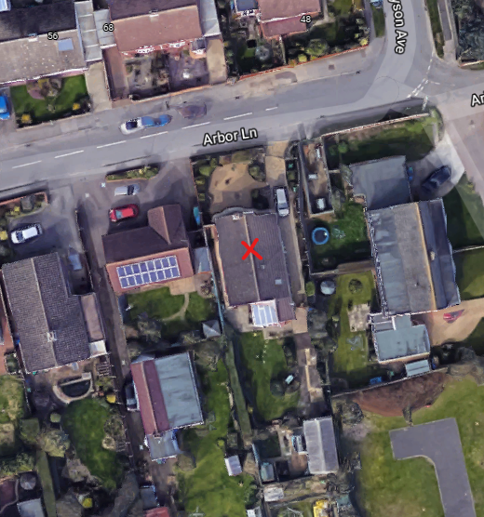
RECONSULTATION Amended Description. One bed holiday let in private enclosed garden area with own private entrance off the road parking with sewerage water and electrical supply. Log cabin 18ft 4 inch X 12ft with ridge height 8ft
DC/21/3070/FUL | 31/08/2021 | Consultee Responses | Environmental Protection
DC/21/3070/FUL | 31/08/2021 | Town/Parish Consultation Response | Lowestoft Town Council
DC/21/3070/FUL | 26/08/2021 | Consultee Responses | Economic Development
DC/21/3070/FUL | 24/08/2021 | Consultee Responses | SCC Highways
DC/21/3070/FUL | 12/08/2021 | Info Sheet | INFO
DC/21/3070/FUL | 11/08/2021 | Plans | 2853.21.1A | Proposed plans
DC/21/3070/FUL | 25/06/2021 | Application Form & Certificate
DC/21/3070/FUL | 25/06/2021 | Photographs
DC/21/3070/FUL | 25/06/2021 | Photographs
DC/21/3070/FUL | 25/06/2021 | Photographs
DC/21/3070/FUL | 25/06/2021 | Photographs
DC/21/3070/FUL | 25/06/2021 | Photographs
DC/21/3070/FUL | 25/06/2021 | Photographs
DC/21/3070/FUL | 25/06/2021 | Photographs
DC/21/3070/FUL | 25/06/2021 | Photographs
DC/21/3070/FUL | 25/06/2021 | Photographs
DC/21/3070/FUL | 25/06/2021 | Photographs
DC/21/3070/FUL | 25/06/2021 | Plans |  | Floor plans and elevations
DC/21/3070/FUL | 25/06/2021 | Plans | Plot at rear garden

DC/21/3871/FUL 4 Thistledown
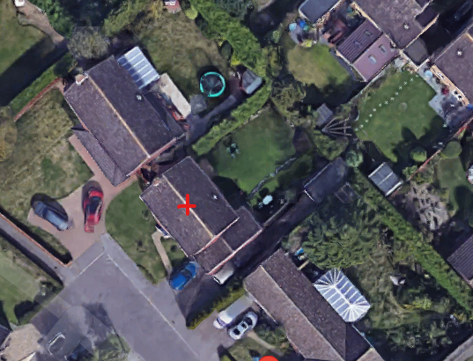
Construction of a single storey front extension
DC/21/3871/FUL | 19/08/2021 | Info Sheet | INFO
DC/21/3871/FUL | 19/08/2021 | Plans | Proposed Elevations & Floor plans
DC/21/3871/FUL | 19/08/2021 | Plans | Site & Block plan
DC/21/3871/FUL | 17/08/2021 | Plans | Existing Elevations & Floor plans
DC/21/3871/FUL | 17/08/2021 | Plans | Proposed Elevations & Floor plans
DC/21/3871/FUL | 17/08/2021 | Site / Location Plan | Site plan & Block plan
DC/21/3871/FUL | 13/08/2021 | Application Form & Certificate | Application form

DC/21/3912/FUL 19 Clifford Drive
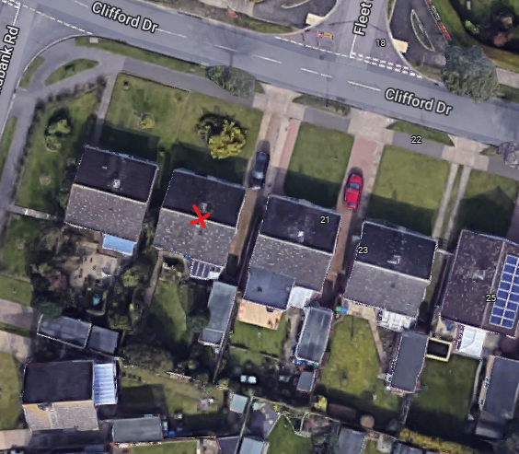
Construction of single storey extensions
DC/21/3912/FUL | 19/08/2021 | Info Sheet | INFO
DC/21/3912/FUL | 18/08/2021 | Application Form & Certificate
DC/21/3912/FUL | 18/08/2021 | Plans | 090821 1 | Existing elevation/floor
DC/21/3912/FUL | 18/08/2021 | Plans | 090821 2 | proposed elevation/floor
DC/21/3912/FUL | 18/08/2021 | Site / Location Plan | 090821 3 | block

DC/21/3021/FUL 60 Denmark Road
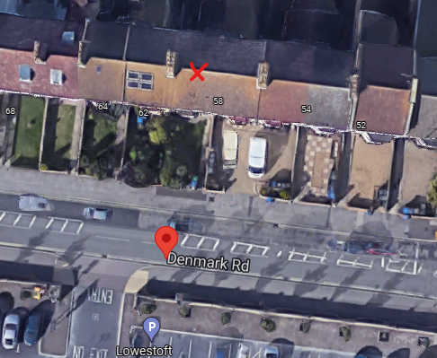
RECONSULTATION Amended Plans. Application to create driveway/carstanding in front garden
DC/21/3021/FUL | 13/08/2021 | Amended Plans & Documents | Site/location plan
DC/21/3021/FUL | 13/08/2021 | Proposed Floor Plan | Drive in turnaround
DC/21/3021/FUL | 13/08/2021 | Proposed Floor Plan | Pedestrian visability splays
DC/21/3021/FUL | 13/08/2021 | Proposed Floor Plan | Reverse in
DC/21/3021/FUL | 11/08/2021 | Town/Parish Consultation Response | Lowestoft Town Council
DC/21/3021/FUL | 03/08/2021 | Consultee Responses | SCC Highways
DC/21/3021/FUL | 21/07/2021 | Info Sheet | INFO
DC/21/3021/FUL | 16/07/2021 | Existing Block / Layout Plan
DC/21/3021/FUL | 16/07/2021 | Site / Location Plan
DC/21/3021/FUL | 23/06/2021 | Application Form & Certificate
DC/21/3021/FUL | 23/06/2021 | Proposed Floor Plan

DC/21/3621/FUL 1 Hamilton Road
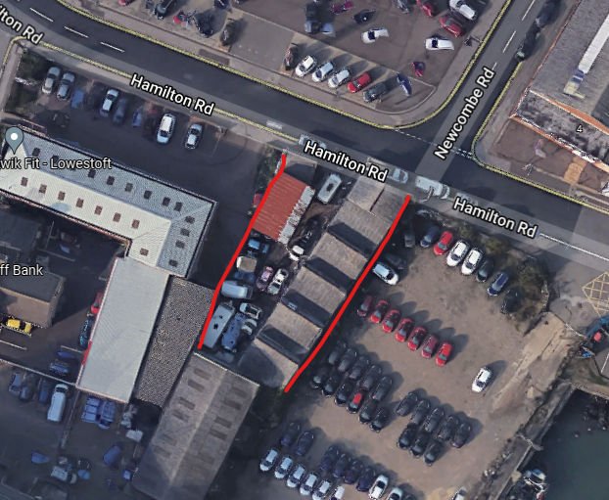
Demolition of Northen Building, Retention of Workshop to South, Erection of Car Sales Building Layout, fencing and access
DC/21/3621/FUL | 06/09/2021 | Consultee Responses | SCC Highways
DC/21/3621/FUL | 27/08/2021 | Consultee Responses | SCC Fire & Rescue
DC/21/3621/FUL | 27/08/2021 | Consultee Responses | SCC Fire & Rescue
DC/21/3621/FUL | 27/08/2021 | Consultee Responses | SCC Fire & Rescue
DC/21/3621/FUL | 17/08/2021 | Contaminated Land Assessment | GroundSure Screening
DC/21/3621/FUL | 17/08/2021 | Contaminated Land Assessment | Land Contamination Questionnaire
DC/21/3621/FUL | 29/07/2021 | Application Form & Certificate
DC/21/3621/FUL | 29/07/2021 | Contaminated Land Assessment | Groundsure Screening
DC/21/3621/FUL | 29/07/2021 | Design & Access Statement
DC/21/3621/FUL | 29/07/2021 | Flood Risk Assessment
DC/21/3621/FUL | 29/07/2021 | Plans | 2833.21.1 | Existing & Proposed Plans - Includes Location & Block Plan
DC/21/3621/FUL | 29/07/2021 | Supporting Documents | WDC Planning Approval

