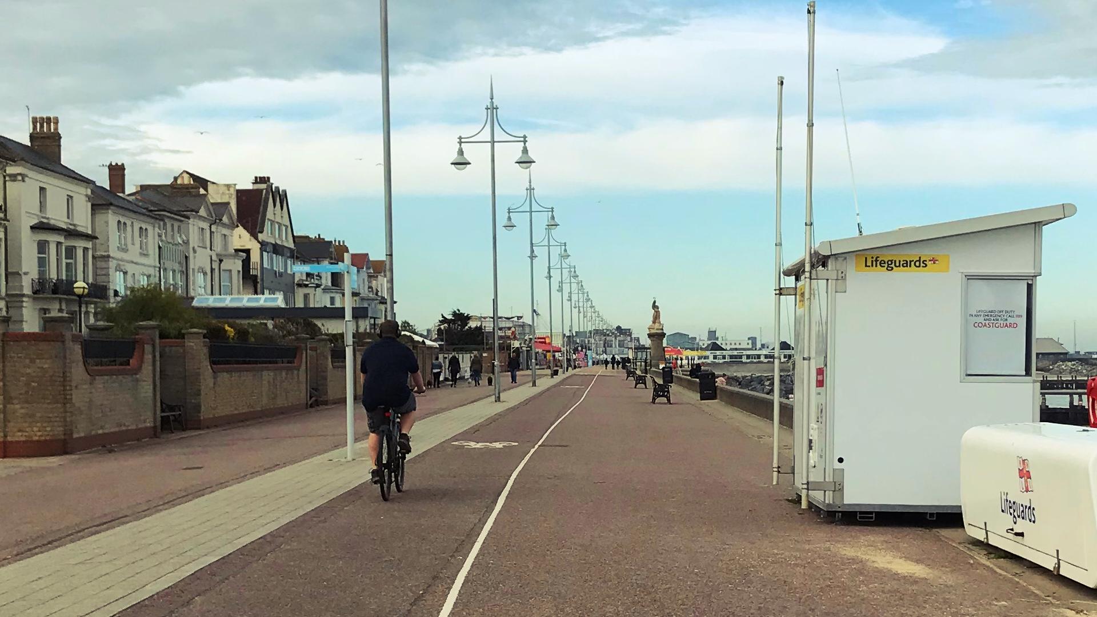
Lowestoft Town Council’s (LTC) Sustainability Strategy includes concerns about human economic, social and environmental vulnerability and disadvantage. The Town Council has no direct statutory role in providing cycling lanes or supporting cyclists. However, we believe there are both environmental and health benefits to be gained from using cycles as a means of transport.
During 2020 we asked the electorate to provide comments on cycling in the Town, good or bad, and these comments have been considered.
To this end we are making a declaration to support cycling as the preferred form of transport in our town and to keep consideration of cycling provision and accessibility as a major ongoing concern for the Town Council.

Our actions will include:
- Working with other statutory authorities who have powers and duties to relation to cycling.
- Lobbying Suffolk County Council on funding for improved cycle paths and connectivity.
- Working with East Suffolk Council in the analysis and action plan from the results of their recent Cycling and Walking Strategy consultation.
- Promoting cycle routes on our social media.
- The Town council is a statutory consultee for all planning applications in Lowestoft. When responding to applications, we will consider the provision of cycle storage and cycle parking.
- Supporting Cycle to Work Day, Cycle to School Week and other national initiatives.
- Considering additional and/or improved cycle paths within in our parks.
- Build policies relating to cycling into the Lowestoft Neighbourhood Development Plan including provision of cycle storage and parking in new developments.
- Work with the Local Planning Authority to ensure implementation and adherence with Waveney Local Plan policy WLP8.28 which promotes adequate provision of cycling storage in new developments and Strategic Priority 8 which seeks to enhance the viability and vitality of town centres by making services and facilities accessible on foot and by cycling.
- Progressing our Sustainability Strategy as there are strong links between health and well-being and climate change and other sustainability issues
- Working with partners and promoting health and well-being initiatives
- Prioritising support and promotion of transport which is not reliant on fossil fuel and which encourages exercise and independence, including not only cycling but also walking and running
- Taking account of health and well-being as part of our decisions on planning and development
- Progressing water fountains in our parks to provide a free quality drink for those enjoying the outdoors using cycles to make their way around our town.
- Supporting the reduction in pollution to improve the environment for cyclists.

