**LOWESTOFT TOWN COUNCIL GRANT – ILLUSTRATIVE OVERVIEW**

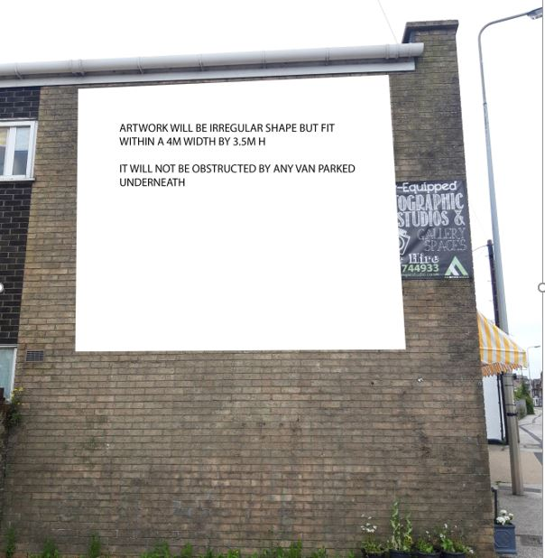

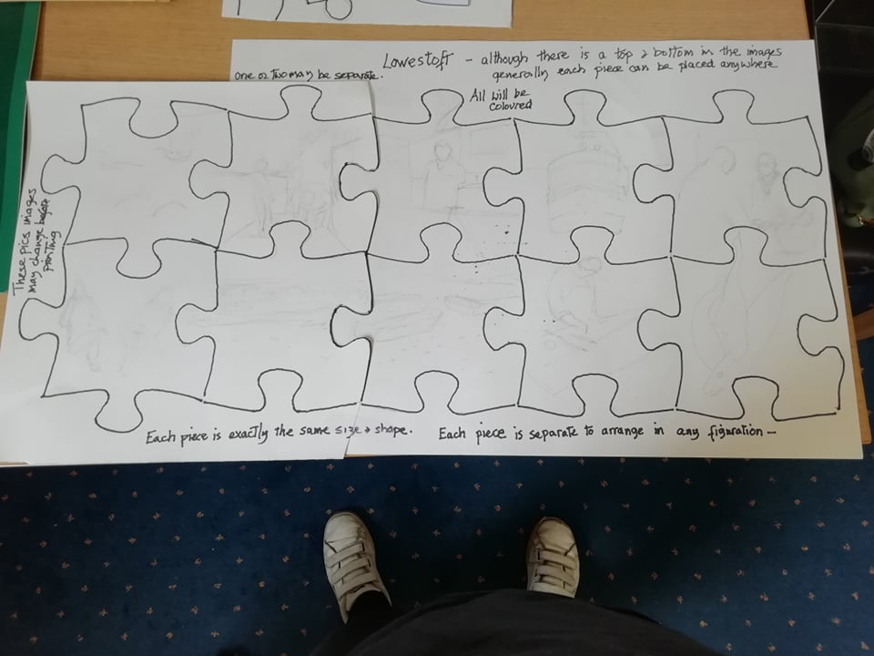

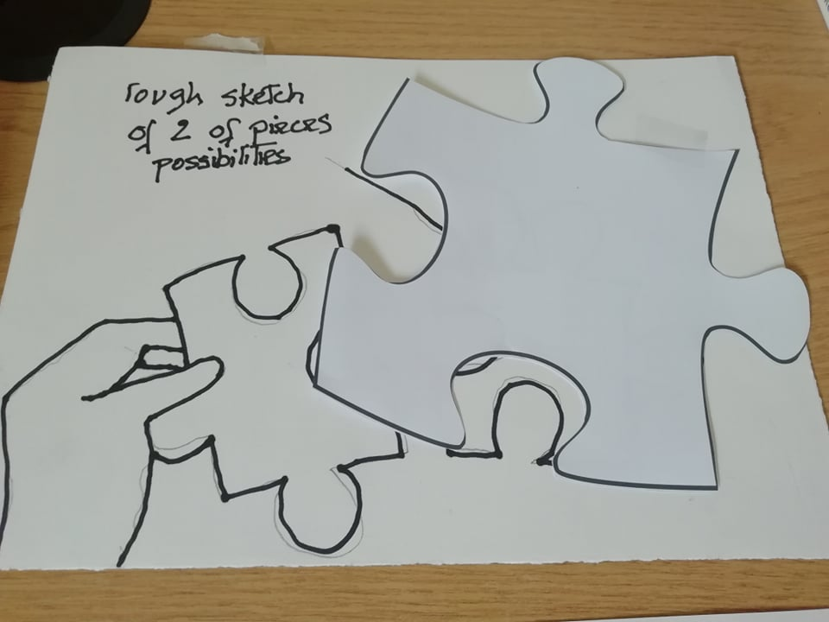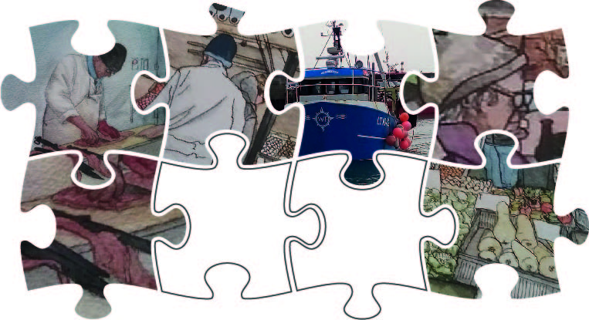

Above: just snippets of Miriams art dropped into the pieces (NOT artwork being used- suggestion only)

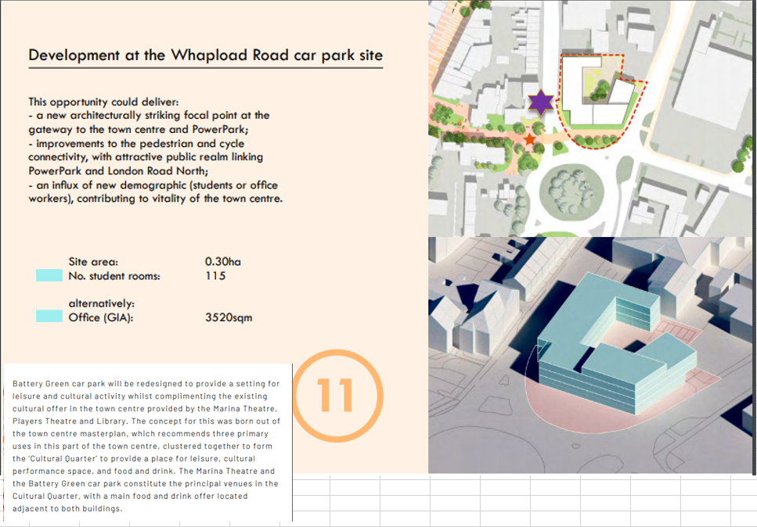

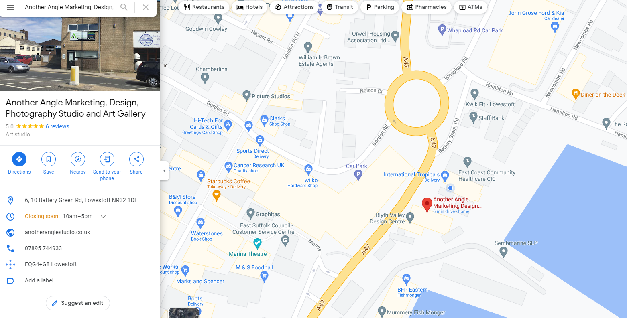

The wall (for the art placement) is on the side of Another Angle Studio and traffic coming past on the A47 heading south will see the artwork prominently

