Dear Members of Lowestoft Town Council
The Lowestoft and Plaisir Twinning Association was first discussed when Jose Littmann and her husband Jean Pierre travelled from Plaisir and were met by Andy Taylor and his wife Sybil at Lowestoft Train Station. The discussions consequently led to the formation of the Lowestoft and Plaisir Twinning Association in 1978. A declaration of Friendship was agreed to establish and maintain friendly relations with each other along with the aim of developing friendship between the people of the two towns.
The first visit of people from Lowestoft to Plaisir took place in 1979 and have continued every two years. The people of Plaisir visit Lowestoft in the intervening years.
To travel from Lowestoft to Plaisir we hire a coach, most recently from Belle Coaches. The cost of the coach is paid entirely by the people travelling on it. In Plaisir we are hosted by people in Plaisir. We are provided with meals and accommodation by our friends and entrance fees to sites of interest which they have arranged for us to visit. Friendships are made and the Plaisirois are welcomed into our homes in Lowestoft with meals and accommodation provided.
The declaration of Friendship also stated to encourage and assist youth and adult organisations and clubs in the two towns to communicate and exchange visits with each other. To this end we have been successful in including people who perform on stage in Lowestoft to perform in the town of Plaisir. Most recently we have taken young members of ‘My Rock Choir’ to Plaisir. They had performed at the Seagull Theatre for the Mayor of Lowestoft during an evening performance arranged for the 40th Anniversary of the Twinning in 2018. The Lady Mayor was enchanted with the children and asked if they would come to Plaisir the following year to perform in Plaisir. This entailed needing two coaches to travel to Plaisir in 2019. At the time Scottish Power were building their office in Lowestoft and when approached very generously gave us the money to pay for the coach for the Choir and also hotel accommodation for the families who were reluctant to stay with a family. At the end of that visit those families wished they had stayed with a host! Indeed one of the youngsters, who had stayed with a family, when asked at the end of the trip what was the best thing about it they responded with ‘staying with my host’. Apparently a day trip to Paris, with boat tickets for travelling on the Seine included, did not top it!
We are currently planning for the Plaisirois to visit in July. We want to keep the visits they make as local as possible and therefore are arranging for them to visit Somerleyton Gardens, Carlton Marshes and also in Suffolk, Sutton Hoo. In both towns the last night of visits are celebrated with a dinner. Hosts pay the cost of their own meals and the cost of the visitors meals are paid by the Associations.
In past times the Council granted us £1000 a year which enabled us to have the funds to cover costs of the Plaisirois visits, as well as contributing to the cost of young people travelling with us where needed. Having spoken to Beccles Twinning Association we have learned that they receive a grant of £1000 each year from their Town Council. We would very much appreciate it if Lowestoft Town Council would consider doing the same for us. This would enable us to ensure continuity of our Association as we enter our fifth decade of Twinning with Plaisir; enable us to help our community to travel to France and to showcase our area when our French friends visit Lowestoft.
Yours sincerely
Richard Pulham (Chairman)
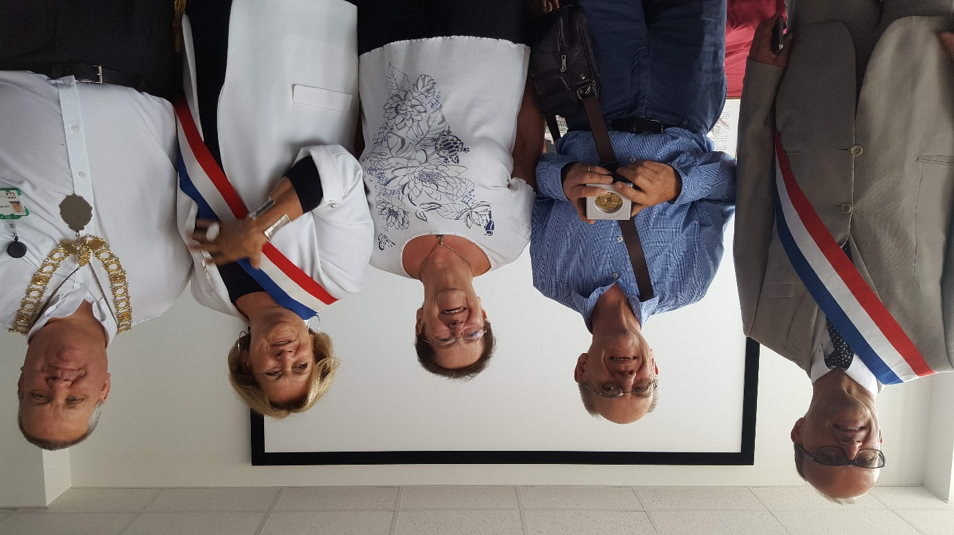

Mayors of Lowestoft and Plaisir with Chairs of Twinning Committees on our 40th Anniversary, July 2018.
Top: Protocols signed by Councillors and Members.

