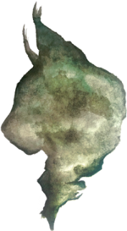
Lowestoft Town Council’s WildEast areas
The Wild East challenge is that we ‘see the light in making our region one of the biggest, best connected and restored nature reserves in the world’ and in so doing enrich our lives and restore our wild(er) hearts.
This Council believes having WildEast areas is essential and part of respecting the environment and preserving and increasing habitat for current and future generations.
WildEast - North Denes
This is the land bordered red below.
This Council has dedicated its North Denes land as ‘Open Space’ accessible for public enjoyment. This dedication will be enshrined in its Neighbourhood Plan which will be submitted to a public referendum.
The Council has also dedicated this land as ‘WildEast’ land. This land will be left in its natural state and only be ‘managed’ where this further enhances the habitat.
There are no exceptions in relation to land management are:
- Tree height management along the western edge owing to any enforceable historic resident rights to a sea view.
- Areas subject to historic allocation for leisure at Denes Oval which will be managed to enable this use (within the green line).
- An area subject to an historic lease for caravans, known as Phase 3 (within the yellow line).
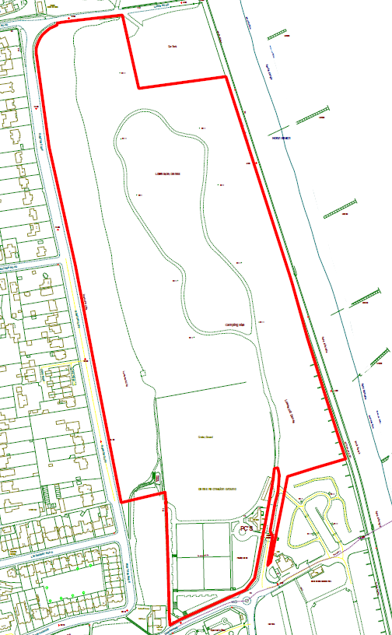

WildEast - Great Eastern Linear Park
The land on either side of the pavements will be left as important habitat other than the first metre of land which will be subject to light management including occasionally cutting back to avoid encroachment on the pavement. Depicted in the maps below, the path is a continuum following the maps from left to right. The land runs from the Yarmouth Road to near Rotterdam Road, the North Quay Retail Park and Normanston Allotments but there is a short stretch at the southern end, which joins the bottom red line on the image to the right, which is not owned by this Council. The natural habitat is prioritised in this area. While paved areas are maintained to enable public enjoyment of this route, management of trees and land is in line with the Council’s commitment to maintaining and improving the natural environment.
A decision is needed on whether to maintain a boardwalk along one lower stretch and on whether to maintain an island of land off the Yarmouth Road as plain grass or develop it further as a habitat.
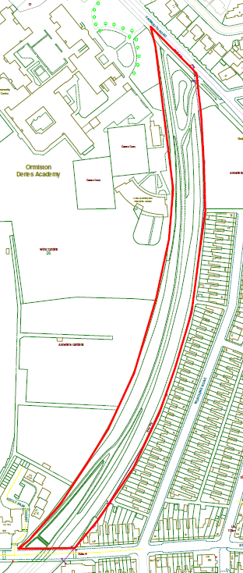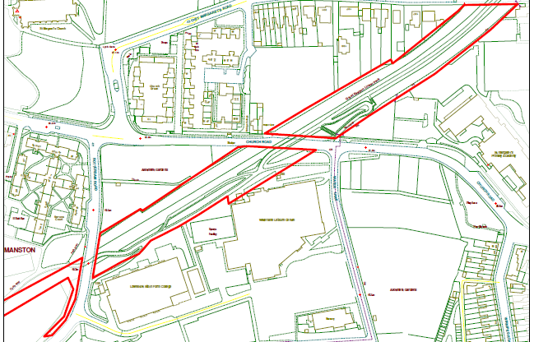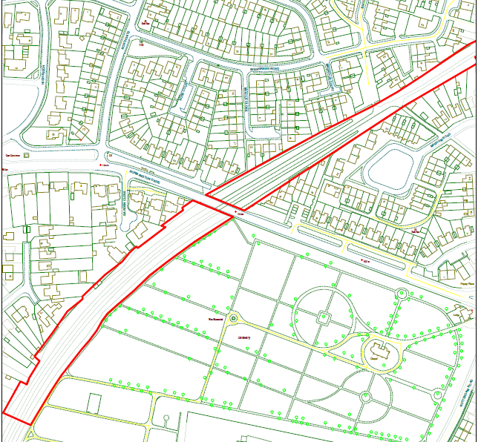
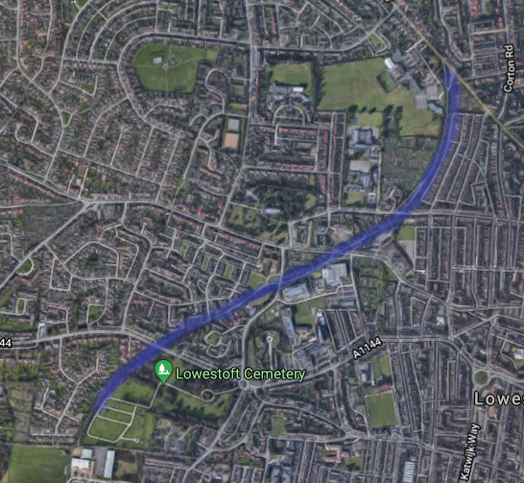

WildEast - Land adjoining 4 High Street
The area to the west of the boundary hedge (blue line) will be retained as, primarily, grassed open space. However, the eastern most stretch of land which contains trees and provides important habitat will be dedicated as a WildEast area.

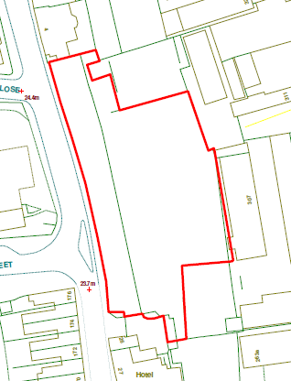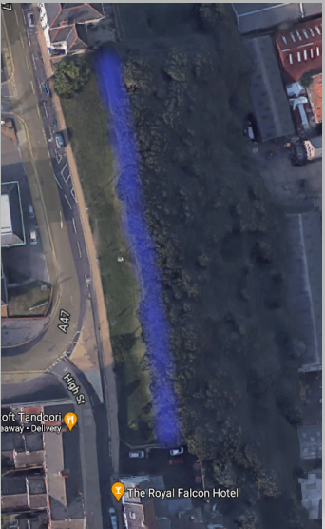

WildEast – Clarkes Lane
One of the main considerations for Clarkes Lane is the lack of parking. Even when visiting for an inspection there is no obvious place to park.
- Rewilding – The whole blue area is cut and has no purpose other than for dog walking. Could this be rewilded with pathways left through it. The more southern red area is an obvious area as the trees in the middle stop the area being used for much more and at the moment seem to be cut around. However, it is noted that this area has also previously been designated in the Town Council’s Open Spaces strategy as having the potential for a community orchard (marked in purple on the second photo), with funding for trees for this has been secured via a Tree Council grant, and a skate park. The Tree Council application also mentioned a wild flower maze, new children’s play area and picnic areas but noting that these are not mentioned in the Open Spaces strategy.
- Community Gardens – There is plenty of scope. But as previously mentioned this would need to be supported by local people as I don’t see it is an area that people would drive to and use the garden as there is no parking!
- Bins – There is one bin at the Pollards Piece entrance. Have more been ordered. The only other bin is a wheelie bin which was just standing in the middle of the area approx. where is shows Clarkes Lane Playground on the visual.

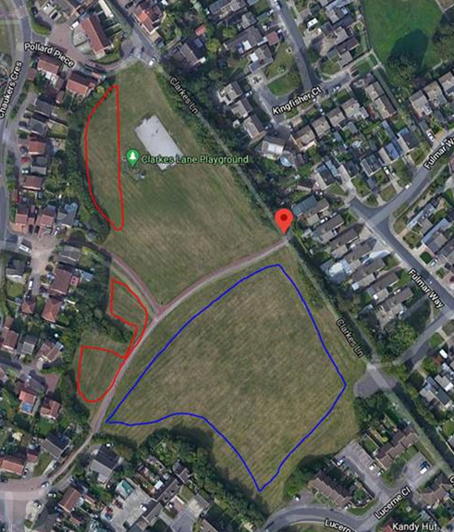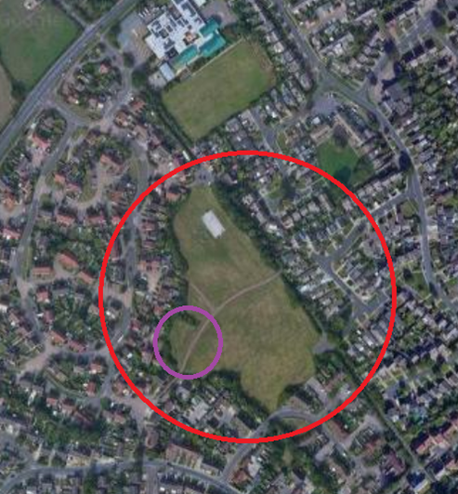

WildEast – Gunton Community Park
Rewilding – the whole area shown with the red circle was previously a play area but had equipment removed several years ago and has since been unattended. Whilst it has a fence around the perimeter of the area, this serves no current purpose and could be removed if not in keeping with the Wild East scheme.

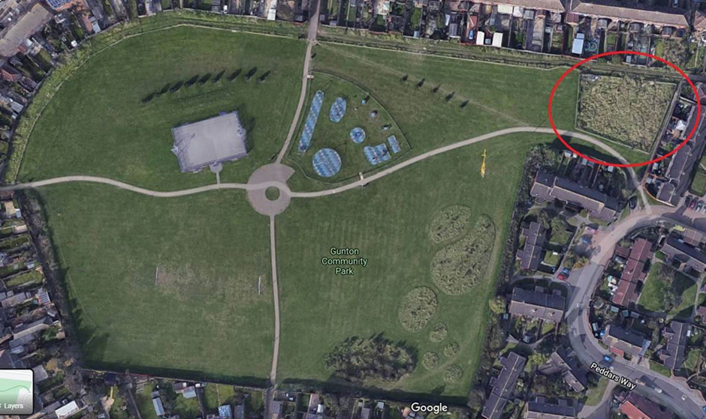

WildEast – Fen Park
Fen Park provides an interesting habitat, including ponds and established trees. Some management is necessary to ensure the pond is a health environment. Broadly the areas coloured green (including the ponds) will be dedicated as a WildEast area as a habitat managed for wildlife, with no unnecessary intervention, but this will exclude pavements, bridges and any margins cut to prevent encroachment onto paths or to enable access around the site and to platforms at the side of ponds.
