Planning notes 9/2/2021

13 Grayson Drive
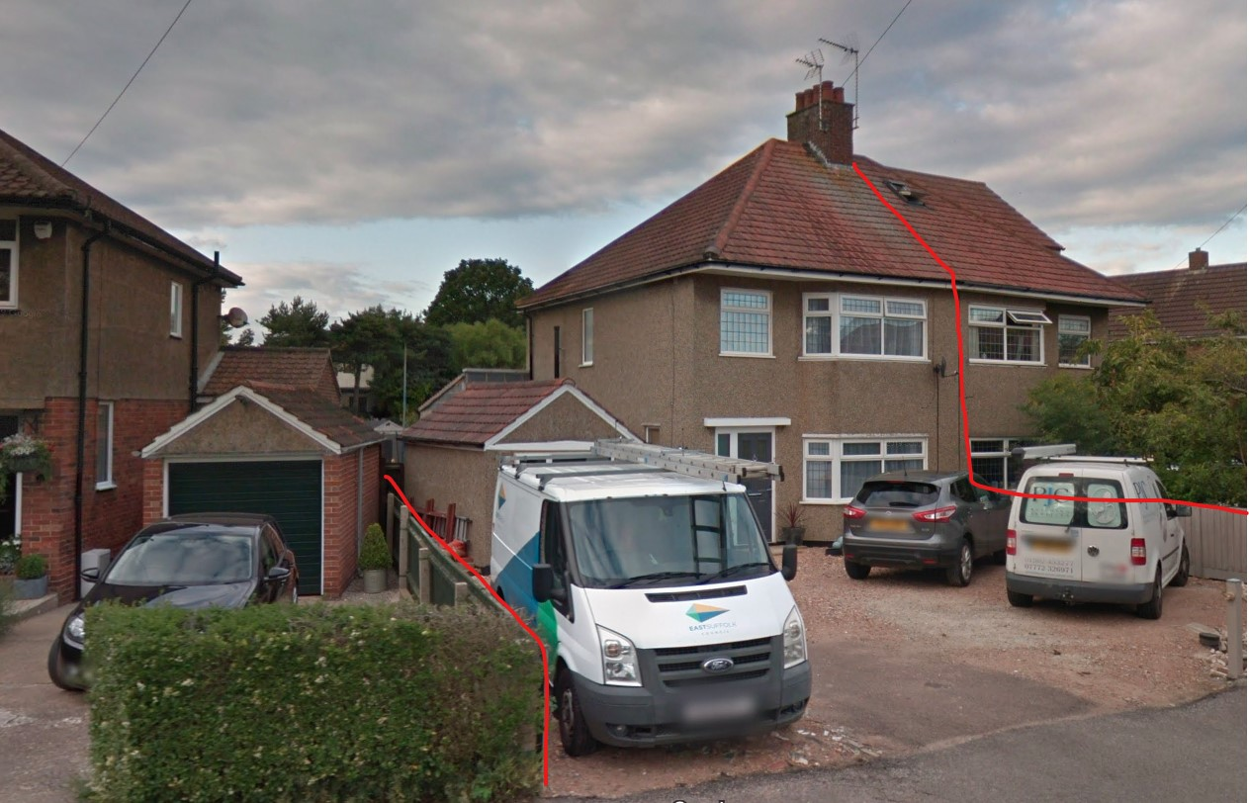
Loft conversion to the rear.
13 Grayson Drive Lowestoft Suffolk NR33 7BA  Loft conversion with proposed dormers  Date Description Information 1 Information 2  01/02/2021 Amended Plans & Documents 2779 - 2E Proposed Elevations, Floor, Site & Block Plans  28/01/2021 Amended Plans & Documents 2779 - 2D Superseded Proposed Elevations, Floor, Site & Block Plans  21/01/2021 Info Sheet INFO  18/01/2021 Application Form & Certificate  18/01/2021 Plans 2729.20.1A Existing floor,elevation,section,block,site | DC/21/0199/FUL  Public comments  Constraints  Related cases  Documents  Map

1 Ranworth Avenue
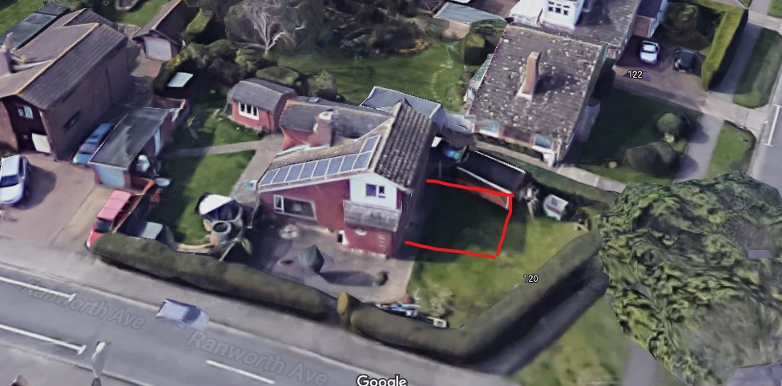
This application was previously rejected by this committee for overdevelopment WLP8.29. These revised plans show extension reduced in size to be behind the building line of nearby properties.
1 Ranworth Avenue Lowestoft Suffolk NR33 9HN  Extension  Date Description Information 1 Information 2  21/01/2021 Plans 2715.20.1A Existing & Proposed - Elevations, Floor, Site & Block Plans  06/01/2021 Town/Parish Consultation Response  21/12/2020 Consultee Responses Environmental Protection  18/12/2020 Info Sheet INFO  10/12/2020 Application Form & Certificate  10/12/2020 Plans 2715.20.1 Superseded Existing & Proposed - Elevations, Floor, Site & Block Plans | DC/20/5066/FUL  Public comments  Constraints  Related cases  Documents  Map

27 The Fairway
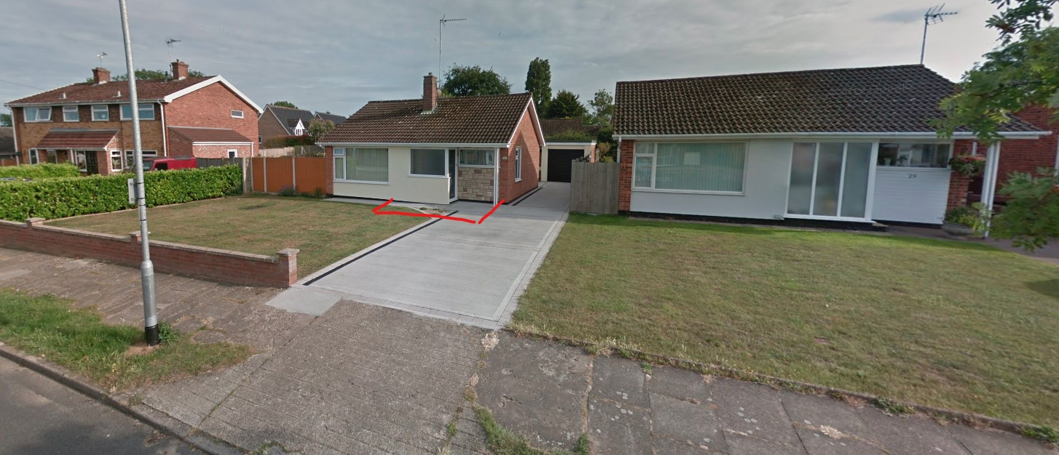
A front porch and additional shower room. Approximate footprint shown above.
27 The Fairway Lowestoft Suffolk NR33 9HZ  Construction of a single storey front extension  Date Description Information 1 Information 2  02/02/2021 Info Sheet INFO  25/01/2021 Plans 190121 1 Existing Elevations & Floor Plans  25/01/2021 Plans 190121 2 Proposed Elevations & Floor Plans  25/01/2021 Plans 190121 3 Site & Block Plans | DC/21/0331/FUL  Public comments  Constraints  Related cases  Documents  Map

St Bridgets Cottage, North Parade
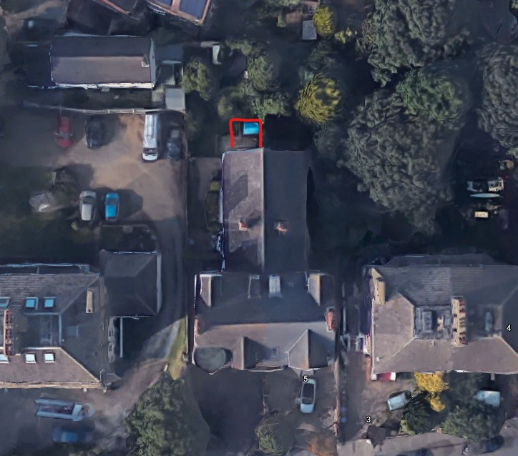
Addition of a garden room to the rear.
St Bridgets Cottage North Parade Lowestoft Suffolk NR32 4PB  Single storey rear extension  Date Description Information 1 Information 2  01/02/2021 Info Sheet INFO  27/01/2021 Application Form & Certificate  27/01/2021 Plans 2102-001 Existing & proposed plans  27/01/2021 Site / Location Plan | DC/21/0387/FUL  Public comments  Constraints  Related cases  Documents  Map

28 Gunton Church Lane
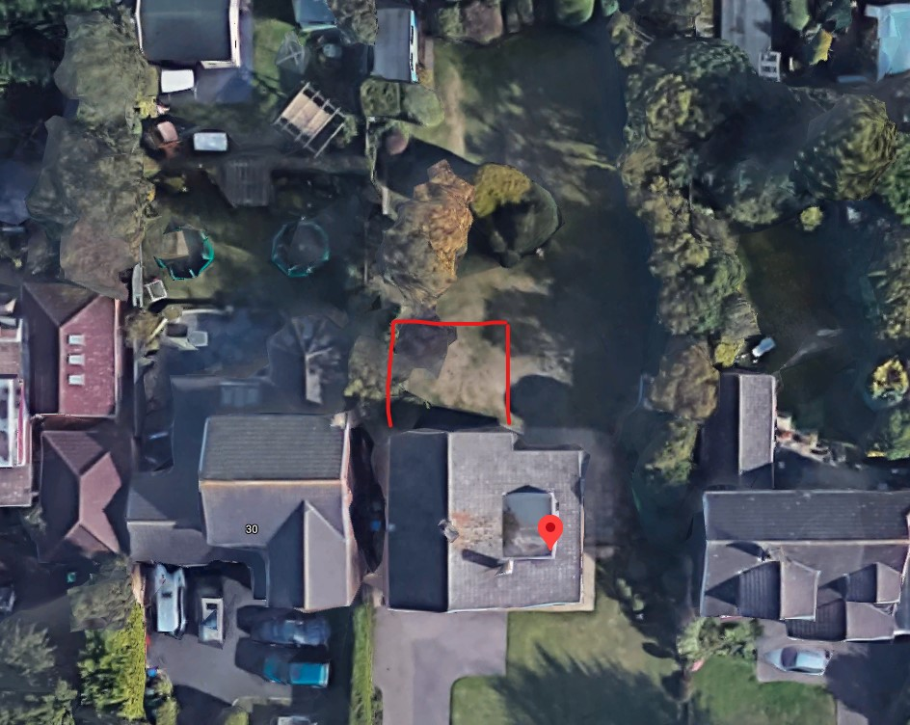
Rear extension. One neighbour objection citing lack of privacy, loss of light.
28 Gunton Church Lane Lowestoft NR32 4LF  Double Storey Rear Extension  Date Description Information 1 Information 2  01/02/2021 Neighbour Responses Denny 30 Gunton Church Lane Lowestoft  25/01/2021 Plans NA-GCL-LS-02 D Proposed - Elevations & Floor Plans  25/01/2021 Plans NA-GCL-LS-SL01 Site & Proposed Block Plan  20/01/2021 Application Form & Certificate  20/01/2021 Plans NA-GCL-LS-01 Existing Elevations/Floor | DC/21/0251/FUL  Public comments  Constraints  Related cases  Documents  Map

16 Gunton Drive
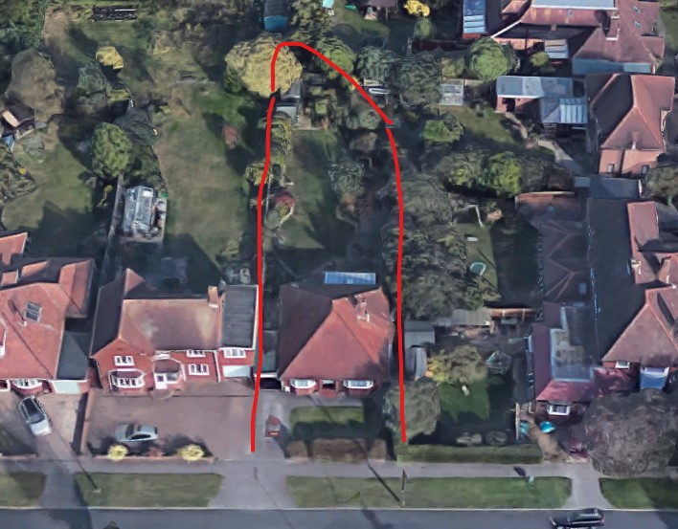
Change of use only.
16 Gunton Drive Lowestoft Suffolk NR32 4QB  Change of use of two bedroom bungalow previously residential to be furnished holiday let  Date Description Information 1 Information 2  05/02/2021 Consultee Responses Suffolk Fire and Rescue Service  02/02/2021 Info Sheet INFO  26/01/2021 Application Form & Certificate  26/01/2021 Site / Location Plan | DC/21/0358/COU  Public comments  Constraints  Related cases  Documents  Map

The Grande Oaks, Yarmouth Road
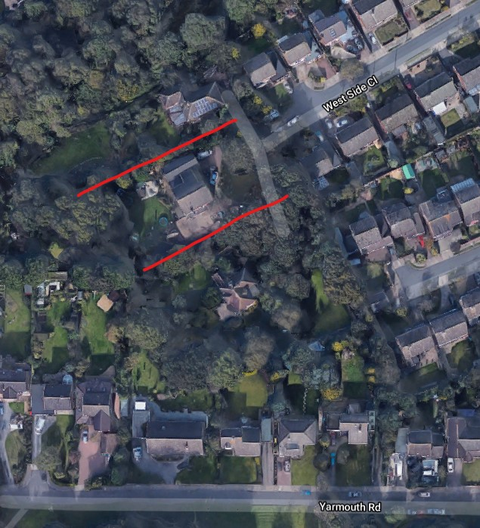
The Grande Oaks Yarmouth Road Lowestoft Suffolk NR32 4AB  Construction of attached garage.  Date Description Information 1 Information 2  02/02/2021 Info Sheet INFO  02/02/2021 Info Sheet INFO  27/01/2021 Application Form & Certificate  27/01/2021 Plans 2105-001 proposed/existing elevation,floor,block  27/01/2021 Site / Location Plan | DC/21/0380/FUL  Public comments  Constraints  Related cases  Documents  Map

9 Lansdowne Road
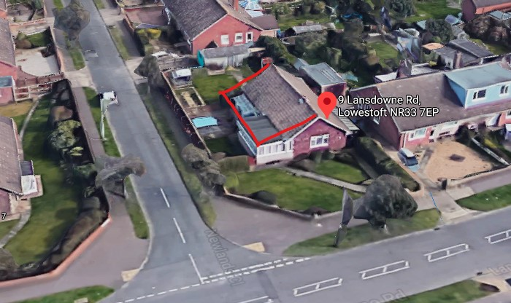
Remodelling of bungalow, side extension and with new driveway.
9 Lansdowne Road Lowestoft Suffolk NR33 7EP  Construct a single storey extension to allow for a lounge at the front and bedroom with en-suite to the rear. Extension to have hipped roof from the original ridge. Construct concrete driveway with drainage.  Date Description Information 1 Information 2  27/01/2021 Info Sheet INFO  21/01/2021 Plans Existing elevations and floor plan  21/01/2021 Plans Garden plans  21/01/2021 Plans Proposed elevations and floor plan  14/01/2021 Application Form & Certificate  14/01/2021 Plans 2744.21.1 Site plan & block plan  14/01/2021 Plans Proposed plans | DC/21/0153/FUL  Public comments  Constraints  Related cases  Documents  Map

