Planning notes 5/1/2021

53 Pinewood Avenue
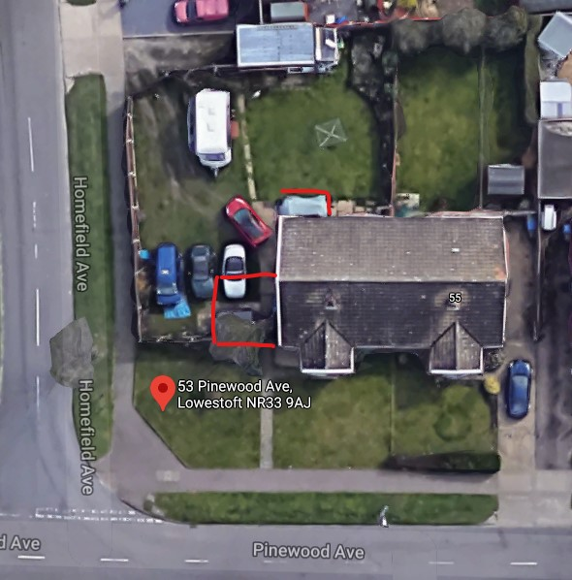
Side extension and rear patio.
53 Pinewood Avenue Lowestoft Suffolk NR33 9AJ  Extend to the north to form bedroom. Move side gate. French doors to rear elevation.  Date Description Information 1 Information 2  21/12/2020 Info Sheet INFO  11/12/2020 Application Form & Certificate  11/12/2020 Plans 2715.20.1 Existing and proposed floor plans, elevations, block plan and si | DC/20/5065/FUL  Public comments  Constraints  Related cases  Documents  Map

61 Westwood Avenue
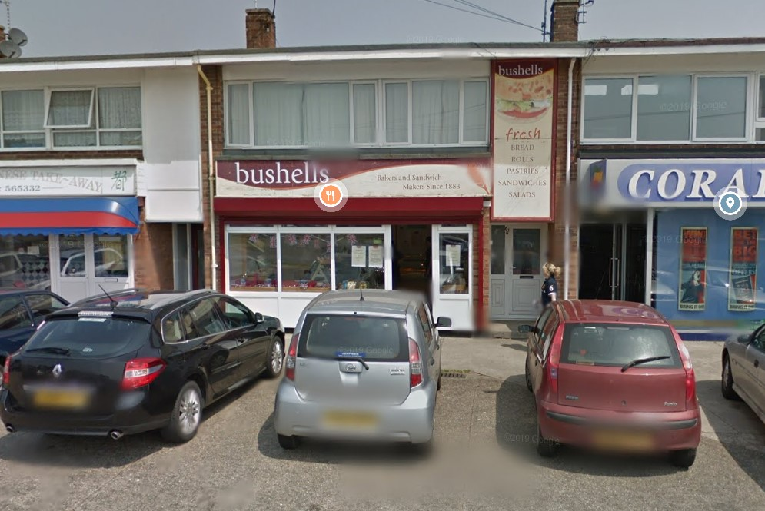
Disabled access ramp.
61 Westwood Avenue Lowestoft Suffolk NR33 9RW  A disable access ramp with handrail and side step to replace the existing step at the front of a retail outlet  Date Description Information 1 Information 2  18/12/2020 Info Sheet INFO  17/12/2020 Proposed Block / Layout Plan  02/12/2020 Existing Elevations  02/12/2020 Existing Elevations  02/12/2020 Photographs Shop Front  02/12/2020 Plans Existing Aerial View  02/12/2020 Plans Proposed Aerial View  02/12/2020 Plans Ramp Details  02/12/2020 Site / Location Plan  23/11/2020 Application Form & Certificate | DC/20/4738/FUL  Public comments  Constraints  Related cases  Documents  Map

1 Ranworth Avenue
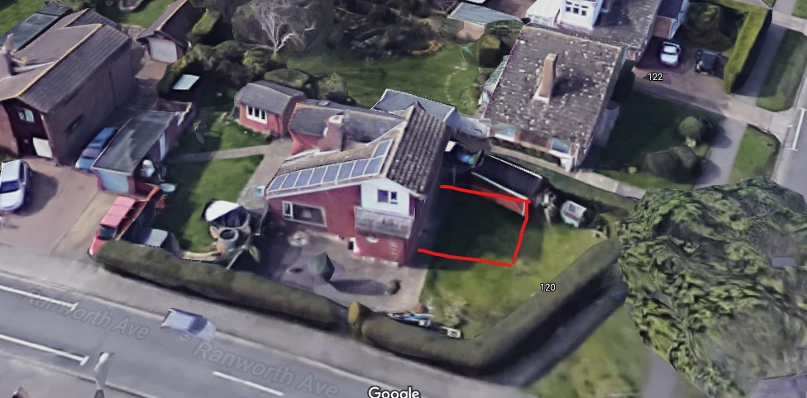
Side extension.
1 Ranworth Avenue Lowestoft Suffolk NR33 9HN  Extension  Date Description Information 1 Information 2  21/12/2020 Consultee Responses Environmental Protection  18/12/2020 Info Sheet INFO  10/12/2020 Application Form & Certificate  10/12/2020 Plans 2715.20.1 Existing & Proposed - Elevations, Floor, Site & Block Plans | DC/20/5066/FUL  Public comments  Constraints  Related cases  Documents  Map

19 The Ridgeways
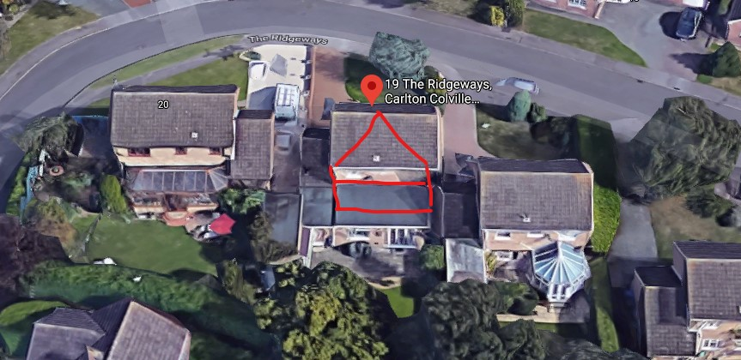
First floor rear extension. One public comment asking for construction to minimise disturbance to neighbours and other provisions.
19 The Ridgeways Lowestoft Suffolk NR33 9NN  First floor extension above existing flat roofed extension and internal alterations to suit. Wood burner flue re-located  Date Description Information 1 Information 2  04/01/2021 Neighbour Responses Everett 20 The Ridgeways  11/12/2020 Info Sheet INFO  09/12/2020 Application Form & Certificate  09/12/2020 Plans 2706.20.1B Existing elevations/floor/block/site  09/12/2020 Plans 2706.20.2B Proposed elevations/floor/block/site | DC/20/5037/FUL  Public comments  Constraints  Related cases  Documents  Map

110 Park Road
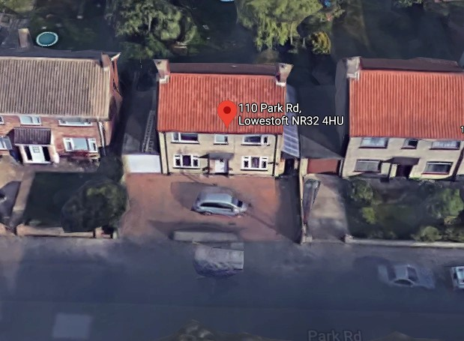
Conversion of garage into a beauty salon.
One neighbour objection, citing: diversification of residential street into mixed use, insufficient parking provision, obstruction of neighbouring property, increased risk of noise and disturbance particularly, evenings, weekends and over the summer. Concerns on fire risk. Reference to WLP8.18 (New Town Centre Use Development) and WLP8.39 (Conservation area).

110 Park Road Lowestoft Suffolk NR32 4HU  Convert the garage into a beauty salon  Date Description Information 1 Information 2  04/01/2021 Neighbour Responses Graham Nourse On Behalf of Mr & Mrs Terry 108 Park Road, Lowestoft  23/12/2020 Consultee Responses Suffolk Fire & Rescue  14/12/2020 Info Sheet INFO  14/12/2020 Plans 1 of 4 Existing & Proposed Floor Plans  14/12/2020 Plans 2 of 4 Proposed South & North Elevations  14/12/2020 Plans 3 of 4 Existing West & East Elevations  14/12/2020 Plans 4 of 4 Proposed East Elevations  27/11/2020 Application Form & Certificate  27/11/2020 Proposed Floor Plan  27/11/2020 Site / Location Plan | DC/20/4839/FUL  Public comments  Constraints  Related cases  Documents  Map

Ashley Downs School
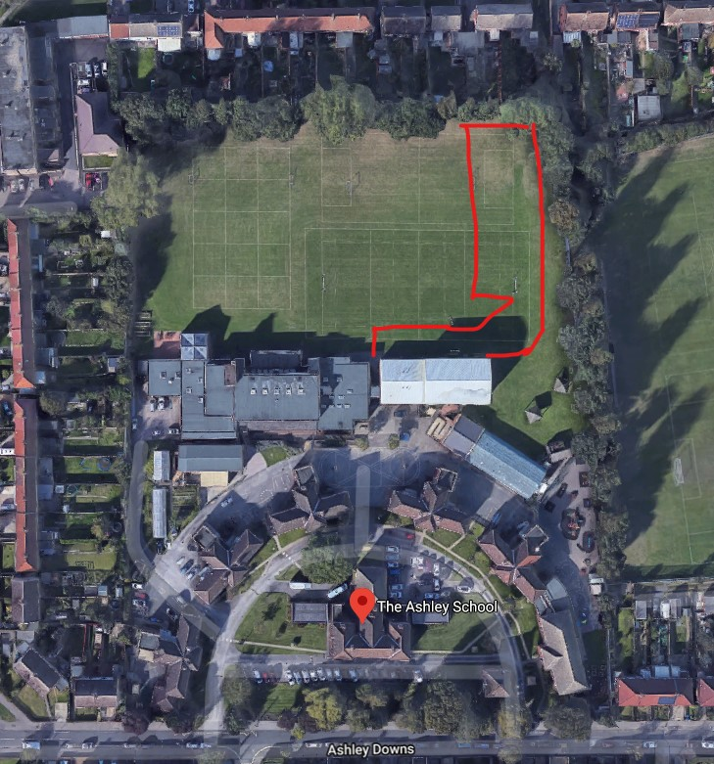
One public comment – concern over insufficient street parking and the resulting road safety problems.
Ashley Downs School Ashley Downs Lowestoft Suffolk NR32 4EU  Single storey classroom extension with internal remodelling, access ramp and provision of a Multi Use Games Area (MUGA)  Date Description Information 1 Information 2  30/12/2020 Neighbour Responses Garvin 57 Ashley Downs, Lowestoft  22/12/2020 Consultee Responses SCC Highways  18/12/2020 Info Sheet INFO  11/12/2020 Application Form & Certificate  11/12/2020 Design & Access Statement  11/12/2020 Existing Elevations 259-5 PL 300.R0  11/12/2020 Existing Floor Plans 259-5 PL 101.R0 Ground  11/12/2020 Existing Floor Plans 259-5 PL 102.R0 First  11/12/2020 Plans 259-5 PL 002.R0 Proposed Extended Footpaths and Fencing  11/12/2020 Plans 259-5 PL 105.R0 Topographic and underground services survey plan  11/12/2020 Proposed Elevations 259-5 PL 301.R0 Sheet 1  11/12/2020 Proposed Elevations 259-5 PL 302.R0 Sheet 2  11/12/2020 Proposed Floor Plan 259-5 PL 103.R0 Ground  11/12/2020 Proposed Floor Plan 259-5 PL 104.R0 First  11/12/2020 Site / Location Plan 259-5 PL 001.R0 Site Plan and Proposed Block Plan | DC/20/5068/FUL  Public comments  Constraints  Related cases  Documents  Map

14 Enstone Road
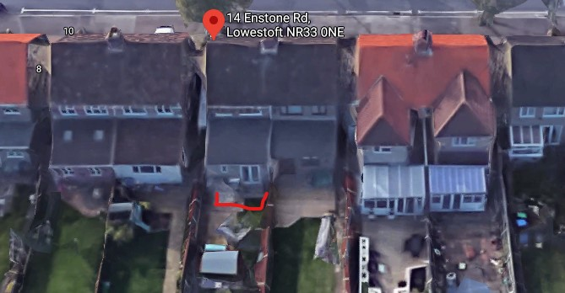
14 Enstone Road Lowestoft Suffolk NR33 0NE  To have constructed, an edwardian style roofed conservatory, will be joined to the extension of the semi-detached house  Date Description Information 1 Information 2  18/12/2020 Info Sheet INFO  17/12/2020 Existing Elevations Existing extension  17/12/2020 Plans Existing and proposed floor plans  17/12/2020 Proposed Elevations  17/12/2020 Proposed Elevations Conservatory joined to extension  26/10/2020 Application Form & Certificate  26/10/2020 Photographs Existing rear elevation  26/10/2020 Plans Proposed conservatory  26/10/2020 Plans Proposed conservatory (colour)  26/10/2020 Proposed Block / Layout Plan  26/10/2020 Proposed Elevations Sketch of West view  26/10/2020 Site / Location Plan | DC/20/4296/FUL  Public comments  Constraints  Related cases  Documents  Map

Land at the Beach End of Grand Avenue
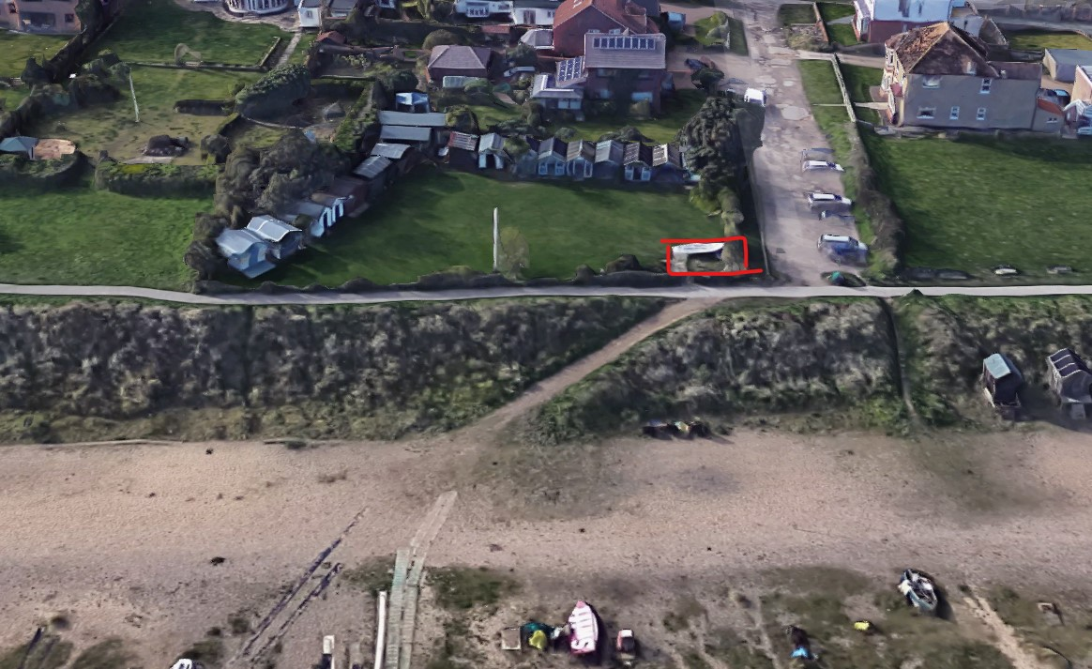
Commercial shed serving drinks and snacks on existing standings.
One neighbour objection. In support of serving hot and cold drinks, but stating that the access road has insufficient capacity, particularly for emergency access.
SCC Highways are in support of this application.
Land At The Beach End Of Grand Avenue Pakefield Lowestoft Suffolk NR33 7AR  To construct a 3m x 2.5m x 2.5m wooden, pitch roof shed in the north eastern corner of my privately owned piece of land, for the purposes of commercially selling hot/cold drinks and snacks. The shed will be placed on top of the original concrete base of the previous construction. The original services are still in place such as the water and electrical supply and drainage.  Date Description Information 1 Information 2  04/01/2021 Neighbour Responses Meaden 48 Grand Avenue, Lowestoft  24/12/2020 Consultee Responses Coastal Management  21/12/2020 Consultee Responses SCC Highways  11/12/2020 Info Sheet INFO  09/12/2020 Site / Location Plan  30/11/2020 Application Form & Certificate  30/11/2020 Proposed Block / Layout Plan  30/11/2020 Proposed Elevations  30/11/2020 Proposed Floor Plan  30/11/2020 Supporting Documents Signed Declaration  30/11/2020 Supporting Documents Supplementary Information - Level b assessment | DC/20/4862/FUL  Public comments  Constraints  Related cases  Documents  Map

