Planning notes 26/5/2020

Jubilee Parade Chalets
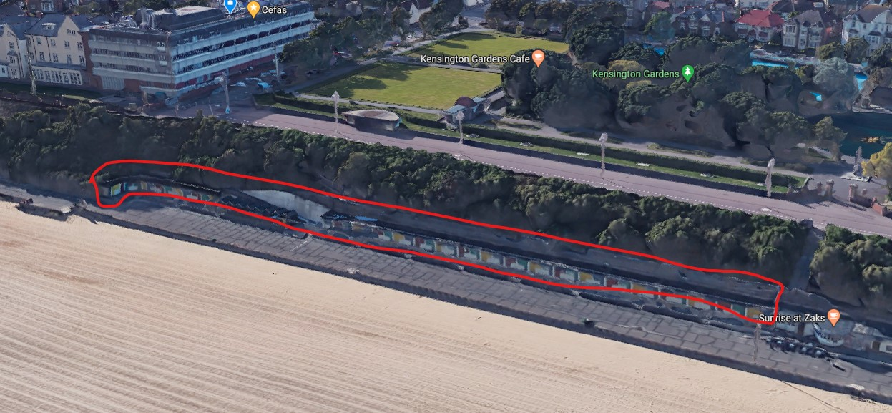
Public objection from Mr King: Poor design with lack of consideration for full impact of proposal, particularly visual impact on views from Jubilee Parade and the promenade. No account of historic or heritage values or concerns. No expert heritage advice on an original piece of seaside architecture.
Note that these designs cover the demolition of the site, but not the reconstruction. Site is not listed, and is outside the bounds of the South Lowestoft Conservation Area.

Jubilee Parade Chalets South Lowestoft Seafront The Esplanade Lowestoft Suffolk  To demolish the concrete beach chalets 1-13 and 22-58. Work necessary to reinforce existing retaining wall and cliff face to prevent land slip and risk to the public. Closure of ramped access.  Date Description Information 1 Information 2  14/05/2020 Neighbour Responses King 294 London Road South  05/05/2020 Existing Block / Layout Plan  01/05/2020 Application Form & Certificate  01/05/2020 Plans 0500 P04 Proposed stability works, extent of works  01/05/2020 Plans 0501 P04 Proposed stability works, section sheet 1  01/05/2020 Plans 0502 P03 Proposed stability works, section sheet 2  01/05/2020 Plans 0503 P02 Proposed stability works, enlarged plan areas  01/05/2020 Plans 0504 P02 Proposed stability works, proposed sequencing  01/05/2020 Plans 10 Plans and elevations as existing  01/05/2020 Plans 11 Plans and elevations as proposed  01/05/2020 Site / Location Plan 01 B  01/05/2020 Supporting Documents Planning statement | DC/20/1648/FUL  Public comments  Constraints  Related cases  Documents  Map

5-6 Bevan Street East
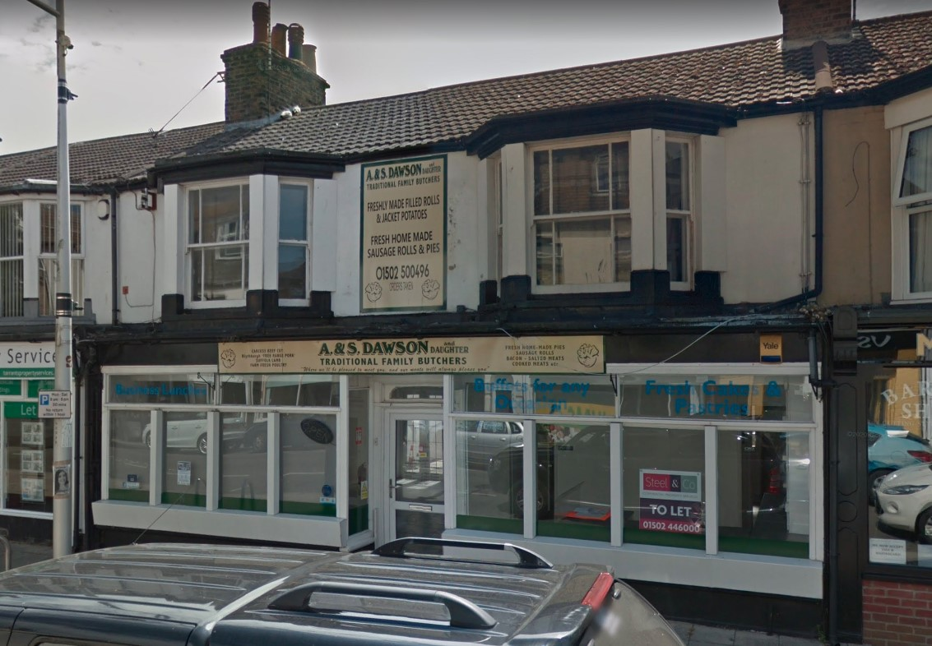

5-6 Bevan Street East Lowestoft Suffolk NR32 2AA  Prior Notification - change of use from a butchers to a dog grooming salon.  Date Description Information 1 Information 2  22/05/2020 Consultee Responses Environmental Protection  07/05/2020 Site / Location Plan  20/03/2020 Application Form & Certificate  20/03/2020 Supporting Documents Cover letter | DC/20/1699/PN3  Public comments  Constraints  Related cases  Documents  Map

158 Yarmouth Road
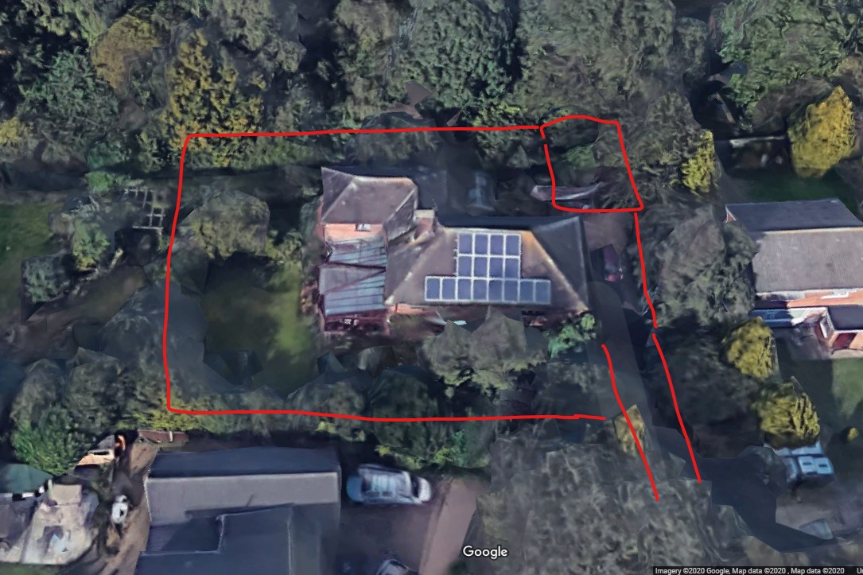
This is a building set well back from Yarmouth Road, with a long driveway. Proposal is to replace tree at top right of site with a garage, in line with the driveway and site access.
Topland 158 Yarmouth Road Lowestoft Suffolk NR32 4AB  Proposed double garage with storage over  Date Description Information 1 Information 2  07/05/2020 Application Form & Certificate Application form  07/05/2020 Plans Existing & Proposed plans  07/05/2020 Site / Location Plan Site plan | DC/20/1714/FUL  Public comments  Constraints  Related cases  Documents  Map

49 Edgerton Road
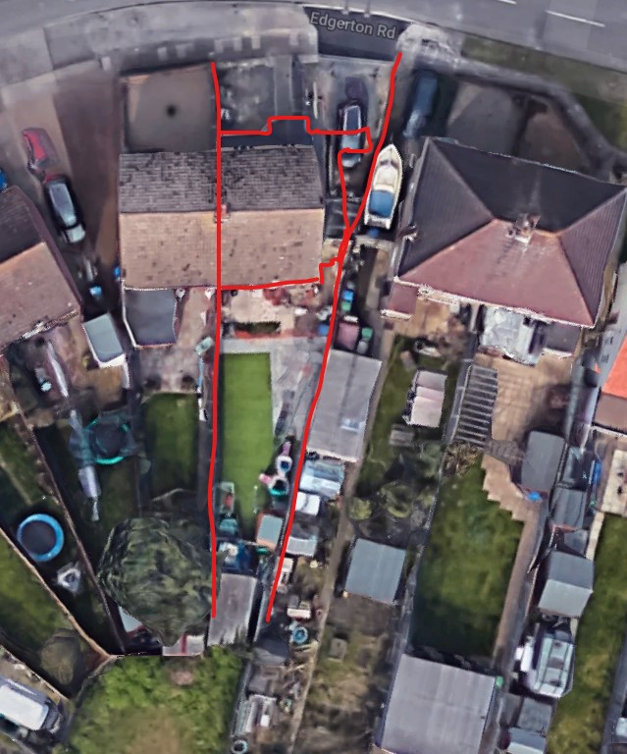
A side extension which makes full use of the width of the plot. No neighbour objection recorded.
49 Edgerton Road Lowestoft Suffolk NR33 9BG  Proposed side extension.  Date Description Information 1 Information 2  12/05/2020 Application Form & Certificate  12/05/2020 Plans 002 A Existing & Proposed Block Plan  12/05/2020 Plans 003 A Existing FP & Elevations  12/05/2020 Plans 004 A Proposed FP & Elevations  12/05/2020 Site / Location Plan 001 | DC/20/1746/FUL  Public comments  Constraints  Related cases  Documents  Map

22 Pinebanks
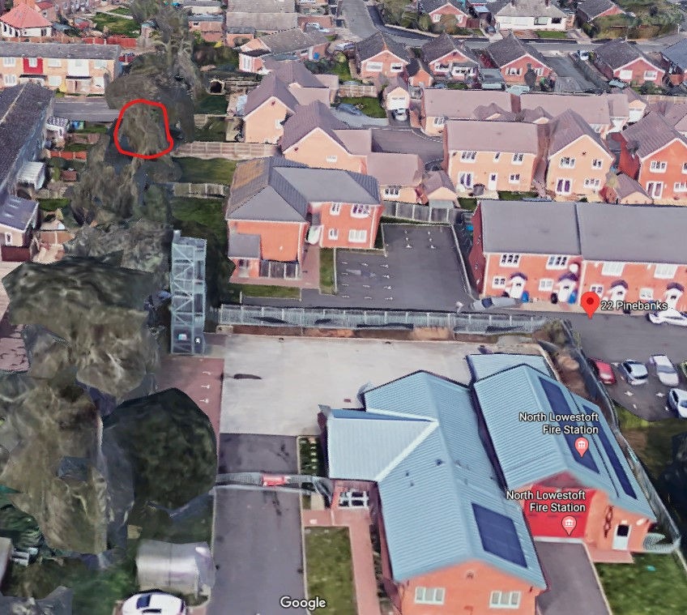
Difficult to get a photo of this one, but it is in the line of trees west of North Lowestoft Fire Station.
22 Pinebanks Lowestoft Suffolk NR32 2QE  Horse Chestnut on rear boundary to be reduced by 30% to allow more light to back of house. | DC/20/1646/TPO  Public comments  Constraints  Related cases  Documents  Map

