Planning notes 23/6/2020

Inverary, London Road South
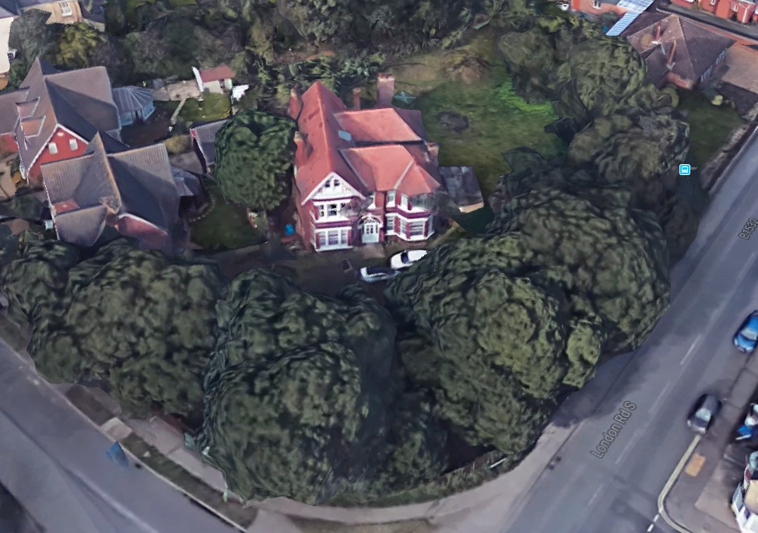
This is a well screened plot on the corner of the Avenue and London Road South.
Inverary London Road South Lowestoft Suffolk NR33 0PD  Sub divide existing property 'inverary' former social club into two semi detached houses and construct 1 bungalow and associated domestic garages within the curtilage of the site  Date Description Information 1 Information 2  17/06/2020 Consultee Responses Arboricultural & Landscape  12/06/2020 Contaminated Land Assessment Updated - Enviro check  11/06/2020 Consultee Responses Environmental Protection  10/06/2020 Info Sheet INFO  09/06/2020 Contaminated Land Assessment Land Contamination Questionnaire  09/06/2020 Design & Access Statement  05/06/2020 Application Form & Certificate  05/06/2020 Plans 01/280 Existing Floor and Elevations plus Site Plan  05/06/2020 Plans 03/280 Proposed Floor and Elevations  05/06/2020 Plans 04/280 Proposed Floor, Elevations and Sections through  05/06/2020 Plans 05/280 - Garage Proposed Floorand Elevations  05/06/2020 Proposed Block / Layout Plan 02/280 | DC/20/2060/FUL  Public comments  Constraints  Related cases  Documents  Map

149 The Avenue
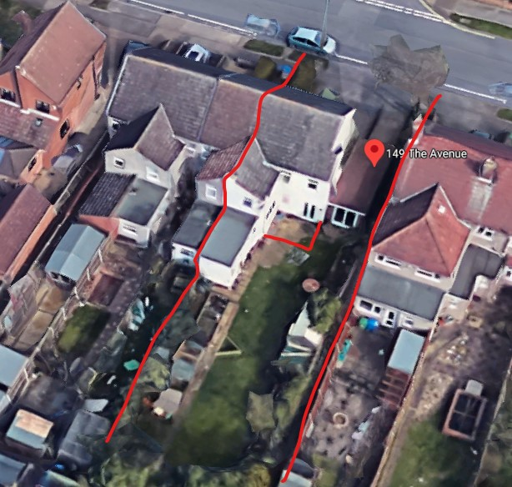
A remodelling of the ground floor, incorporating a rear extension – outline shown in red above.
149 The Avenue Lowestoft Suffolk NR33 7LJ  Single storey rear extension, vaulted ceiling, plans attached 466-01-149 The Avenue  Date Description Information 1 Information 2  12/06/2020 Info Sheet INFO  11/06/2020 Plans Proposed & Exisiting Plans Including Block & Site Plan 466-01 A | DC/20/2123/FUL  Public comments  Constraints  Related cases  Documents  Map

23 Rodber Way
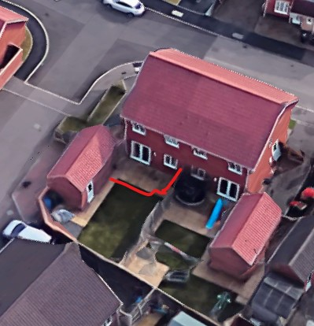
Creation of a single storey extension to the rear. No neighbour objections to date.
23 Rodber Way Lowestoft NR32 4WJ  Construction of a single storey rear extension and conversion of garage to study/play room  Date Description Information 1 Information 2  04/06/2020 Info Sheet INFO  03/06/2020 Application Form & Certificate  03/06/2020 Plans 244.01 Survey  03/06/2020 Plans 244.03 Proposals  03/06/2020 Site / Location Plan And block plan | DC/20/2019/FUL  Public comments  Constraints  Related cases  Documents  Map

55 Gainsborough Drive

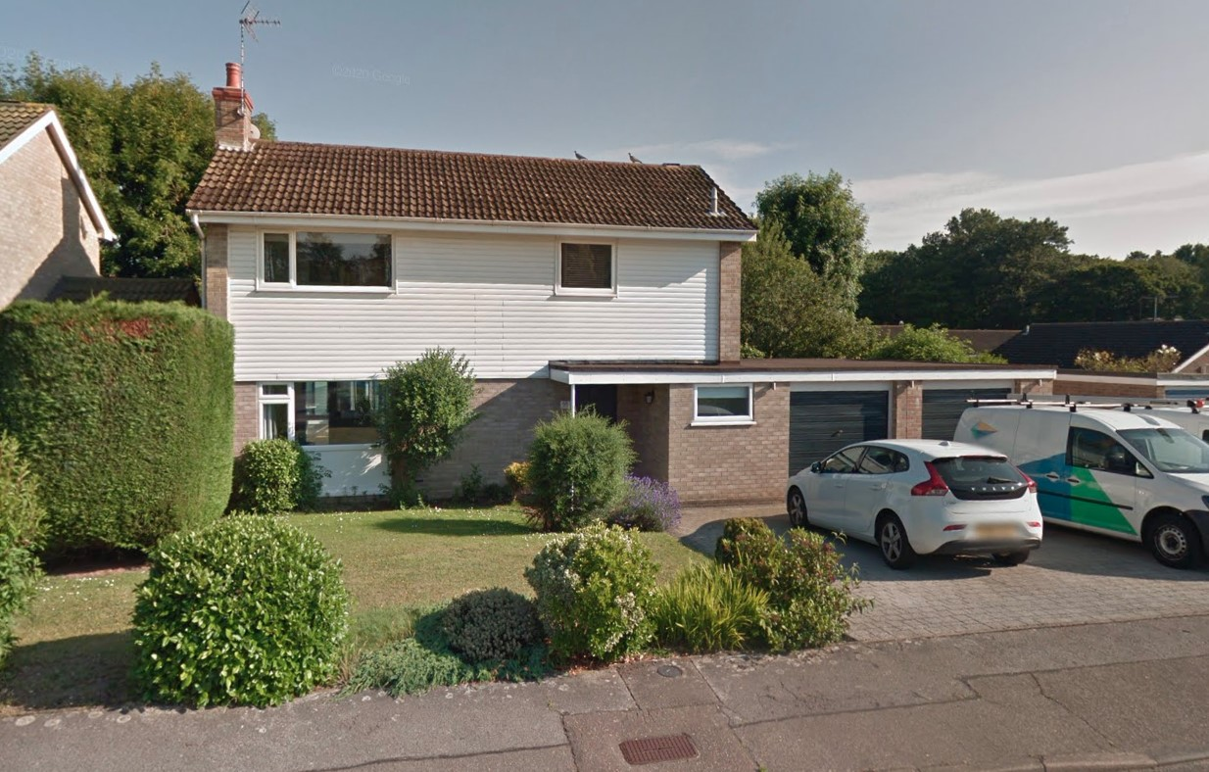
Replacement of a flat roof with a pitched roof, and replacing one garage with a kitchen.
55 Gainsborough Drive Lowestoft NR32 4NJ  Conversion of original garage to kitchen extension with additions to the roof of the garage and front porch to include; a short catslide running across into a dual-pitched roof over the garage.  Date Description Information 1 Information 2  15/06/2020 Consultee Responses Landscape Team  04/06/2020 Info Sheet INFO  03/06/2020 Plans Existing & Proposed Elevations  18/05/2020 Site / Location Plan  06/05/2020 Application Form & Certificate  06/05/2020 Plans Existing & Proposed Elevation | DC/20/1704/FUL  Public comments  Constraints  Related cases  Documents  Map

119 London Road North
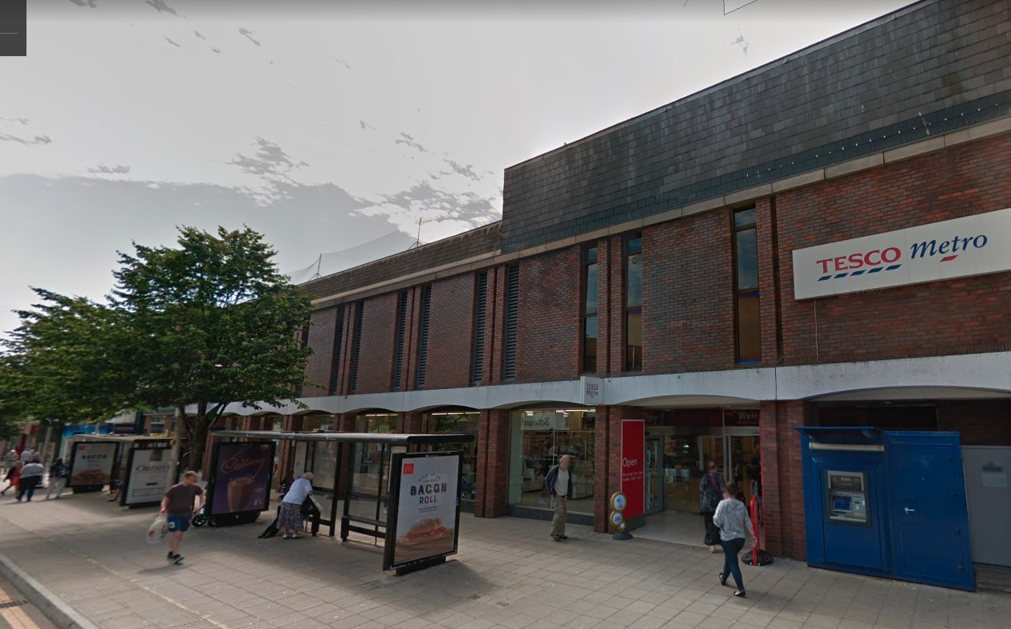
Redevelopment of the former Tesco site.
Several public comments:
Newsome: General support.
Castleton: Objection. Oversaturation of low cost housing in the area. Concern over the negative societal effects on the area. Area should remain commercial or public service.
King: Objection. Contrary to WLP8.29 – poor quality of design, does not complement local character. Particular concern over the elevations from Gordon Road and Regent Road, which show the development towering over the Victorian era streetscene. Inadequate provision for car parking. Concern over financial viability of the proposal.
Brooks: Counter to WLP 2.14 – “To improve the natural, historic and built environment”. Contrary to the WLP desire for a vibrant town centre. Design is not visually attractive. Loss of light to surrounding properties.
Pickess: Objection. No consideration to loss of light and privacy to nearby residents. Overpowering development. No provision for car parking.
119 London Road North Lowestoft Suffolk NR32 1LZ  Part demolition, conversion and extension of existing building, to provide commercial units (Class A1-A5, B1(a) and D2) and Class C3 residential units at 119-125 London Road North, Lowestoft.  Date Description Information 1 Information 2  22/06/2020 Neighbour Responses Pickess 120B London Road North  19/06/2020 Neighbour Responses Brooks 40 Melbourne Road  19/06/2020 Neighbour Responses King 294 London Road South  17/06/2020 Consultee Responses Environmental Protection  16/06/2020 Neighbour Responses Castleton 24 York Road  15/06/2020 Neighbour Responses Newsome 656 London Road South  04/06/2020 Info Sheet INFO  26/05/2020 Application Form & Certificate  26/05/2020 Contaminated Land Assessment Part 1 of 4  26/05/2020 Contaminated Land Assessment Part 2 of 4  26/05/2020 Contaminated Land Assessment Part 3 of 4  26/05/2020 Contaminated Land Assessment Part 4 of 4  26/05/2020 Design & Access Statement Rev A  26/05/2020 Existing Block / Layout Plan 6093_002 Rev A  26/05/2020 Existing Elevations 6093_008  26/05/2020 Existing Floor Plans 6093_003 Existing Ground Floor Plan  26/05/2020 Existing Floor Plans 6093_004 Existing Lower First Floor Plan  26/05/2020 Existing Floor Plans 6093_005 Existing First & Upper First Floor Plan  26/05/2020 Existing Floor Plans 6093_006 Existing Second & Upper Second Floor Plan  26/05/2020 Noise Report  26/05/2020 Plans 6093 / 010 rev A Proposed Demolition Ground Floor Plan  26/05/2020 Plans 6093 / 012 Proposed Demolition First & Upper First Floor Plan  26/05/2020 Plans 6093 / 013 Proposed Demolition Second & Upper Second Floor Plan  26/05/2020 Plans 6093 / 014 Proposed Demolition Sections  26/05/2020 Plans 6093 / 026 rev A Proposed Section A-A  26/05/2020 Plans 6093 / 027 rev A Proposed Section C-C  26/05/2020 Plans 6093 / 028 Proposed Section D-D  26/05/2020 Plans 6093_007 Existing Roof Plan  26/05/2020 Plans 6093_009 Existing Sections  26/05/2020 Plans 6093_011 Proposed Demolition Lower First Floor Plan  26/05/2020 Plans 6093_021 Proposed Fifth Floor/ Roof Plan  26/05/2020 Plans 6093_022 Proposed Roof Plan  26/05/2020 Proposed Block / Layout Plan 6093_015  26/05/2020 Proposed Elevations 6093 / 024 Proposed South East Elevation  26/05/2020 Proposed Elevations 6093 / 025 Proposed North West Elevation  26/05/2020 Proposed Elevations 6093/023 rev A South East Elevation  26/05/2020 Proposed Floor Plan 6093_016 Rev B Proposed Ground Floor Plan  26/05/2020 Proposed Floor Plan 6093_017 Rev A Proposed First Floor Plan  26/05/2020 Proposed Floor Plan 6093_018 Rev A Proposed Second Floor Plan  26/05/2020 Proposed Floor Plan 6093_019 Rev A Proposed Third Floor Plan  26/05/2020 Proposed Floor Plan 6093_020 Rev B Proposed Fourth Floor Plan  26/05/2020 Site / Location Plan 6093_001  26/05/2020 Supporting Documents 6093 Drawing Register  26/05/2020 Supporting Documents Accommodation Schedule  26/05/2020 Supporting Documents Existing Area Schedule  26/05/2020 Supporting Documents Flood Map  26/05/2020 Supporting Documents Planning Statement May 2020  26/05/2020 Supporting Documents Proposed Area Schedule 18.05.2020  26/05/2020 Supporting Documents Residential/Dwelling Units Supplementary information  26/05/2020 Supporting Documents Structural Appraisal | DC/20/1914/FUL  Public comments  Constraints  Related cases  Documents  Map

119 Bevan Street
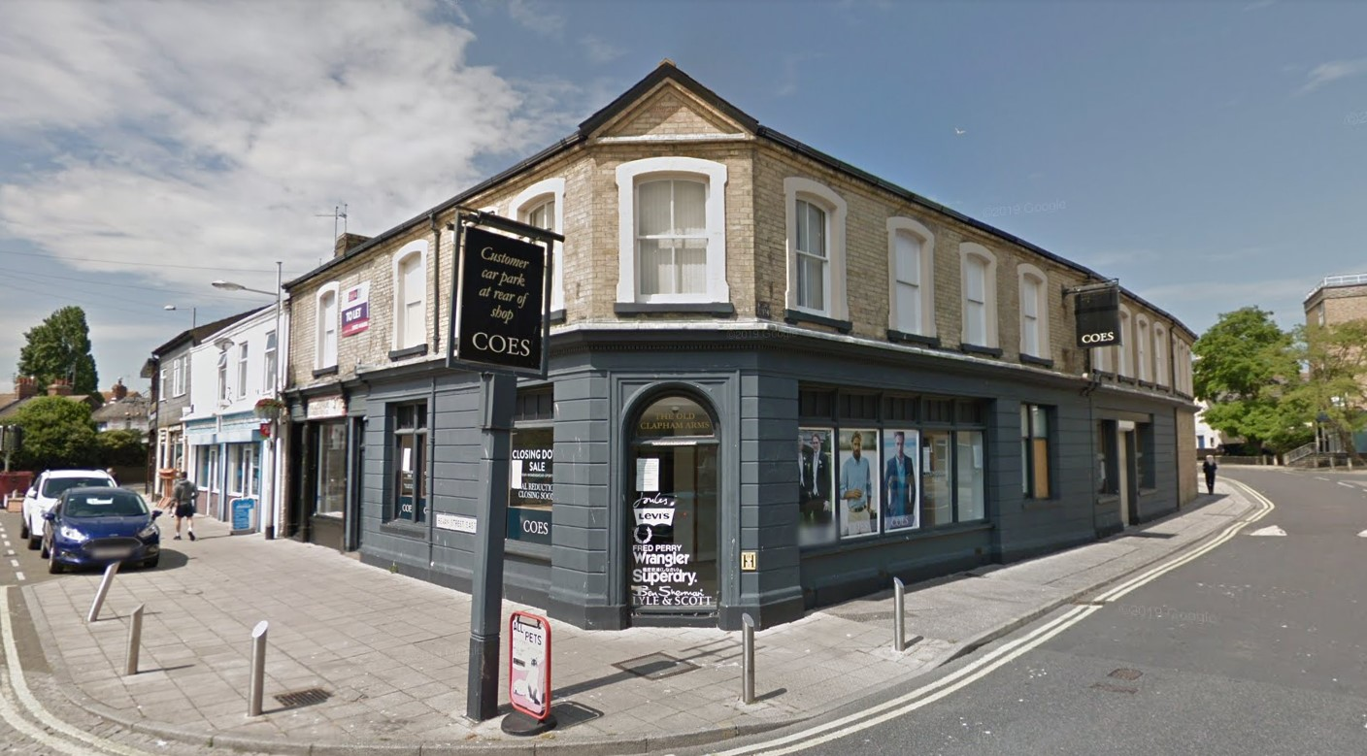
Change of use from A1 (Shops) to D1 (Non-residential institution). Application from by Allsorts support services.
119 Bevan Street Lowestoft Suffolk NR32 2AG  Change of use to A1 to D1 (non residential institutions).  Date Description Information 1 Information 2  15/06/2020 Info Sheet INFO  11/06/2020 Site / Location Plan l  08/06/2020 Flood Risk Assessment  08/06/2020 Proposed Floor Plan Ground & first floor plan | DC/20/2088/COU  Public comments  Constraints  Related cases  Documents  Map

84 Edgerton Road
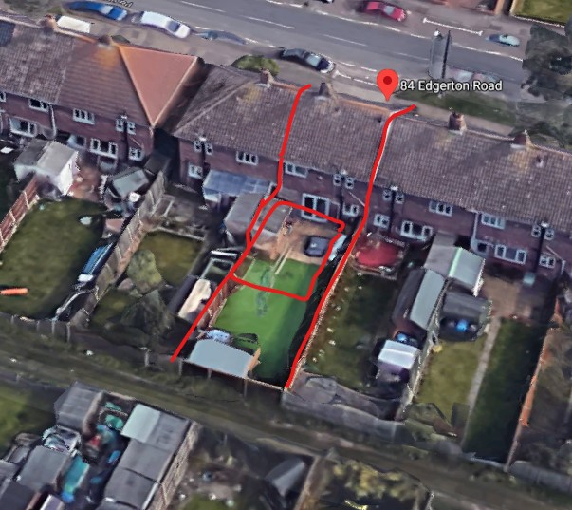
Application incorporates a 5.8m long rear extension and addition of two bedrooms in loft space.
84 Edgerton Road Lowestoft Suffolk NR33 9BH  Proposed roof conversion and rear extension  Date Description Information 1 Information 2  10/06/2020 Consultee Responses Environmental Protection  03/06/2020 Info Sheet INFO  28/05/2020 Application Form & Certificate  28/05/2020 Plans 982/0 Existing  28/05/2020 Plans 982/1 Proposed  28/05/2020 Site / Location Plan | DC/20/1954/FUL  Public comments  Constraints  Related cases  Documents  Map

34 Pinewood Avenue
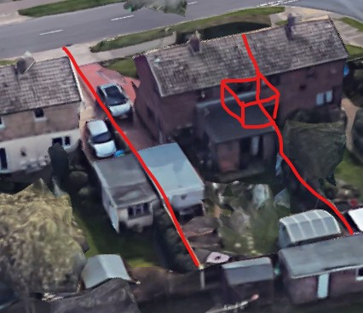
Addition of a rear first storey extension. Approximate location shown above in red.
34 Pinewood Avenue Lowestoft Suffolk NR33 9AQ  Construction of a first floor rear extension  Date Description Information 1 Information 2  09/06/2020 Info Sheet INFO  04/06/2020 Application Form & Certificate  04/06/2020 Supporting Documents Covering Letter  03/06/2020 Site / Location Plan  03/06/2020 Site / Location Plan 491/01 Existing & Proposed - Elevations, Floor & Block Plan | DC/20/2055/FUL  Public comments  Constraints  Related cases  Documents  Map

Third Crossing, Lake Lothing
This covers the latest version of the Design Guidance Manual, which covers the style of the bridge, associated highway changes, landscaping and lighting.
Third Crossing, Lake Lothing  Discharge of Requirement 3 (2) - Design of the authorised development Design Guidance Manual of The Lake Lothing (Lowestoft) Third Crossing Order 2020.  Date Description  03/06/2020 2020-06-03 Valid Letter  20/05/2020 Covering Email From Sam Cliff  10/06/2020 2020-06-10 Archaeology Response Redacted  10/06/2020 2020-06-10 Marine Management Organisation Response Redacted  10/06/2020 2020-06-10 Emergency Planning No Comment Redacted  15/06/2020 GHI Public Rights of Way Response Redacted  17/06/2020 Flood Response  20/05/2020 Design Guidance Manual Final May2020 | SCC/0040/20/DOR3

27 The Avenue
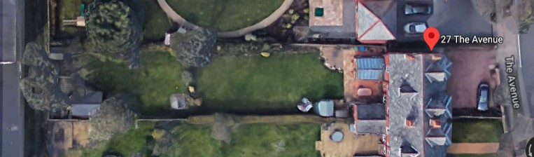
27 The Avenue Lowestoft Suffolk NR33 7LH  Rear garden T1 Sycamore - Reduce crown by up to 50% to create a more compact canopy T2 Sycamore - Reduce crown by up to 50% to create a more compact canopy T3 Sycamore - Bring back down to hedge height to allow more light into the garden and to match the other two trees also 1 x poor quality Sycamore on boundary with neighbour - Fell to ground level reason poor quality and being smothered by neighbouring macracarpa works agreed on site visit 17 June Front garden T4 Cherry - Crown lift from over the public footpath to give recommended 2.5m clearance  Date Description Information 1 Information 2  08/06/2020 Application Form & Certificate | DC/20/2065/TCA  Public comments  Constraints  Related cases  Documents  Map

16 Farm Close
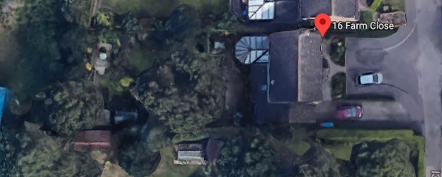
16 Farm Close Lowestoft Suffolk NR33 8RP  TPO 62 G5 Rear garden 2 x Oaks - Thin canopy by 30% and remove epicormic growth as part of ongoing maintenance  Date Description Information 1 Information 2  01/06/2020 Application Form & Certificate | DC/20/1977/TPO  Public comments  Constraints  Related cases  Documents  Map

