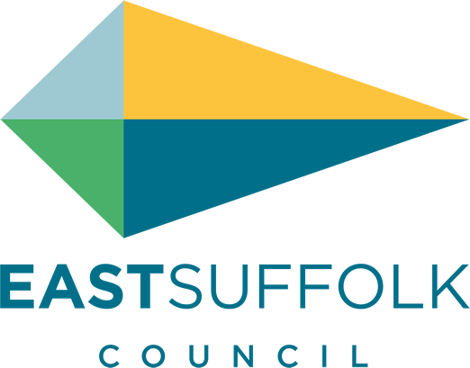

Hamilton House
Battery Green Road
Lowestoft
Suffolk
NR32 1DE
 | Date: | 25/03/2021
 | Please ask for: | Jamie Behling
 | Direct dial: | 07912303788
 | Email: Jamie.behling@eastsuffolk.gov.uk

Dear Mrs Shona Bendix

Re: Removal of BT Payphones – OPP NO 69, PCO1 LOVE ROAD, LOWESTOFT

The District Council is writing to you as part of its formal consultation process regarding BT’s current program of proposed public payphone removals which affects a payphone located in your parish. It is the responsibility of the District Council to canvas the opinions of the local community on the removal of payphones and determine whether to veto their removal or not. More information on the removal process can be found online – http://stakeholders.ofcom.org.uk/binaries/consultations/uso/statement/removals.pdf

Should the District Council agree to the removal of the payphone facility, BT does also offer Parish Councils and registered charities the facility to adopt a kiosk, taking ownership of the kiosk for a fee of £1 thereby protecting the heritage of the community. More information on the adoption process can be found online – http://bt.com/adopt

The consultation period with BT will close on 14th June 2021; therefore all responses to this consultation letter should be submitted to the District Council Planning Department for consideration within three weeks of the date of this letter. Please specify the Parish Councils recommendation on the proposal to remove the payphone within the attached table that should specify the recommendation and reasons to accept or object to the proposed payphone removal. Please also indicate within the table whether the Parish Council would be interested in adoption of the kiosk.

All correspondence should be marked for the attention of Jamie Behling.

Yours sincerely
Jamie Behling (Planning & Enforcement Officer)

Consultation Return
BT Payphone Removal Programme

Parish/Town Council | Lowestoft Town Council
Payphone Address | OPP NO 69, PCO1 LOVE ROAD, LOWESTOFT
Payphone Number | 01502572893
Calls made in past year | 15
Accept/Object
Comments/Reasons
Would the Parish/Town Council wish to adopt the kiosk?

Date: Signed: Town/Parish Clerk

