Planning notes 10/11/2020

137 Stradbroke Road
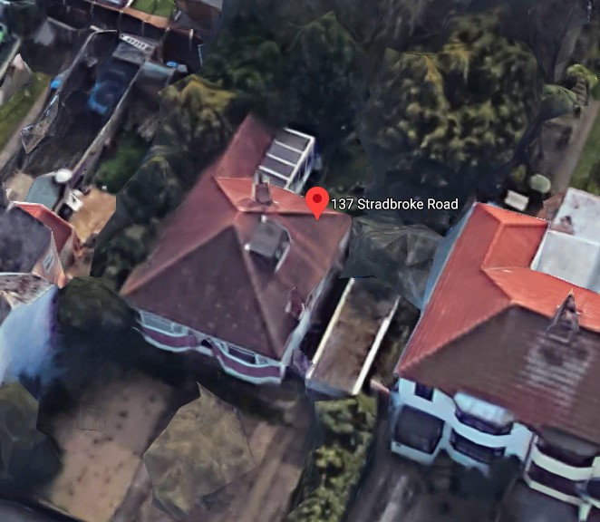
Squaring off the rear of the house, and adding a 2m x 5m side extension.
137 Stradbroke Road Lowestoft Suffolk NR33 7HP  Demolition of Existing Conservatory, and Part Kitchen, and Erection of Single Storey Rear and Side Extensions  Date Description Information 1 Information 2  02/11/2020 Info Sheet INFO  30/10/2020 Application Form & Certificate  30/10/2020 Plans Drawing No 1 existing elevation/floor/block  30/10/2020 Plans Drawing No 2 proposed elevation/floor/block  30/10/2020 Site / Location Plan | DC/20/4364/FUL  Public comments  Constraints  Related cases  Documents  Map

22 The Avenue
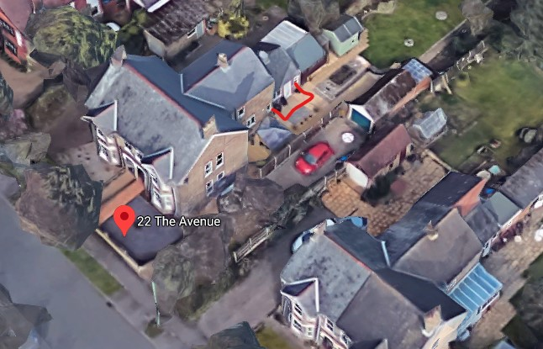
22 The Avenue Lowestoft NR33 7LL  Single storey rear extension  Date Description Information 1 Information 2  22/10/2020 Info Sheet INFO  15/10/2020 Application Form & Certificate  15/10/2020 Plans 1 Existing floor layout and elevations  15/10/2020 Plans 2 Proposed floor layout and elevations  15/10/2020 Plans 3 Site plans | DC/20/4113/FUL  Public comments  Constraints  Related cases  Documents  Map

10 Vermeer Close
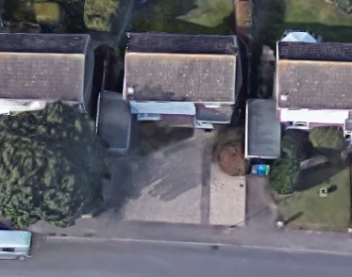
Several other properties in this close have similar front extensions.
10 Vermeer Close Lowestoft Suffolk NR32 4NQ  Single-storey front extension to create new kitchen, together with new porch.  Date Description Information 1 Information 2  29/10/2020 Consultee Responses Arboriculture & Landscape  22/10/2020 Info Sheet INFO  20/10/2020 Application Form & Certificate  20/10/2020 Existing Block / Layout Plan  20/10/2020 Plans 548-01 Existing Elevations & Floor Plans  20/10/2020 Plans 548-02 Proposed Elevations & Floor Plans  20/10/2020 Proposed Block / Layout Plan  20/10/2020 Site / Location Plan | DC/20/4180/FUL  Public comments  Constraints  Related cases  Documents  Map

Cherry Lodge, 23-24 Lyndhurst Road
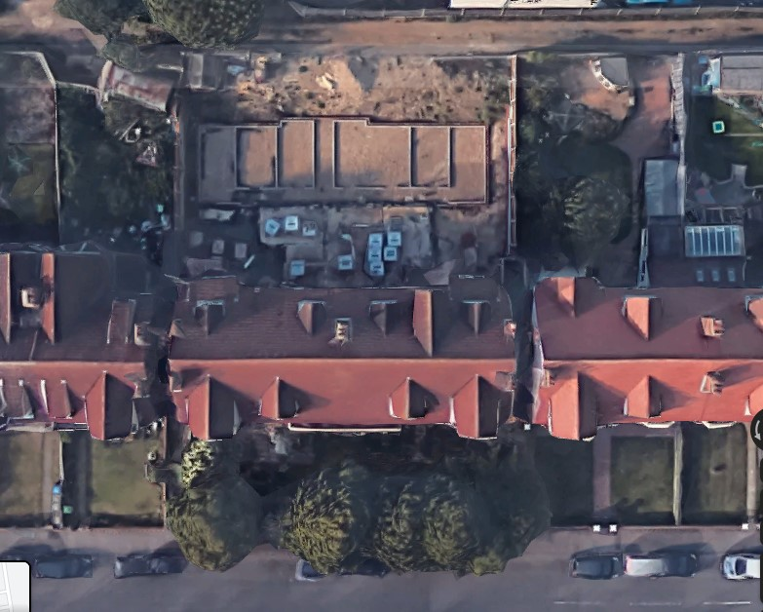
Extension above the rear wing (shown under construction above).
Cherry Lodge 23 - 24 Lyndhurst Road Lowestoft Suffolk NR32 4PD  Construction of a first floor extension (partially above lower ground floor rear wing) to provide 3 additional bedrooms and associated works  Date Description Information 1 Information 2  21/10/2020 Design & Access Statement & Heritage Statement  21/10/2020 Info Sheet INFO  21/10/2020 Plans 200919 1 Existing floor/elevations  14/10/2020 Application Form & Certificate  14/10/2020 Plans 200919 2 Proposed floor/elevations  14/10/2020 Site / Location Plan & Block  14/10/2020 Supporting Documents Care home bed availability  14/10/2020 Supporting Documents Covering letter  14/10/2020 Supporting Documents Evidence of Care Need  14/10/2020 Supporting Documents Statement of Housing Land Supply | DC/20/4090/FUL  Public comments  Constraints  Related cases  Documents  Map

175 Oulton Road
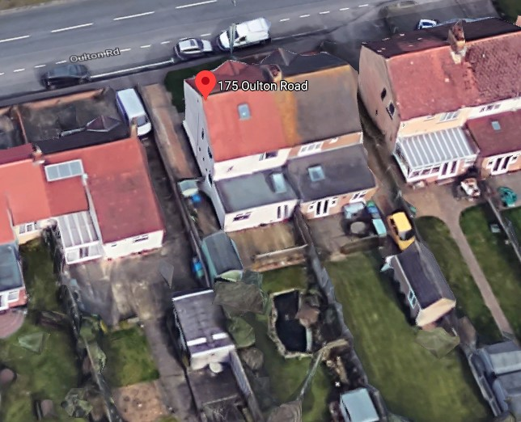
175 Oulton Road Lowestoft Suffolk NR32 4QT  Rear extension  Date Description Information 1 Information 2  21/10/2020 Info Sheet INFO  14/10/2020 Application Form & Certificate  14/10/2020 Plans 2694.20.1 Existing & Proposed - Floor, Elevations, Site, Block & Section | DC/20/4102/FUL  Public comments  Constraints  Related cases  Documents  Map

72 Pinewood Avenue
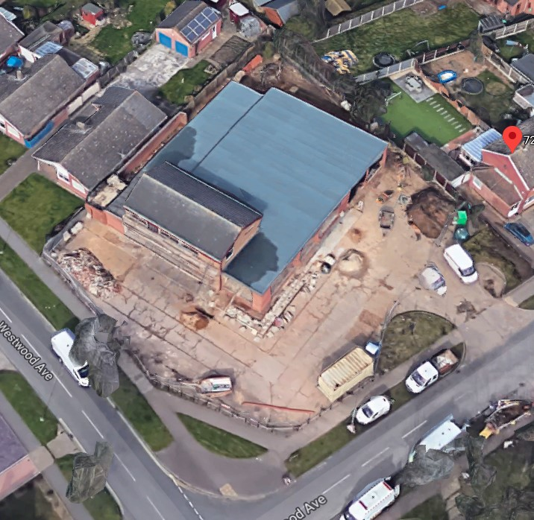
This was viewed by this committee and approved. Since then, the plans have been updated to better define the exact location of the change of use. There have been three public objections raised.
Burpitt: On grounds of smell, and undercapacity of sewer.
Houghton: Fire risk, littering and resultant vermin, noise and light pollution at night, disturbance from loud clientele, smell, adverse effect on house prices.
Diggins: Noise from chimneys and fans. Kitchen smells. Increased traffic. Littering. No need for another food outlet in the area.
72 Pinewood Avenue Lowestoft Suffolk NR33 9AJ  Change of use from shop (Class E) to Hot Food Takeaway (Sui-generis)  Date Description Information 1 Information 2  03/11/2020 Neighbour Responses Burpitt 73 Westwood Avenue, Lowestoft  27/10/2020 Consultee Responses Environmental Protection  23/10/2020 Plans CA-SEP-30-02A Proposed Elevations, Floor & Block Plan  06/10/2020 Consultee Responses Suffolk Highways  29/09/2020 Neighbour Responses Diggens 71 Westwood Avenue, Lowestoft  25/09/2020 Consultee Responses Environmental Protection  24/09/2020 Neighbour Responses Houghton 68 Pinewood Avenue, Lowestoft  23/09/2020 Town/Parish Consultation Response  14/09/2020 Info Sheet INFO  10/09/2020 Application Form & Certificate  10/09/2020 Plans CA-SEP-30-01 Existing Elevations, Floor & Block Plan  10/09/2020 Plans CA-SEP-30-02 Superseded Proposed Elevations, Floor & Block Plan | DC/20/3540/COU  Public comments  Constraints  Related cases  Documents  Map

32 Holton Avenue
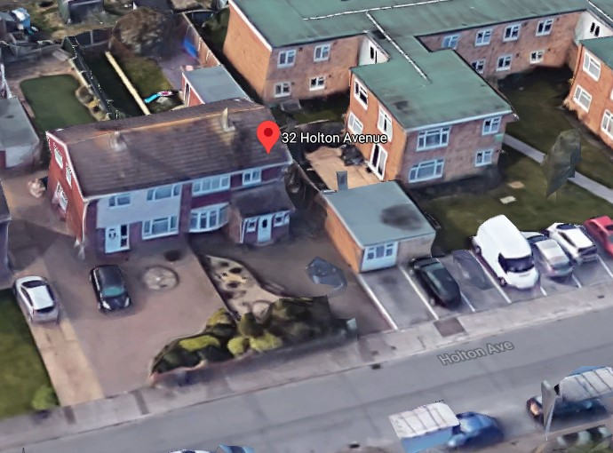
32 Holton Avenue Lowestoft Suffolk NR32 4RR  First floor extension above porch, removal of garage and new rear extension  Date Description Information 1 Information 2  05/11/2020 Town/Parish Consultation Response  21/10/2020 Info Sheet INFO  05/10/2020 Application Form & Certificate  05/10/2020 Plans 2666.20.1B Existing & Proposed - Elevations, Floor, Site & Block Plans | DC/20/3943/FUL  Public comments  Constraints  Related cases  Documents  Map

