Great Eastern Linear Park, Lowestoft, Suffolk

Current Site information
Ward: Normanston Site Reference: SK116830
Area: Special Status:
Covenants:
TPOs:
Services: Facilities on site: Tarmac pathway, cctv
Access: Various access points along the length
Species on Site: Soil Type:
Issues:
The park is the remains of the old Lowestoft to Gt Yarmouth railway track and is very long but also very narrow for a park. It is in a dip and there are few locations for activities, there is limited lighting and a lack of visibility over or along it. There is limited cctv. As the town expanded after it was built sewerage runs over the park and there are also drainage & fly-tipping issues.

Current main use of site:
The park is generally used as a transit route than a place to spend time and enjoy. It does however provide a key wildlife corridor through the town.

Future planned use of site:
The layout of the park prevents a lot of uses however there is a potential working party between the council and Ormiston Denes Academy as well as bringing other partners on board.
Whilst the site would remain essentially a transit park and wildlife corridor, there are improvements which could be made. Park users would like improved lighting and CCTV as the park is often used in low light and good segregation of pedestrians and cyclist areas would be safer. There have been suggestions that hides/screens to watch wildlife would be beneficial. Alternative forms of access have been suggested such as slides as a lot of the park users are young (this would have to be looked into for H&S reasons). Narrow play equipment and games such as hopscotch which could be painted on the tarmac would be preferred particularly in the areas close to the primary schools and maybe seating/bins in those areas reflecting the schools.
A further suggestion is a heritage trail/Lowestoft timeline which could be installed along the length of the park possibly using carved telegraph poles or sleepers as this would provide a reason for people to traverse the park rather than just for getting from A to B. This could be done pictorially as well as via an app.
Planting should remain natural and low maintenance whilst providing cover for wildlife and improving the sense of safety for park users.
The name “The Great Eastern Linear Park” is not used by locals who call it “The Trams”. Although not strictly accurate it is possibly a better name than calling it “The Tracks”. As “The Trams” is in current general usage it would seem sensible to formally rename it as such and erect new signage.
Resources Required:
The school would like to start by forming a stakeholder group which we would work on with them and this is currently underway. The initial activities would be litter picks and mapping the park so that an actual plan can be drafted.

Funding Required:
The school has a small fund which can be used for the park but other funding would be required however with involvement of the school and colleges as well as other key stakeholders this may open up potential grant pots for which we may need to provide seed money. Lighting and re-tarmacking will be expensive projects but cctv structures are in place although how they link into service would need consideration. Benches and bins would need to be budgeted for as would play equipment but potentially wildlife screens could be built as part of a project. Signage would also need to be budgeted for.

Stakeholder Group Yes, forming
Friends Group Not yet and may form different format
Maintenance Contract holder: Norse

Gunton Community Park, Lowestoft, Suffolk

Current Site information
Ward: St Margaret’s Site Reference: SK261132
Area: Special Status:
Covenants: Entrances: 5
TPOs:
Services: Facilities on site:
Access: Vehicular access from Montgomery Avenue, pedestrian access from Hilcrest Drive, Hilcrest Gardens and Peddars Way
Species on Site: Soil Type:
Issues:
The park is fully enclosed by housing, no visibility from the road which has positive and negative issues

Current main use of site:
The park is a large site which is predominantly used by children and dog walkers. There is a lot of open space but the site does not have the amenities to make it into a destination park, even with the facilities necessary to gain that status the park has no real parking nearby to allow non-locals to access it.

Future planned use of site:
The site has a lot of potential and already has good play equipment and a MUGA. There is also a football pitch which is more for fun and not formal competition as there are no changing facilities or parking. The site contains a wildlife area which has not been cared for but could potentially be improved or relocated to elsewhere on the site. All the paths on site intersect in an area which calls out for a public work of art or specimen/notable tree. In the south eastern corner of the park there are some natural hummocks’ and planting which could be emphasised to provide a more natural play area to enhance the other play facilities within the park. The park suffers from a lack of seating, bins and planting which would significantly improve the park for the local residents.

There are three trees coming from the Tree Council plus a cherry tree for the centre of the park with some planting around it.

Key Development Opportunities:
- Definition of areas within the park whilst maintain cohesion across the whole.
- Sports area in south west area
- Community garden/orchard in area towards community centre
- Planting of hedgerow along the rear of the house on Montgomery Avenue between the park and the access way to the houses
- Additional mounds made from “plastic bricks” in the mound areaplant with wildflowers to create a natural play area
- Bins
- Bike racks
- Low level lighting
- Benches/picnic benches
- teenage seating
- Dinking water fountain (water supply?)
- additional planting/trees
- toilet/changing room provision but this would need to be assessed.
- CCTV

Resources Required: | Various
Funding Required: | Elements could be funded from the Parks Development Budget as well as the using for seed funding for grants.
Stakeholder Group | No but potential with church
Friends Group | No
Maintenance Contractor | Waveney Norse

Kensington Gardens, Lowestoft, Suffolk

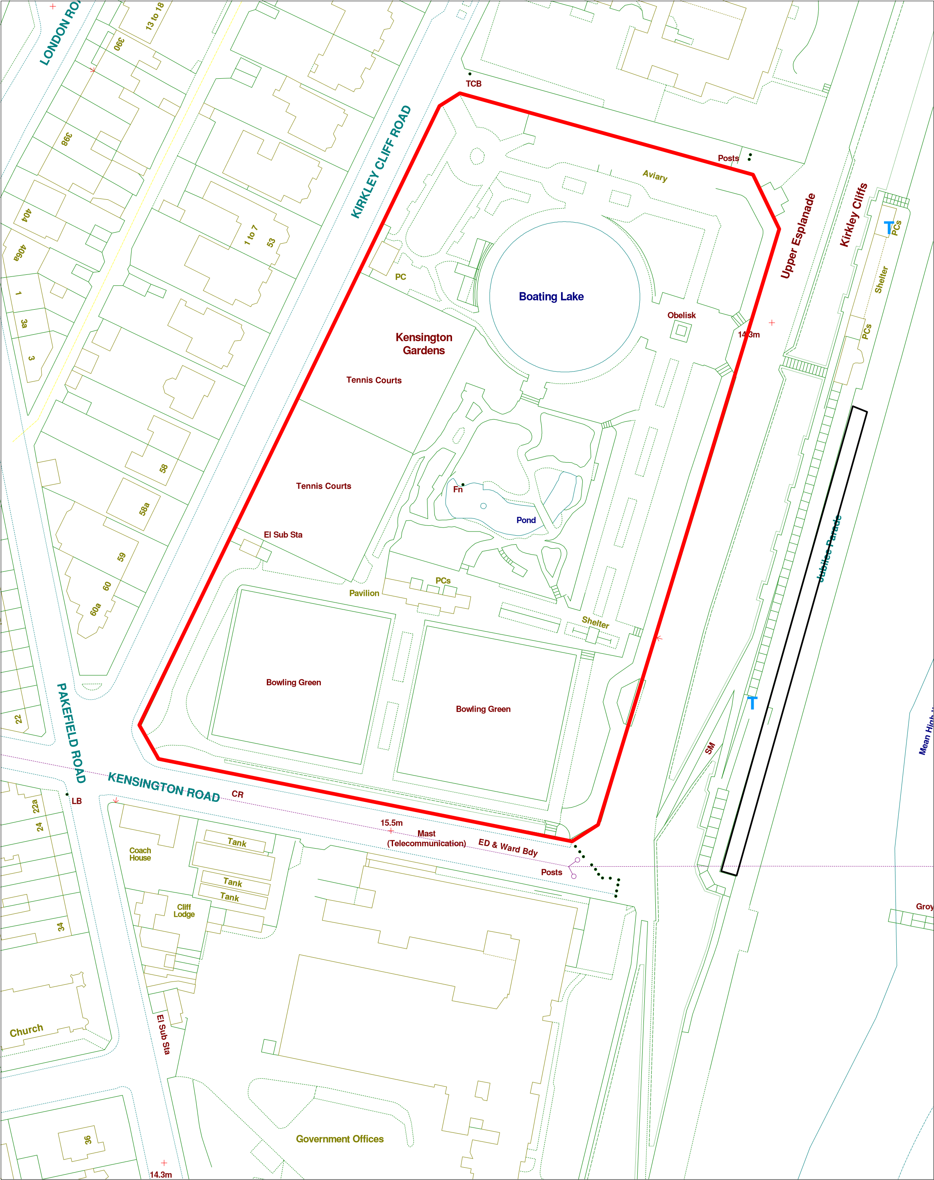

Current Site information
Ward: Kirkley Site Reference:
Area: Specification: Destination Park
Covenants: Special Status: Conservation Area
TPOs: Entrances: 5
Services: Water, electricity, drainage, gas?
Access: Four entrances with pedestrian and vehicular access
Species on Site: Soil Type:
Issues:
Facilities on site: Café, Toilets, Park Keepers Store, Bowling Pavilion, 2 Bowling Greens, 4 tennis courts, Oriental garden, boating lake, kiosk, boats store, memorial, Long border, compost bin, promenade building, noticeboard
Current main use of site:
Park and sports area

Future planned use of site:
Destination Park based around its heritage as a Victorian Pleasure Garden and its links with Kensington Gardens in London and through that Peter Pan. Originally had a Japanese Garden however the soil is not acidic enough to recreate and the ground is very compressed in the Japanese garden due to the trees and old planting. Need to discuss with Friends Group whether to recreate the Japanese Garden or create a new dell garden. This would affect design of the structure.
Key Development Opportunities:
- Roofed pergola to rear of “Japanese Garden”
- A new Peter Pan sculpture for the fish pond. Either Peter Pan and merfolk or Pen Pan and pirates ship to make it more unique and link in the maritime location to Peter Pan.
- Possibly a fun second statue of a crocodile with an actual working clock or clock with movable hands in its mouth emerging from the pond at one end.
- “Lost boys” sculptures in the trees incorporating wildlife houses etc
- Addition to the Bowls Club – linking the café to the bowls club to still maintain the two access points but with a continuous roof, a central covered bench area, and an enclosed extension at the bowls club end to contain bowls equipment at the front and a shallow store at the rear for Friends gardening tools (see diagram).
- CCTV possibly in 3 – 4 locations
- Drinking Water Fountain
- Children’s Play area linked to the theme of the park of a more natural style?
- Limited seating required
- Gates with arched tops
- Signage
- Bins
- Bike racks
- Lighting
- Holocaust Garden
- Holocaust Plinth
- Kinder Transport Memorial Bench
- Islands in the boating lake
- Rainwater capture and storage
Resources Required: | Various
Funding Required: | Grant/Capital funding for pavilion, Parks Development Budget, sponsorship/grants
Stakeholder Group | Yes
Friends Group | Yes
Maintenance Contractor | Waveney Norse

