Dog litter bag dispensers
I am a local dog daycare business in premises on Newcombe Road. I supplied some dog poo dispenser units to Kensington garden and wondered if I could do the same at the new Ness point play area. I have noticed a lot of dog walkers and thought this would help them clean up after themselves.
The only cost you would be responsible for is the initial placement of the dispenser. It can be mounted on a post or on a wall etc. I would pay for the unit, the logo and the initial poopbags. These are bio degradable. I am then happy to keep restocking the units as I walk there most days.
Like I said I placed two units at Kensington gardens so if you have any more sites you think this could be beneficial then please let me know.
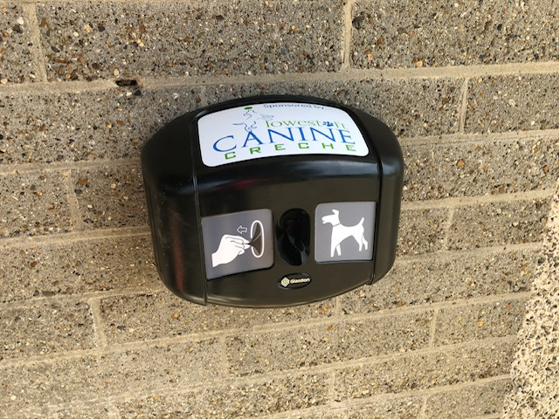
Does come in green if you didn’t want black.

