CYCLE STRATEGY

Contents

- Introduction

- Current cycling provision in Lowestoft
2.1 Map of cycle routes
2.3 Hire and parking
2.4 Tourism

- Supporting policy documents
3.1 Waveney Local Plan Policies WLP 8.21 Sustainable Transport
3.2 Lowestoft Town Council Neighbourhood Development Plan (emerging)
3.3 East Suffolk Council - https://www.eastsuffolk.gov.uk/assets/Planning/Waveney-Local-Plan/Background-Studies/Waveney-Cycle-Strategy.pdf
3.4. East Suffolk Council - Lowestoft Town Centre Master Plan https://www.eastsuffolk.gov.uk/assets/Business/Regeneration-projects/Lowestoft-Town-Centre-Masterplan.pdf
3.5 Suffolk County Council Prioritised Rolling Five Year Plan for Cycling
(file:///C:/Users/footes/Downloads/Agenda%20Item%207c%20-%20Appendix%20B%20-%20Prioritised%20five%20year%20plan%20(1).pdf)
3.6 Lowestoft Town Council Climate Emergency Declaration
3.7 Lowestoft Town Council Health Emergency
3.8 Central Government
https://www.gov.uk/government/publications/cycle-infrastructure-design-ltn-120
https://www.gov.uk/government/publications/cycling-and-walking-plan-for-england

- Partner organisations
4.1 Sustrans - have been approached twice but to date no response
4.2 Cycling Clubs within Lowestoft - https://www.vcbaracchi.co.uk/
https://www.britishcycling.org.uk/club/profile/8817/lowestoft-wheelers-cycling-club-

- Consultation and responses

- How the Town Council will promote and support development of cycling as the preferred method of transport for short journeys

- Introduction

There are many calls for cycling to be the first form of transport for short journeys. This document explores the current provision in Lowestoft to support cycling and how the Town Council can develop provision by working with other statutory authorities and stakeholders and adopting policy for improved cycling.
Cycling has become popular for a variety of reasons. The health benefits of cycling daily rather than taking a car for short trips outweigh the risks of inhalation of air pollutants. Regular cycling boosts physical fitness and is an efficient way to prevent obesity.

2. Current cycling provision in Lowestoft
Extracted from the Suffolk County Council Lowestoft Cycle Map 2020 and can be downloaded from https://www.suffolkonboard.com/cycle/cycle-maps--1/lowestoft/
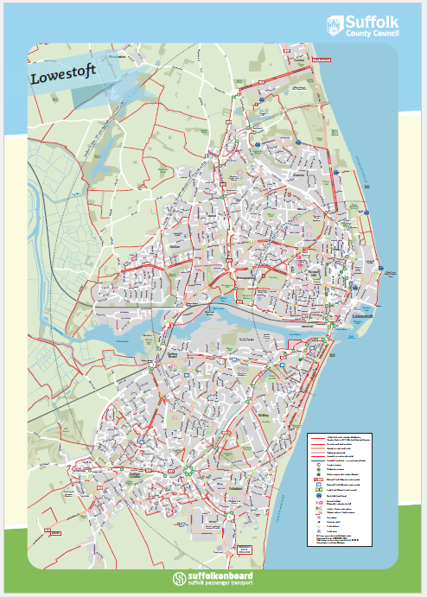

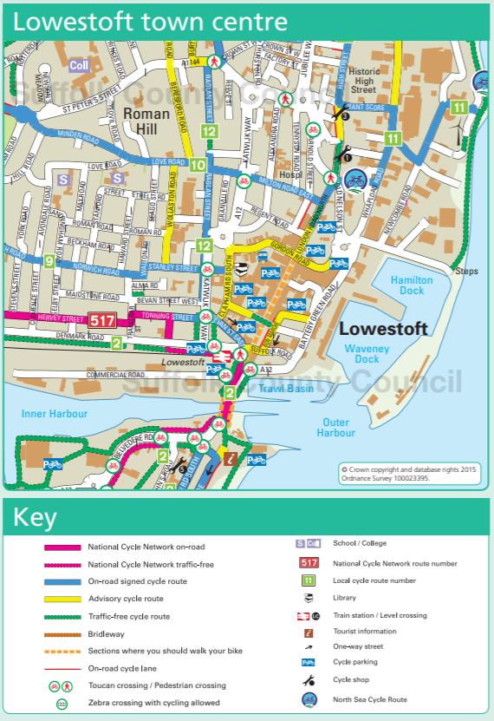

2.3 Hire and parking

This section is still to be completed. Thought to be given to how cycling parking is required in new housing development as well as provision in the town for cycle parking and hire

2.4 Tourism

Can cycling support the tourist economy. There are several cycle routes published on-line which mention cycling to Britain’s most easterly point.

3. Supporting Policy Documents
3.1 Waveney Local Plan
There are several references to the promotion of cycling in Lowestoft and throughout the Waveney area in the Local Plan. The policy to support this is WLP8.2.

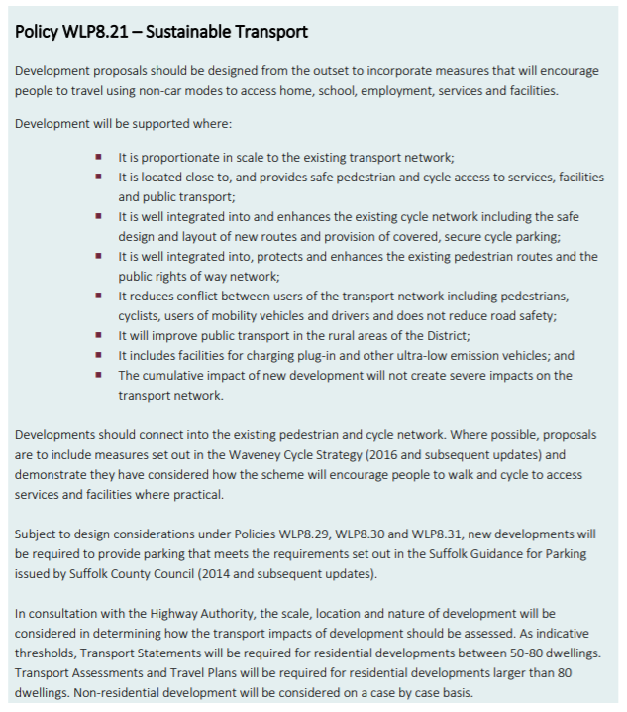

3.2 Draft Policy from the Lowestoft Neighbourhood Development Plan
The emerging NDP includes policies for transport and movement around the Town. These policies will be included in the forthcoming public consultation.

Transport and Movement
Purpose
To provide balanced and sustainable transport for people of all ages, means and mobility.
Rationale and Evidence
National Policy
Paragraph 109 of the NPPF states:

‘Development should only be prevented or refused on highways grounds if there would be an unacceptable impact on highway safety, or the residual cumulative impacts on the road network would be severe’.

Paragraph 102 requires transport issues to be considered from the earliest stages of plan-making and refers to a range of issues, including impacts on transport networks, walking, cycling and public transport, environmental impacts of traffic and transport infrastructure, patterns of movement and design.

Local Policy
The Local Plan Policy WLP8.21 – Sustainable Transport, requires development proposals to be designed from the outset to incorporate measures that will encourage people to travel using non-car modes to access home, school, employment, services and facilities.
Planning Rationale
The main A12 road from London into the southern area of Lowestoft ends at the town’s harbour bascule bridge. This connects to the A47 which runs around the centre of the town, before exiting the town and crossing the county border into Norfolk (towards Great Yarmouth).
Lowestoft Railway Station is centrally located within walking distance of the beach and the town centre. It provides services to Ipswich on the East Suffolk Line and to Norwich along the Wherry Line. Both Ipswich and Norwich provide high speed connections to London Liverpool Street. The City of Norwich offers an airport which connects internationally via Schipol.

However, overall, transportation to Lowestoft is very poor, giving it a feeling of being isolated. Poor transportation infrastructure discourages tourism and business growth. New business hesitate to establish themselves here and existing business struggle to grow because it is so difficult to get workers, supplies, etc. in and out of the town. There is no major dual carriageway road that is a continuous link to other major towns, including its own county seat.
For the town to serve current business needs, accommodate growth and attract development focussed on the North Sea, significant investment in Lowestoft’s road infrastructure and its access routes via the A12 and A47 is necessary. These involve unlocking pinch points and re-routing traffic away from congested areas, including:

- New crossing over Lake Lothing
- Upgrades to Urban Traffic Management Control System
- Improvements to the A47/A12
- Junction and Access Improvements to Enterprise Zones

Public transportation in town is limited to buses and taxis. Lowestoft’s central axis runs down Yarmouth Road, High Street and down through London Road South to Pakefield. The new Tom Crisp road runs about a half mile west and also feeds traffic north south. Public transport runs down these main roads north/south but is very weak east to west.

A key characteristic of Lowestoft is that around 80% of people who work in the town also live there. 6% of Lowestoft residents use public transportation to get to work. Nationally, in towns like Lowestoft, there are 1.24 cars/vans per household. 64% of Lowestoft residents use a car to travel to work. The national average for car ownership is 43% (one car or van).

As a compact and relatively flat town, cycling is a major transportation mode through town and again, the north/south links for a cyclist are good, but the east/west links are very poor. Most journeys are short and could be made without the car. However, cycle paths are inadequate and poorly laid out, with good paths being isolated in sections and suddenly disappearing altogether. A new pedestrian and cycle bridge has been proposed to cross Lake Lothing.

The Suffolk County Council Transport Plan estimates that 80% of people living within Lowestoft also work in the town which means that many journeys are short.

The policy requires a balanced approach to transport provision in new development, including emphasis on pedestrian convenience and cyclists. It is intended to augment Local Plan Policy WLP8.21.

POLICY TM1: Balanced Transport Provision
- New development must incorporate a balanced provision of transport options. This includes:
- Prioritising the needs and convenience of pedestrians and cyclists, including ease of movement and making connections to surrounding pathways, as required by policy EP1;
- Designing for low vehicle speeds, varied provision of parking and ensuring that the public realm is not dominated by traffic and parking, as required by Policy EP1;
- Including convenient links within the layout of new development to nearby public transport facilities;
- Including secure, covered storage for cycles, scooters and other personal transport within all new development, including facilities for every new dwelling in residential development;
- Providing electric charging points.
- Car-free development will be supported within the Town Centre, defined in Policy ETC1.

Interpretation and Guidance
The requirement for secure, covered storage for cycles, scooters and other personal transport may be addressed through collective facilities for apartments or employment or community development. For houses, each dwelling should normally have its own facility.
The policy ensures that sustainable transport options are designed into new development, avoiding over-reliance on motor vehicles. Priority should be given to pedestrian convenience, especially in the layout of new development. Some parts of the policy only apply to development that includes new layout. The requirement for secure, covered storage and electric charging points would also apply to changes of use or new single dwellings.
No figure is given for the extent of provision of electric charging points (though a minimum of one point is required to comply with the policy). However, it is important to consider that development without adequate provision will become unviable in a relatively short period of time.
This policy and Policy EP1 encourage a varied approach to parking, so that the public realm is not dominated. This may best be achieved through mixed provision of garages, hard standing spaces and on-street. For apartments, parking could be incorporated into the ground floor.

3.3 East Suffolk Council Cycle Strategy
The current cycle strategy can be viewed at https://www.eastsuffolk.gov.uk/assets/Planning/Waveney-Local-Plan/Background-Studies/Waveney-Cycle-Strategy.pdf
On 19 October 2020 East Suffolk Council issued the following consultation which closed on 30 November 2020. A response was submitted by the Town Council’s Planning and Environment Committee on behalf of the Town Council.
Further details can be found at https://sway.office.com/Srx8JnLoIFRbef0b?ref=Link

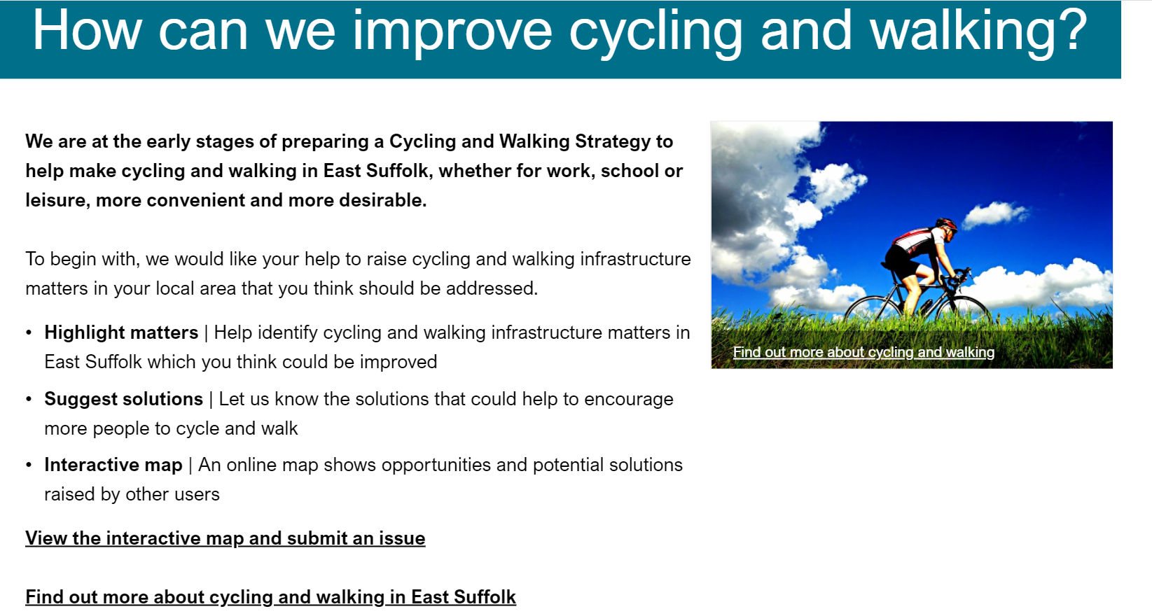

3.4 Extract from the Lowestoft Town Centre Master Plan
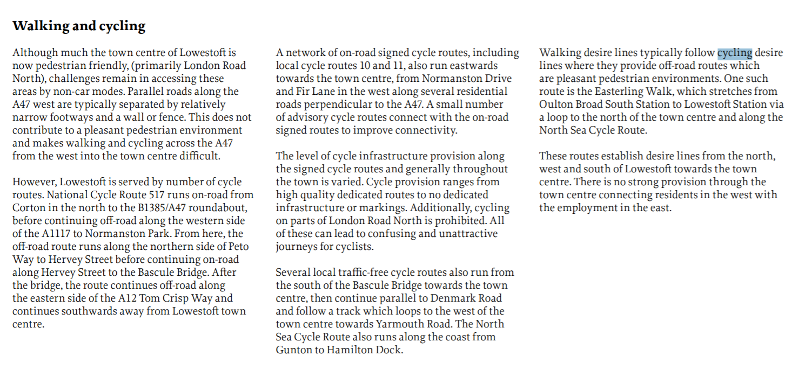
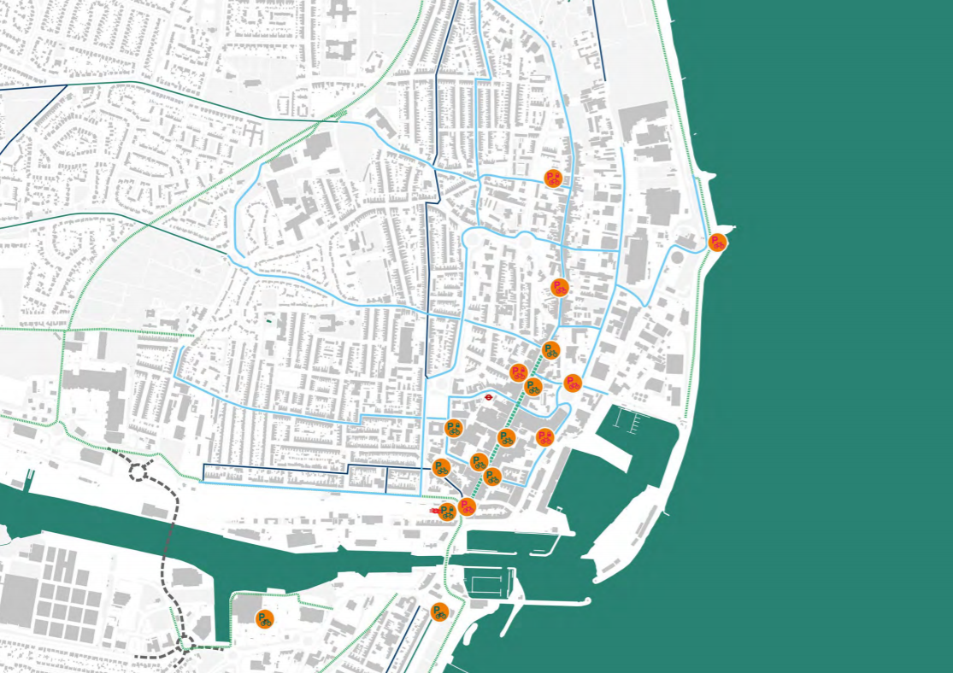

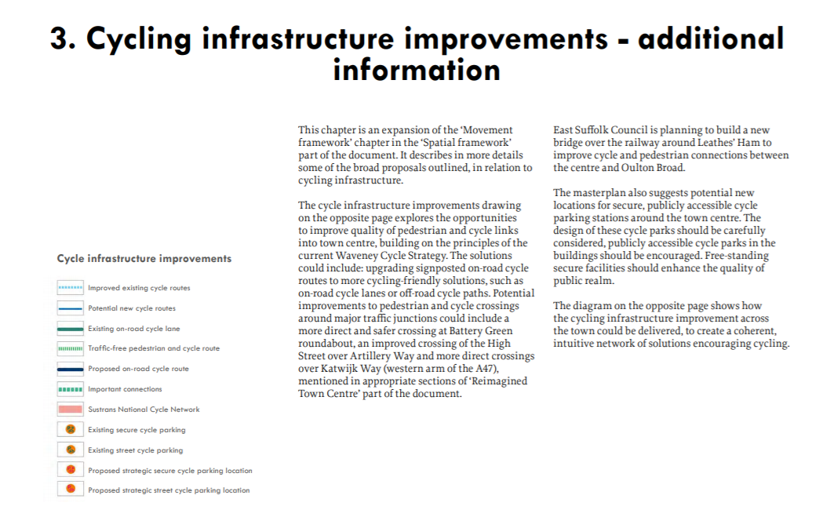

3.5 Suffolk County Council Prioritised Rolling Five Year Plan for Cycling
file:///C:/Users/footes/Downloads/Agenda%20Item%207c%20-%20Appendix%20B%20-%20Prioritised%20five%20year%20plan%20(1).pdf)
This document should be viewed in its entirety to see the priorities allocated to cycling across the county and where Lowestoft featured within the prioritisation. It seems the town has missed substantial funding for projects which would have supported the environmental and physical well-being of the town and its people.

3.6 Lowestoft Town Council Climate Emergency Declaration
The Town Council’s climate emergency declaration of June 2019 supports alternatives to car use including walking, cycling and public transport.
https://www.lowestofttowncouncil.gov.uk/about-the-council/climate-emergency/

3.7 Lowestoft Town Council Health Emergency Declaration
The Town Council’s Health Emergency Declaration prioritises support and promotion of transport which is not reliant on fossil fuel and which encourages exercise and independence, including cycling, walking and running.
https://www.lowestofttowncouncil.gov.uk/assets/Webpage-Important-Documents/Policies-and-Procedures/Health-and-Well-Being-Emergency-Declaration.pdf

4.Partner organisations

This section will be completed once engagement with local cycle clubs has happened and a response from Sustrans has been received.

5. Consultation Responses

During August and September 2020, The Town Council asked via its Facebook page, website and
articles in the Lowestoft Journal for comments on cycling provision within the town.

May I suggest joining up the cycling dots from Pakefield (Arbor Lane) to Pakefield Road along the very popular scenic cliff top and waterfront, with some will and a little modification to existing pedestrian infrastructure along a 1km section we could have a continuous 3km cycling route linking up Pakefield to the traffic free sea-front and onto Lowestoft town centre a real asset and perfectly complements what the government wants to happen. Currently, as you can see in the attached photographs, this 1km section is narrow along parts of the route and even passing pedestrians and/or cyclists have to step off the footpath which a popular route for cyclists, yes I know cyclists are supposed to dismount and walk this 1km section but let’s move on and grasp the nettle and make it a harmonious link for both pedestrians and cyclists into Lowestoft, a win-win for all along the scenic cliff? Please note this very popular cliff top route offers no possibility for social distancing in many parts even for pedestrians?

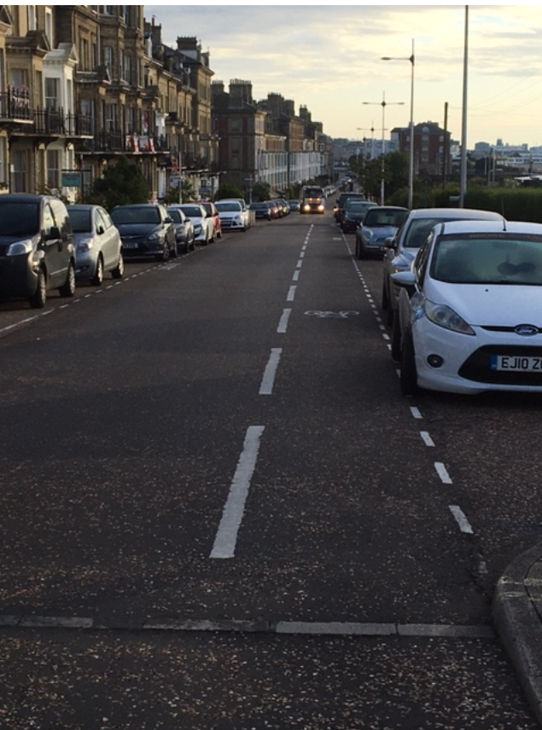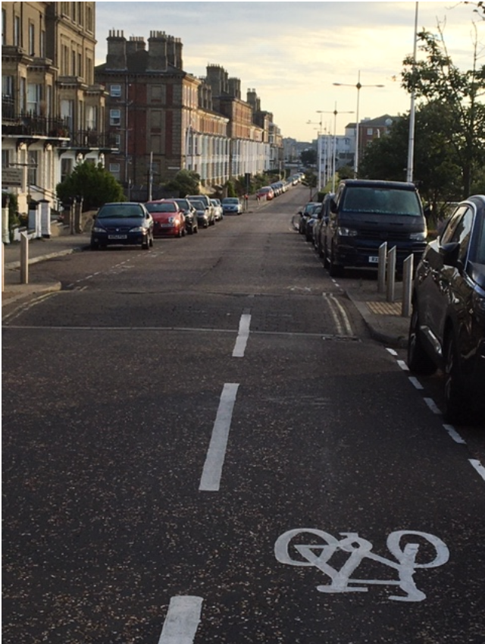

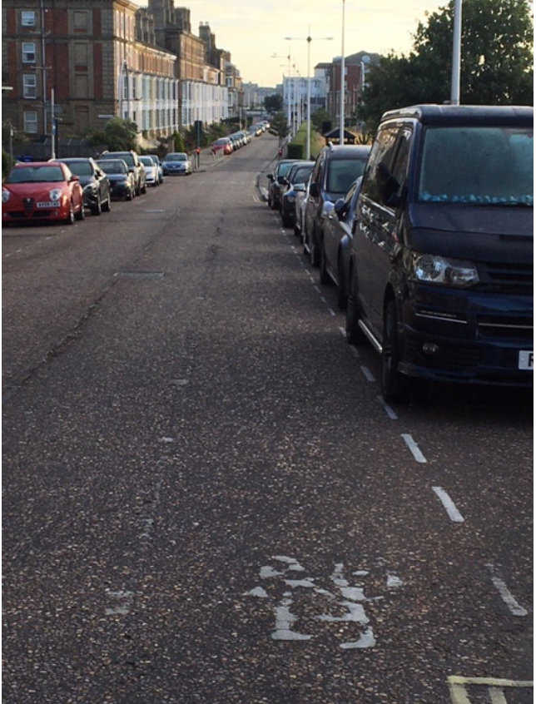

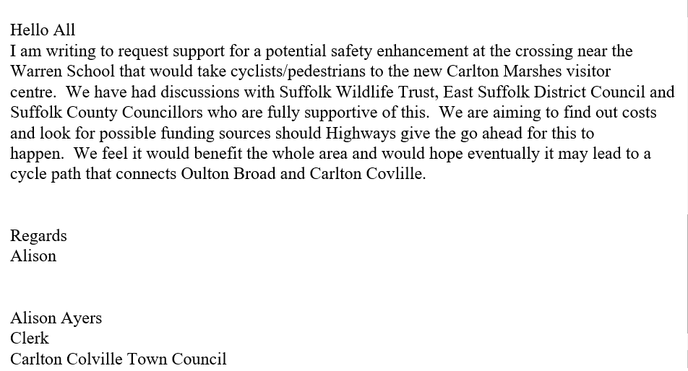

IMPROVING CYCLING IN Lowestoft

In response to the Town Council’s request for ideas, may I suggest the following
Third Crossing – we must ensure good routes to, from and on the bridge

20mph zones. A study should be made of where more could be installed, in particular to take advantage of traffic diverting over the Crossing. The residential part of Yarmouth Road would be a good place to examine

Normanston Park to Brooke peninsula – this planned strategic cycle/pedestrian bridge is of huge importance for the future

Care must be taken that cyclists do not lose out in the many regeneration schemes planned
Most advisory cycle lanes are now invisible and should be re_marked.

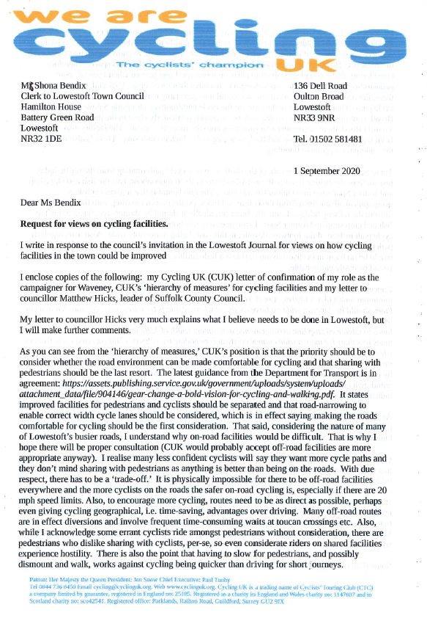

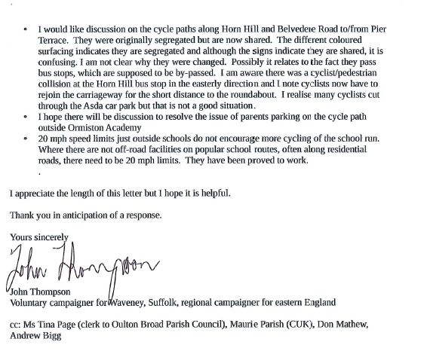

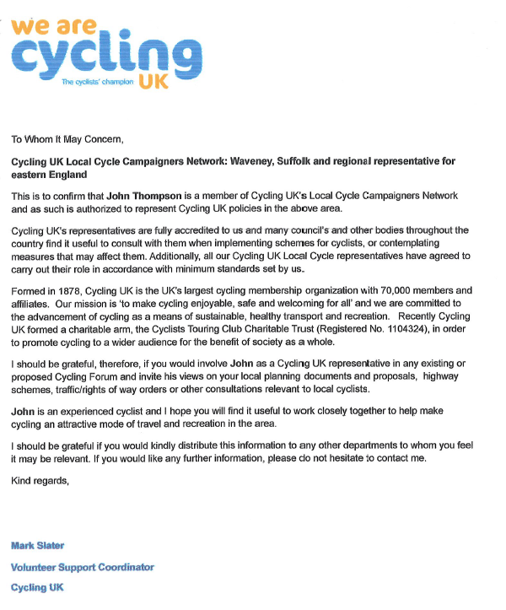

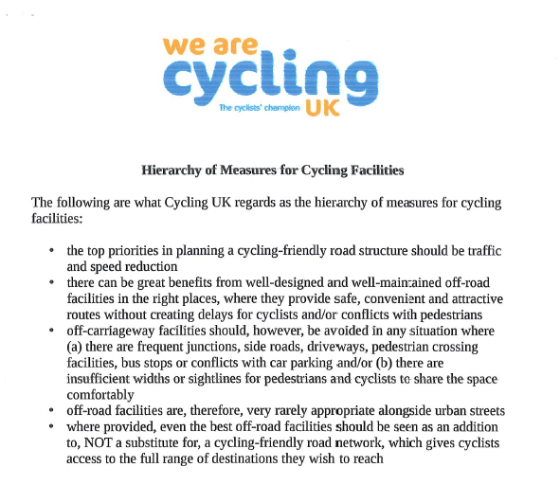
_____________________________________________________________________________

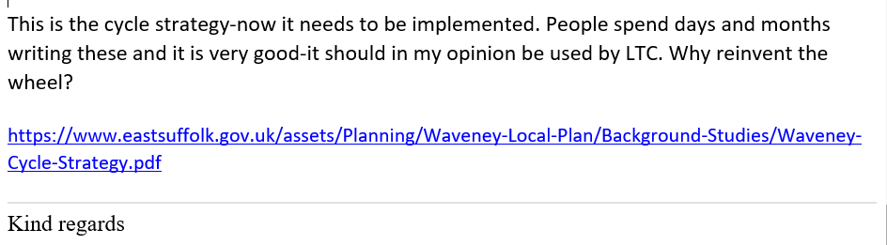

6. How Lowestoft Town Council will support the development and promotion of cycling in the Lowestoft

Committees and Sub-Committees will need to consider this section and feed in their ideas; Climate Emergency, Parks and Open Spaces, AID.

Agenda Item 7

Cabinet
Report Title: | Prioritised Rolling Five Year Plan for Cycling
Meeting Date: | 16 June 2020
Lead Councillor(s): | Councillor Andrew Reid, Cabinet member for Highways,  Transport & Rural Affairs, Councillor David Ritchie, Cycling  Policy Development Panel Chairman
Local Councillor(s): | Councillors Graham Newman, Helen Armitage, Robert Everitt, Andy Drummond, Caroline Page
Director: | Mark Ash, Executive Director, Growth, Highways and Infrastructure
Assistant Director or Head of Service: | Sue Roper, Assistant Director, Strategic Development, Growth, Highways and Infrastructure
Author: | Carl Ashton, Transport Policy & Development Manager,  Growth, Highways and Infrastructure,  Carl.Ashton@suffolk.gov.uk, 01473 265923
Brief summary of report
- A cross-party Cycling Policy Development Panel (PDP) met over four meetings between March and May 2020.
- It has identified, evaluated, costed and prioritised proposed cycling schemes across the county, producing a five-year rolling plan.
- The prioritised schemes are those which have the greatest potential to provide modal shift; support economic growth in Suffolk; and have the highest cost benefit ratio.
What is Cabinet being asked to decide?
4. | The Cabinet is asked to endorse the recommendations from the Cycling Policy Development Panel as laid out in its report to Cabinet at Appendix A. Specifically, to:  - Endorse the prioritised rolling 5-year plan for cycling in Suffolk. This relates to the motion as adopted by the Council meeting held on 20 July 2018 to provide a 5-year plan for cycling.  - Request officers to engage with district and borough councils to develop the rolling 5-year plan for cycling.  - Ask officers to bring forward detailed feasibility studies of the highest 20 ranked schemes as identified on the rolling 5-year plan, with detailed costings, potential funding sources, and estimated timeframe for delivery.
• |  | Request officers to prepare a prospectus for cycling in Suffolk to accompany the rolling 5-year plan.
• |  | Give approval to prepare for future publication, the separate Local Cycling and Walking Infrastructure Plan for Ipswich, establish the board, and further develop projects identified within it.
Reason for recommendation
- The recommendations reflect the outcomes of the PDP to develop a rolling 5year plan and enable it to be taken forward to implement cycling improvement schemes.
- The outcomes would provide support for the County Council’s declared climate emergency and the actions to tackle traffic congestion, improve public health and support economic growth. The rolling 5-year plan also supports the Local Transport Plan’s aims and objectives.
- The rolling 5-year delivery plan has been subject to objective review and evaluation of the strategic benefit of the schemes. The plan will provide focus for those prioritised schemes for which funding will be sought. The methodology used in constituting the plan will be used to evaluate any new schemes which may be proposed in the future.
- The Local Cycling and Walking Infrastructure Plan is included, as it is likely to be the basis for some funding opportunities announced by Government, as part of the £2bn fund for active travel, in February 2020.
What are the key issues to consider?
- Funding has been identified, but not secured to deliver the plan. Potential funding sources include funding from the Integrated Transport Block grant funding which funds the Local Transport Plan; S106/CIL developer funding; Sustrans; and future Government initiatives related to the £2bn walking and cycling funding announced in February 2020. This includes the opportunity presented by the Government’s emergency active travel fund to invest in popup infrastructure to support cycling and walking during and after the coronavirus pandemic.
- The costings provided in Appendix B are high-level estimates based on a linear metre rate to allow for comparison. Further work will be required to provide accurate costings for individual schemes.
- The plan contains those schemes which have been evaluated as being strategic. The plan is a dynamic document, capable of adding or removing schemes in the light of potential funding related to changes in local plans and/or developments.
- Further engagement with key stakeholders, including district and borough councils, on potential schemes to be delivered or added to the prioritised list will need to be undertaken.
- The rolling 5-year plan should be viewed as an overall plan of how cycling schemes can be implemented, as funding becomes available, not a programme of works to be delivered on an annual basis.
What are the resource and risk implications?
- At present funding sources have been identified but not secured, with the exception of the Local Transport Plan funding, through the Integrated Transport Block grant, for which limited funding is available. Some schemes would be able to be progressed from this budget, but significant further funding would be needed to complete the 20 schemes identified below.
- The rolling 5-year plan will require officer resource to continue to manage and update the plan to reflect completed schemes and to evaluate and add/remove schemes which will develop over time.
- Officer resource will be required to undertake the feasibility studies for the schemes identified within the plan, to engage with borough and district colleagues to develop the details of the schemes and to firm up costs.
- In taking forward any work, the PDP recommends that feasibility studies of schemes should focus on consolidating the estimated costs and creating a project brief for each scheme. An investigation of land ownership, equality impact, ecological status and highway status will help identify potential issues and to reduce the level of uncertainty around scheme costs. It is possible that the feasibility study may identify a significant issue which may necessitate a reevaluation of the benefit cost ratio, in which case the scheme may need to be repositioned within the rolling 5-year plan.
- There are expected to be opportunities presented by emergency funding to provide pop-up cycle ways as part of the emergency response to Covid 19.
- An Equality Impact Assessment was not required for the Policy Development Panel itself; no risks being identified with this aspect of the Policy Development
Panel. Any policy changes and/or construction schemes resulting from the
Policy Development Panel will require an individual Equality Impact Assessment.
What are the timescales associated with this decision?
- The current plan contains prioritised cycling schemes over a rolling 5-year period, other recommendations are based on working with partners and stakeholders and seeking funding from additional sources.
Alternative options
- It is advised that all recommendations are endorsed, however the Cabinet could decide:
  - to reject the Panel’s recommendations.
  - to accept some of the recommendations.
Who will be affected by this decision?
- The focus on improvements to cycling has the potential to benefit every resident of Suffolk, helping reduce congestion, benefit health and wellbeing and to generate economic benefit. Cycle tourism will also benefit with the associated advantages of more visitors spending time and money in the County.
- Encouraging more people to a healthier and sustainable mode of travel, reducing traffic congestion, improving air quality and reducing the demands on the National Health Service and social services resulting in reduced costs to the taxpayer.
Main body of report

Introduction
- The panel met on 02 March, 15 April, 05 May and 15 May 2020 (the meetings in April and May were via conference call due to the Covid-19 lockdown). The panel consisted of: -
  - Cllrs David Ritchie, Andy Drummond, Graham Newman, Caroline Page, Helen Armitage, Robert Everitt
  - Expert guests Anthony Wright (cycling advocate, with many years’ experience as a SCC cycling officer and Sustrans local area officer), Gwyneth McMinn (Sustrans Head of Network Development – England Midlands & East), Philip Broadbent-Yale (Sustrans Network Development Manager, Midlands and East (retired March 2020)).
  - Officers Carl Ashton, David Falk, Adam Baker, Paul Horne.
- The PDP adopted a government recognised methodology to score schemes to enable them to be prioritised.
- Having identified the schemes for the rolling 5-year plan, the PDP recommends that each scheme is developed for a funding bid. The PDP proposes that those schemes at the top of the list are prioritised for this work.
- The schemes prioritised at the top of the plan for further work are in the table below. A full list of schemes is at Appendix B. The schemes listed below are those which scored most highly in the assessment.
Area | Scheme Type | Location | Details
Ipswich | Cycling | Ipswich  Waterfront | University of Suffolk waterfront building to Stoke bridge on quayside
Ipswich | Cycling | Portman Road | Barrack Corner to Princes Street junction
Ipswich | Cycling | Yarmouth Road | London Road to Bramford Road
Bury St  Edmunds | Cycling | Cotton Lane | Northgate Street to Mustow Street
Ipswich | Cycling | Princes Street | Link to rail station
Ipswich | Cycling | Belstead Road | Luther Road to Stoke Bridge
Ipswich | Cycling | Grove Lane to Civic Drive | Rope Walk, Tackett Street, Dogs Head Street
Haverhill | Cycling | Manor Road | Ruffles Road/Millfields Way junction, Manor Road, Eringhausen Way
Haverhill | Cycling | Mill Hill -  Crowland Road | Duddery Hill, Recreation  Road, Camps Road, Castle  Road, Withersfield
Ipswich | Cycling | Maryon Road to Waterfront | Using Nacton Road Bishops  Hill,
Bury St  Edmunds | Cycling | Mount Road  (Eastgate Street) | Orttewell Road to Eastgate  Street, and Eastgate Street to  Angel Hill
Sudbury | Cycling | East Street B1115 | A134 to King Street
Newmarket | Cycling | Park Lane & Sun Lane | Granby Road to High Street
Ipswich | Cycling | Bramford Lane to Bramford Road junction | Bramford Lane from Ulster Avenue to Bramford Road
Ipswich | Cycling | Ranelagh Road to Burrell Road | Ancaster Road to Stoke Bridge
Beccles | Cycling | Lowestoft Road - Hillside Avenue to  Ellough Road | Waveney Cycle Policy Be11.  Improve link on Beccles to Worlingham cycle route [ PCT scheme * BCR Hillside to Ellough]
Haverhill | Cycling | Withersfield Road | Howe Road to Cangle junction - potential alternate parallel route using railway walk
Stowmarket | Cycling | Finborough Road | B1115 Thirlmere  Drive/Onehouse Road to  Church Walk/Tavern Street
Bury St  Edmunds | Cycling | Barton Road | Orttewell Road to Eastgate Street
Bury St  Edmunds | Cycling | Cullum Road | A1302 Nowton Road to  Westgate Street + Guildhall to Cornhill
- The work on the feasibility studies would not prevent urgent action being taken to provide emergency pop up cycle infrastructure. Officers can respond to emergency funding from government to mitigate the transport challenges during and after the pandemic.
- As a live document, the PDP recommends the rolling 5-year plan should be reviewed and managed as described in the methodology. Suffolk County Council will need to work with the district and borough councils and other bodies to capture strategic cycling schemes for inclusion in future updates of the plan.
- Associated with the activity on the rolling 5-year plan itself, work should also progress on the Local Cycling and Walking Infrastructure Plan for Ipswich (preparing it for publication and the working on the measures it identifies). The Local Cycle and Walking Infrastructure Plan for Ipswich should form a supplement to the studies for the rolling 5-year plan for cycling and inform the work for the Ipswich Strategic Planning Area. The Department for Transport has indicated that these documents would likely be the basis for funding opportunities resulting from the £2bn for walking and cycling announced in February 2020. The current draft can be found at Appendix C.
Conclusions
- The Cycling PDP has produced a prioritised and costed list of schemes as requested by Cabinet.
- The PDP recommends a number of next steps to take forward this work including feasibility studies, discussion with key stakeholders, and final preparation of the Local Cycling and Walking Infrastructure Plan.
- There may be opportunities to seek early delivery of some schemes through the emergency Covid:19 funding to deliver temporary works.
Sources of further information
- https://www.gov.uk/government/publications/webtag-tag-unit-a5-1active-mode-appraisal-may-2018 Active Mode Appraisal Toolkit
- https://www.pct.bike/ Propensity to Cycle Toolkit
- https://assets.publishing.service.gov.uk/government/uploads/system/upl oads/attachment_data/file/863723/cycling-and-walking-investmentstrategy-report-to-parliament.pdf Cycling and Walking investment strategy
- https://assets.publishing.service.gov.uk/government/uploads/system/upl oads/attachment_data/file/883082/cycling-walking-infrastructuretechnical-guidance.pdf Local Cycling and Walking Infrastructure Plan guidance

Agenda Item 7 -Appendix B
Area | Scheme  Type | Location | Details | Potential  Funding  Source * | Deliverability  (3 = easiest to deliver to 1 = most  challenging) | Estimated Cost  (calculated by linear metre) | Unweighted  Multi  Criteria  Assessment  Framework total | Benefit  Cost  Ratio  (ebike) | Approx  Distance  (metres)
Ipswich | Cycling | Ipswich Waterfront | University of Suffolk waterfont building to Stoke bridge on quayside | LTP,  S106/CIL,  DfT | 3 | £473k | 5 | 44.1 | 789
Ipswich | Cycling | Portman Road | Barrack Corner to Princes St junc | LTP,  S106/CIL,  DfT | 3 | £214k | 3 | 32.6 | 360
Ipswich | Cycling | Yarmouth Rd | London Rd to Bramford Rd - | LTP,  S106/CIL,  DfT | 3 | £327k | 2 | 22.9 | 545
Bury St  Edmunds | Cycling | Cotton Lane | Northgate St to Mustow St | LTP,  S106/CIL,  DfT | 1 | £205k | 4 | 15.2 | 685
Ipswich | Cycling | Princes St | link to rail station | LTP,  S106/CIL,  DfT | 2 | £461k | 3 | 14.9 | 770
Ipswich | Cycling | Belstead Rd | Luther Rd to Stoke Bridge | LTP,  S106/CIL,  DfT | 2 | £969k | 3 | 13.4 | 1615
Ipswich | Cycling | Grove Ln to Civic Dr | Rope Walk, Tackett St, Dogs  Head St | LTP,  S106/CIL,  DfT | 2 | £1163k | 3 | 13.1 | 1940
Haverhill | Cycling | Manor Rd | Ruffles Rd/Millfields Way junc,  Manor Rd,Eringhausen Way | LTP,  S106/CIL,  DfT | 3 | £174k | 3 | 12.9 | 580
Haverhill | Cycling | Mill Hill - Crowland  Rd | Duddery Hill, Recreation Rd,  Camps Rd, Castle Rd,  Withersfield | LTP,  S106/CIL,  DfT | 1 | £257k | 3 | 11.8 | 860

Ipswich | Cycling | Maryon Rd to  Waterfront | using Nacton Rd Bishops Hill, | LTP,  S106/CIL,  DfT | 2 | £1576k | 4 | 11.6 | 2630
Bury St  Edmunds | Cycling | Mount Road  (Eastgate St) | Orttewell Rd to Eastgate St, +  Eastgate St to Angel Hill | LTP,  S106/CIL,  DfT | 1 | £1137k | 4 | 11.6 | 1895
Sudbury | Cycling | East St B1115 | A134 to King St - | LTP,  S106/CIL,  DfT | 1 | £598k | 4 | 10.8 | 1400
Newmarket | Cycling | Park Ln & Sun Lane | Granby Rd to High St | LTP,  S106/CIL,  DfT | 1 | £326k | 4 | 10 | 510
Ipswich | Cycling | Bramford Ln to  Bramford Rd junc | Bramford Lane from Ulster Ave to Bramford Rd | LTP,  S106/CIL,  DfT | 1 | £1100k | 3 | 9.1 | 1830
Ipswich | Cycling | Ranelagh Rd to  Burrell Rd | Ancaster Rd to Stoke Bridge | LTP,  S106/CIL,  DfT | 3 | £1167k | 3 | 8.1 | 1945
Beccles | Cycling | Lowestoft Rd - Hillside Ave to Ellough Rd | Waveney Cycle Policy Be11. Improve link on Beccles to Worlingham cycle route [ PCT scheme * BCR Hillside to Ellough] | LTP,  S106/CIL,  DfT | 2 | £486k | 3 | 7.6 | 810
Haverhill | Cycling | Withersfield Rd | Howe Rd to Cangle junction - potential alternate parallel route using railway walk | LTP,  S106/CIL,  DfT | 1 | £287k | 3 | 7.6 | 960

Stowmarket | Cycling | Finborough Road | B1115 Thirlmere Dr/Onehouse  Rd to Church Walk/Tavern St- | LTP,  S106/CIL,  DfT | 2 | £538k | 3 | 7 | 896
Bury St  Edmunds | Cycling | Barton Road | Ortwell Rd to Eastgate St | LTP,  S106/CIL,  DfT | 1 | £266k | 3 | 7 | 890
Bury St  Edmunds | Cycling | Cullum Road | A1302 Nowton Rd to Westgate  St + Guildhall to Cornhill | LTP,  S106/CIL,  DfT | 3 | £923k | 3 | 6.8 | 1540
Bury St  Edmunds | Cycling | Thetford Rd | Lark Valley Drive junc, Culford  Rd & The Street to Tollgate on  B1106, land acquisition, +  Fornham Rd scheme | LTP,  S106/CIL,  DfT | 1 | £1616k | 3 | 6.6 | 2694
Mildenhall | Cycling | Field Rd (A1101) | Rnbt, College Heath Rd, Folly Rd junctions to Queensway - | LTP,  S106/CIL,  DfT | 2 | £1140k | 3 | 6.2 | 1900
Felixstowe | Cycling | Grange Rd | Grange Rd & Maidstone Rd -  Ferry Ln to High St | LTP,  S106/CIL,  DfT | 2 | £1189k | 3 | 6.2 | 1980
Beccles | Cycling | Lowestoft Rd -  Kempton Cross to  A146 Rbt | BCR A146 - Hillside, include safety improvements at A146 rnbt | LTP,  S106/CIL,  DfT | 1 | £718k | 3 | 6.1 | 1100
Beccles | Cycling | Tesco to Ingate | Grove Rd, | LTP,  S106/CIL,  DfT | 1 | £636k | 3 | 6.1 | 1060
Haverhill | Cycling | Chivers Rd | Park Road to Burton End | LTP,  S106/CIL,  DfT | 3 | £413k | 3 | 6.1 | 700

Bury St  Edmunds | Cycling | Westgate St &  Abbeygate St | Westbury Ave, Queens Rd,  Kings Rd, Cornhill | LTP,  S106/CIL,  DfT | 2 | £1101k | 3 | 6 | 135
Sudbury | Cycling | Cornard Rd B1508 | Head Ln to Gt Eastern Rd incl  Gainsborough St | LTP,  S106/CIL,  DfT | 2 | £1304k | 4 | 5.8 | 2170
Bury St  Edmunds | Cycling | Hardwick Ln and  Vinery Rd | Nowton Rd (using Wilks Rd) to  Horringer Rd | LTP,  S106/CIL,  DfT | 1 | £489k | 3 | 5.7 | 1630
Ipswich | Cycling | Oyster Reach to  Stoke Bridge (aka  Wherstead Rd) | Wherstead Rd, & St Peters/  Falcoln St | LTP,  S106/CIL,  DfT | 2 | £1678k | 4 | 5.6 | 2797
Haverhill | Cycling | Burton End | Mill Rd to Chivers Rd | LTP,  S106/CIL,  DfT | 1 | £294k | 3 | 5.2 | 1400
Newmarket | Cycling | Studland Park Ave | Studland Park Ave & Brickfields  Ave, Exning Rd to Fordham Rd | LTP,  S106/CIL,  DfT | 2 | £668k | 4 | 5.2 | 1100
Lowestoft | Cycling | Gorleston Road |  | LTP,  S106/CIL,  DfT | 2 | £1042k | 4 | 5 | 1736
Mildenhall | Cycling | Kingsway (A1101) | Kingsway from North Terrace to  Brandon Rd | LTP,  S106/CIL,  DfT | 2 | £427k | 3 | 5 | 710
Lowestoft | Cycling | Oulton Road | Peto Way/Oulton Rd to Church  Rd/Crown St W | LTP,  S106/CIL,  DfT | 2 | £1021k | 3 | 5 | 1702

Haverhill | Cycling | Duddery Hill | Duddery Hill, Greenfields Way | LTP,  S106/CIL,  DfT | 2 | £382k | 4 | 5 | 1270
Lowestoft | Cycling | Yarmouth Road &  Bentley Drive | A47 Sussex Rd to Bentley Dr  (Tesco) | LTP,  S106/CIL,  DfT | 1 | £1214k | 4 | 4.9 | 2023
Sudbury | Cycling | Melford Rd & Girling  St A131 | A134 rnbt to Newton Rd - | LTP,  S106/CIL,  DfT | 1 | £1027k | 4 | 4.7 | 2400
Ipswich | Cycling | Hospital to  University | Freehold Rd, Foxhall Rd | LTP,  S106/CIL,  DfT | 3 | £1197k | 4 | 4.6 | 1995
Ipswich | Cycling | Bury Rd to  Northgate St | Norwich Rd, St Matthews St | LTP,  S106/CIL,  DfT | 2 | £2124k | 4 | 4.5 | 3540
Lowestoft | Cycling | Tom Crisp Way | Blackheath Rd to Waveney Dr  (Asda) | LTP,  S106/CIL,  DfT | 3 | £1483k | 2 | 4.4 | 2471
Bury St  Edmunds | Cycling | Westgate St &  Hospital Rd | West Rd, Hospital Rd, Westgate  St, | LTP,  S106/CIL,  DfT | 2 | £657k | 3 | 4.3 | 2190
Lowestoft | Cycling | Victoria Avenue &  Waveney Drive | from Bascule Waveney Dr,  Victoria Ave (existing off road old rail line much of route, see discussion with E Suff Waveney  Cycle Strategy) | LTP,  S106/CIL,  DfT | 2 | £1645k | 4 | 4.1 | 2742
Lowestoft | Cycling | Kessingland to  London Road | Field Lane/A12 to Bloodmoor rndt | LTP,  S106/CIL,  DfT | 1 | £1768k | 3 | 4.1 | 2947

Ipswich | Cycling | Valley Rd | Henley Rd to Norwich Rd | LTP,  S106/CIL,  DfT | 3 | £1383k | 5 | 4 | 2300
Lowestoft | Cycling | Normanston Drive &  Fir Lane | from Fir Ln/ Oulton Rd junc to Bridge Rd / CommodoreRd | LTP,  S106/CIL,  DfT | 2 | £1155k | 3 | 4 | 1925
Mildenhall | Cycling | Worlington Rd to  Mildenhall Rd  (B1102) | Newmarket Rd junc, Station Rd junc, Aldrich Place junc, Market  Place jnc to Queensway, | LTP,  S106/CIL,  DfT | 1 | £1275k | 4 | 4 | 2120
Felixstowe | Cycling | Princes Rd | Sea Rd, Mill Ln | LTP,  S106/CIL,  DfT | 2 | £430k | 3 | 3.9 | 715
Felixstowe | Cycling | Beach Stn Rd  (A154) | Dock Rd rnbt , Sea Rd, Sea Front to Undercliff Rd | LTP,  S106/CIL,  DfT | 2 | £1028k | 3 | 3.8 | 1715
Lowestoft | Cycling | London Road | Bloodmoor rndt to Belvedere Rd  (A12) | LTP,  S106/CIL,  DfT | 1 | £1967k | 2 | 3.7 | 3278
Felixstowe | Cycling | Garrison Lane  (A154) | Undercliff Rd to Grove Rd &  Langer Rd schemes | LTP,  S106/CIL,  DfT | 3 | £1396k | 4 | 3.6 | 2327
Beccles | Cycling | Lowestoft Rd to  Bluebell Way | on Ellough Rd | LTP,  S106/CIL,  DfT | 3 | £123k | 3 | 3.6 | 410
Stowmarket | Cycling | Gipping Way | Needham Rd rnbt to Station Rd junction | LTP,  S106/CIL,  DfT | 3 | £672k | 3 | 3.6 | 1120

Stowmarket | Cycling | Ipswich Road | The Crescent/Poplar Hill to  Tavern St | LTP,  S106/CIL,  DfT | 1 | £1134k | 3 | 3.6 | 1890
Bury St  Edmunds | Cycling | Bedingfield Road &  Rougham Road | From Skyliner Way to Southgate  Green rbt | LTP, S106 |  |  |  | 3.6 | 1900
Ipswich | Cycling | Henley Rd to  Ipswich town centre |  | LTP,  S106/CIL,  DfT | 2 | £1736k | 5 | 3.4 | 2890
Beccles | Cycling | Rigbourne Hill  Lane/Oak Lane | Improve off road route PCT scheme * proxy data for the potential route | LTP,  S106/CIL,  DfT | 2 | £144k | 5 | 3.4 | 700
Bury St  Edmunds | Cycling | Beetons Way (&  Tollgate ln) | Newmarket Rd to Fornham Rd using Beetons Way & Tollgate Ln | LTP,  S106/CIL,  DfT | 3 | £780k | 4 | 3.2 | 2600
Felixstowe | Cycling | High Rd | Faulkeners Way to Western Ave | LTP,  S106/CIL,  DfT | 3 | £2123k | 4 | 3.1 | 3540
Haverhill | Cycling | Sturmer Rd (A143)-  Hamlet Rd | Sturmer Rd / Chalkstone Rd junc, Hamlet Rd, High St | LTP,  S106/CIL,  DfT | 2 | £389k | 3 | 3 | 1295
Lowestoft | Cycling | Bascule Bridge to  Yarmouth Road | bascule bridge, A47 to Sussex  Rd junction (potential alternate  Corton Rd Lowestoft -Gt  Yarmouth route) | LTP,  S106/CIL,  DfT | 2 | £1222k | 4 | 2.9 | 2036

Beccles | Cycling | Ellough Rd to  Ringsfield | Ellough Rd - via Priory Ln to  Ringsfield | LTP,  S106/CIL,  DfT | 2 | £712k | 3 | 2.9 | 1190
Newmarket | Cycling | Fordham Rd corridor | Noel Murless Dr to Clocktower  Rnbt | LTP,  S106/CIL,  DfT | 1 | £1283k | 4 | 2.6 | 1150
Beccles | Cycling | Ingate to Bluebell  Way | via Castle Hill & Queen Elizabeth Dr | LTP,  S106/CIL,  DfT |  | £107k | 4 | 2.6 | 180
Ipswich | Cycling | Tuddenham Rd | Colchester Rd to St Margarets | LTP,  S106/CIL,  DfT | 3 | £1736k | 5 | 2.5 | 1460
Ipswich | Cycling | Westerfield Rd to St  Margarets St | from Valley Rd junc to St Margarets St | LTP,  S106/CIL,  DfT | 3 | £875k | 5 | 2.5 | 1460
Bury St  Edmunds | Cycling | Southgate St &  Angel Hill | Southgate Green, Crown St,  Angel Hill | LTP,  S106/CIL,  DfT | 1 | £1028k | 3 | 2.4 | 3425
Newmarket | Cycling | Yellow Brick Road NCR51 area improvements | Yellow Brick Road intersections  & Wellington St | LTP,  S106/CIL,  DfT | 2 | £1368k | 5 | 2.1 | 2800
Newmarket | Cycling | Exning Rd (B1103)  corridor incl Mill Hill | Exning Rd, St Phillips Rd to  Wellington St (incl Wellington St) | LTP,  S106/CIL,  DfT | 3 | £2197k | 4 | 1.7 | 925
Felixstowe | Cycling | Mill Lane | Mill Ln & Crescent Rd to High  Road | LTP,  S106/CIL,  DfT | 3 | £1118k | 3 | 1.7 | 1863

Ipswich | Cycling | Heath Rd to Valley  Rd | Bixley Rd, Heath Rd, Colchester  Rd (orbital) | LTP,  S106/CIL,  DfT | 3 | £2617k | 3 | 1.5 | 4360
Lowestoft | Cycling | Castleton Avenue &  Stradbroke Road |  | LTP,  S106/CIL,  DfT | 1 | £1857k | 3 | 1.5 | 3095
Needham  Market | Cycling | Gt Blakenham to  Needham Mkt | route to be investigated | LTP,  S106/CIL,  DfT | 3 |  | 4 | 1.23 | 5500
Stowmarket | Cycling | Navigation  Approach | Thorney Green in Stowupland,  Mortimer Road to Gipping  Way/Navigation App junction | LTP,  S106/CIL,  DfT | 2 | £1456k | 4 | 1.2 | 2426
Bury St  Edmunds | Cycling | Newmarket Rd &  Risbygate Street | Newmarket Rd cycle route  inconsistent off road & on road, at Beetons Way junc rejoin carriageway in advisory cycle lane | LTP,  S106/CIL,  DfT | 2 |  | 4 | 1.02 | 1800
Beccles | Cycling | Benacre  Road/Copland Way from Church Rd to Anson Way cycle link feasibility | Segregated cycle/ped facility approx. Waveney cycle strategy  Be21 | LTP,  S106/CIL,  DfT | 1 | £465k | 5 | 0.8 | 775
Clare | Cycling | Clare to Cavendish | route tbc (A1092) | S106? | 1 | 2490k | 5 | 0.3 | 4150
Shotley | Cycling | Shotley Cycle Link to Ipswich  (Community Path) | new cycle link from Shotley to Ipswich | LTP,  S106/CIL,  DfT | 1 |  | 2 | 0.27 | 17000
Long Melford | Cycling | Long Melford to  Cavendish | via A1092 & B1064 route tbc | LTP,  S106/CIL,  DfT | 2 | 3600k | 4 | 0.2 | 6000

Sudbury | Cycling | A134 (Northern Rd) | A134 Richard Burns Way to  Nowton Rd | LTP,  S106/CIL,  DfT | 2 | £551k | 3 | 0.14 | 1900
Haverhill | Cycling | Park Rd - A1307 to  Castle Manor  Academy | potential new route | LTP,  S106/CIL,  DfT | 3 |  | 6 | 0 | 500
Beccles | Cycling | London Road | New crossing to cycle route 30/31 | S106 | 3 |  | 6 | 0 | 0
Haverhill | Cycling | Eastern Ave | in progress | LTP,  S106/CIL,  DfT | 3 |  | 6 | 0 | 300
Haverhill | Cycling | Chimswell Estate | crossing points & cycle priority  Bergamot Rd, Chimswell Way  Chivers Rd | LTP,  S106/CIL,  DfT | 3 |  | 5 | 0 | 0
Haverhill | Cycling | Burton End - School  Lane to North Ave | new route | LTP,  S106/CIL,  DfT | 3 |  | 5 | 0 | 300
Sudbury | Cycling | Valley Walk to  Railway Station | Upgrade surface for link and convert RoW to bridleway or cycle track | LTP,  S106/CIL,  DfT | 3 |  | 4 | 0
Stowupland | Cycling | cycle link Thorney Green to school | in progress / Construction phase 1 Jan 2020, phase 2 post C-19 | LTP,  S106/CIL,  DfT | 3 | £86k | 3 | 0 | 500

Ipswich | Cycling | Old London Road Copdock/Washbroo k | allocate space for segregated cycling on ex A12 dual carriageway | LTP,  S106/CIL,  DfT | 3 |  | 3 | 0 | 3000
Elmswell | Cycling | Elmswell to Bury St  Edmunds Cycle Link | Provide a cycle link from Elmswell to Bury St Edmunds (Mount Rd) | LTP,  S106/CIL,  DfT | 3 |  | 3 | 0 | route dependant
Lowestoft | Cycling | A12 Battery Green  Road Cycle track | cycle route to Beach Industrial area | LTP,  S106/CIL,  DfT | 3 |  | 3 | 0 | 400
Long Melford | Cycling | A134 | Sustrans NCN route review recommendation | LTP,  S106/CIL,  DfT | 3 |  | 3 | 0 | 0
Bungay | Cycling | Hillside Road East toucan crossing |  | S106 | 3 |  | 2 | 0 | 0
Bury St  Edmunds | Cycling | Kings  Road/Parkway junction | Provide cycle facilities across  Parkway - | LTP,  S106/CIL,  DfT | 3 |  | 2 | 0 | 0
Lowestoft | Cycling | Higher Drive to  Normanston Park cycle route | crossing plus | LTP,  S106/CIL,  DfT | 3 |  | 2 | 0 | 400
Lowestoft | Cycling | Gorleston Road/Sands lane/Gresham Avenue cycle crossing | crossing | LTP,  S106/CIL,  DfT | 3 |  | 2 | 0 | 0
Lowestoft | Cycling | Castleton Ave / Hollow Ln wayfinding | route wayfinding as identified in Waveney Cycle Stratefy L72 | LTP,  S106/CIL,  DfT | 3 |  | 2 | 0

Lowestoft | Cycling | Rushton Drive wayfinding | Waveney cycle strategy L73 - connectivity -way-finding measures | LTP,  S106/CIL,  DfT | 3 |  | 2 | 0
Sudbury | Cycling | Waldingfield Rd to  Acton Ln | amend barriers, convert to cycle track | LTP,  S106/CIL,  DfT | 3 |  | 2 | 0
Bungay | Cycling | Castle Lane to library signing | Improved conspicuity | LTP,  S106/CIL,  DfT | 3 |  | 1 | 0 | 600
Sudbury | Cycling | Belle Vue Rd/  Constitution Hill | assess potential for new link and convert RoW | LTP,  S106/CIL,  DfT | 3 |  | 1 | 0 | 110
Lowestoft | Cycling | Long Road wayfinding | Waveney Cycle Strategy L64 | LTP,  S106/CIL,  DfT | 3 |  | 1 | 0
Ipswich | Cycling | Ipswich town centre mini-holland project | Estab filtered permeability to create active travel environment in residential areas of town | LTP,  S106/CIL,  DfT | 2 | £1m over 3 years | 8 | 0
Lowestoft | Cycling | Blundeston Church  Road to Hall Road | Widen Waveney Cycle Strategy  R2 upgrading link between ex  Blundeston prison site | LTP,  S106/CIL,  DfT | 2 |  | 5 | 0 | 400
Sudbury | Cycling | Sudbury Common | Improve section of well used routes where they cross water  courses, feas to identify extent of work | LTP,  S106/CIL,  DfT | 2 |  | 4 | 0 | route dependant
Felixstowe | Cycling | Walton Avenue  (A154) cycle facility | Improves cycling to and around docks area, north end of road | LTP,  S106/CIL,  DfT | 2 |  | 4 | 0 | 500

Stowmarket | Cycling | Chilton Way to Bury  Road (Chilton Way)  Cycle link | This link Lowry Way/Rugby Club junction | LTP,  S106/CIL,  DfT | 2 |  | 3 | 0 | 825
Lowestoft | Cycling | Cycle Link between  Somerleyton &  Oulton B1074 | Identified in Waveney Cycle  Strategy R1 6 | LTP,  S106/CIL,  DfT | 2 |  | 3 | 0 | 10000
Stratford St  Andrew | Cycling | A12 Inker Brook | Sustrans NCN route review recommendation |  | 2 |  | 3 | 0
Sudbury | Cycling | Talbot Rd | potential cycle link between Talbot Rd and Acton Lane existing highway, links to Acton  Ln from 135 Talbot Rd |  | 2 |  | 2 | 0 | 310
Hollesley | Cycling | Duck Corner to  Stores Corner path | Scoring made on assumptions while awaiting details from Cllr |  | 2 |  | 2 | 0 | 750
Bury St  Edmunds | Cycling | Upgrade FP1 | Upgrade FP1 to shared-use cycleway between Westley Middle School and Oliver Road to side of school entrance (RoW request) |  | 2 |  | 1 | 0 | 70
Sudbury | Cycling | B1508 Kings Hill -  Stannard Way to  Belle Vue junction | Gt Cornard to town/rail station, |  | 2 |  | 1 | 0 | 1000
Ipswich | Cycling & Pedestrian | Hadleigh  Rd/Sproughton Rd  Cycle Bridge | Connect Sproughton Road to  Hadleigh Road across the River Gipping. Associated  development not due in near term tbc |  | 1 | £2.5m | 10 | 0 | 0
Bury St  Edmunds | Cycling | River Linnet -  Shared Surface | Commuting & Leisure link, need study re extent | LTP,  S106/CIL,  DfT | 1 |  | 5 | 0 | 3000

Ipswich | Cycling | River Gipping cycle track Bramford to St  Peter's dock | active travel - see Ipswich Cycling SPD. 3700m distance along whole riverside corridor linking Sugar Beet site to town centre, cost options tbc -potential for route to utilise Sugar Beet estate routes NOT SCORED NO PCT  DATA | LTP,  S106/CIL,  DfT | 1 |  | 5 | 0 | 3700
Beccles | Cycling | Ingate/Fredricks  Rd/Ashmans Rd |  | LTP,  S106/CIL,  DfT | 1 |  | 5 | 0 | 1250
Lowestoft | Cycling | Pakefield coast path from Arbor Ln to All  Saints & St Mary's  Church | Cliff path ROW proposal | LTP,  S106/CIL,  DfT | 1 |  | 4 | 0 | 600
Coddenham | Cycling | Coddenham to Needham Market cycle route | route study reqiured | LTP,  S106/CIL,  DfT | 1 |  | 4 | 0 | 6000
Newmarket | Cycling | Burwell to Exning cyclelink | Cambridgeshire scheme | LTP,  S106/CIL,  DfT | 1 |  | 4 | 0 | 1400
Ipswich | Cycling | Kesgrave to Ipswich  Hospital link | Route options study | LTP,  S106/CIL,  DfT | 1 |  | 4 | 0 | 3400
Stowmarket | Cycling | Stowmarket to  Ipswich Cyce Link | Route options study | LTP,  S106/CIL,  DfT | 1 |  | 4 | 0 | 15000
Lowestoft | Cycling | Kessingland to  Pakefield cycle track | High school route |  | 1 |  | 3 | 0 | 2700

Lowestoft | Cycling | Woods Meadow  cycle track | new cycle track work in progress | LTP,  S106/CIL,  DfT | 1 |  | 3 | 0 | 375
Homersfield | Cycling | A143 | Sustrans NCN route review recommendation | LTP,  S106/CIL,  DfT | 1 |  | 3 | 0
Leiston | Cycling | B1122 | Sustrans NCN route review recommendation | LTP,  S106/CIL,  DfT | 1 |  | 3 | 0
Snape | Cycling | A1094 Farnham  Road | Sustrans NCN route review recommendation | LTP,  S106/CIL,  DfT | 1 |  | 3 | 0
Bury St  Edmunds | Cycling | Horringer - Bury cycle / ped link | route between village & town avoiding A road - RoW | LTP,  S106/CIL,  DfT | 1 |  | 3 | 0 | 1500
Woodbridge | Cycling | River Deben Path | Melton Station to Kyson point route tbc | LTP,  S106/CIL,  DfT | 1 |  | 3 | 0 | 3500
Lowestoft | Cycling | Harbour Rd to  Normanston Park | E Suffolk / Sustrans | LTP,  S106/CIL,  DfT | 1 |  | 2 | 0
Mildenhall | Cycling | A11 Five ways junction crossing routes | Highways England | LTP,  S106/CIL,  DfT | 1 |  | 1 | 0
Stowmarket | Cycling | Chilton Way to St  Edmund Rd | Link to schools, leisure centre and housing estates | LTP,  S106/CIL,  DfT | 3 |  | 2 |  | 220

Felixstowe | Cycling | Trimley St Mary to  St Martin cycle route | public request via Cllr Ritchie - surface bridle way Candlet farm to Capel Hall Lane, adjacent to east of A14 | LTP,  S106/CIL,  DfT | 3 | £500k |  | 2 | 0 | 1700
Stowmarket | Cycling | Constable Way to St Marys | Short cycle link off of main carriageway, potential to reuse existing surface? | LTP,  S106/CIL,  DfT | 3 |  |  | 1 | 0 | 70
Chillesford | Cycling | B1084 | Sustrans NCN route review recommendation |  | 2 |  |  | 3 | 0
Eye | Cycling | Yaxley Road B1117 |  |  | 2 |  |  | 3 | 0
Newmarket | Cycling | A142 cycle path to  Turners | request from local business for completion of link |  | 2 |  |  | 2 | 0 | 3000
Stowmarket | Cycling | Bury Rd (A1308), Stowmarket South  of roundabout cycle  link | Link from the roundabout to town centre |  | 2 |  |  | 2 | 0 | 625
Stowmarket | Cycling | St Edmunds Rd,  Stowmarket | cycle path will create a link to cemeteries, health centre, schools and recreation grounds/parks. |  | 2 |  |  | 2 | 0 | 650
Woolpit | Cycling | Woolpit to Elmswell community path | connectivity between rail station and medical facilities across 2 villages cost dependant upon complexity/design | LTP,  S106/CIL,  DfT | 1 |  | #REF! |  | 0 | 2000
Haverhill | Cycling | Burton End/Camps  Rd - North Ave toMill |  | LTP,  S106/CIL,  DfT | 1 |  |  | 5 | 0 | 650
Sudbury | Cycling | Rd  Long Melford to  Lavenham | route options study using old rail line | LTP,  S106/CIL,  DfT | 1 |  |  | 4 | 0 | 1000
Beccles | Cycling | cycle track North  Cove to Carlton  Colville | Beccles to Carlton Colville gap | LTP,  S106/CIL,  DfT | 1 |  | 4 |  | 0 | 5000
Ipswich | Cycling | Bramford to  Sproughton | create cycle way via Church Lane underpass | LTP,  S106/CIL,  DfT | 1 |  | 3 |  | 0
Halesworth | Cycling | Chediston Street contraflow cycle lane | Waveney Cycle Strategy H14 | LTP,  S106/CIL,  DfT | 1 |  | 1 |  | 0
Saxmundha m | Cycling | 3 communities link  B1121 | Kelsale, Saxmundham, Benhall link as identified locally | LTP,  S106/CIL,  DfT | 2 |  | 5 |  | 0 | 3200
Lowestoft | Cycling | Gisleham - Carlton  Colville Primary  School Pedestrian and Cycling facilities | (L8) School area is congested with parents cars. Proposals would encourage more children to walk and/or cycle to school 885m ped cycle path. Zebra Crossing. | LTP,  S106/CIL,  DfT | 2 |  | 3 |  |  | 885
Clare | Cycling | Clare to Essex | via A1092 tbc | LTP,  S106/CIL,  DfT | 1 |  | 4 |  | 0 | 6000
Bury St  Edmunds | Cycling | Fornham St Martin cycle track | cycle track on B1106 Fornham St G rndbt to West Stow fork | LTP,  S106/CIL,  DfT | 1 |  | 2 |  |  | 1300
*LTP = Local Travel Plan, S106 - Section 106, CIL = Community Infrastructure Levy, DfT = Department of Transport

Revisions
Date | Amendment

https://www.eastsuffolk.gov.uk/business/regeneration-projects/lowestoft-transport-and-infrastructure-projects/
(www.suffolk.gov.uk/roads-andtransport/public-transport-bus-pass-and-transport-planning/transport-planningstrategy-and-plans/).

