Planning notes 21/1/2020

10 Minos Road
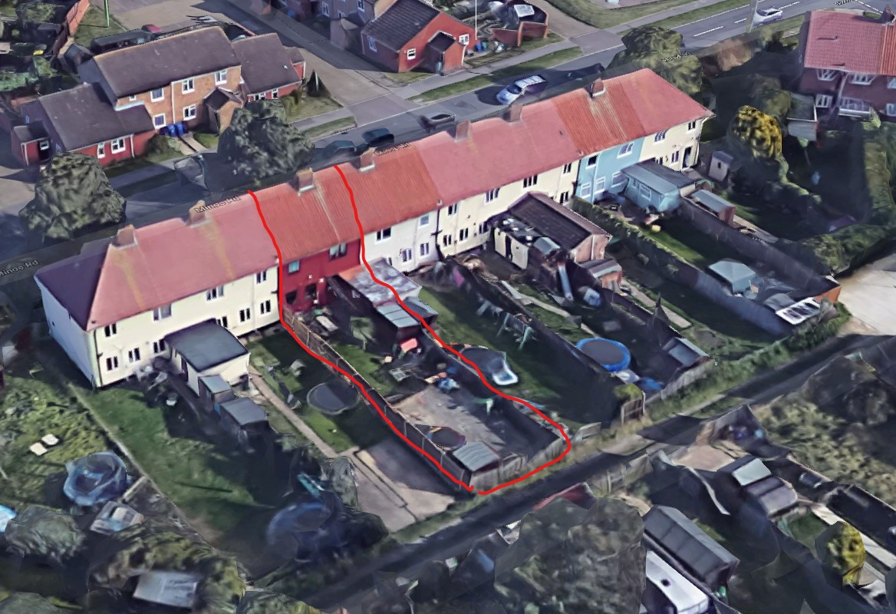
This is a full width single floor rear extension to extend the dining room and kitchen areas.
Several other houses have some form of rear extension, but none of this shape.
10 Minos Road Lowestoft Suffolk NR32 4BL  Proposed single storey rear extension to existing dwelling to provide a family room and downstairs cloak room.  Date Description Information 1 Information 2  03/01/2020 Application Form & Certificate  03/01/2020 Plans 236.01 Survey  03/01/2020 Plans 236.03 Plans, elevations and images  03/01/2020 Site / Location Plan And proposed block plan  03/01/2020 Site Notice & Neighbourhood Notification SNOTQR | DC/20/0008/FUL  Public comments  Constraints  Related cases  Documents  Map

18 Long Meadow Walk
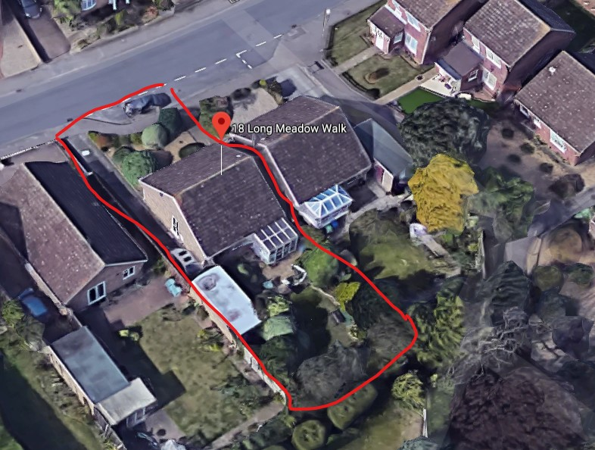
A rear extension to provide a new living room space. This would replace the existing conservatory with a wider structure with a pitched roof.
18 Long Meadow Walk Lowestoft Suffolk NR33 8LT  Construction of a rear extension  Date Description Information 1 Information 2  24/12/2019 Application Form & Certificate Application form  24/12/2019 Plans 002 Rev A Block plans  24/12/2019 Plans 003 Rev A Existing plans  24/12/2019 Plans 004 Rev A Proposed plans  24/12/2019 Site / Location Plan 001 Rev A  02/01/2020 Site Notice & Neighbourhood Notification SNOTQR | DC/19/5053/FUL  Public comments  Constraints  Related cases  Documents  Map

243 Long Road
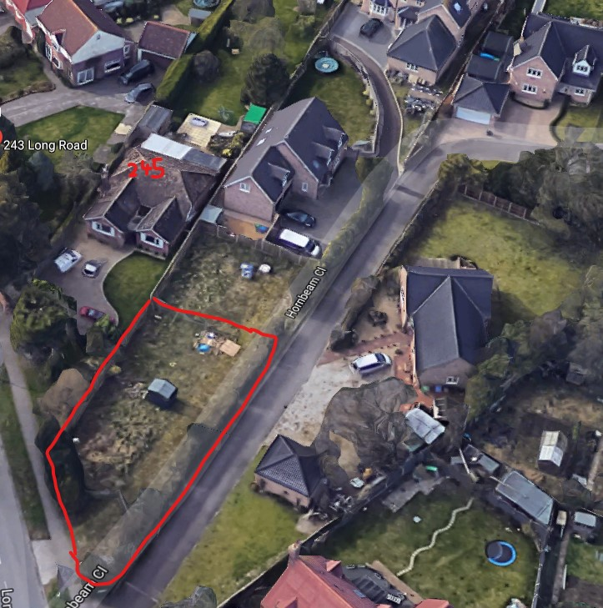
This application has a long history, with 6 variations on the original planning permission from 2010 so far – 3 permitted, 1 withdrawn and 1 refused. We are deciding on number 6 tonight.
2 neighbour objections based on
- Dedicated wheely bin parking for properties 4 and 5 missing from application (Hutchings)
- Floor plan 23% enlarged over permission granted in 2010 (Dye)
- General behaviour by the developer (Dye)
- Lack of privacy to neighbour properties (Dye)
- Proximity to boundary, noise disturbance (Dye)
- Overbearing development (Dye)

243 Long Road Lowestoft NR33 9DF  Variation of Condition No.2 of DC/10/0003/FUL - Construction of 3no. detached houses. Removal of Condition 2 - Alteration to the design and siting of plot 1.  Date Description Information 1 Information 2  30/12/2019 Application Form & Certificate  30/12/2019 Plans 572/6A Proposed Elevations, Floor & Block Plans  02/01/2020 Site Notice & Neighbourhood Notification SNOTQR  03/01/2020 Consultee Responses Anglian Water  06/01/2020 Consultee Responses Environmental Protection  13/01/2020 Neighbour Responses Hutchings 2 Hornbeam Close  16/01/2020 Neighbour Responses Dye 245 Long Road  17/01/2020 Consultee Responses Suffolk Highways | DC/19/5063/VOC  Public comments  Constraints  Related cases  Documents  Map

90 Cotmer Road
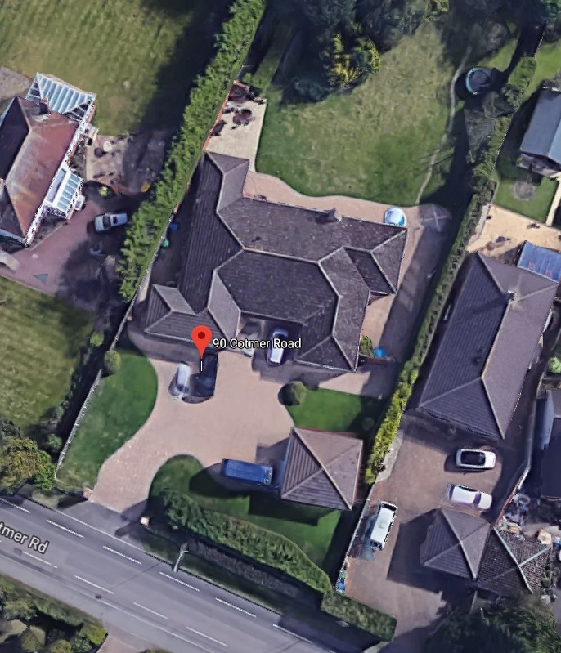
This application is for a front porch and a rear extension to enlarge the kitchen area. No neighbour objections to date.
90 Cotmer Road Lowestoft NR33 9PR  Kitchen and bedroom extension with porch  Date Description Information 1 Information 2  31/12/2019 Application Form & Certificate  31/12/2019 Plans Existing Floor and Elevations  31/12/2019 Plans Proposed Floor, Elevations and Block plan  31/12/2019 Site / Location Plan  31/12/2019 Site Notice & Neighbourhood Notification SNOTQR | DC/19/5072/FUL  Public comments  Constraints  Related cases  Documents  Map

4 The Gap
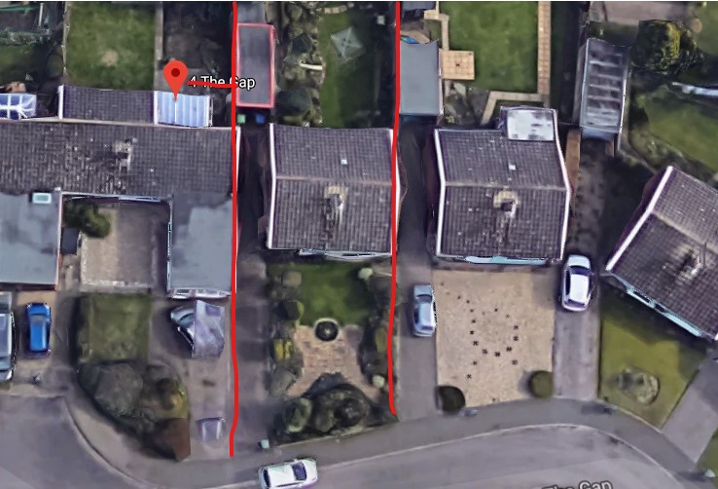
Add a lounge extension to the front, and a kitchen/dining extension to the rear. This would bring the house in line with the building line to the left on the view above.
4 The Gap Lowestoft Suffolk NR33 9AU  Extensions  Date Description Information 1 Information 2  27/12/2019 Plans 2567.19.1 Existing and proposed  30/12/2019 Site Notice & Neighbourhood Notification SNOTQR | DC/19/5059/FUL  Public comments  Constraints  Related cases  Documents  Map

74 Beccles Road
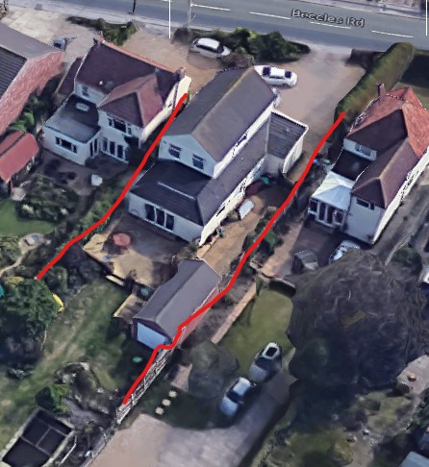
Extending the rear of the first floor to the full length of the building to provide a larger bedroom.
74 Beccles Road Lowestoft Suffolk NR33 8QY  Construction of rear first floor extension  Date Description Information 1 Information 2  14/01/2020 Application Form & Certificate  14/01/2020 Plans 1903/1 Existing and proposed elevations and floorplans, block plan and  14/01/2020 Site Notice & Neighbourhood Notification SNOTQR  15/01/2020 Consultee Responses Environmental Protection | DC/20/0123/FUL  Public comments  Constraints  Related cases  Documents  Map

31 Cleveland Road
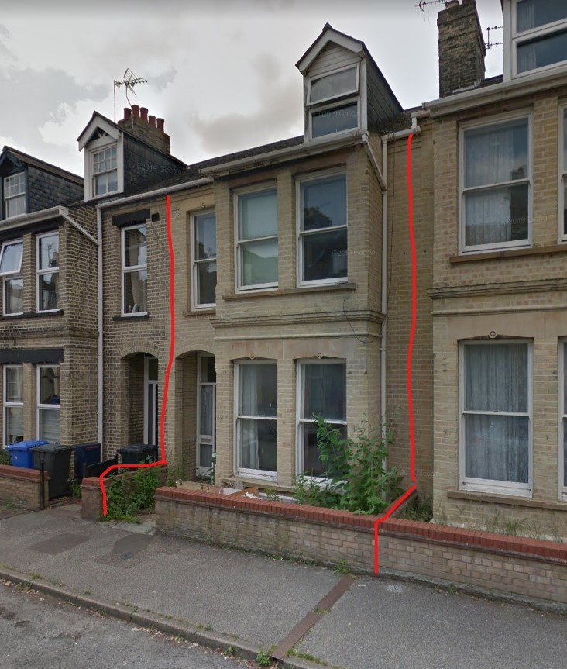
31 Cleveland Road Lowestoft Suffolk NR33 0BN  Replace Existing Front Windows & Door with White PVCu Sash Style Casement Windows & Composite Door  Date Description Information 1 Information 2  13/01/2020 Application Form & Certificate  13/01/2020 Photographs Existing  13/01/2020 Photographs Proposed Front Door & Side Panel  13/01/2020 Proposed Block / Layout Plan  13/01/2020 Proposed Elevations Proposed Windows  13/01/2020 Site / Location Plan  15/01/2020 Site Notice & Neighbourhood Notification SNOTQR | DC/20/0091/FUL  Public comments  Constraints  Related cases  Documents  Map

Trowel & Hammer, 49 Pakefield Street
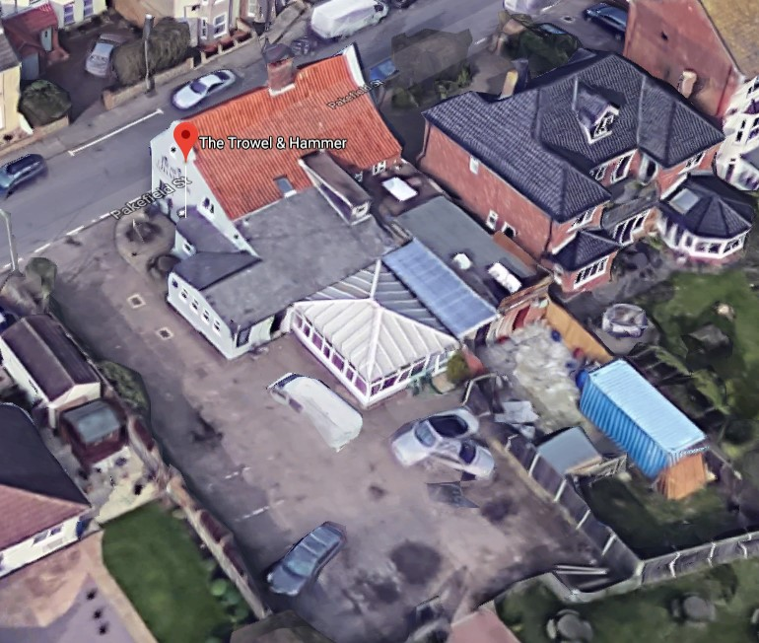
Replacing the existing conservatory style sunroom shown above with a brick build extension of a similar size.
Trowel & Hammer Public House 49 Pakefield Street Lowestoft Suffolk NR33 0JS  Rebuild the existing sunroom/restaurant seating area, following demolition of the existing sun room.  Date Description Information 1 Information 2  13/01/2020 Application Form & Certificate  13/01/2020 Plans H6531/01 Existing Floor and Elevations Plus Existing Block Plan  13/01/2020 Plans H6531/02 Proposed Floor and Elevations Plus Proposed Block Plan  13/01/2020 Site / Location Plan  13/01/2020 Site / Location Plan Flood Map  13/01/2020 Supporting Documents Cover Letter  14/01/2020 Site Notice & Neighbourhood Notification SNOTQR | DC/20/0112/FUL  Public comments  Constraints  Related cases  Documents  Map

