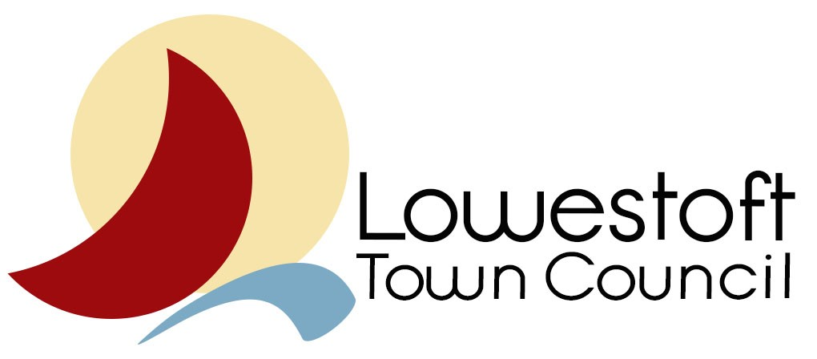

Friends, Stakeholders and Assets Policy

December 2017
Management Structure for Assets with Friends Groups

Full Council

Implementation Committee

Assets Stakeholders Forum Facilities Manager

Asset Committee

Two Councillors
Chair & Secretary of Friends Group
Stakeholder Representatives
Staff Representation

Introduction
This document is designed to inform Lowestoft Town Council’s Friends and Stakeholders as to how the Council manages its assets that have multiple user groups and/or Friends Groups.

Structure
The overall responsibility and decision-making powers lie with the Full Council however they have the ability to allocate designated responsibilities and powers to the Implementation Committee who will deal with the day to day management of the assets in conjunction with both the Town Clerk and Facilities Manager.
The normal point of contact between the Council and the individual assets committees would be via the Facilities Manager or the Council’s representatives on the committee however in addition the Council will organise quarterly Asset Stakeholders Forums which can bring forward policy and financial issues where there is a common interest across the assets. The quarterly forum will be chaired by the Chair or Deputy Chair of the Implementation Committee. Any issues proposed at the forum will move up to the Implementation Committee for consideration and action or preparing a recommendation to Full Council.

Assets Stakeholder Forum
The Forum will meet quarterly (Feb, May, August & September) and will be chaired by the Chair or Vice Chair of the Implementation Committee.
Each recognised Asset Committee will be able to send two nominated representatives to the Forum.
The Forum has no formal powers however it has the ability to send recommendations to the Implementation Committee. The Implementation Committee has a responsibility to report back on the actions it has taken in regard to the recommendations. If the Forum is not satisfied it has the right to resubmit its proposal to the Implementation Committee who, if they still oppose, have to forward it to Full Council with an explanation of their opposition.

Asset Committees
The Asset Committees should meet a minimum of quarterly, generally just prior to the Stakeholder Forums. The Asset Committees will deal with issues relating to their individual assets and be able to progress issues where they have delegated authority and will allow liaison between the asset stakeholders.
Each Asset Committee will comprise of:
- Two members of the Town Council
- The Chair & Secretary (or their representatives) from the recognised “Friends of” group
- One representative from each recognised stakeholder in the asset. This includes tenants as well as sports and/or cultural organisations (who have signed a user agreement).
- Any council staff employed or contracted at the asset.
- The Council Facilities Manager.

The Facilities Manager will facilitate the meetings, ensure that representatives to the Forum are contacted and that minutes are taken and forwarded to the Implementation Committee.

