Introduction
  - Automated External Defibrillators (AEDs) are a safe, effective and prompt way of providing early defibrillation.

Scope and Purpose of the Policy
  - The purpose of this policy is to provide the Town Council with protocols for the acquisition, maintenance, disposal, record keeping and all other activities associated with the management and use of defibrillators provided by or situated on land owned by the Town Council.

Objectives
  - The objectives of this policy are to ensure:
- Safe, prompt and effective operation of defibrillators
- Accurate record keeping
- Continuity of accountability and responsibility

Establishing the Criteria for an AED
  - There is no generally agreed criteria on which to base definitive advice on whether or not to provide an AED in any specific place, but consideration of the following points should assist with the decision making process:

4.1a People
- Sudden Cardiac Arrest (SCA) affects predominantly middle-aged and older people, and typically men more than women. SCA can also affect athletes and elite sportspeople
- SCA often occurs during exertion
- The greater the number of people present in, or passing through, any one place, the greater the risk of SCA occurring there

4.1b Location, including accessibility and visibility of the AED, and whether it adds value
- The purpose of installing an AED is to deliver a shock as soon as possible after SCA, if possible within a maximum of five minutes

4.1c Training
- Although untrained members of the public have successfully used AEDs to save a life, the majority of successful AED uses have been by trained people who were nearby. The consideration of installing an AED at a particular location should be on the basis that there are people on site who are willing to be trained in its use
- In a workplace situation, training would normally be given in the use of an AED. However, untrained persons can use the AED in line with the instructions given by the ambulance service and equipment. Lowestoft Town Council has in place Employers Liability Insurance
- Training will be made available to all Lowestoft Town Councillors and officers.

4.1d Maintenance
- Consideration should be given to whether the Council or organisation applying for the AED should take responsibility for maintaining the equipment, keeping records, insuring the AED and ensuring an appropriate budget is in place to cover operating costs, maintenance and replacement parts, the electricity supply and replacement of the AED if necessary
  - This Council recognises that the ambulance service cannot guarantee an immediate response to an emergency call.

Legal Issues
5.1 The current updated guidance Cardiopulmonary Resuscitation, Automated Defibrillators and the Law was issued in April 2018 by the Resuscitation Council (UK). Their latest advice should be referred to for full advice on the law. In brief, the current guidance includes that:
- There are no statutory laws covering resuscitation specifically but potential liability could arise in common law where a person is left in a worse position than if no action were taken.
- A potential liability could arise if a civil claim were brought by the victim, or their family, against someone on the grounds that intervention occurred without their consent and constituted an assault and/or battery. A defence of necessity may be available to a lay person assisting someone they reasonably believe is suffering a cardiac arrest, where no more qualified person is available.
- The Social Action Responsibility and Heroism Act 2015 aimed to encourage social responsibility and good citizenship by requiring courts to take account the motivation of volunteers in claims for negligence. The Mental Capacity Act 2005 allows a reasonable inference of consent to be resuscitated where this in the best interests of someone unable to give consent.
- Liability might arise for organisations providing equipment which directly causes harm owing to failure to maintain etc.

Accountability and Responsibilities
  - The Town Council will consider applications from outside bodies to enter match funding for the provision of AEDs. The Council would normally expect that the organisation applying for the AED has overall accountability and responsibility for the AED, and all those matters referred to in 6.2. The Council has committed to installing at least two of its own defibrillators per year and match funding at least a further five defibrillators per year for at least the next five years (commencing 2021 – 2022).
  - For those AEDs for which the Town Council assumes responsibility, insurance, registration, training, record-keeping and maintenance will be arranged by the Town Clerk.
  - The Community Safety Committee will review and report on the application of this policy, and management of the associated defibrillator budget of £10,000, as necessary to Full Council.

Equipment Maintenance and Storage
  - It is essential that all AEDs are stored, maintained and used in accordance with the manufacturers’ instructions.

Disposal of Equipment
  - AEDs that are no longer operational or cannot reasonably be repaired will be disposed of with due consideration to the Council’s declaration of a climate emergency.

Adverse Incident Reporting for Defibrillation
  - All adverse incidents relating to AEDs on land owned by the Town Council must be recorded and action taken to prevent further occurrences.
  - The reporting of adverse incidents is highly important and the Town Council will adopt a ‘no blame’ culture.
  - If an adverse incident is a result of equipment malfunction, the equipment must be immediately withdrawn from service and the Council should be notified.
Annex 1 – AED locations, photographs and additional information
Denes Oval Pavilion
Located under the veranda on the putting green side of the building
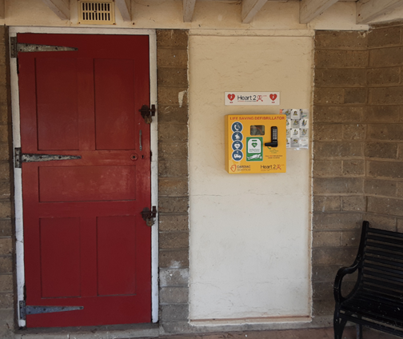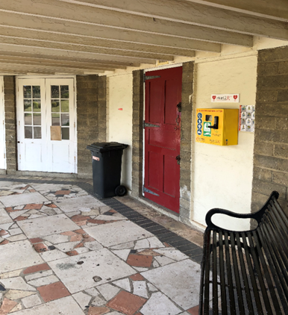
Sparrows Nest
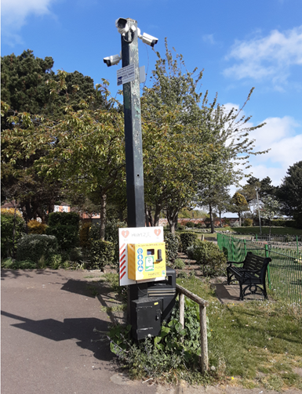
Normanston Park
Located to the right of the entrance door of Jesters Diner. Jesters have confirmed they insure the AED, pay for the electricity and will periodically check and carry out any required maintenance actions.
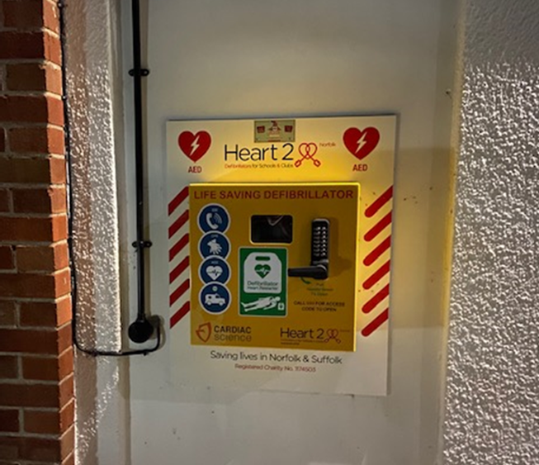

Gunton Drive
Located within the Town Council’s adopted red telephone kiosk
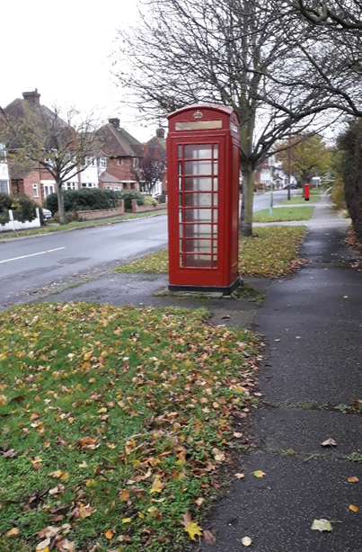

Revisions
Date | Amendment

