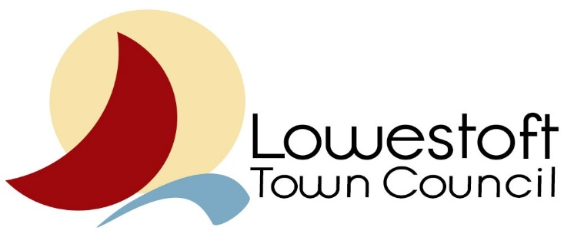
Councillor Representation Reporting Form
Councillor: Sonia Barker
Body: Marina Theatre Trust Board
Report Date: 9.12.21

Meetings attended and dates | - Marina Theatre Trust Board Meeting 3.00 pm on Thursday 25th November 2021.  - Six members of the Board were in attendance (one on Zoom) plus the Administrative Officer.
Key issues discussed at the meeting(s)  (relevant to LTC and its constituents) | Reports from the following were received before the meeting and questions raised were answered by those present:-  - CEO Report – November 2021  - MT Board Marketing Report  - Front of House/Box Office Report  - Technical Report  - Health & Safety Report  - Finance Report  - Redevelopment Update  - Climate & Bi-diversity changes  - LTC/WDC Transfer update
Any actions required by LTC? | LTC aware of on-going liaison with MTT as future meetings have been arranged.
 |  | Date: 9.12.21.

