Hi Lauren,

Thanks for the e-mail and l would like you to mention the following under the following items:

62.2b - The Friends of Kensington Gardens Group would like to explore the possibilities of installing up lighters for the lighting in the gardens. This would then avoid the need for any posts being installed plus the lights could then be placed amongst the plants/trees in the gardens. There could also be some lights attached to the existing buildings for security reasons.

62.3 - The Friends of Kensington Gardens have drawn up a list of bulbs for the coming year but would like to ask for permission to plant the daffodils, Narcissus & Crocus in the grassed area in the corner between the school fencing and the prom. l have attached a sketch to show location. These would be pocket planted which still allows for mowing of the grass.
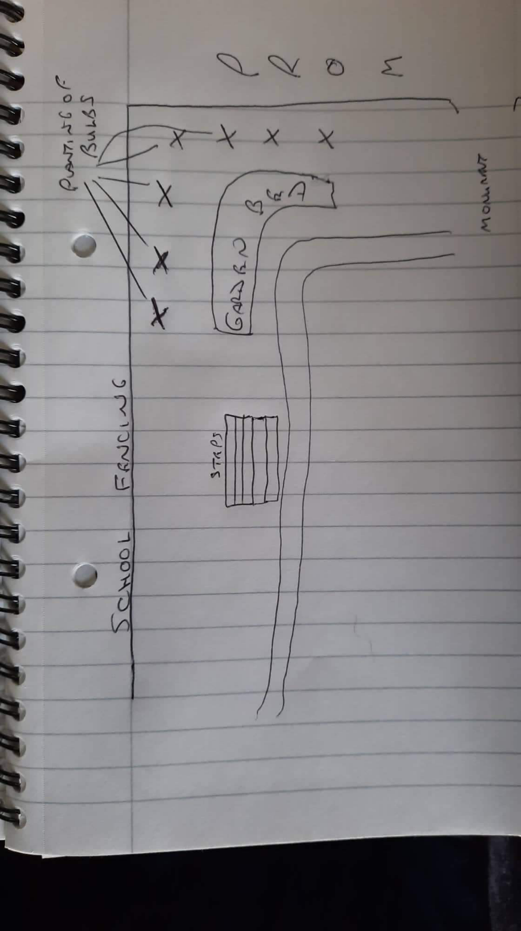

62.12 - A suggestion for the location of the ' Talking Bench ' would be as marked on the attached sketch.

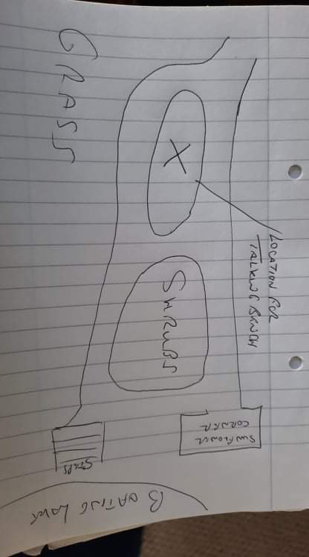

62.15 - We think LTC need to get a professional survey carried out on the condition of the wall along with what can & cannot be done re any construction in the area.

