Planning notes 7/7/2020

Sur-la-Mer 32 Grand Avenue
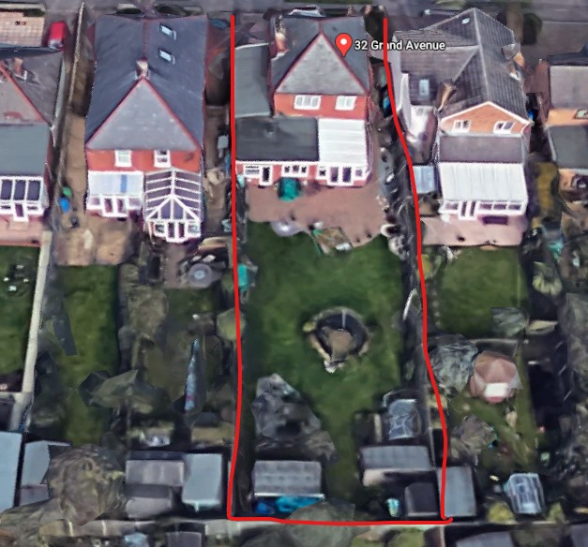
Large development to the rear of the property.
One neighbour objection from Cowley:
‘Annex’ is misleading as development is a self-contained residential unit.
Submitted material provides insufficient information – missing dimensions on elevations (particularly overall height of building). Quotes policy DM6 of Suffolk Coastal Local Plan and WLP8.10 which he argues disallow this annex. Quotes DM23 (privacy, overlooking, light, noise etc) which is relevant as development is close to boundary and runs for 10m along its length.

Sur-la-Mer 32 Grand Avenue Lowestoft Suffolk NR33 7AR  Construction of one bedroom single storey annex  Date Description Information 1 Information 2  02/07/2020 Neighbour Responses Mr. A Cowly 34 Grand Avenue  25/06/2020 Consultee Responses Environmental Protecion  18/06/2020 Info Sheet INFO  18/06/2020 Proposed Elevations North Elevations 5 of 6  18/06/2020 Proposed Elevations South & North Elevations 3 of 6  18/06/2020 Proposed Elevations West Elevations  18/06/2020 Proposed Floor Plan Proposed Floor Plan 4 of 6  18/06/2020 Site / Location Plan Proposed Site Plan  08/06/2020 Proposed Block / Layout Plan Proposed Annex No 6 of 6  08/06/2020 Proposed Elevations Elevations Plan 5 of 6  08/06/2020 Proposed Elevations South & North Elevations Plan 3 of 6  08/06/2020 Proposed Elevations West Elevations Plan 2 of 6  08/06/2020 Proposed Floor Plan Basic Floor Plan | DC/20/2094/FUL  Public comments  Constraints  Related cases  Documents  Map

16 Pakefield Road
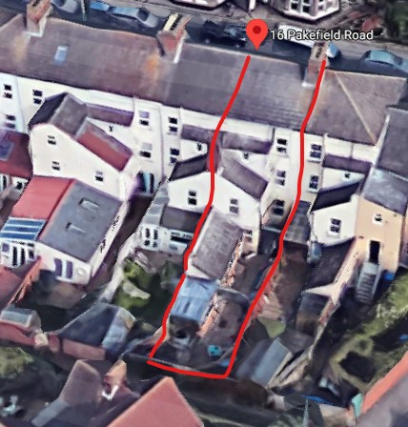
Squaring off of the existing rear extension, converting a store room into a bedroom.
16 Pakefield Road Lowestoft Suffolk NR33 0HS  Construction of a single storey rear extension  Date Description Information 1 Information 2  26/06/2020 Info Sheet INFO  26/06/2020 Info Sheet INFO  23/06/2020 Application Form & Certificate  23/06/2020 Plans 150620/1 Existing elevations & floor  23/06/2020 Plans 150620/2 Proposed elevations & floor  23/06/2020 Plans 150620/3 Site and block | DC/20/2290/FUL  Public comments  Constraints  Related cases  Documents  Map

P F K Ling, Riverside Road
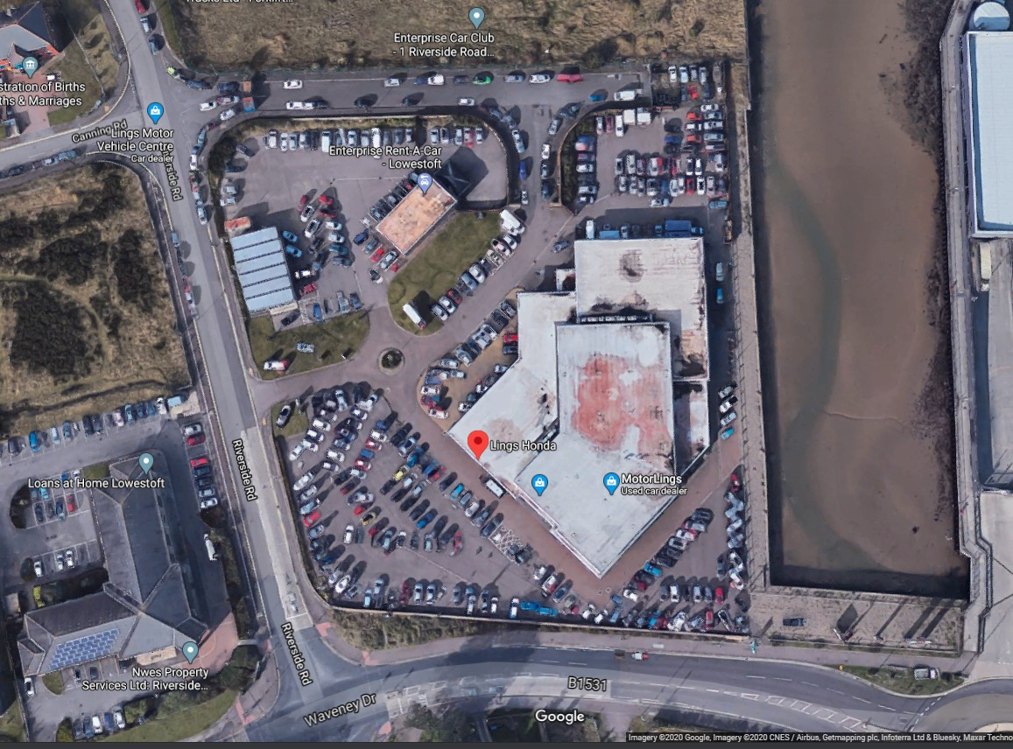
Changes to the site layout. See P04 document below for a summary.
P F K Ling Riverside Road Lowestoft Suffolk NR33 0TQ  Creation of hard standing and associated kerbing for car parking display. Erection of fence to create secure compound for car storage. Erection of bollards and barriers to prevent vehicle incursion in to the show room and parked vehicles.  Date Description Information 1 Information 2  29/06/2020 Info Sheet INFO  29/06/2020 Site / Location Plan Location Plan LLTC/SCC P02  17/06/2020 Application Form & Certificate  17/06/2020 Existing Block / Layout Plan  17/06/2020 Flood Risk Assessment Lowestoft FRA Statement  17/06/2020 Site / Location Plan Motorling Amended Site Layout P04  17/06/2020 Site / Location Plan Motorlings Location Plan P01.3  17/06/2020 Site / Location Plan Storm Drainage 100 A | DC/20/2204/FUL  Public comments  Constraints  Related cases  Documents  Map

84 Kirkley Park Road
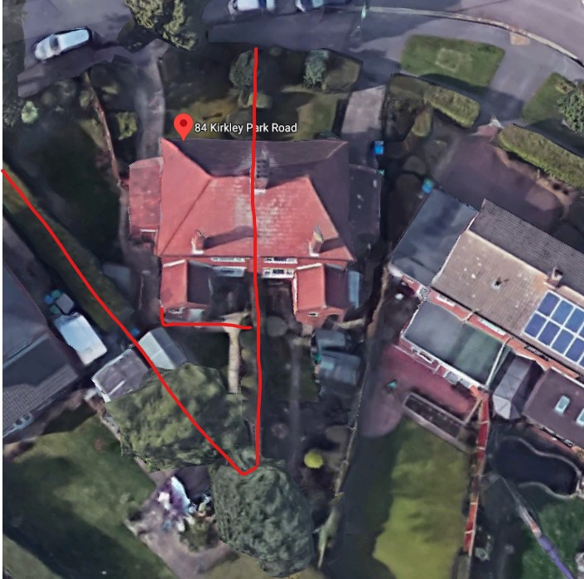
A 4m extension to the rear, incorporating one additional bedroom, enlarged kitchen and second sitting room.
84 Kirkley Park Road Lowestoft Suffolk NR33 0LG  Proposed single and two storey rear extensions  Date Description Information 1 Information 2  30/06/2020 Info Sheet INFO  29/06/2020 Application Form & Certificate  29/06/2020 Plans 160620.1 Survey drawing  29/06/2020 Plans 160620.2 Proposed  29/06/2020 Site / Location Plan And block plan | DC/20/2349/FUL  Public comments  Constraints  Related cases  Documents  Map

Port House, Station Square
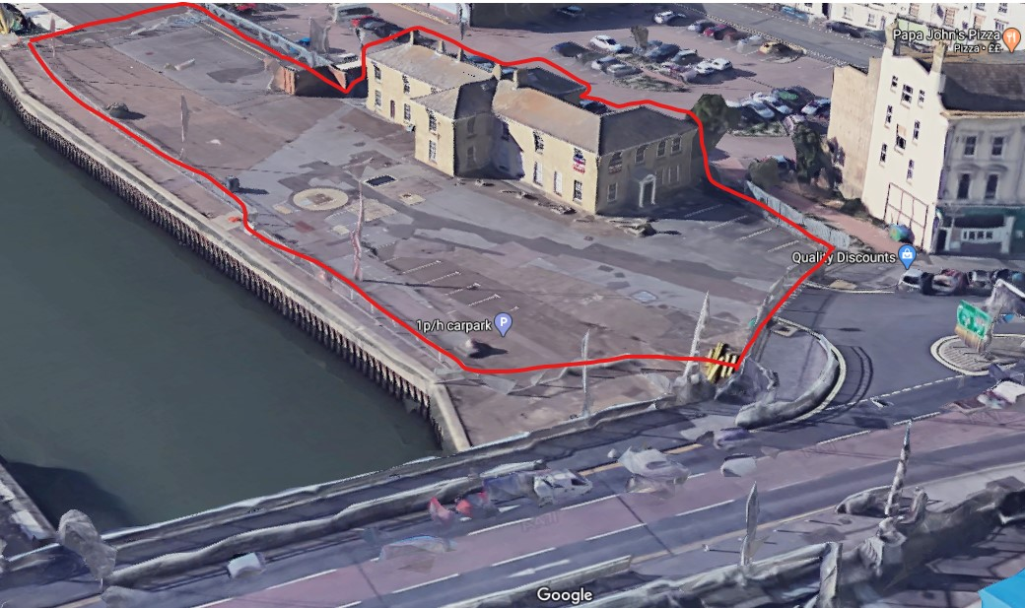
On 20 April LTC recommended approval of this application. Since then a heritage statement, a design and access statement and an amended block plan have been submitted.
Port House The Bridge Station Square Lowestoft Suffolk NR32 1BG  Change of use from offices to resturant. Re-instatement of double door and patio. Associated works to surrounding external areas.  Date Description Information 1 Information 2  29/06/2020 Application Form & Certificate  26/06/2020 Amended Plans & Documents 2558.19.1A Site & Block Plan  26/06/2020 Design & Access Statement 2558 REV A  26/06/2020 Heritage Statement 2558 REV A  20/04/2020 Consultee Responses Highways Department  08/04/2020 Town/Parish Consultation Response  20/03/2020 Application Form & Certificate  20/03/2020 Existing Floor Plans 2558.19.2 Ground Floor  20/03/2020 Existing Floor Plans 2558.19.3 First Floor  20/03/2020 Flood Risk Assessment 2453/RE/01-20/02  20/03/2020 Plans 2558.19.6 Existing & proposed elevations & Site layout  20/03/2020 Proposed Floor Plan 2558.19.4 Ground Floor  20/03/2020 Proposed Floor Plan 2558.19.5 First Floor  20/03/2020 Supporting Documents Second world war damage | DC/20/1271/FUL  Public comments  Constraints  Related cases  Documents  Map
Port House The Bridge Station Square Lowestoft Suffolk NR32 1BG  Listed Building Consent - Change of use from offices to resturant. Re-instatement of double door and patio  Date Description Information 1 Information 2  29/06/2020 Application Form & Certificate  26/06/2020 Amended Plans & Documents 2558.19.1A Site & Block Plan  26/06/2020 Design & Access Statement 2558 REV A  26/06/2020 Heritage Statement 2558 REV A  20/04/2020 Consultee Responses Highways Department  08/04/2020 Town/Parish Consultation Response  20/03/2020 Application Form & Certificate  20/03/2020 Existing Floor Plans 2558.19.2 Ground Floor  20/03/2020 Existing Floor Plans 2558.19.3 First Floor  20/03/2020 Flood Risk Assessment 2453/RE/01-20/02  20/03/2020 Plans 2558.19.6 Existing & proposed elevations & Site layout  20/03/2020 Proposed Floor Plan 2558.19.4 Ground Floor  20/03/2020 Proposed Floor Plan 2558.19.5 First Floor  20/03/2020 Supporting Documents Second world war damage | DC/20/1272/LBC  Public comments  Constraints  Related cases  Documents  Map

22 Damask Close
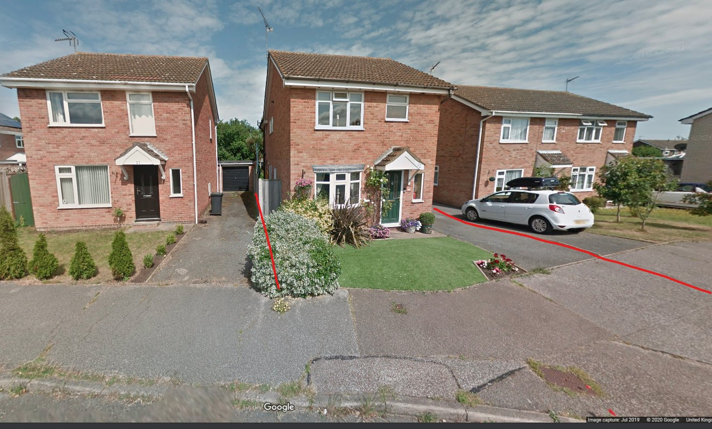
A 2.5m extension to the front. This is significantly proud of the existing building line.
22 Damask Close Lowestoft Suffolk NR33 8LL  Proposed single storey front extension  Date Description Information 1 Information 2  29/06/2020 Application Form & Certificate  29/06/2020 Plans 210620 1 existing floor and elevations  29/06/2020 Plans 210620 2 Proposed floor and elevations  29/06/2020 Plans 210620 3 site and block | DC/20/2333/FUL  Public comments  Constraints  Related cases  Documents  Map

5 Reynolds Walk
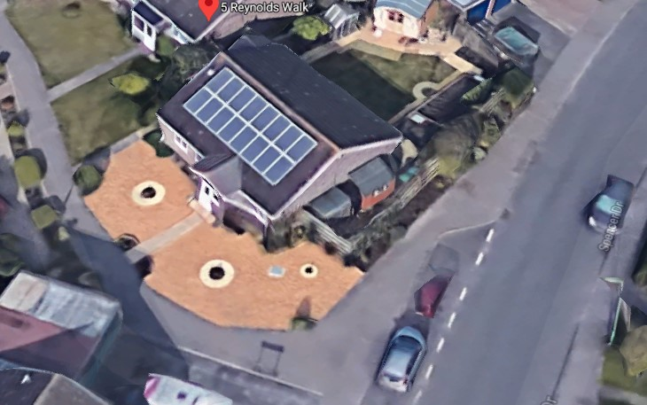
Construction of en-suite and dressing room in the location of existing outhouses.
5 Reynolds Walk Lowestoft NR32 4LN  Construction of a single storey side extension to house an en-suite and dressing room  Date Description Information 1 Information 2  19/06/2020 Application Form & Certificate  19/06/2020 Plans proposed and existng elevations  19/06/2020 Plans proposed/existing floor block  19/06/2020 Plans Drainage drawings  19/06/2020 Site / Location Plan | DC/20/2248/FUL  Public comments  Constraints  Related cases  Documents  Map

30 Corton Road
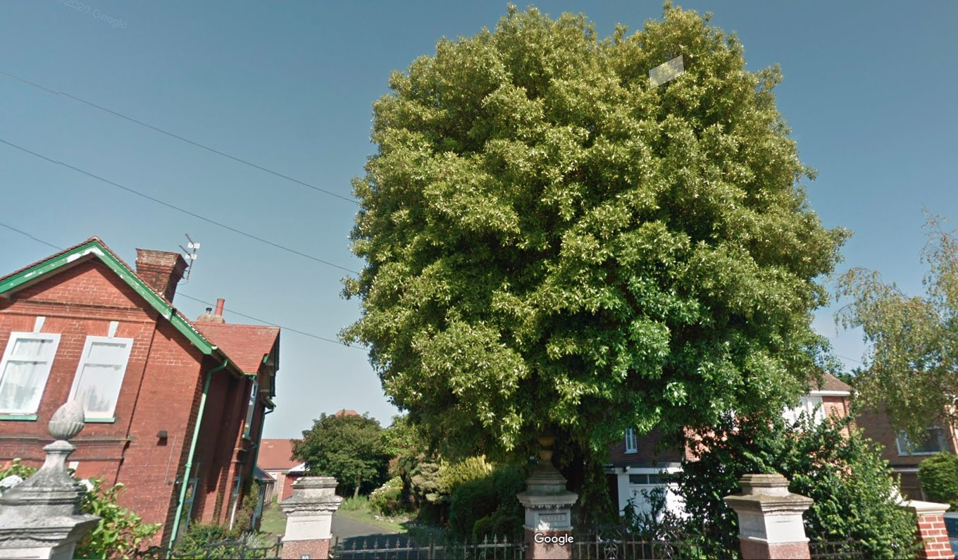
30 Corton Road Lowestoft Suffolk NR32 4PL  1 x Evergreen Holm Oak - Reduce crown by 20% and overhang to perimeter and neighbouring property and reshape. The planned work is routine maintenance last carried out in 2013.  Date Description Information 1 Information 2  30/06/2020 Application Form & Certificate  30/06/2020 Plans Sketch - Tree Location | DC/20/2390/TCA  Public comments  Constraints  Related cases  Documents  Map

