Seafront and Waterfront

Purpose

To create a 21st century waterfront and seafront, to promote economic development and create more diversity in living accommodation.

Rationale and Evidence

National Policy

Paragraph 13 of the National Planning Policy Framework 2019 (NPPF) states that ‘Neighbourhood plans should support the delivery of strategic policies contained in local plans or spatial development strategies; and should shape and direct development that is outside of these strategic policies. Paragraph 28 states that ‘non-strategic policies should be used … to set out more detailed policies for specific areas, neighbourhoods or types of development’ including consideration of infrastructure, community facilities, design principles, conserving and enhancing the natural and historic environment. Paragraph 69 refers to neighbourhood plans allocating small and medium sized sites.

Local Policy

The Waveney Local Plan has allocated the following sites for development (See Plan **):

- WLP2.2 Power Park
- WLP2.3 Peto Square
- WLP2.4 Kirkley Waterfront and Sustainable Urban Neighbourhood (part of allocated site is in Lowestoft)
- WLP2.5 East of England Park (since adoption of the Local Plan this area is now known as Ness Park)
- WLP2.10 Inner Harbour Port Area

The Local Plan Policy WLP2.1 ‘Central and Coastal Lowestoft Regeneration’ seeks to work with numerous agencies including Suffolk County Council, Lowestoft Town Council, Oulton Broad Parish Council, Associated British Ports, Environment Agency, Network Rail, Marine Management Organisation, the Broads Authority, to deliver regeneration projects in central and coastal Lowestoft.

Planning Rationale

The strategic importance of the allocated waterfront site, allocated by the Local Plan, is recognised by the Neighbourhood Plan. The neighbourhood plan seeks to shape development to ensure that it is sustainable, of high quality and appropriate to the waterfront location.

As far as physical growth is concerned, Lowestoft is landlocked. The border to the east is the North Sea. To the west and north any expansion is curtailed by the Norfolk Broads and the Carlton Marshes and the parishes of Oulton Broad and Oulton. The parishes of Carlton Colville and Gisleham border the south and south west. Land directly to the south of the town, between the ward of Pakefield and the parish of Kessingland is designated as an Area of Outstanding Natural Beauty.

Therefore, the prospects of Lowestoft expanding in physical area to accommodate any expansion in industry and population is limited. So it is important to make more efficient use of land within the Neighbourhood Plan area.

The temptation for the strategic housing sites and other key sites may be to adopt a development-at-any-cost approach, including acceptance of poor design. This would be a grave error which, in the longer term, would be likely to lock the area into a cycle of underperformance. So robust application of the later design policies in conjunction with the site-specific design principles is crucial.

In order to tackle challenges of land reclamation, viability and low land value and to make development of the appropriate quality happen, any relaxation of affordable housing requirement for waterfront sites should only be considered where superior environmental performance can be achieved, reducing running costs and addressing climate change. The seafront and Ness Point sites have the potential for transformational development, as a magnet for tourists and visitors. These complement the site allocations made in the Local Plan, but with an emphasis on economic development.

It is clear that both the Local Authority and the local community have an aspiration to create a 21st century waterfront and seafront. The Pavilion is currently being refurbished, but redevelopment is likely in the medium-term. The surrounding Lowestoft Seafront Vision project area provide opportunities, identified by Wayne Hemingway on behalf of the council, to regenerate the south beach and to bring forward opportunities presented by the seafront. Ness Point provides similar opportunities.

SW1: Seafront Pavilion Site

- The East Point Pavilion site on the south beach seafront is allocated for development to support tourism and the visitor economy. This includes performance, display, exhibition, recreation, and other tourism and visitor-related uses.

- Development must comply with the following development principles:

- The seafront and surrounding public realm must be overlooked by active frontages, provided through features like glazing and balconies;

- Creative and aspirational architectural and landscape design should be employed to create a distinctive landmark and strong seafront identity;

- The scheme must include a high-quality public realm, taking account of the proximity of the war memorial.

- Higher buildings may be supported where they demonstrate exceptional design quality.

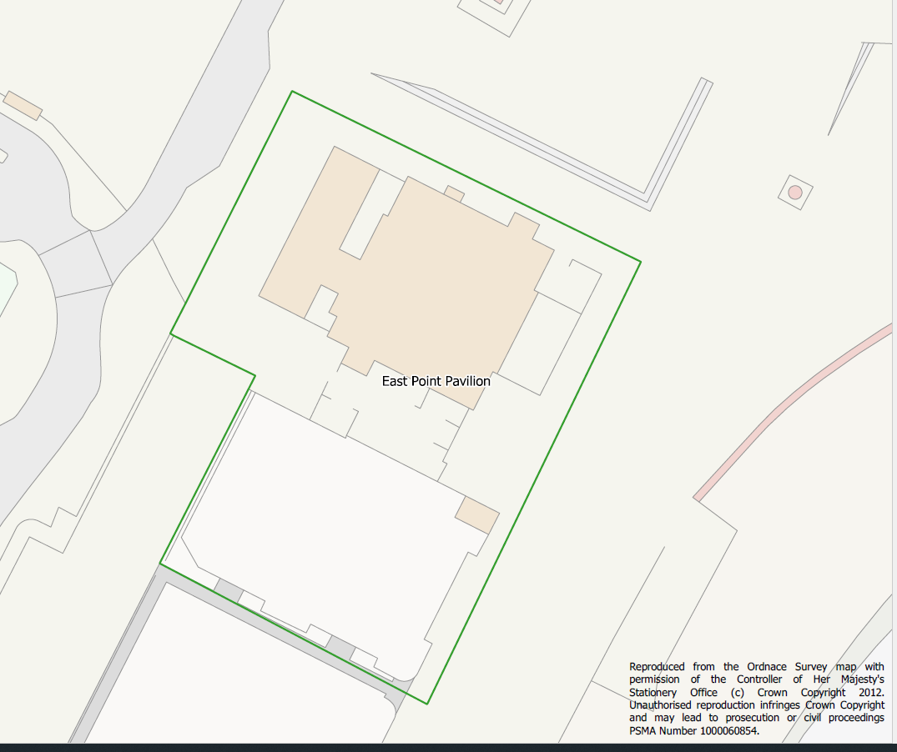

Interpretation and Guidance

This is a key site for a major visitor attraction, to attract visitors, tourists and people from the local and surrounding areas. The site could accommodate an art gallery, arts and innovation centre, events space, performance space, viewing tower and other similar uses.

Independent design review is encouraged, in line with NPPF advice. Alternatively, the site would be an ideal subject for an architectural competition. The aim of the policy is to achieve exemplar design, to creative a positive symbol of an area transforming.

Whereas the later Policy EP1 seeks to ensure that the scale of development complements surrounding townscape, this policy modifies that requirement, recognising the opportunity that this site presents in terms of landmark development. The scheme should provide a strong identity from all viewing angles, including the seafront and from the surrounding spaces.

Achievement of a suitable scheme may involve remodelling of the wider public realm and parking areas.

SW2: Seafront Ness Point

- Development of a visitor centre will be supported within Ness Park (as identified below and in Waveney Local Plan WLP2.5).

- Development must comply with the following development principles:

- The seafront and surrounding public realm must be overlooked by active frontages, provided through features like glazing and balconies;

- Creative and aspirational architectural and landscape design should be employed to create a distinctive landmark and strong seafront identity.

- The scheme must include a high-quality public realm, taking account of the proximity of the Ness point.

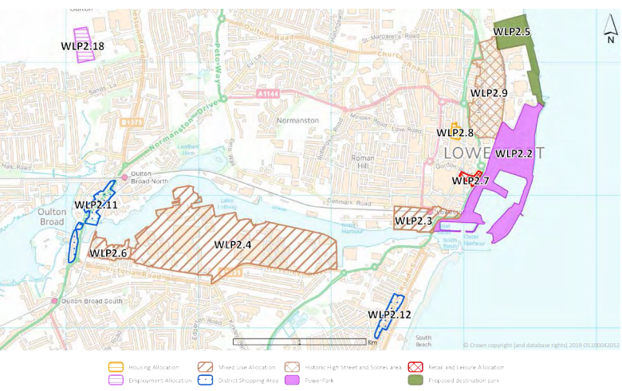

Interpretation and Guidance

The policy allows a visitor centre associated with Ness Point. This could include exhibition space, interpretation, café, shop and related facilities.

Independent design review is encouraged, in line with NPPF advice. The aim of the policy is to achieve exemplar design and regeneration.

SW3: Kirkley Waterfront Sites

- Development of waterfront sites (Waveney Local Plan Policy WLP2.4 as above) must result in the creation of a high-quality urban waterfront, including residential and employment uses,

- Development must comply with the following development principles:

- There must be public access to the waterfront edge, provided through a combination of walkways, cycle ways, public spaces and high-quality landscape design;

- Spaces must be designed to encourage public and visitor use the of waterfront;

- The layout must prioritise pedestrian access to the waterfront edge and include clear sight-lines through the development;

- The waterfront must be overlooked by active frontages (windows, doors and balconies);

- Higher buildings may be supported on the waterfront, where they demonstrate exceptional design quality and superior environmental performance;

- For sites adjacent to and/or facing the waterfront, residential accommodation may be provided at upper levels, but not at ground floor level. Suitable uses at ground floor level would include a mix of employment and commercial uses, food and drink and/or community uses.

- Creative architectural design should be employed to create a strong waterfront identity.

- Affordable housing provision should take account of Policy LH2.

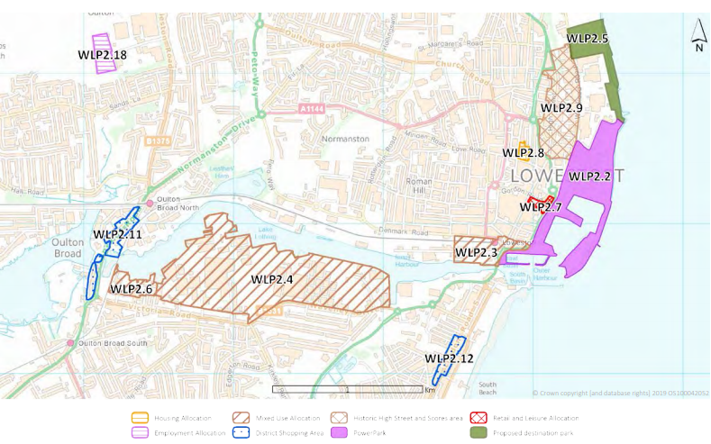

Interpretation and Guidance

The policy sets a high level of expectation for development in general and in particular the waterfront edge, in recognition of the strategic importance of the sites.

Independent design review is encouraged, in line with NPPF advice. As with the seafront policy, the aim of this policy is to achieve exemplar design, to create a positive symbol of an area transforming. The layout and design of development should also meet the requirements of Policy ETC1.

The key to compliance with the policy is to create a new neighbourhood with an accessible and vibrant waterfront.

Economy and Town Centre

Purpose

To achieve sustainable growth and development, including enhancing retail areas, attracting employment and creating local economic opportunity and realising the social and economic potential of Lowestoft’s heritage.

Rationale and Evidence

National Policy

Rapid changes to the retail and leisure necessitate a more flexible and positive approach to planning for the future of town centres, especially following on from COVID impacts. Paragraph 20 of the NPPF states that strategic policies should make “sufficient provision” for retail, leisure and other commercial development. Paragraph 85 states that meeting anticipated needs for town centre uses should not be compromised by limited site availability, it suggests review of town centre boundaries can take place to meet these needs. In line with Paragraph 185, plans should set out a positive strategy for the conservation and enjoyment of the historic environment. In developing their strategy, plan-making bodies should identify specific opportunities within their area for the conservation and enhancement of heritage assets

Local Policy

Local Plan policies in the Retail, Leisure and Town Centres chapter provide support for economic development through specific policies on ‘New Town Centre Use Development’, ‘Vitality and Viability of Town Centres’ and ‘Local Shopping Centres’. The Local Plan identifies within the economic profile for Lowestoft (p13) that:

“The town’s economy benefits from its strong links to Great Yarmouth, which also profits from the offshore sector. Tourism is an important sector to the town, and its unique position between the Broads and the sandy beaches on the North Sea help attract high numbers of tourists each year. The town is quite self-contained with 54% of working people living in the town also working in the town. However, an increasing number of residents are commuting to Great Yarmouth for work.”

The Local Plan further states that Lowestoft’s economy has shifted from fishing and manufacturing in recent years and recognises potential for future jobs growth in offshore renewables and the significant benefits from the Port of Lowestoft.

The Local Plan also states:

“Lowestoft town centre acts as a day-to-day shopping centre for residents of the town and the surrounding area. However, its catchment is quite small, given its coastal location and competition from nearby centres of Great Yarmouth and Norwich. The town centre has suffered in recent years with higher levels of vacant shop units and residents consider that the shopping offer could be better.”

Planning Rationale

Lowestoft is recognised as a place to invest by different industries due to its access to the North Sea and lower operating costs, fuelling demand for leisure, community and retail. To offer employees a healthy life/work balance, East Suffolk Council aims to improve this offer across Lowestoft, with the town centre at its core.

The following policies recognise the need for Town Centre and Historic High Street to diversify. Retail alone will not create a competitive town centre. The whole offer needs to be considered, including retail, food and drink, entertainment, community facilities, culture, recreation and other uses that draw people into the area. The historic environment is also an important factor in making the Town Centre attractive. The Historic High Street in particular has potential to create a magnet for visitors, perhaps based more on independent businesses. Lower rentals mean that the area can support enterprise, independent business and start-ups.

The bustling town centre is surrounded by a mix of residential housing and industry an Enterprise Zone and the seafront tourist area. It is served by the central railway station with direct links to Norwich, Ipswich and London.

There are three Enterprise Zones in Lowestoft (South Lowestoft Industrial Site, Riverside Road and Mobbs Way), designed to fast track development on vacant employment land and encourage business investment. They represent an ideal relocation area to unlock future development opportunities in and around Lowestoft. Businesses relocating to the enterprise zones can apply for up to 3 years of Business Rate Relief.

Enhancing the public realm by improving accessibility and developing the urban landscape, will act as a catalyst for investment and link the whole Lowestoft area from the south beach to the Heritage Action Zone. Development of the former post office and Battery Green car park will address the need for a central leisure offer, whilst residential developments and the utilisation of vacant properties will develop the area as a community hub, following the aims of the Waveney Local Area Plan.

Repopulation of the town centre based on conversion of upper floors and newbuild development around the edges has potential to make it far more vibrant (see also next chapter on ‘Living’).

ETC1: Lowestoft Town Centre and Historic High Street

- The Town Centre is defined as the retail core, Historic High Street, London Road north and south and railway station retail areas (see plan **).

- The refurbishment or extension of sites and buildings in and around the Town Centre will be supported, subject to meeting other requirements of this and other policies.

- Redevelopment of buildings will be supported, providing it does not involve the demolition of listed buildings or a buildings in a Conservation Area that contribute positively to the special architectural or historic interest of the area.

- Ground floor street-frontage units must remain in appropriate town centre uses. Appropriate town centre uses include shops, financial or professional services, food and drink, pubs, leisure and recreational uses, community facilities, and other open to the public.

- Residential uses will be supported for upper levels or sites peripheral to the town centre, but not for ground floor street-frontage units. Upwards extension will be supported, subject to meeting the requirements of design and other policies.

- Ground floor street frontages must retain or create shop fronts or other active frontages;

- Reuse and refurbishment of listed buildings and buildings in the Town Centre Conservation Area, will be supported, providing the scheme preserves the buildings and their settings and preserves or enhances the character or appearance or special architectural or historic interest of the Conservation Area.

- Conditions relating to the hours of operation of uses may be considered where necessary to protect residential amenity.

Interpretation and Guidance

The policy recognises the need for high street ground floors to remain as town centre uses, but recognises that this is not just about retail, but other uses such as food and drink and personal services. The policy also recognises that upper floors can accommodate a range of commercial uses or hotels or residential accommodation. Appropriate town centre uses include those falling within Use Classes E and F1.

The policy does aim to repopulate retail areas through residential development. This requires some care and possible use of conditions to avoid conflicts between residential development and evening commercial uses.

ETC2: Historic Town Hall Regeneration

- Change of use of the Town Hall to provide a creative hub will be supported (see Plan **). This may include enterprise space, meeting space, work space, a café and other uses to support creative and knowledge-based businesses and activities.

- Conversion works for the Town Hall must preserve or enhance the character or appearance of the building and retain features of interest.

- Change of use of land adjacent to the historic town hall for parking, servicing and other uses connected with the regeneration of the building will be supported (see Plan **). This is subject to provision of a high-quality scheme for the layout, surfacing and landscaping of the site.

- Development of the land adjacent to the Town Hall for other purposes that would compromise the reuse of the building will not be supported, unless alternative parking and servicing space is provided nearby.

Interpretation and Guidance

The policy recognises the need for servicing areas to support the regeneration of the historic town hall and ensures that any such scheme is carried out to a high standard.

ETC3: Enterprise, Employment and Tourism

- New business and enterprise uses will be supported in sustainable locations, including:

- Newbuild development, redevelopment or reuse of floorspace within the Town Centre, subject to the requirements set out in Policy ETC1;

- Within existing business or industrial areas outside of the Town Centre, providing there are safeguards to prevent change of use to retail;

- As part of mixed-use development on strategic housing sites allocated by the Local Plan, meeting the requirements of Policy SW3;

- Suitable schemes to reuse historic buildings or to bring vacant community buildings back into use.

- Schemes to create hot desking or co-working space close to residential areas.

- Support for business and enterprise development is subject to there being no significant adverse impacts on the amenities of local residents or the local environment, including through visual, noise, pollution, vibration or other impacts.

- Newbuild development must include infrastructure within sites for fast broadband connectivity.

Interpretation and Guidance

The policy sets out suitable locations where employment, enterprise and tourism development will be supported, subject to consideration of impacts. This helps to ensure that existing retail areas and employment areas remain viable and encourages the reuse of vacant historic or community buildings (this could include designated and non-designated heritage, or disused schools and public houses).

It is recognised that much employment involves home working. However, homeworkers often also need meeting space or occasional desk space. The policy supports development to create co-working space.

Living

Purpose

To ensure that new residential development meets the needs of existing and incoming populations and is encouraged in locations close to community facilities.

Rationale and Evidence

National Policy

National housing policies are contained primarily in Paragraphs 59 to 76 of the National Planning Policy Framework, with further guidance in Planning Practice Guidance.

Paragraph 69 of NPPF enables neighbourhood plans to make small or medium site allocations for housing. Strategic sites have been allocated in the Local Plan. It is not the intention of the Neighbourhood Plan to allocate additional housing sites, but the plan does identify other opportunities for residential development.

Local Policies

The Waveney Strategic Housing Market Assessment (SHMA) and Objectively Assessed Need (OAHN) Study (April 2016) concluded that its OAN between 2011 and 2036 would be 381 dwellings per annum (dpa). Amounting to a 41 dpa uplift on the most recent household projections from CLG, taking account of the results of the Offshore Wind employment scenario.

The figure eventually adopted by the Local Plan equates to 374 dwellings per annum, of which annually, 208 need to be affordable to meet local need. 56% of this new growth is to be directed to the Lowestoft area. In terms of the form that housing should take, the Local Plan states at Paragraph 2.37:

“Waveney has an ageing population and the Strategic Housing Market Assessment (2017) identified a significant need for new sheltered and extra care housing and new care homes.”

Planning Rationale

Much of the identified need is met by the Strategic site allocations in the Local Plan. However, this neighbourhood plan encourages additional housing provision, primarily by enabling development in and around the Town Centre, including conversion of upper floors above retail units. The conversion of upper levels above larger units and the collective impact of smaller conversions, together with suitable new-build, will add significantly to the provision of residential units, whilst also contributing to town centre regeneration.

The Community Survey to residents contained questions on what is good, what is bad and what would you change on the subject of life in Lowestoft. The responses informed the structure of the neighbourhood plan and actually noted that the cost of housing in Lowestoft is one of its positive attributes.

The Local Plan notes “Life expectancy is lower in some of the central wards of Lowestoft than the rest of the [former Waveney] District, and death rates are higher”, which may imply that the housing stock has some influence.

In July 2019, Lowestoft Town Council declared a climate emergency. The subjects raised included Standards for sustainable development and insulation in properties. Most recently, March 2020, engagement has been undertaken with landowners of sites designated for development in Waveney Local Plan, looking at securing green space within development and residential mix for housing development.

The policies are designed to enable housing development in and around the town centre, as a sustainable location which supports town centre regeneration. In addition, policies address housing standards and also affordability requirements, recognising the relatively low property prices and that the challenges in Lowestoft are related to viability, design quality and ongoing running costs.

The Former Lowestoft Hospital site is recognised in the Local Plan as being suitable for housing development. The following policies include sustainable development principles for this site.

LH1: Residential Development

- In addition to the sites allocated in the Local Plan, new residential development will be supported and in other sustainable locations, including:

- Sites in the Town Centre, in locations set out in Policy ETC1;

- ***. Hospital site, identified in the Local Plan, subject to meeting the requirements of Policy LH2 of this Neighbourhood Plan;

- Conversion and adaptation of upper levels above shop and commercial units;

- Development of infill sites within existing residential areas;

- Redevelopment of existing residential buildings.

Interpretation and Guidance

The policy identifies sustainable locations where housing schemes will be supported, subject to meeting other policy requirements. The importance of repopulating retail areas is recognised by enabling residential development of sites around the main retail streets, or of upper storeys, above retail units. It does not enable residential development of ground floor units in main retail streets.

Infill and redevelopment proposals will require careful consideration against other policies, such as those relating to design and character.

Potential for incompatibility between housing and commercial uses would arise primarily from noise and disturbance through late hours of operation. Existing commercial uses could be compromised by new residential development where there would be a significant likelihood of complaints being made by residents, following occupation. Planning conditions relating to hours of operation may provide the necessary safeguards in some circumstances.

LH2: Former Lowestoft Hospital Site

- Development of the Former Lowestoft Hospital site must comply with the following development principles:

- The historic ranges from 1882, 1927 and the earliest 20th century should be retained and be sensitively refurbished, to preserve or enhance their architectural or historic interest;

- Unsympathetic alterations and extensions should be reversed and/or demolished;

- The layout, height and massing of new buildings should complement the historic building complex, creating spaces enclosed and defined by continuous building ranges;

- The palette of materials used for the new buildings should include those used in the historic building ranges, though these may be combined with green materials and construction to create superior environmental performance.

- Spaces within the development should include planting using native species to create amenity for residents and to support biodiversity.

Interpretation and Guidance

The policy complements Policy WLP2.8 in the Local Plan, setting out development principles for the retention and refurbishment of the historic building complex.

The policy requires new buildings should respond to the townscape characteristics of the complex, but should not be interpreted as requiring or implying stylistic imitation. Indeed, the design of buildings and spaces should respond to the current global context of climate change.

Policy LH3: Residential Mix and Standards

- The mix residential development must reflect the latest evidence of local need and must include housing suitable for the elderly.

- Residential development must provide screened storage space for refuse bins and recycling bins. For housing, this must be provided within the curtilage of every property.

- Where there is an affordable housing requirement, it must be provided as an integral part of the scheme and be tenure blind.

- Where a reduction of the proportion of affordable housing is proposed on grounds of viability, this will be supported only where the development adds to the mix, quality and choice of residential accommodation in the area, meeting the following requirements:

- The scheme incorporates exceptional design quality and exceeds national space standards;

- 100% of accommodation meets identified shortfalls in provision within Lowestoft, based on the latest evidence of local need;

- The scheme incorporates superior environmental performance, significantly bettering minimum building regulations requirements, thereby achieving lower running costs.

Interpretation and Guidance

The policy should be applied with regard to ‘Technical Housing Standards nationally described space standard’ (March 2015) or any equivalent standard superseding that document.

The requirement for affordable housing to be tenure blind means that it is indiscernible from the market housing. The policy requires affordable housing to be within the site, and not be addressed through a financial contribution for housing on a remote site.

The policy enables a degree of flexibility in affordable housing provision, but only where specific tests are met. This is to enable specialist housing and to address viability challenges. It also recognises that affordability is not just about the purchase or rental cost of housing, but also low running costs.

Please note, Policy TM1 enables car-free development within the Town Centre.

Environment and Place

Purpose

To preserve or enhance the natural, built and historic environments, making Lowestoft an attractive and sustainable place to live, work, visit and invest.

Rationale and Evidence

National Policy

Paragraph 9 of the NPPF supports the economic, social and environmental objectives that guide development towards sustainable solutions, taking local circumstances into account, to reflect the character, needs and opportunities of each area. Paragraph 16 reinforces that plans should be prepared with the objective of contributing to the achievement of sustainable development. Paragraph 92 ensures that social, recreational and cultural facilities and services are provided that the community needs. Local Green Space designations are dealt with by Paragraphs 99 and 100. Paragraph 124 seeks the creation of well-designed places as a key aspect of sustainable development, by being clear about design expectations, grounded in an area’s defining characteristics, particularly through Neighbourhood plans.

Local Policy

The policies in this section find support in Local Plan policies: WLP8.28 – Sustainable Construction; WLP8.29 – Design; WLP8.30 – Design of Open Spaces; WLP8.37 – Historic Environment; Policy WLP8.38 – Non-Designated Heritage Assets; Policy WLP8.39 – Conservation Areas.

The North Lowestoft Conservation area appraisal focuses on the medieval core of the town and explains the heritage value of this key location –

‘At the core of the conservation area is the High Street, an historic and largely self-contained streetscape which follows the local topography, curving to follow the edge of the cliff. The narrow width of the street and its undulating character, combined with continuous building frontages of varied form, height, and materials creates an enclosed streetscape that draws in views and maintains visual interest. The scores punctuate this space to the east, providing long views towards the North Sea, whilst to the west, perpendicular streets terminate in wide and disjointed vistas towards Jubilee Way’.

Included within the northern limits of the Conservation Area is Belle Vue Park. The Waveney Strategic Play Evaluation Action Plan (2015) undertaken by Sentinel found that Lowestoft scored lowest after Halesworth and Holton for play space provision quality across the board, for toddlers, juniors and teens. Whilst this showed some improvement since 2010, this was a low base and requires enhancement.

Planning Rationale

The historic High Street and Scores area are the subject of a Heritage Action Zone. This recognises the need for regeneration and enhancement.

In terms of Open Space Provision per 1000 people, North Lowestoft has approximately 3.5 hectares per thousand and South Lowestoft has 2 hectares per thousand.

The National Playing Fields Association (NPFA) recommended minimum standard is 2.4 hectares of ‘outdoor playing space’ per 1000 population (commonly referred to as the ‘6 acre standard’). The Fields in Trust (FIT) is the operating name of the NPFA produced Planning and Design for Outdoor Sport and Play which updated and modernised previous recommendations made in ‘The Six Acre Standard’ published in 2001, arriving at recommendations very similar to previous. FIT concluded that the total recommended standard for outdoor sport is 1.6ha per 1,000 population, which is consistent with the previous Six Acre Standard. This is reinforced by Guidance for Outdoor Sport and Play England (April 2018)

Overall, Lowestoft generally meets these standards, but with small room for improvement in the south of the town.

The coast off Lowestoft is designated as a Special Protection Area. As such, any development with the potential to impact on the SPA will need to be supported by information to inform a Habitat Regulations Assessment.

Larger-scale development of the Port would be classed as nationally significant infrastructure, so would be an excluded matter for neighbourhood plans. The policy on port development relates to smaller-scale development that would be subject to normal planning control.

Good design is a requirement for all development, including the strategic housing sites. The following policies draw on the Design Council’s Building for Life 12. Local Plan WLP8.29 deals with design, but is vague and fails to differentiate between polite architecture and vernacular buildings, which makes its application particularly problematic in historic areas. The policies of this neighbourhood plan have been drafted to provide more specific design requirements and to deal with this discrepancy.

The North Lowestoft Conservation Area is subject to a draft character appraisal and management plan and this has informed the following policies.

The Port is important economically to Lowestoft, but there is a need to consider off-setting its considerable environmental impact.

Local Green Space (LGS) designations are based on a background appraisal document, against NPPF criteria. Chapter 14 of this plan also supports the LGS designations.

Larger landscape areas which have strategic importance to Lowestoft (a predominantly urban area) are recognised as Strategic Green Landscape. These form the backbone of Lowestoft’s green infrastructure. Such areas are protected for their amenity, recreational and environmental value. It also helps to ensure that new-build development is focused on brownfield sites and the need to regenerate the existing urban environment.

Lowestoft has larger areas of green space, which support community activities and provide essential green breaks in the otherwise urban structure.

Parks include: Sparrows Nest, Belle Vue Park, Kensington Gardens, Normanton Park, Fen Park, and Gunton Warren.
EP1: Design and Character

- Development must be locally distinctive and sustainable, responding to the following requirements of this policy, proportionate to the scale and nature of the scheme.

- Design solutions must respond to the topography, landscape, heritage, boundaries and other features of the site and local context.

- An integrated approach should be taken to the design of buildings, townscape, streets, urban and green spaces and green infrastructure to create a safe, convenient, attractive and functional public realm, overlooked by active frontages with doors and windows to provide natural surveillance.

- Development must complement the scale, height, massing, set back from the road, and character of surrounding townscape, providing similar enclosure and definition to streets and spaces.

- Development must prioritise the amenities, safety and convenience of pedestrians, providing ease of movement within a site and connections to surrounding pathways. This includes designing street layouts for low vehicle speeds, with varied provision of parking so that the public realm is not dominated by traffic and vehicles.

- High-quality and durable materials with a high standard of finish must be used. Local, reclaimed or recycled materials will be supported. Green materials and construction with low embodied energy or superior environmental performance will also be supported.

- Future maintenance requirements must be considered in the design, layout and spacing of properties.

- Creative and innovative design solutions will be supported, especially where they add to the architectural quality and diversity of the area or where they incorporate superior environmental performance.

Interpretation and Guidance:

Active frontages can include doors and windows at ground floor level and windows and possibly balconies at upper floors.

This policy and Policy TM1 encourage a varied approach to parking, so that the public realm is not dominated. This may best be achieved through mixed provision of garages, hard standing spaces and on-street. For apartments, parking could be incorporated into the ground floor.

Complementing local context is not about stylistic imitation, but in responding to the characteristics of the site and to the scale and townscape character of the local context.

Materials can be modern or traditional. In historic areas and locations, where using traditional materials, they should be authentic materials and not poor imitations, such as plastic windows or concrete roof tiles.

A suitable gap between properties to allow for maintenance would usually mean around 2 metres.

EP2: Green Infrastructure, Urban Green Space and Biodiversity

- Development must have no adverse impact on ecology or wildlife habitats. Where there are negative impacts, they should be balanced by positive buildings design and landscape features to support the enhance ecology and wildlife. Development must achieve biodiversity net gain.

- Development of strategic housing sites should be based on a masterplan for the whole site, to avoid the risks of uncoordinated, incremental, unsustainable development. The masterplan should include the location of key pedestrian paths and new urban green space.

- Urban green space must be designed to provide an attractive setting for development and:

- Provide opportunities for social interaction and recreation;

- Include retention of existing trees and landscape features and new tree planting using native species;

- Incorporate layouts with active frontages to paths and green space and avoid flanking it with rear boundaries and high fencing.

Interpretation and Guidance

The policy highlights the importance of creating urban green spaces and paths as an integral part of site planning, and not as an afterthought.

The nature of space provided depends on the specific site. For some sites, existing trees and landscaping may indicate the best location. For sites linking pathways, a linear space may be the best response.

EP3: Port Development

- Development involving the port must balance environmental impacts by taking opportunities to improve the site, its boundary and environs.

Interpretation and Guidance

The policy recognises the importance of the port and seeks in particular to ensure that development enhances the site, for example through boundary improvements, such as improved fencing and landscaping.

Larger scale developments would be dealt with under separate planning provisions for nationally significant infrastructure. Whilst neighbourhood planning policies would not apply in this instance, the Town Council would still seek to work with the Port to secure improvement of the site.

EP4: North Lowestoft Conservation Area

- Development within or adjacent to North Lowestoft Conservation Area must preserve or enhance its character or appearance and special architectural interest, This includes maintaining and complementing the flowing key characteristics:
s
- The predominant 2-3 storey height, with occasional taller buildings;
- Rear of the footway frontages;
- Architectural diversity, resulting from development over the centuries;
- Variations and contracts in form, including commercial properties with shop fronts, warehouses, villas and town houses, religious and public buildings, terraced gardens and yards;
- The varied palette of authentic traditional materials;
- Surviving historic pub and shopfronts.

- Development must not encroach onto the ‘The Scores’ footpaths or harm their character, accessibility or amenity.

- Creative and innovative design solutions will be supported, where they preserve or enhance the character or appearance of the area and add to its architectural quality and diversity.

Interpretation and Guidance

Preserving or enhancing the character or appearance of the Conservation Area is not about stylistic imitation, but in responding to key characteristics of the area. Indeed, development should represent the time of its construction, in the same way that older buildings represent different periods of construction. Green design is positively encouraged within the Conservation Area, as elsewhere.

The pallet of materials used in the area is varied. Walling materials include painted render, stucco, ashlar, roughcast, hanging tiles, red and white brick, faience and flintwork. Dressings are sometimes of stone or contrasting brick. Roofing materials include slate and plain clay tiles. Ground surface treatments include cobble stone setts.

Where using traditional materials, they should be authentic materials and not poor imitations, such as plastic windows or concrete roof tiles.

EP5: Local Heritage

- Development should take opportunities to preserve, enhance and reuse non-designated above-ground heritage assets and avoid harming below-ground non-designated heritage.

- The South Pier (non-designated heritage asset) is of particular importance to Lowestoft as a seaside town. Development to realise the economic and community potential of the pier is encouraged and will be supported, providing it preserves or enhances the structure and its setting.

- Development of designated or non-designated historic parks and gardens must preserve or enhance their historic, architectural and landscape character. Development adjacent to historic parks and gardens must enhance and have no adverse impact on their setting or historic, architectural or landscape character.

Interpretation and Guidance

Designated heritage assets are already subject to special statutory duties under the Planning (Listed Buildings and Conservation Areas) Act 1990. Undesignated heritage assets fall outside of these duties. However, it should be noted that development affecting unlisted buildings within conservation areas is subject to the special statutory duty under Section 72. The policy augments Policy WLP8.36 of the Waveney Local Plan.

Parks are also protected by Policy EP7.

EP6: Local Green Space

- The following green spaces are designated as Local Green Space, based on the boundary plans contained in Chapter 14.

- LGS1:
- LGS2:
- Etc.

- Development must not encroach on Local Green Spaces. In exceptional circumstances, small-scale development may be supported within Local Green Spaces where it directly supports the community use of the space and;

- does not harm the open and green character of the space;

- includes design features to offset the loss of green space.

- Development near or adjacent to Local Green Spaces must have no adverse impact on their accessibility, character, setting, amenity or safety.

Interpretation and Guidance

Local Green Spaces enjoy similar protection to green belts. However, it should be noted that the purpose of LGS is different than that for green belts. The policy does make provision for small-scale development related to the community use of the space, for example a small storage building in a park or next to a sports pitch.

For small-scale-development, design features to offset loss of green space could include things like green roofing.

EP7: Strategic Green Landscape

- The following landscape areas are recognised as Strategic Green Landscape (see Plan **):

- List of landscapes

- Development must not encroach onto Strategic Green Landscape or harm their character as open areas of greenery with amenity value for communities and visitors.

- Development adjacent to Strategic Green Landscape must have no significant adverse impact on their amenity, recreational and environmental value.

Interpretation and Guidance

The policy protects key green landscapes from development.

EP8: Parks, Recreation Spaces and Footpaths

- Development must not encroach onto Lowestoft’s parks, green recreational spaces or public footpaths.

- Development adjacent to parks, green recreation spaces and footpaths must take opportunities to enhance, and have no significant adverse impact on, their accessibility, amenity or safety.

- Development within parks may be supported, providing:

- It is necessary to support the operation and community use of the park;

- It preserves or enhances their architectural, historic or landscape character, as required by Policy EP4.

Interpretation and Guidance

The policy protects parks, recreation spaces and footpaths, but also recognises that limited development may be necessary in parks to allow them to adapt to changing requirements. Such development must be specifically related to community use of the park to meet the policy requirements. The policy would prevent parks being used for mainstream development.

Policy EP7 does not apply to designated Local Green Space, which is dealt with by similar provisions in Policy EP5. Policy EP4 deals with impacts on the character of parks and gardens.

The requirement for adjacent development to have no adverse impacts would include consideration of active frontages and overlooking, to create natural surveillance.

Flooding

Purpose

To manage flood risk.

Rationale and Evidence

National Policy

Section 14 of the NPPF deals with climate change, flooding and coastal change. Paragraph 148 states:

“The planning system should support the transition to a low carbon future in a changing climate, taking full account of flood risk and coastal change. It should help to: shape places in ways that contribute to radical reductions in greenhouse gas emissions, minimise vulnerability and improve resilience; encourage the reuse of existing resources, including the conversion of existing buildings; and support renewable and low carbon energy and associated infrastructure.”

Paragraph 167 deals with reduction of risk from coastal change.

Local Policies

This is reinforced in Local Plan Policy WLP8.24 ‘Flood Risk’, which requires development proposals to “consider flooding from all sources and take in to account climate change.”

Planning Rational

The threat of flooding is of major concern to both residential and commercial property owners and occupiers in the town and a significant proportion of the Waterfront allocation is subject to flood risk. This will open up unique challenges and opportunities for development in this location.

Lowestoft faces the threat of both fluvial and tidal flooding separately and in combination and flooding can also occur when high tides and severe precipitation occur concurrently due to the closure of surface water outlet flaps. Ongoing strategic flood protection proposals in the town are intended to address such issues:

- Tidal flood barrier at Lowestoft Harbour
- Mitigate against surface water flooding
- Temporary flood protection at vulnerable locations

FSW6: Mitigating Flood Risk

- Development must have no adverse impact on the risk of flooding and associated impacts on people, property and the local environment. Development will be refused if it reduces significantly the ability of existing drainage and flood attenuation areas to alleviate flooding.

- Development in flood sensitive areas must be designed and constructed to reduce the overall level of flood risk compared to the pre-development state and to include flood-resilient features.

- Driveways, parking areas, servicing areas and other hard surfaces must be permeable.

- Opportunities should be taken to reduce water use, for example through the incorporation of soakaways of sustainable urban drainage systems (SUDS), water harvesting and storage.

Interpretation and Guidance

The policy considers the impact of development and sets out measures to mitigate such impacts. The policy augments Local Plan Policy WLP8.24.

For significant new development, compliance with the policy is likely to involve use of Sustainable Urban Drainage Systems (SUDS) to reduce the runoff of surface water. Suffolk County Council has guidance on SUDS. SUDS should be designed as an integral part of the green infrastructure and street network, as a positive feature of the development.

Sustainable Drainage Systems proposals should include the means for their management and maintenance in perpetuity.

Transport and Movement

Purpose

To provide balanced and sustainable transport for people of all ages, means and mobility.

Rationale and Evidence

National Policy

Paragraph 109 of the NPPF states:

‘Development should only be prevented or refused on highways grounds if there would be an unacceptable impact on highway safety, or the residual cumulative impacts on the road network would be severe’.

Paragraph 102 requires transport issues to be considered from the earliest stages of plan-making and refers to a range of issues, including impacts on transport networks, walking, cycling and public transport, environmental impacts of traffic and transport infrastructure, patterns of movement and design.

Local Policy

The Local Plan Policy WLP8.21 – Sustainable Transport, requires development proposals to be designed from the outset to incorporate measures that will encourage people to travel using non-car modes to access home, school, employment, services and facilities.

Planning Rationale

The main A12 road from London into the southern area of Lowestoft ends at the town’s harbour bascule bridge. This connects to the A47 which runs around the centre of the town, before exiting the town and crossing the county border into Norfolk (towards Great Yarmouth).

Lowestoft Railway Station is centrally located within walking distance of the beach and the town centre. It provides services to Ipswich on the East Suffolk Line and to Norwich along the Wherry Line. Both Ipswich and Norwich provide high speed connections to London Liverpool Street. The City of Norwich offers an airport which connects internationally via Schipol.

However, overall, transportation to Lowestoft is poor. Poor transportation infrastructure discourages tourism and business growth, because it is so difficult to get workers, supplies, and goods in and out of the town.
For the town to serve current business needs, accommodate growth and attract development focussed on the North Sea, significant investment in Lowestoft’s road infrastructure and its access routes via the A12 and A47 is necessary. These involve unlocking pinch points and re-routing traffic away from congested areas, including:

- New crossing over Lake Lothing
- Upgrades to Urban Traffic Management Control System
- Improvements to the A47/A12
- Junction and Access Improvements to Enterprise Zones

Public transportation in town is limited to buses and taxis. Lowestoft’s central axis runs down Yarmouth Road, High Street and down through London Road South to Pakefield. The new Tom Crisp road runs about a half mile west and also feeds traffic north south. Public transport runs down these main roads north/south but is very weak east to west.

A key characteristic of Lowestoft is that around 80% of people who work in the town also live there. 6% of Lowestoft residents use public transportation to get to work. Nationally, in towns like Lowestoft, there are 1.24 cars/vans per household. 64% of Lowestoft residents use a car to travel to work. The national average for car ownership is 43% (one car or van).

As a compact and relatively flat town, cycling is a major transportation mode through town and again, the north/south links for a cyclist are good, but the east/west links are very poor. Most journeys are short and could be made without the car. However, cycle paths are inadequate and poorly laid out, with good paths being isolated in sections and suddenly disappearing altogether. A new pedestrian and cycle bridge has been proposed to cross Lake Lothing.

The Suffolk County Council Transport Plan estimates that 80% of people living within Lowestoft also work in the town which means that many journeys are short.

The policy requires a balanced approach to transport provision in new development, including emphasis on pedestrian convenience and cyclists. It is intended to augment Local Plan Policy WLP8.21.

TM1: Balanced Transport Provision

- Development that generates additional journeys must incorporate a balanced and sustainable provision of transport options, meeting the following requirements proportionate to the scale and nature of the scheme.

- The needs and convenience of pedestrians and cyclists must be prioritised, including:

- Supporting ease of movement and making connections to surrounding pathways, as required by policy EP1.

- Designing for low vehicle speeds, varied provision of parking and ensuring that the public realm is not dominated by traffic and parking, as required by Policy EP1;

- Including convenient links within the layout of new development to nearby public transport facilities.

- Secure, covered storage for cycles and scooters must be provided, including facilities for every new dwelling.

- Electric charging points should be provided as part of car parking provision.

- Car-free development will be supported in or near to the Town Centre, as defined in Policy ETC1, or on public transport routes.

Interpretation and Guidance

The requirement for secure, covered storage for cycles, scooters and other personal transport may be addressed through collective facilities for apartments or employment or community development. For houses, each dwelling should normally have its own facility.

The policy ensures that sustainable transport options are designed into new development, avoiding over-reliance on motor vehicles. Priority should be given to pedestrian convenience, especially in the layout of new development. Some parts of the policy only apply to development that includes new layout. The requirement for secure, covered storage and electric charging points would also apply to changes of use or new single dwellings.

No figure is given for the extent of provision of electric charging points (though a minimum of one point is required to comply with the policy). However, it is important to consider that development without adequate provision will become unviable in a relatively short period of time.

This policy and Policy EP1 encourage a varied approach to parking, so that the public realm is not dominated. This may best be achieved through mixed provision of garages, hard standing spaces and on-street. For apartments, parking could be incorporated into the ground floor.

Sustainable Energy

Purpose

To support proposals for renewable energy schemes.

Rational and Evidence

National Policy

NPPF Paragraph 151 requires renewable and low carbon energy and heat to be addressed through
a positive strategy, identifying opportunities, but ensuring that adverse impacts are addressed.

Local Policy

The Local plan devotes a chapter to Renewable and Low Carbon Energy. Policy WLP8.27 ‘Renewable and Low Carbon Energy’ expands on this with strong support for the role of Neighbourhood Plans:

‘The Council will support Neighbourhood Plans in identifying suitable areas for renewable and low carbon energy development.

Renewable and low carbon energy schemes, including wind energy schemes, will be permitted where the proposal is in a suitable area for renewable and low carbon energy as identified in a Neighbourhood Plan’.

Planning Rationale

The neighbourhood plan supports renewable energy, subject to impacts on the area’s sensitive environments. Renewable energy is a growing part of the local economy. Its success is intimately tied the port, Lowestoft’s biggest asset and economic opportunity, in particular, to support offshore wind farms. These in turn create significant employment and business opportunities. The port and the town need to ensure that these opportunities are maximised which is best achieved by removing obstacles to growth. In one regard this involves port improvements such as limited draft adjacent quays, clear width through the bascule bridge and the need to upgrade quay headings to meet changes in industry demands.

In another respect, enhancements at the waterfront aim to exploit the town’s potential as a renewable energy hub.

The Powerpark project will reconfigure employment land to provide the focus for the energy industry within Lowestoft. It provides 24.7 hectares of excellent port related facilities and the opportunity to build upon Lowestoft’s international position within the offshore renewables, oil and gas industry. It is already home to offshore related companies such as Sembmarine SLP and Scottish Power and Renewables.

Powerpark is also the location of OrbisEnergy, built by Suffolk County Council in 2008, a 3,300m² eco-building, with office accommodation, meeting rooms and conference facilities for the offshore industry. A wind turbine sits adjacent to OrbisEnergy, which is a significant local landmark, at 126 metres high and generating 2.75 megawatts of power.

Policy SE1: Local Energy Schemes

- Local energy schemes will be supported, subject to:

- The siting, scale and appearance of the scheme causing no significant adverse visual impact, including on listed buildings and their setting or on conservation areas;

- There being no significant adverse impacts on the amenities of residential properties, including noise, pollution, vibration or, in the case of wind turbines, shadow flicker.

- There would be no significant adverse impact on the local environment, having regard to other policies in this Neighbourhood Plan.

Interpretation and Guidance

The policy applies to all local energy schemes, including wind power, solar photovoltaic panels, local biomass facilities, anaerobic digestions and wood fuel products, and innovative schemes such as tidal energy generation.

Application of the policy includes consideration of the cumulative impacts of the scheme, other schemes with planning permission and existing schemes.

Proposals for wind turbine development are more likely to meet the requirements of the policy if they are located in areas identified as suitable for wind energy development (MAP).

Conditions may be used to ensure that local energy structures are removed, once they reach the end of their operational life.

https://www.eastsuffolk.gov.uk/business/regeneration-projects/lowestoft-transport-and-infrastructure-projects/
(www.suffolk.gov.uk/roads-andtransport/public-transport-bus-pass-and-transport-planning/transport-planningstrategy-and-plans/).

