Toilet Overview
and Strategy

July 2018

Contents

INTRO 3
Why do public toilets matter? 3
OVERVIEW 4
LTC and Public Conveniences 4
Public Conveniences, the Law and relevant existing local authority powers 4
Issues Affecting Public Conveniences and Public Perception. 5
Anti-social behaviour 5
Charging 5
Condition 6
Equality Issues 6
Age discrimination 6
Disability 6
Gender 6
Location 7
Opening times 7
COMMUNITY TOILET SCHEME 8
Advantages of the CTS 8
Disadvantages of the CTS 8
CURRENT CONDITION AND TOILET INFORMATION 9
Denes Oval 9
Sparrows Nest 9
Triangle Market Place Toilets. 13
Lowestoft Cemetery Toilets. 15
Normanston Park Toilets 19
Kirkley Cliff Toilets 21
Kensington Gardens Toilets 24
Pakefield Street Toilets 26
Fen Park Toilets 28
Belle Vue Park Toilets 29
Other Public Toilets in Lowestoft 29
RECOMMENDED SCHEDULE OF RENOVATION 30
STRATEGIC RECOMMENDATIONS 31
WEB SITES OF INTEREST: 34
HISTORIC RESEARCH CONDUCTED INTO LOWESTOFT TOILETS……..………………35

INTRODUCTION
Going to the toilet is a universal need. Public toilets are a necessity for anyone who wants to enjoy public spaces if those public spaces are not to be degraded. Public toilets are especially important for older people, disabled people, families (especially those with babies and very young children), tourists and visitors. Also, since opening hours were extended for licensed premises, there has been a greater need for public toilets to be open for longer.

This strategy has been developed to put in place a policy with regard to public conveniences, their provision, maintenance, refurbishment and costs as well as look at options and make recommendations regarding the public conveniences for which Lowestoft Town Council has responsibility.

Why do public toilets matter?
Public toilets matter, for a variety of reasons. Without them, in many areas local authorities and residents need to clean up every morning because of public fouling.

A lack of public toilets results in certain groups feeling anxious about going out. Older people, for example, do not readily leave their homes without the reassurance that they will have access to public toilets, which can lead to ill-health, with consequent burdens on the NHS. Help the Aged’s paper “Nowhere to Go” highlights the social cost to older people of the decrease in public toilets.

Disabled people and their carers also lack the freedom to leave their homes without the reassurance of adequate toilet facilities being available. Having an ‘accident’ in public is every person’s worst fear and can have a devastating effect on people’s ability to undertake everyday activities such as going to work, shopping or socialising.

The Changing Places Consortium is a group of organisations working to support the rights of people with profound and multiple learning disabilities to access their community. The Consortium argues that, in the absence of suitable provision such as the Changing Places toilets, many disabled people are prevented from travelling into town centres and spending money, which would support the local economy. Conversely, if suitable facilities are provided, so that disabled people have a level of provision comparable to that of other people, then not only are disabled people more able to go out, but the pressure on their carer’s and families is greatly reduced, enabling them to continue their caring role.

Tourists and visitors also rank the availability of toilets high in their lists of reasons why a location is worth visiting. It makes a lot of difference to the whole attitude that people have as tourists when they come to a town if they find there are conveniences where they want them. After all, most journeys start and finish with people going to the toilet.

There are direct benefits to local authorities providing public toilets, of which tourism is one as is the local economy. Clara Greed, Professor of Inclusive Urban Planning at the University of the West of England, who has researched and written extensively on the provision of public toilets, states, “It is important to argue ‘the business case’ that investment in good toilet provision has been shown to increase retail turnover, tourist numbers, and economic growth.” If you want people to remain at a location for longer than a brief visit then toilet provision is essential.

The cost of providing toilets cannot simply be costed on what the loo paper and bricks might end up costing, you have got to see it as part of a broader context of a neighbourhood that is supporting and enabling its members to take part and get out and about.

OVERVIEW

LTC and Public Conveniences
Lowestoft Town Council inherited the majority of public conveniences in the town from Waveney District Council (WDC) on its formation in April 2017. These toilets are in various locations in the town, some of which are within LTC assets and some are standalone public conveniences. WDC retained some toilets under their control in key areas such as the south beach area and one that is attached to a building for which they have redevelopment plans. There is a mixture of provision and standards across the toilets that have been passed to LTC however the majority are in a fit for purpose state but may not meet the standards that the Council would desire. It would be fair to say that, on the whole, there has been a lack of long term planning and funding by WDC for the provision of public conveniences for a variety of reasons. Moving forward this is something that LTC needs to address and that is the aim of this strategy.

Historically there is a service contract with Waveney Norse for the cleaning and maintenance of the toilets which LTC have also inherited. The delegated costs for the toilets vary depending on the location and whether on-site staff look after them (as at our parks) or whether they have cleaning teams who visit them. The services such as electricity and water are dealt with via Vertas (as with other WDC properties) and are then billed to LTC.

Public Conveniences, the Law and relevant existing local authority powers
There is no requirement under law for a town or parish council to provide toilets indeed Section 87 of the Public Health Act 1936 gives local authorities a power to provide public toilets but imposes no duty to do so. The lack of compulsion of local authorities to provide public toilets has inevitably led to a patchwork of standards and availability of public toilets across the country which has been exacerbated by ongoing reductions in local governance finance from central Government. Many councils have also used the DDA (now Equality Act 2010) to close public toilets rather than upgrade them to the necessary specifications. This has not been the case in Lowestoft and most of our toilets have a disabled facility.

If councils do provide toilets then they have to comply with British Standards 6465-1, 6465-2, 6465-3, 6465-4, and 8300.

Local authorities have existing planning, licensing and leasing powers by which they can ensure that public toilets are provided for the general public. Often these powers are not being used to their full potential by local authorities. Section 106 of the Town and Country Planning Act 1990 allows a local planning authority to enter into a legally binding agreement or planning obligation with a land developer over a related issue. Anywhere where there is a public realm involvement, be it a car park, a public place, a shopping centre, it could be expected that the planning application be examined for some toilet capability. There are other locations where planning applications could be inspected for possible public toilet provision.

Public toilets could also be provided via Section 106 or CIL, however toilets gained this way still have to be maintained and often this is not done by the developer. If the building of a toilet is funded in this way then the Council would need to look at the future maintenance costs and their effect on the council’s budget.

Positive Letting Policies are another way to increase the number of public toilets. The Council may include in future leases of it premises a clause that allows non-paying customers use of the property’s toilet facilities
The Public Lavatories (Turnstiles) Act 1963 prohibits the use of turnstiles in any part of a local-authority owned or managed public toilet.

Issues Affecting Public Conveniences and Public Perception.
There are six key areas which can have an effect on public conveniences and whether the public use them

- Anti-social behaviour
- Charging
- Condition (Cleanliness and design)
- Equality Issues
- Location
- Opening times

Anti-social behaviour
There is a perception that public toilets attract anti-social behaviour, indeed this excuse has been used over the years for local authorities to close public toilets citing indecent acts or drug taking to be the reason. Often this can be caused by the location of the toilets and the opening times. We have spoken to the police and they report that we have no major issues with anti-social behaviour within our toilets in Lowestoft. They have not been called out to deal with problems for several years. This is not to say that there are no incidents, some of our toilets definitely have graffiti of a sexual nature and drug taking could be taking place but there have been no incidents where the police or medical support has been required due to anti-social behaviour.

Sexual activity in a public toilet is a criminal offence, under Section 71 of the Sexual Offences Act 2003. The Anti-Social Behaviour Act 2003 allows the police; local authority officers and Community Support Officers to issue a fixed-penalty notice to anybody caught vandalising property such as public toilets. Section 1 of the Criminal Justice and Police Act 2001 states that on-the-spot fines can be issued to people for disorderly behaviour, for destroying or damaging property and for behaviour likely to cause harassment, alarm or distress. The laws controlling drug use are complicated but there are three main statutes regulating the availability of drugs in the UK: The Misuse of Drugs Act (1971), The Medicines Act (1968) and The Psychoactive Substances Act (2016)

Charging
At present all bar one set of public toilets in Lowestoft are free. The exception is WDC’s toilets at the South Pier which have an attendant. There are pros and cons with charging. Whilst many people may be willing to pay a nominal charge to use a well-kept public toilet, it could be off-putting to those for whom money is tight. It can be especially awkward for parents of young children or those who need to use facilities urgently and for those with less dexterity or sight issues. Alternatively, there is a view that a charge prevents vandalism on the basis that having to pay may deter potential vandals entering the toilets in the first place. Whether the Council decides to implement charges in the future or not, it would be sensible that the design of new public conveniences will allow that charging could be introduced if appropriate and if practicable.

Condition
Our toilets have to meet the required standards both in terms of design and cleanliness. Many of our toilets are functional but appear run down and shabby and few have seen investment in many years. On the whole they are kept clean and maintained via our Norse contract but obviously this can change immediately after a cleaner has left the premises.

National guidance suggests that toilets should be checked and cleaned twice a day although this does depend on usage. Although we should aim for our toilets to be clean, well maintained and pleasant to use, we have to realise that it would not be practical for them to be luxurious and have hot running water and heating etc.

Equality Issues
This covers a wide range of issues which are briefly covered below.

- Age discrimination - Older people rely on public toilets, they are more likely to suffer from conditions such as incontinence, urgency and prostrate problems. It is estimated that urinary incontinence affects around 6 million people in the UK; more than half are over 65 and the majority are women. They rely on the availability of public toilets so they can go out without fear of accidents. The 2001 census shows that the 65+ age group had increased by 31 per cent (to 9.4 million) whereas those aged 16 and under had fallen by 19 per cent. Older people contribute to the local economy as much as any other group. The Government has placed a duty on local authorities and primary care trusts to carry out a joint strategic needs assessment of the health and well-being needs of the local community.

- Disability - An estimated 10 million people in Britain have disabilities and more than one third of people aged over 50 are registered as disabled in some way. Public authorities are required by the Equality Act 2010 to consider all sectors of the society they serve. If we are to encourage inclusivity within our society we have to provide adequate toilet facilities for members of society with serious mental or physical impairment.

The Changing Places Consortium focuses on the needs of people with profound Disabilities. They state “It is now accepted and expected that everyone has a right to live in the community, to move around within it and to access all its facilities. Government policy promotes the ides of ‘community participation’ and ‘active citizenship’, but for some disabled people the lack of a fully accessible toilet is denying them this right. The Changing Places Consortium campaigns for public toilets that are spacious and clean, with suitable equipment for severely disabled people, including a height-adjustable, adult-sized, changing bench and hoist. The Changing Places Consortium wants local authorities to be more proactive in creating toilets for severely disabled people, alongside standard disabled toilet provision. Obviously, if we were to go down this route, we would have to consider inspection, maintenance and servicing needs and the effect on the budget.

British Standard BS8300 applies with regard to disabled toilets.

- Gender - Women take longer to go to the toilet because of “a range of sartorial, biological and functional reasons…Women have more functions than men [and] at any time about a quarter of all women of childbearing age will be menstruating, whereas pregnant women, those at menopause and those with diabetes…will need to use the toilet more often.” Women make up more than half the UK population, with a higher proportion of older people being women, yet women are catered for on a 50:50 basis, and sometimes on a 70:30 basis in favour of men. There is more provision for men, primarily because of the smaller space that urinals take and also, according to the BTA, “Britain’s public toilets were established in an age when men walked, cycled or caught a bus to work and women stayed at home to raise the family.” The BTA recommends a ratio of provision of 2 female to 1 male facility. Most people compare cubicle numbers only but the male urinals have to be added to male cubicles to ascertain the total male provision. Hence, when a toilet has three male urinals and two male cubicles – i.e. a total of five male facilities, the female toilet should have ten cubicles to achieve the 2:1 ratio.

Additionally, we have a responsibility to transgendered individuals as well as those who are transitioning between genders and may find gender specific toilets an issue.

Further to this we also have the concerns of parents to consider. At what age does a child become too old to accompany a parent of the opposite sex into the toilet designated for the parent? If the child has attained this age then does the parent take the child into the appropriate toilet for the child’s gender even if it is not the appropriate toilet for the parent’s gender? This is a debate that has been taking place on “MumsNet” amongst other places.

Location
This may seem obvious but the best locations for public toilets are in open public spaces with a steady flow of passers-by and users. Toilets encourage people to stay in a location and the busier the location the less chance that there will be anti-social behaviour.

Opening times
Toilets need to be accessible for the longest period of the day that it is practical however 24hr toilets are more likely to suffer from anti-social behaviour. There is definitely a need for 24hr toilets in Lowestoft as there are a lot of night workers and people moving around the town 24hrs a day. Our 24hr toilets tend to be those which are in clear view of the highway and in key locations in the town. Automated toilets may be an alternative option however they tend to be more expensive to install and some individuals do not feel happy using them as they are concerned they might get trapped, have the door automatically open whilst they are still using the toilet or be inside when the automatic cleaning takes place.

COMMUNITY TOILET SCHEME

A significant number of local authorities have adopted a new means of making existing
toilets in private premises available to the general public. The schemes differ in detail, but the general principle is a simple one: that local authorities work in partnership with local businesses to provide access for the public to clean, safe toilets and may provide a payment to participating local businesses. The Environmental Campaigns (ENCAMS) Toolkit shares good practice of implementing Community Toilet Schemes, based on work done with the London Borough of Richmond upon Thames, and of implementing the use of mobile phone technology to help the public locate their closest public toilet, based on work done with Westminster City Council.

Advantages of the CTS
Community Toilet Scheme means that, potentially, far more toilets are open to the public, at less cost to the local authority. The scheme allows local authorities to provide public access to toilets at low capital cost. The BTA suggests some people do not like to be seen directly entering a toilet cubicle in a public place, but are more comfortable using toilets within shops, cafes or pubs. The
scheme involves local businesses in the local area and the public toilets are ‘locally owned’.

Disadvantages of the CTS
While Community Toilet Schemes offer an alternative approach to the provision of public toilets, there are problems connected with them. The CTS toilets are not suitable for large numbers of visitors needing the toilet at the same time and may only be open when the business is open; this means 10am until midnight in some pubs but means far shorter opening hours in other establishments. However, taking the number of outlets as a whole, Community Toilet Schemes potentially offer much longer open hours than provided by traditional public toilets.

The terms and conditions of the Community Toilet Scheme often state that: “The Service Provider/Proprietor retains the right in exceptional circumstances to refuse a member of the general public admission to their premises and/or use of their toilet facilities.” This means that the toilets are not public in the same sense that municipal toilets are public; the scheme’s toilets are open to the public, provided that the service provider is prepared to accept them. This highlights the need to have local authority-run public toilets to supplement the CTS.

Additionally, there is a high level of cost and time needed to administer a Community Toilet Scheme. It can take a dedicated member of staff to organise and oversee the scheme. It is an ongoing commitment as businesses come and go. There is a cost to every council who introduces a community toilet scheme, not only in possible remuneration to the participants through a subsidy towards consumable or cleaning costs but also in managing it and ensuring that the toilets are up to standard. There is also the issue that CTS toilets may not be a facility that some members of the community would be happy to use due to their location. Concern about the scheme has also been raised on behalf of those women, families with young children and people from ethnic and religious minorities who do not like going into pubs.

There is also the need for good signage and consideration of how visitors are made aware of the scheme.

CURRENT CONDITION AND TOILET INFORMATION

Denes Oval Toilet
There is a single toilet not attached to dressing rooms which is tucked around the rear of the building. It is a single cubicle which is rather basic. Opposite is another toilet which was previously a urinal toilet. The old urinal lays outside and the plumbing has been stopped off but not removed. There is no door to this space and there is a pipe which has been capped rather than removed which needs to be dealt with. This toilet, along with those in Sparrow’s Nest, Belle Vue and the Triangle, is within the HAZ boundary and a conservation area.

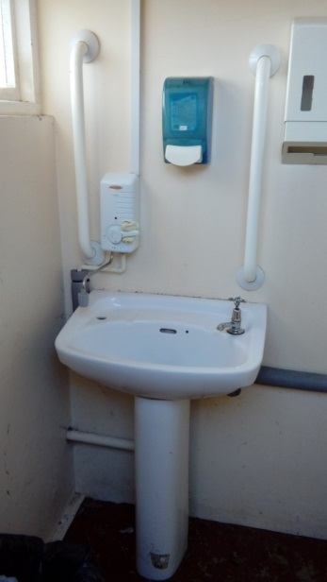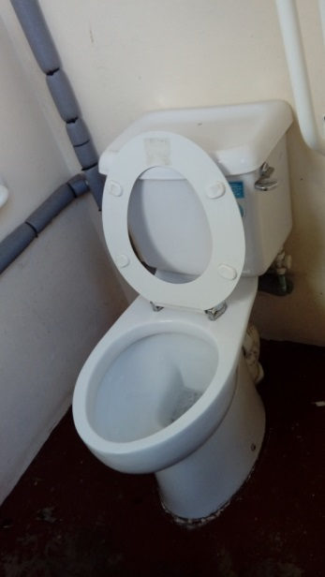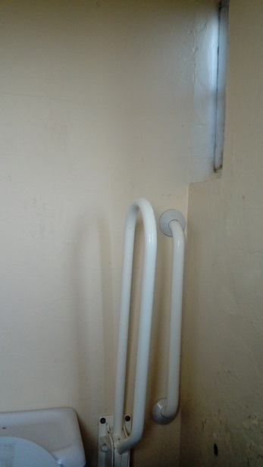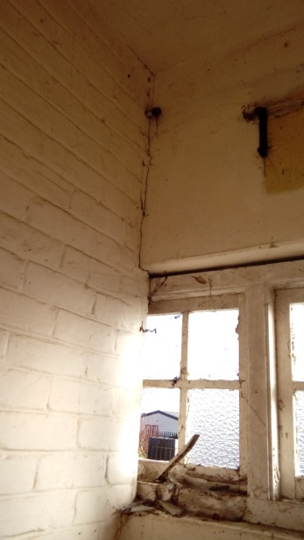
1.Unisex wash basin 2. Unisex toilet 3. Unisex DDA 4. Capped pipe in
equipment disused toilet

Sparrows Nest Toilets

There is a ladies, a gents and a disabled toilet on the premises all in a single block.

Ladies - The ladies toilet has four cubicles although one was locked when we visited. There are two wall mounted sinks with cold water feed, two stainless steel “mirrors” a soap dispenser and an electric wall mounted hand drier. It has an old terracotta tile floor of the type that is common in public conveniences. The walls are covered floor to ceiling in white vertical rectangular tiles with a double band of vertical baby pink tiles. All appear in reasonable condition although the grout appears aged. The cubicles are melamine construction with a mishmash of internal fixtures each has a larger toilet paper dispenser. The toilets are ceramic with small wooden plates on each edge instead of a seat and cisterns are behind panels in the cubicles. The cubicles appear to have had some design to tie them into the tiles however the rear of them bears no relation decoration wise. Lighting was adequate but working. The pipes appeared unlagged. The toilets appeared reasonable well maintained. All the cubicle locks were functional.
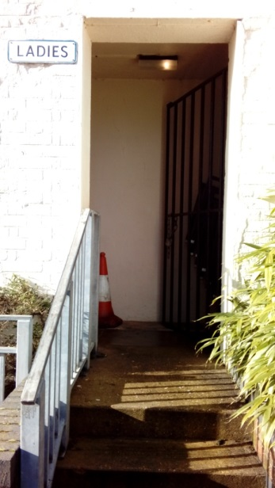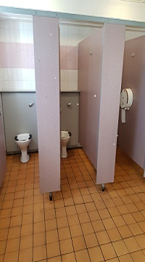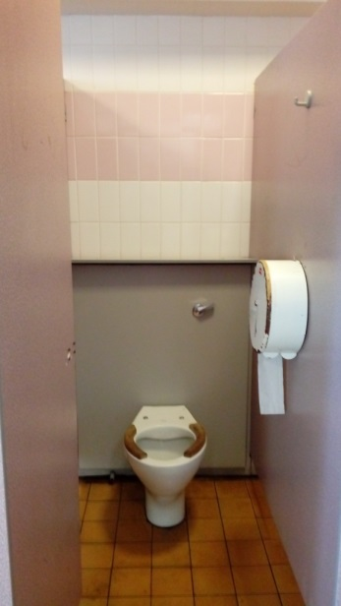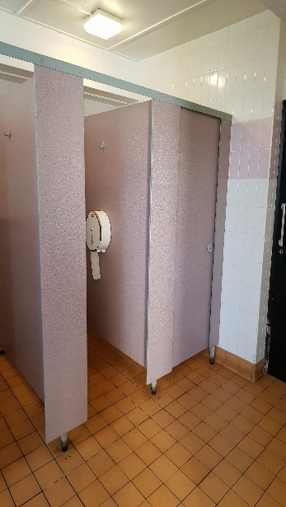
5. Entrance to Ladies 6. Cubicles 7. Cubicle Interior 8. Locked Cubicle
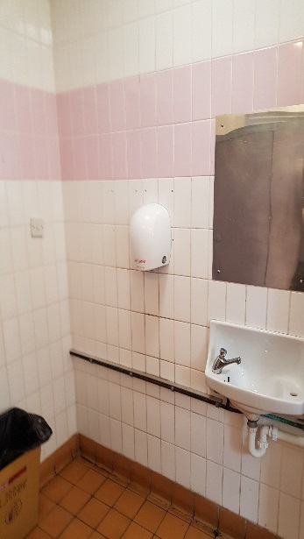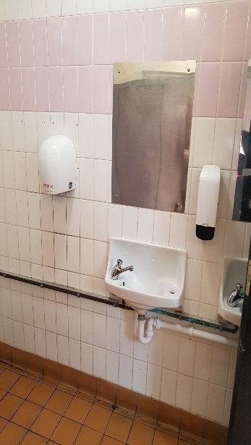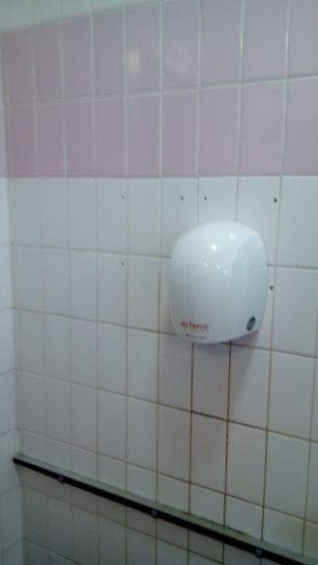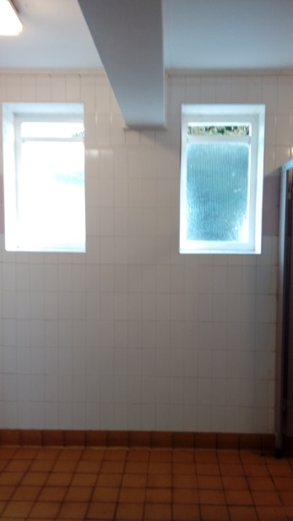
9. Basins 10. Basins 12. Hand Drier 13. General Decor
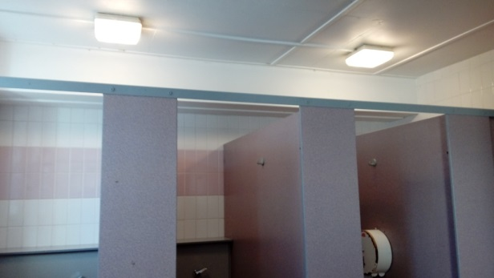
14. Lighting

Disabled – Accessed via a ramp and kept locked with access by a Radar key. There is a single toilet with seat a range of wall bars, a wall heater, wall mounted basin, wall mounted large toilet roll holder. The floor is again the same terracotta floor tile with plain while floor to ceiling white vertical rectangular tiling. There is a floor drain which appeared well maintained and the pipes are lagged. There was adequate lighting. There was also a white plastic garden chair in the toilet which seems superfluous. There is a missing air vent/extractor.
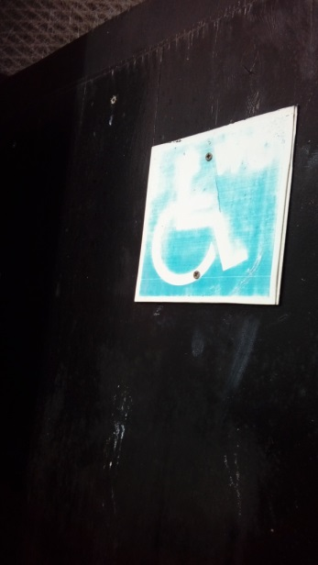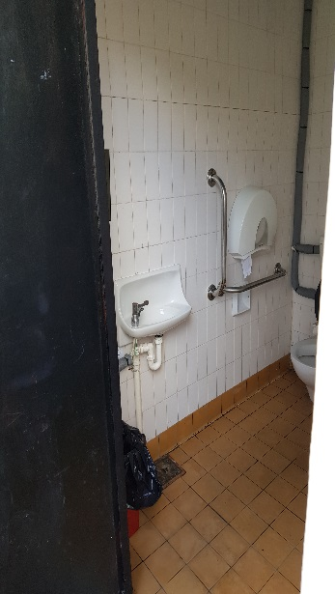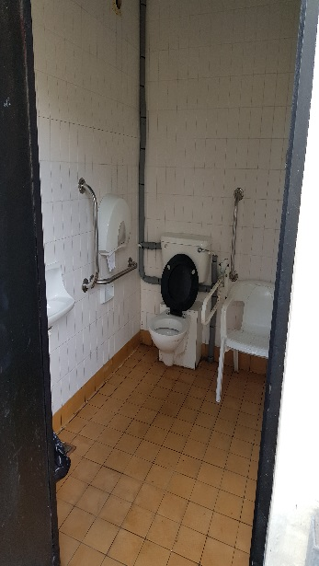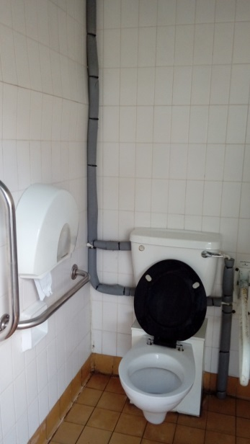
15. Entrance 16. Basin & toilet 17. Toilet & chair 18. Toilet
paper holder

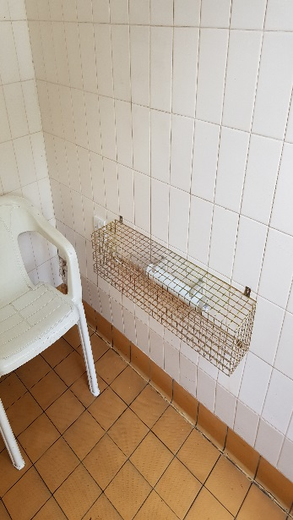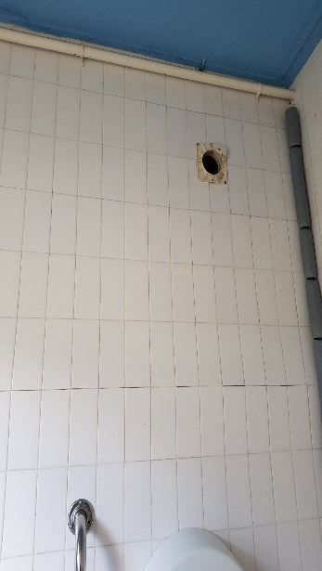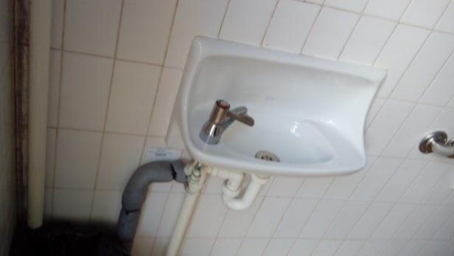
19. Heater 20. Broken Air Vent 21. Basin

Gents – This toilet has a stainless-steel urinal, a single cubicle and a single wall mounted basin. The toilet had the rear wall repaired last year due to damp however the replacement tiling has yet to be done. This was pointed out during our inspection in spring/summer 2017. The toilet has the same terracotta floor tile, white vertical rectangular tiles and a double row of blue vertical tiles. The grout did not appear as discoloured as in the ladies’ toilet. The cubicle and cistern panel are in grey melamine and in reasonable condition. There is a white ceramic toilet with plastic seat. There is a stainless steel “mirror”, wall mounted cold water fed basin, electric wall mounted drier and wall mounted soap dispenser. The pipes are lagged. All the lights were working (which they weren’t on our previous inspection however they were a mishmash, one new LED and two old round florescent fixtures. Cubicle lock was functional.

Has the rear wall has not been re-tiled because they cannot get matching tiles anymore? Considering the standard of the park these toilets do let it down and may be a primary focus in a toilet schedule.
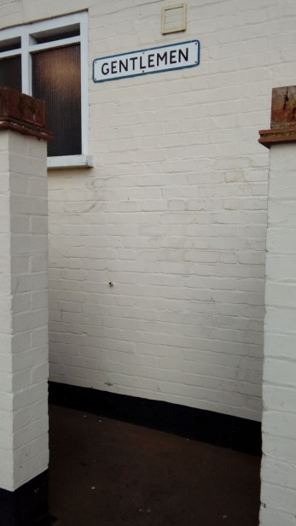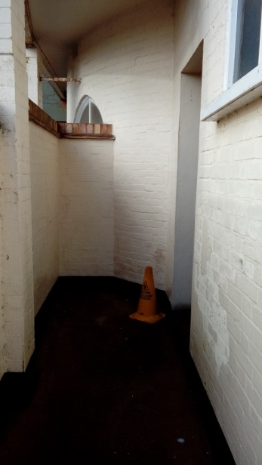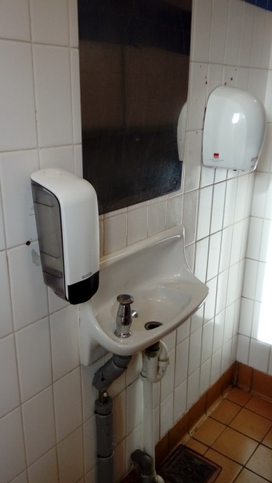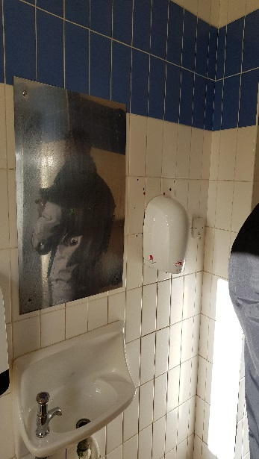
Gents Entrance Gents Entrance Gents Basin Gents Basin
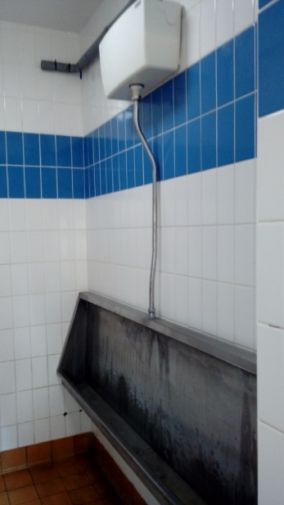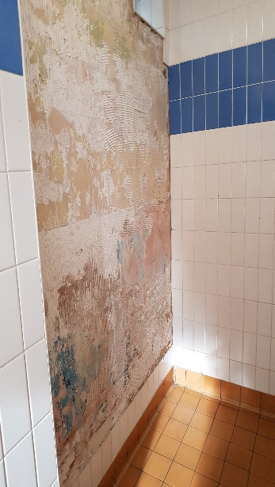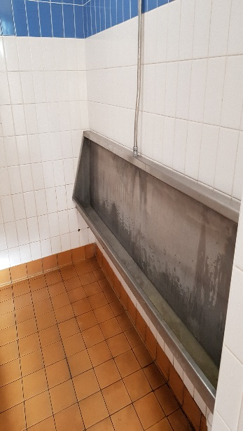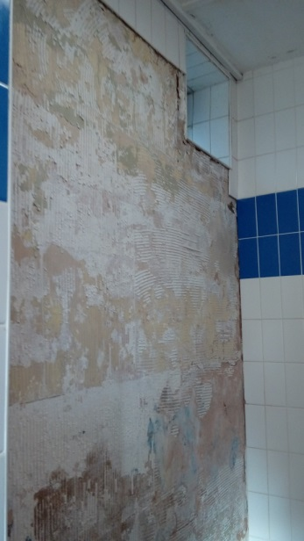
Urinal & Cistern Untiled Wall Urinal Untiled Wall
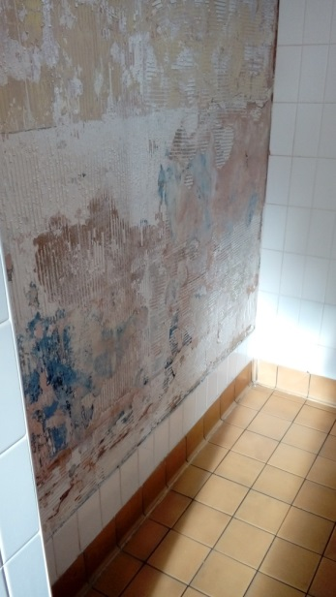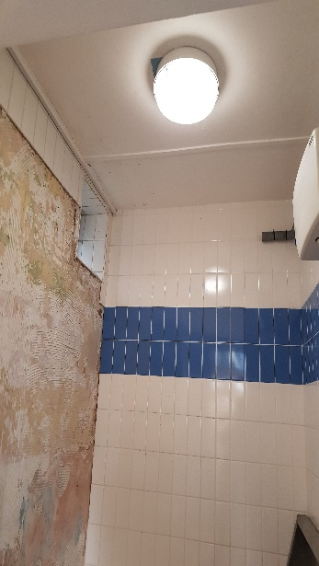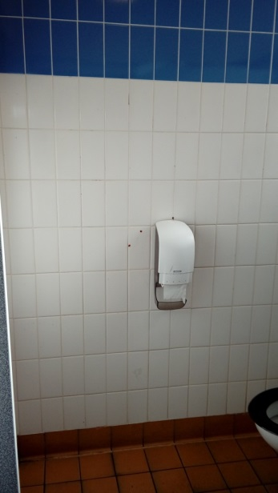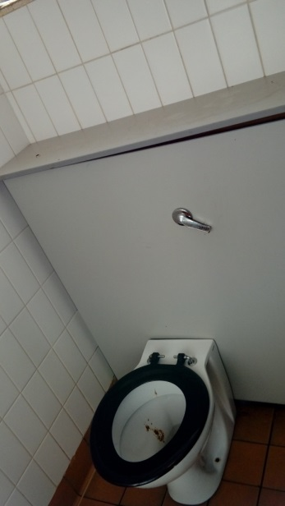
Untiled Wall lower Lighting Cubical & dispenser Cubical

Triangle Market Place Toilets.
This block of toilets is made up of individual toilets consisting of two female, two male, one disabled and a cleaner’s store. All the toilets appeared to have been cleaned just prior to us visiting as the floors were still wet. The toilets have no natural lighting and are narrow. They have the same terracotta flooring with white 6” square tiles inset with random yellow and blue tiles in the middle four tile section. All the toilets are stainless steel with various toilet seats. They have stainless steel cistern panels with push button flush systems. There appear to be a mishmash of toilet paper dispensers and each toilet has a Wallgate combination basin, soap dispenser and drier unit. The toilets are lit with blue light in order to reduce drug use. All locks were in place and working.

There is also a cleaner’s store/access area which contains the hot water heater and facilities but also appears to be being used as storage for the market perhaps as there are a couple of freezers and chairs etc in there.

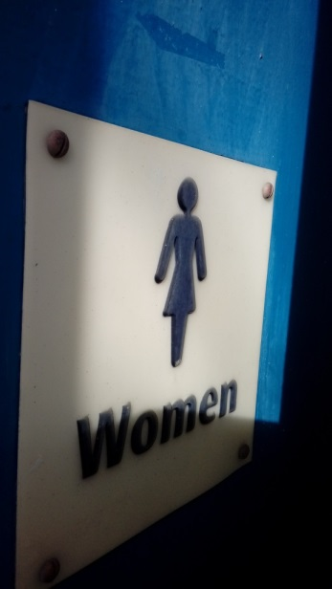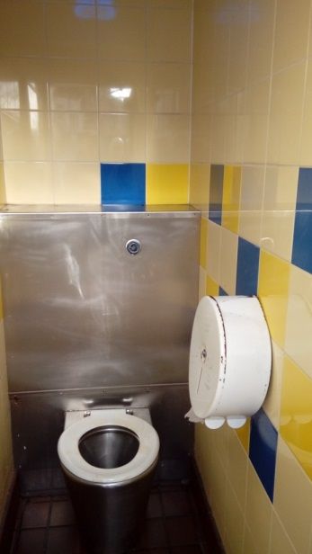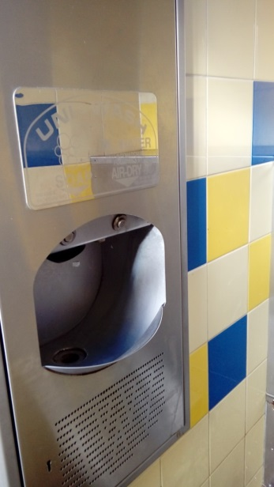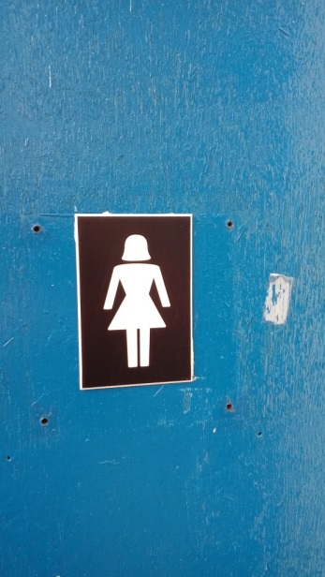
Entrance to Ladies Ladies Cubicle 1 Ladies cubicle 1 Entrance to Ladies cubicle 1 with vandalised Wallgate unit cubicle
paper dispenser
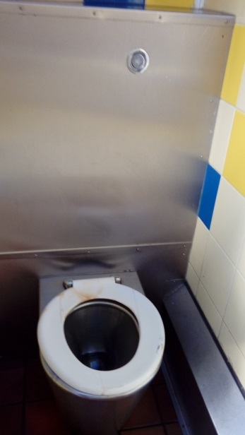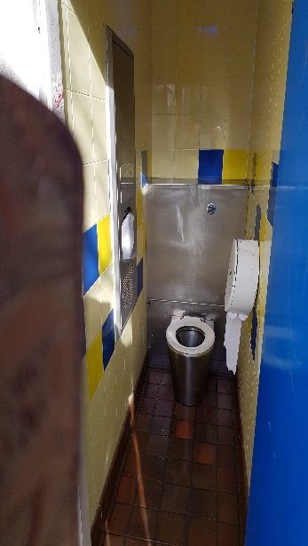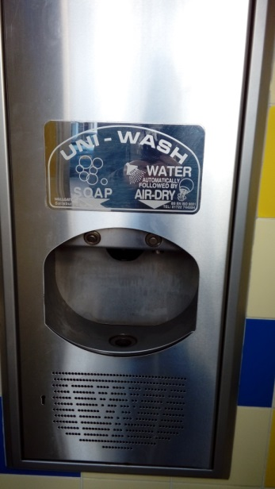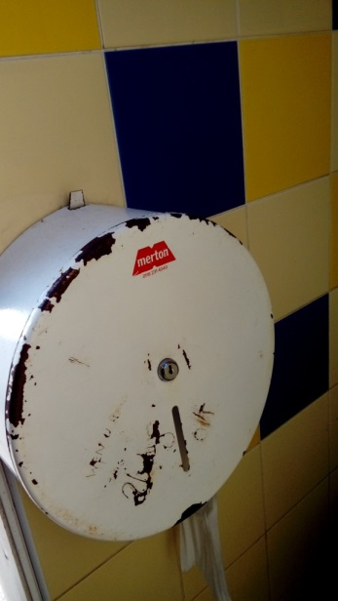
Ladies cubicle 2 Ladies cubicle 2 Ladies cubicle 2 Ladies cubicle 2
Wallgate unit paper dispenser
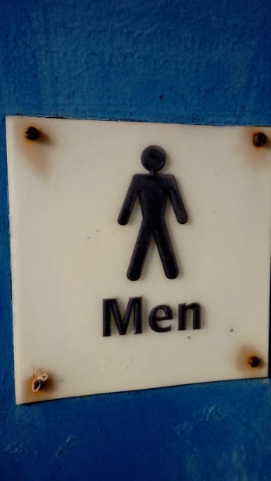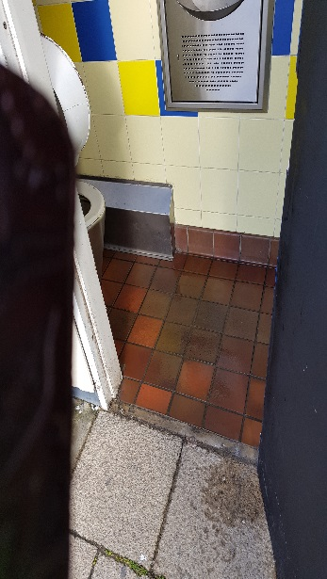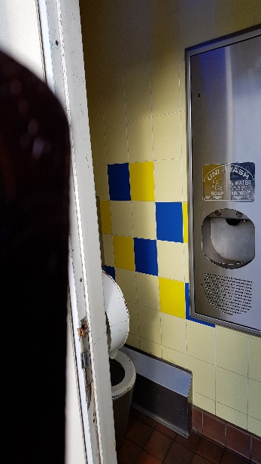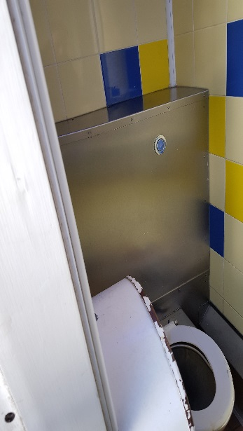
Men’s cubicle 1 Men’s cubicle 1 Men’s cubicle 1 Men’s cubicle 1
Door entrance entrance toilet unit

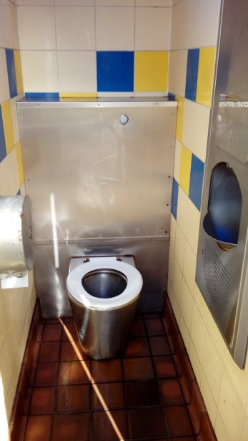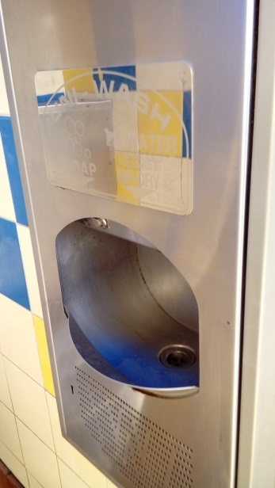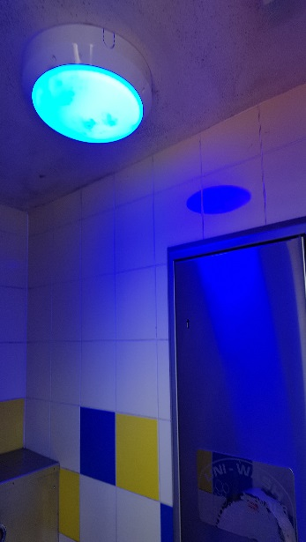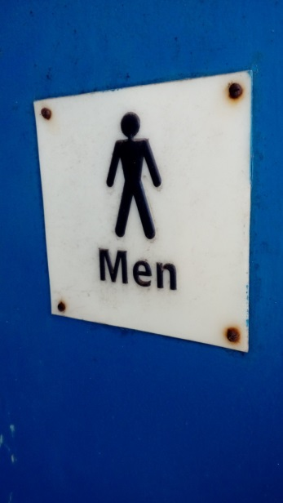
Men’s cubicle 1 Men’s cubicle 1 Men’s cubicle 1 Men’s cubicle 2
Wallgate unit lighting door

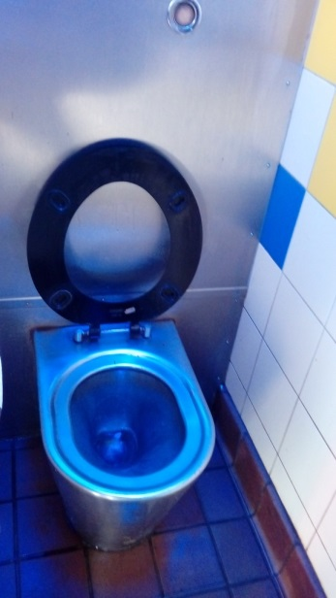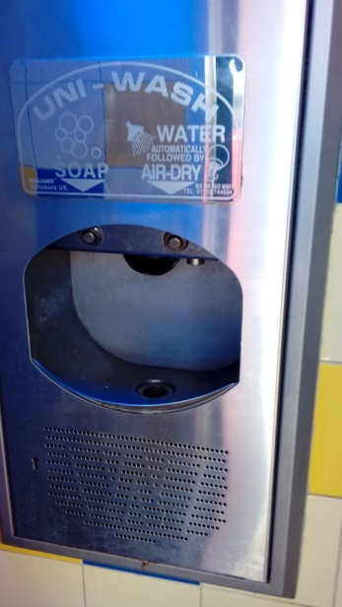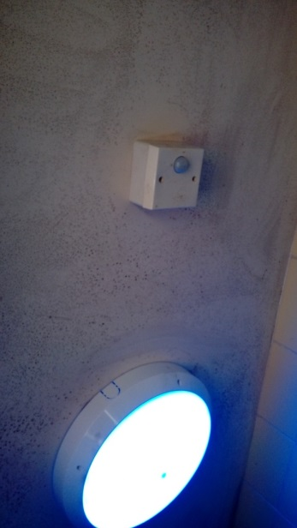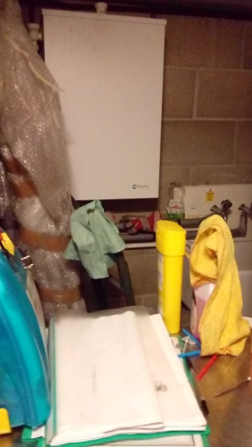
Men’s Cubicle 2 Men’s Cubicle 2 Men’s Cubicle 2 Cleaners Area &
toilet Wallgate unit light and PIR water heater (front)

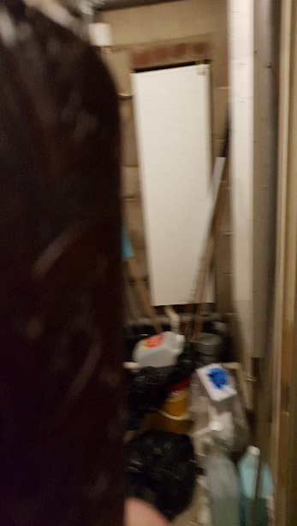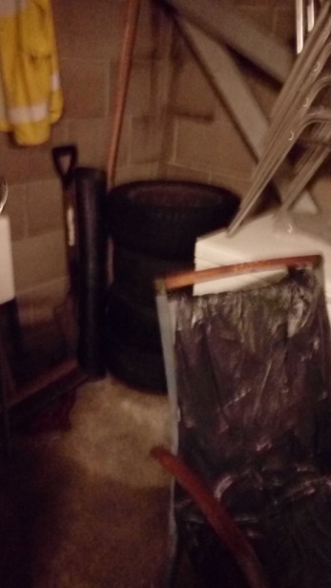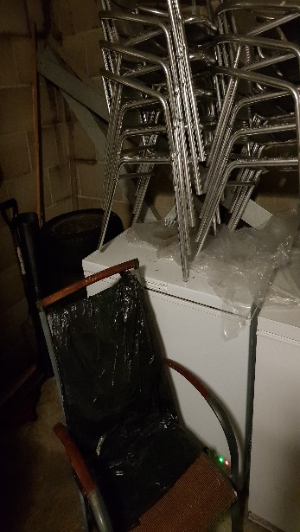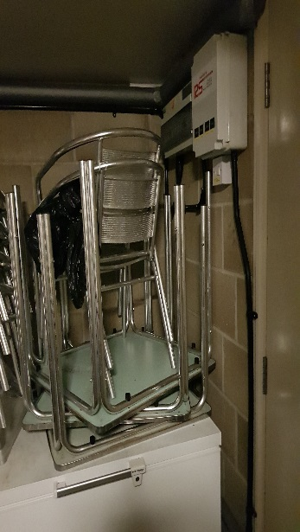
Cleaners Area & Cleaners area Cleaners Area Cleaners area
water heater (side) chairs and freezers Chairs and freezers

We have no photos of the disabled toilet at the Triangle at present.

Lowestoft Cemetery Toilets.
This block of toilets has been transferred to the town council even though the cemetery has not been. Interestingly, in other areas where WDC has maintained the asset (such as the Pavilion, Sea Front and Battery Green Car Park, they have also kept the toilets.
Externally the building appears in good repair and well maintained. It is of brick and tile construction with wooden windows. The facility is accessed at one end by a covered walkway from which you access the gents, handicapped and ladies’ toilets in order. The exterior signs on the toilets are so old they list the Town Hall and offices in Beccles, Bungay and Southwold as contact points.
The toilets appeared clean and all the door were lockable although one toilet in the ladies was sealed shut at the time of visiting so only one toilet was available.

Ladies Toilet - The decoration is the standard terracotta floor tiles and 6” white wall tiles with a two-tile alternate pink and white border at dado height and a single pink and white border at picture rail height. Paintwork is in brown gloss. There should be two cubicles, the one we saw had a high-level cistern with pull chain and a porcelain toilet bowl with black plastic seat. There are two stainless steel basins with cold supply, one of which impedes access to the sealed off cubicle. The ladies’ toilet also contains the cleaners store, which is basically a cupboard.

Disabled Toilet - The decoration is as in the ladies but without any borders or colour variations. The paintwork is again brown gloss. There is a porcelain bowl with black plastic seat and a low-level porcelain hand basin and appropriate mobility bars.

Gents Toilet - The decoration in the gents is identical to the disabled toilet, white tiles and brown gloss work. There is a single cubicle with a stainless-steel toilet bowl which had no seat, a concealed cistern, a stainless-steel urinal (which is functional but passed its best) and a stainless-steel hand basin. This toilet appeared more run down than the other two toilets in the block.

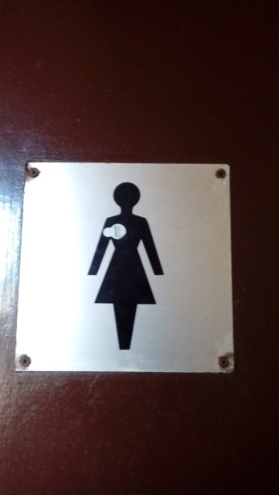 | 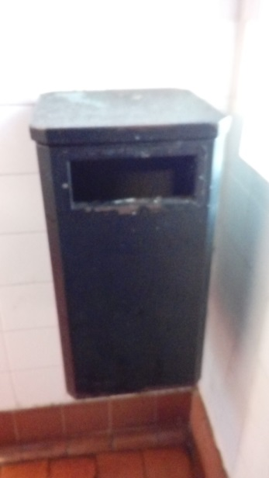 | 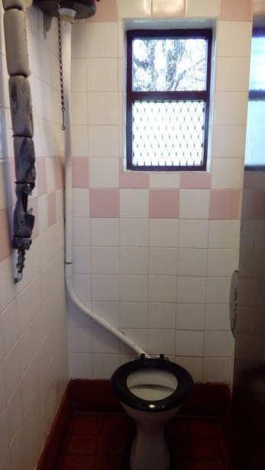 | 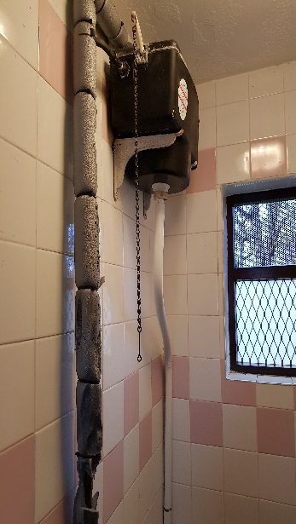
Entrance to ladies | Ladies waste bin | Ladies toilet | Ladies toilet
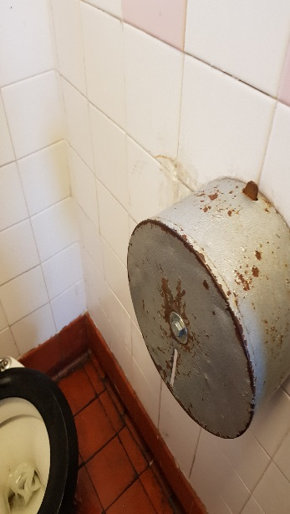 | 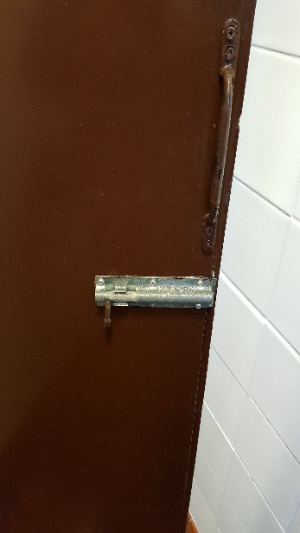 | 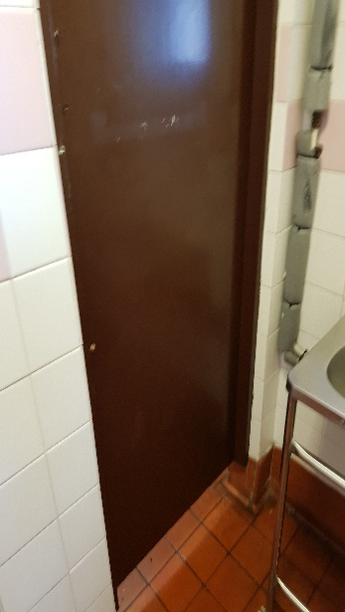 | 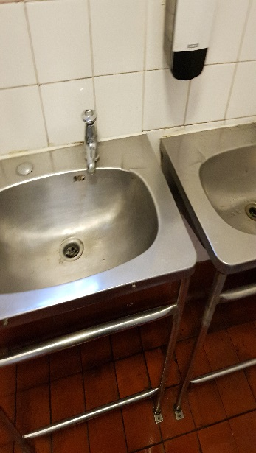
Ladies toilet roll holder | Bolt on ladies’ cubicle | Sealed door in ladies | Ladies basins
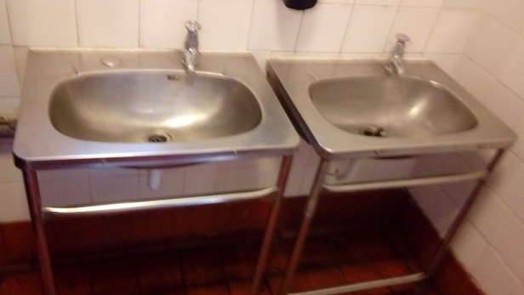 | 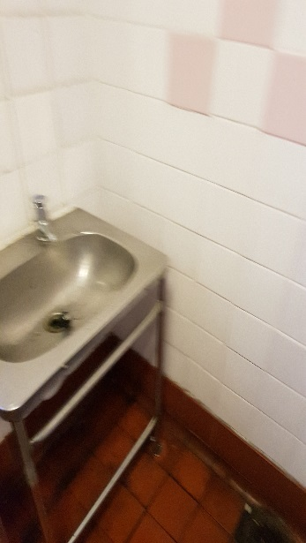 | 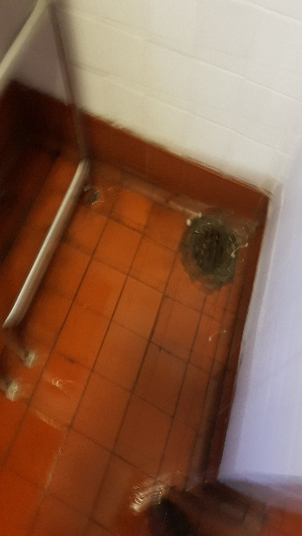 | 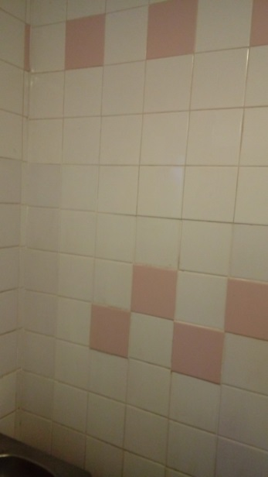
Basins in ladies | Basins and drain in ladies | Drain in ladies | Ladies decoration
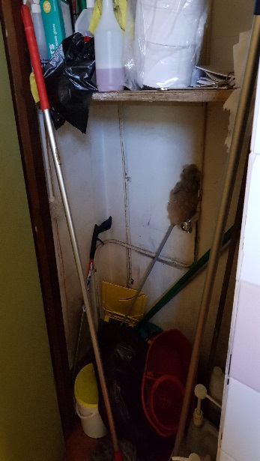 | 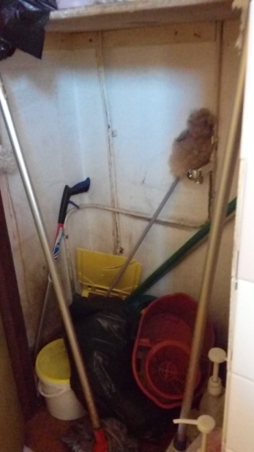 | 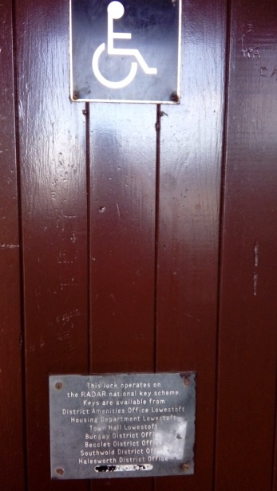 | 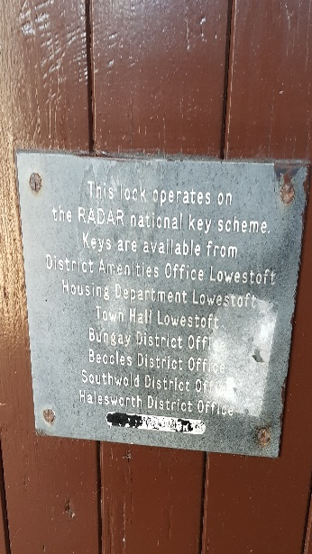
Cleaners cupboard in ladies’ toilet | Cleaners cupboard in ladies’ toilet | Entrance to disabled toilet | Out of date signage
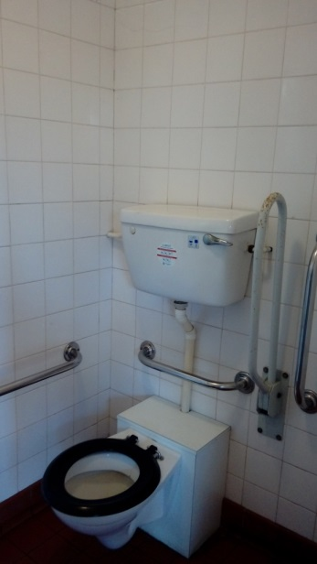 | 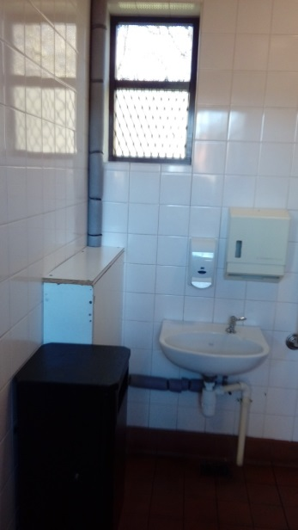 | 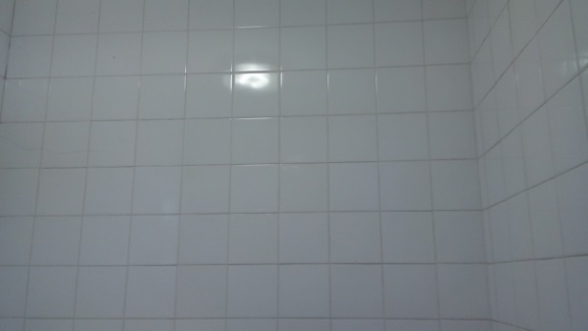 | 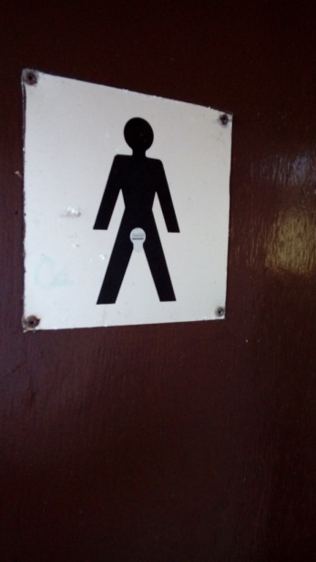
Disabled toilet and hand rails | Disabled toilet and hand rails | Disabled toilet decoration | Gents toilet door
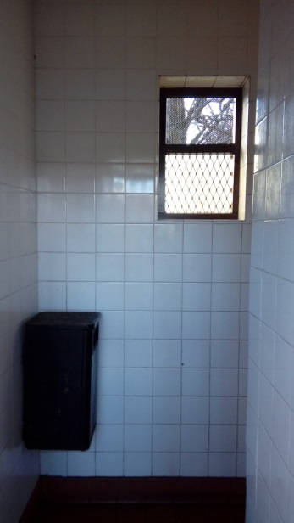 | 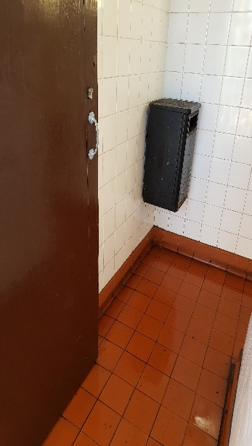 | 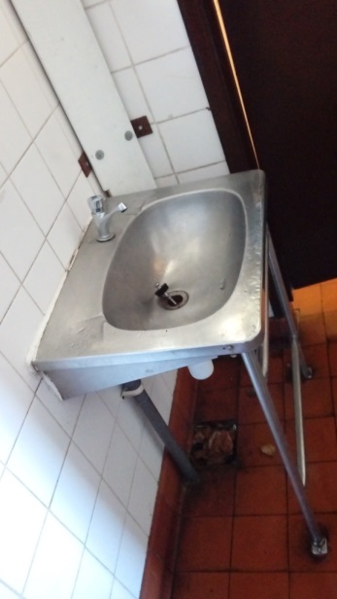 | 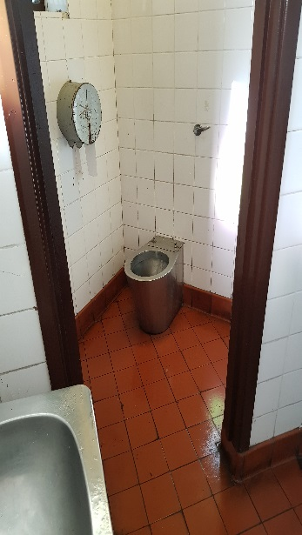
Entrance to gents’ toilet | Gents waste bin | Gents basin | Gents cubicle
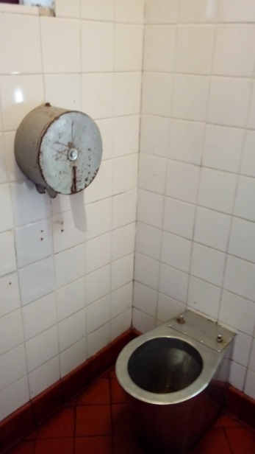 | 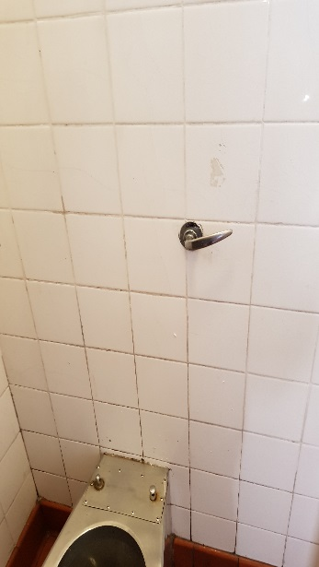 | 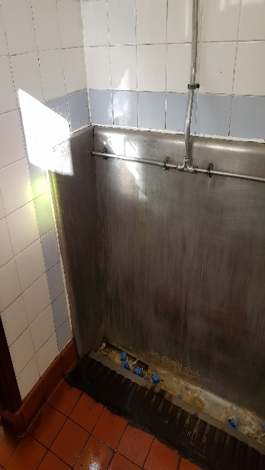 | 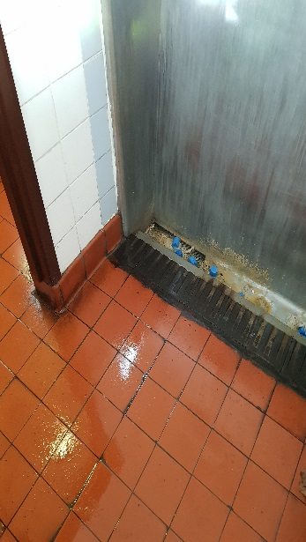
Gents toilet and paper dispenser | Concealed cistern | Gents urinals | Condition of urinal
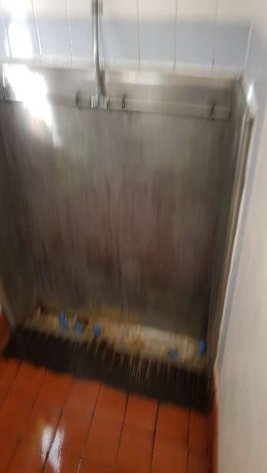 | 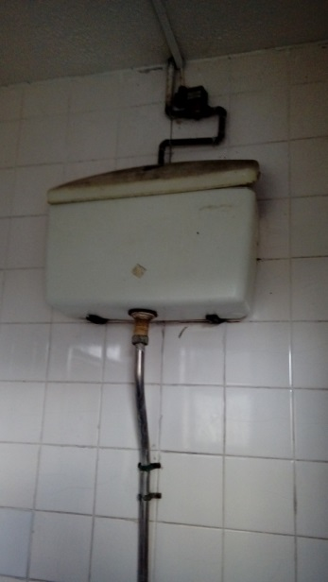 | 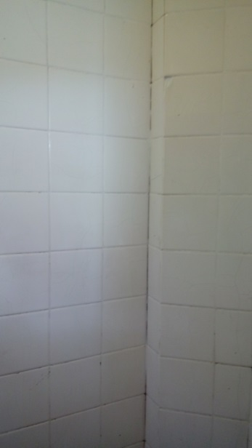 | 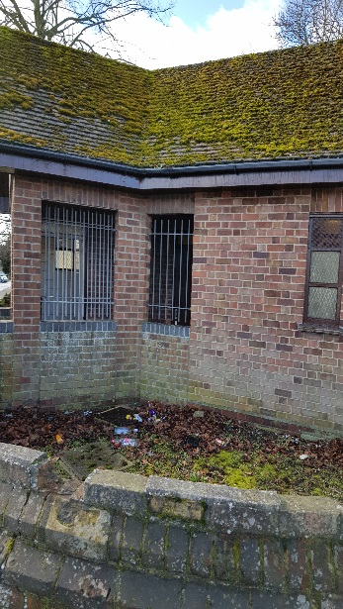
Condition of urinal | Urinal cistern | Gents Toilet decoration | Front exterior
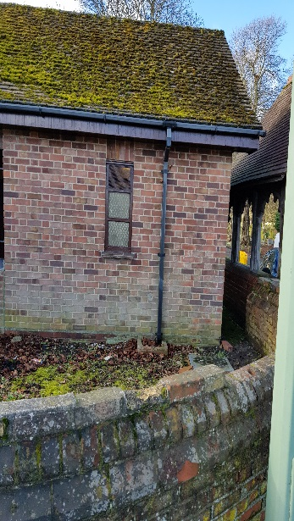 | 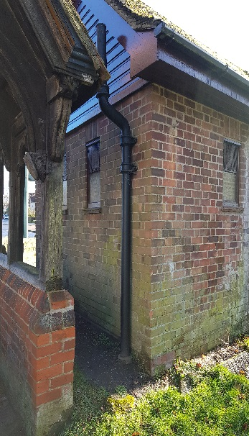 | 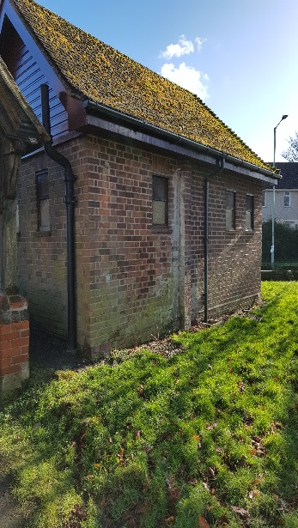
Front nearest lychgate | Rear by lychgate | Rear of toilet block
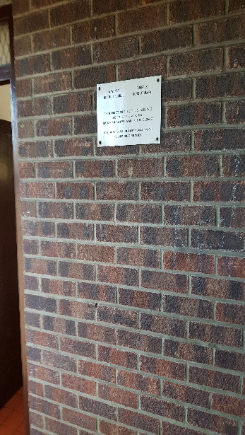 | 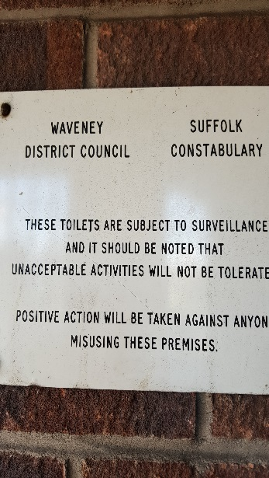 | 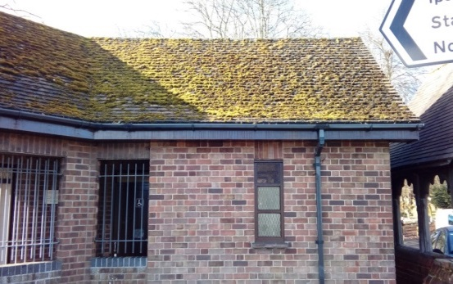
Waveney signage | Signage | Front of toilets

Normanston Park Toilets.
These toilets are in the same block as Jesters and the old changing rooms and possibly reflect the past use rather than current needs. They are poorly laid out and designed, run- down and need attention.

Gents Toilet - The gents’ toilet is accessed via a lobby at the rear of the café close to the driveway to the car park. The lobby has two doors, one that is locked which connects with the old changing rooms and the other which goes into the gents’ toilet itself. This has the standard terracotta floor tiles and plasticised wall boards. There is a ceramic urinal and a single cubicle with porcelain toilet bowl, black plastic seat and high-level cistern. There is a single porcelain hand basin.

Ladies/handicapped/baby changing toilet - As it says in the title this is a one size fits all toilet consisting of a single cubicle/room with low level toilet with blue seat, low level basin, pull down baby changing unit and mobility bars. There is plentiful graffiti which would not be suitable for minors which is written and scratched on the plasticised wall boards.

Overview - Normanston Park does seem to cater for men rather than anyone else, maybe this reflects its original usage and the loss of the old pavilion. The changing room block is designed with four changing rooms around a central communal shower and toilet area with open showers and urinals. The old changing rooms, which we gather are still used despite them having no water, are also men only. This is a site that needs a radical re-think and overhaul as most of the public facilities on site could be described as not fit for purpose.

The main building originally contained caretaker/head grounds-keepers accommodation before it was converted to a café. The conservatory of the café is pretty much at the end of its life, Waveney had an agreement with the tenant to share costs for replacing it once it reached that position. The old changing rooms that occupy a large proportion of the ground floor are run down and used by Norse to store the football equipment and by the away teams as dressing rooms although they have no running water. The whole of this building seems to have been adapted and added to with no long-term thought.

The existing external block of changing rooms were designed to hold 24 players per room as that was the team size at the time. They would have been compact back then but teams are now about 18-19 strong. The shared shower and toilet facilities for these 100 users consist of 4 open showers, 2 toilets and four urinals including one at a low height for a child.

The referees changing space is even worse and consists of a room which is probably 5’ x 8’ including a single toilet cubical, an open shower in the corner of the changing room and a single row of old benches.

We have been assured (although not by WDC) that the insurance money for the old pavilion was ring-fenced although it was significantly reduced by the cost of clearing the remains of the pavilion. This is being researched.

The reason for listing all this information that does not relate to the toilets is that it does affect them. We could renovate the toilets but that would not solve the issues. This particular asset is going to need a lot of consideration and may need us to look at external funding and planning for the long term to make both the café, changing room and toilets more user friendly and inviting. We will probably need to involved architects to reconfigure the layout and replace elements of the structures with new buildings.

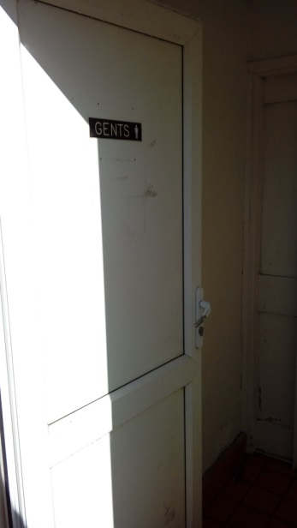 | 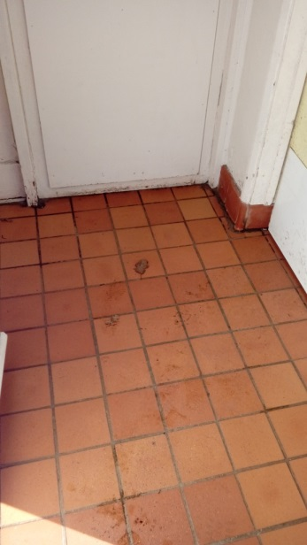 | 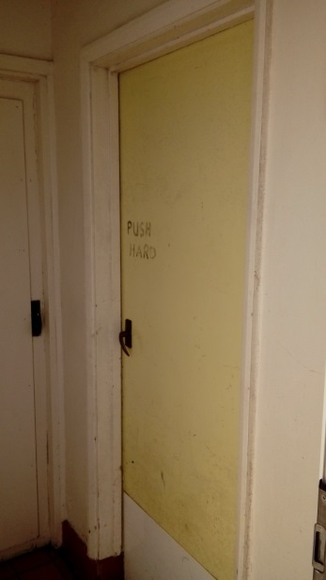 | 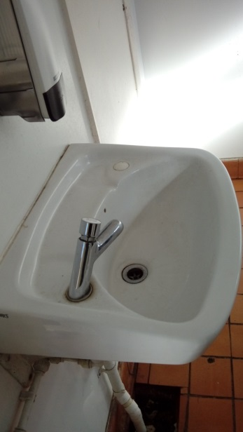
Entrance to gents’ toilet. | Entrance lobby to gents’ toilet. | Internal entrance door to gents’ toilet. | Gents toilet wash basin with cold only non-concussive tap.
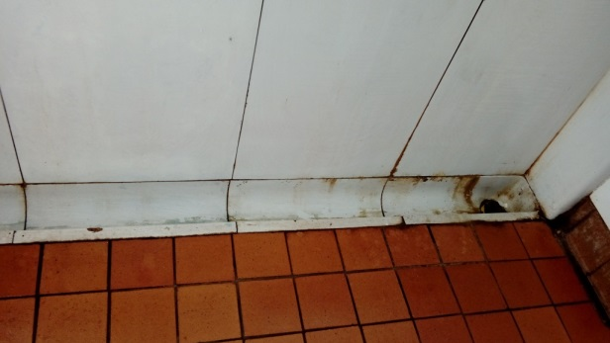 | 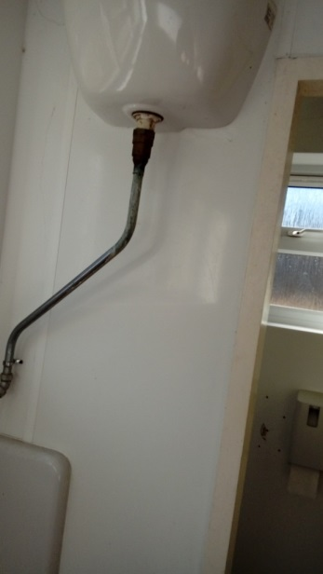 | 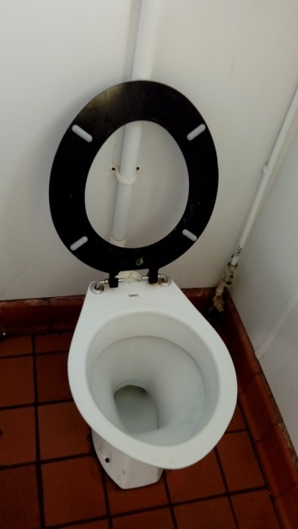 | 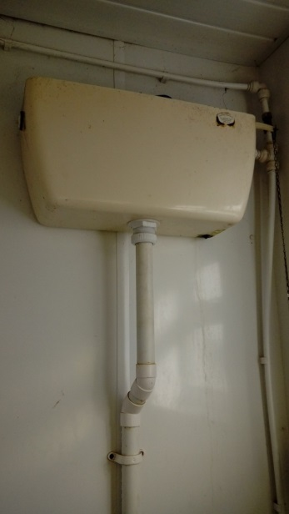
Gents toilet ceramic urinal. | Gents toilet urinal ceramic cistern. | Gents toilet. | Gents plastic toilet cistern.
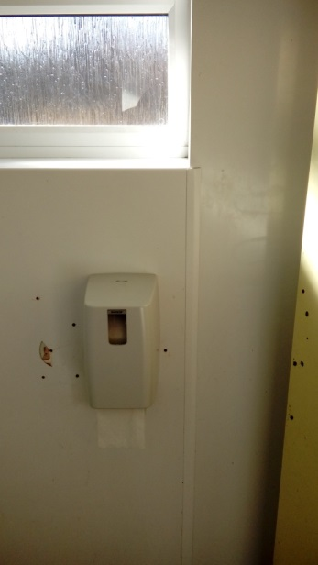 | 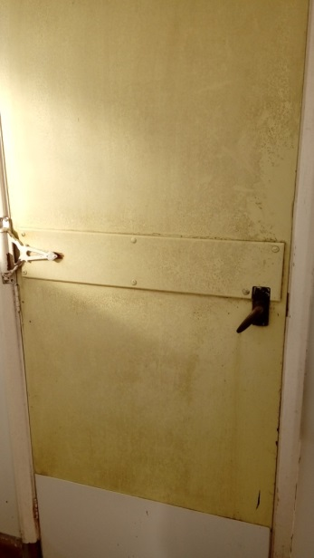 | 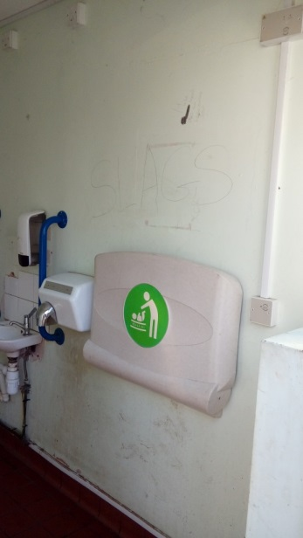 | 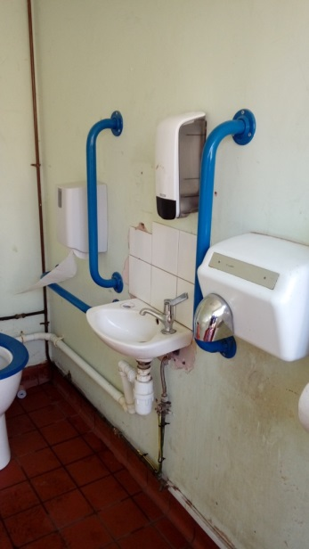
Gents paper dispenser. | Gents lobby locked through door | Unisex/baby change/ disabled toilet | Unisex/baby change/ disabled toilet
 | 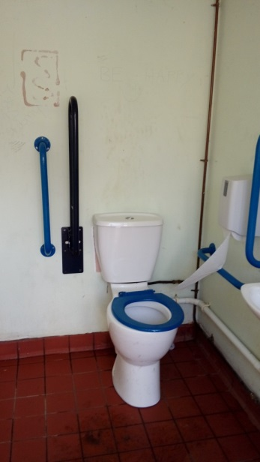 | 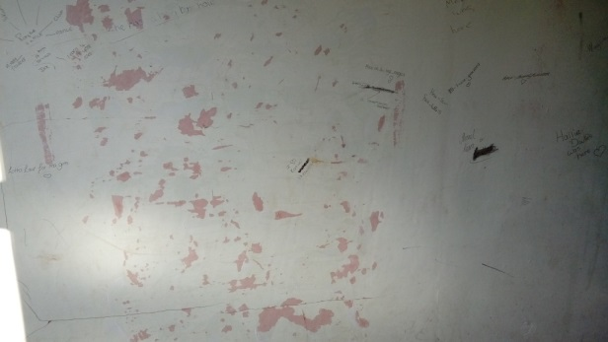
Unisex/baby change/ disabled toilet | Unisex/baby change/ disabled toilet | Unisex/baby change/ disabled toilet – wall.

Kirkley Cliff Toilets.
These are probably our most recently built toilet block (the others may be the Triangle Market toilets) and is externally in good repair. Despite this, internally it is one of our most tired set of toilets. Whether this is due to a higher usage, vandalism or the fact that it is on a main road and open for longer hours is open to debate. It has the highest mismatch of fittings from originally fittings like Wallgates to replacement basins and hand driers, multiple types of lights and bulbs, toilet paper dispensers etc. Even the décor is not consistent as when necessary changes have been made, as in the ladies’ toilet with the removal of the Wallgates meant that the tiled wall had to be refinished and only that area was changed. Several of the toilets have skylights which does mean that they have natural lighting as there are no windows. This set of toilets are prominent in the South Lowestoft conservation area.

Ladies Toilet - The ladies toilet has gender specific generic decoration however there has been partial remodelling since the original build as the Wallgate units have been removed and replaced with a vanity unit/basins with a “plasticised” unit and rear panel which we assume was installed when the Wallgates were taken out and matching tiles were unavailable/ unmatchable. The toilets themselves are mismatched, at least seat wise and the toilets appear tired.

Disabled Toilet - This appears in reasonable repair and has full functionality although the signage is out of date.

24hr Toilet - This appears functional except that there was no functioning light which does seem to be a key fitting to enable 24hr use. There also appears to be some movement behind the tiles as there is a gap travelling down the wall which could indicate this or just missing grout.

Gents Toilet - The gents toilet has gender specific decoration with a stainless-steel urinal trough and single cubicle with a composite toilet which is lacking a seat. There are two Wallgate units and a variety of ceiling lights. The cubicle door has a range of graffiti on the interior.

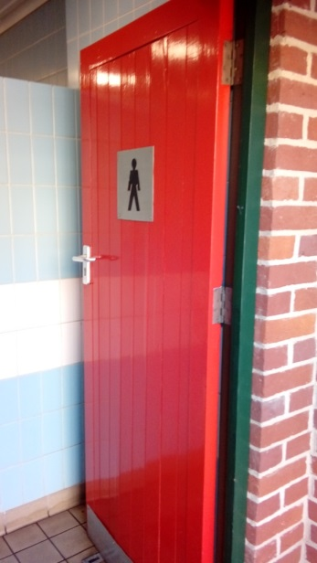 | 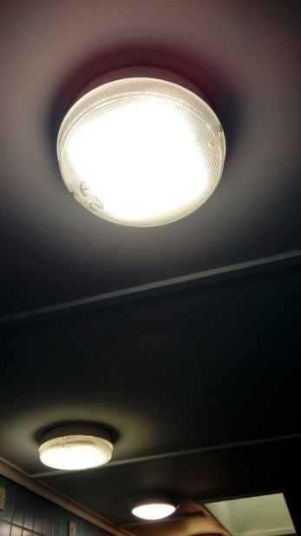 | 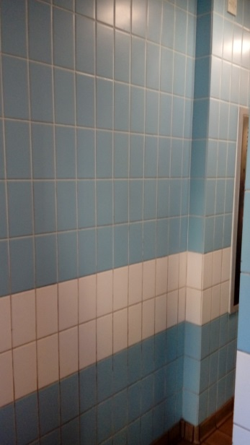 | 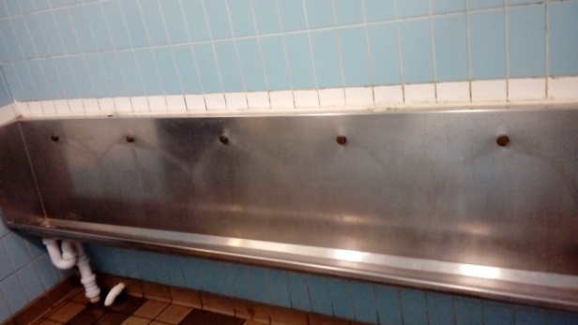
Gents toilet entrance. | Gents fluorescent lighting | Gents decoration. | Gents stainless steel urinal.
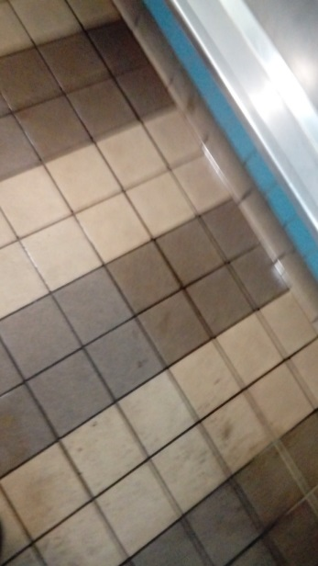 | 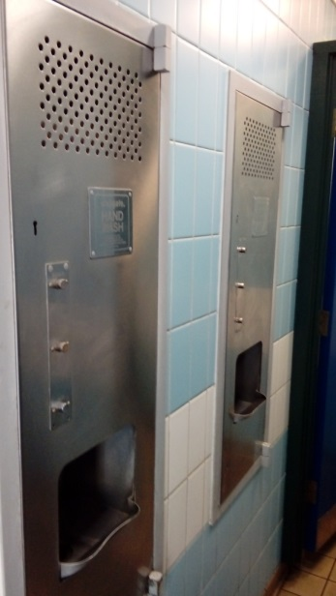 | 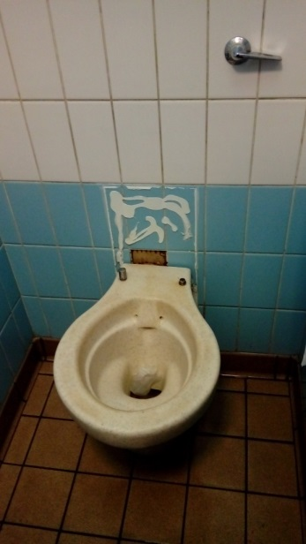 | 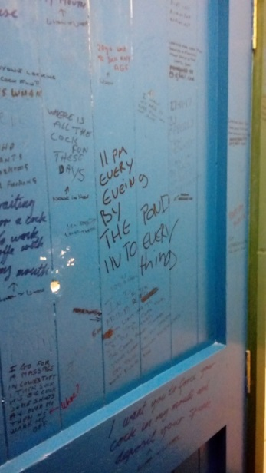
Gents toilet floor | Gents wallgate units | Gents composite toilet | Gents vandalised door
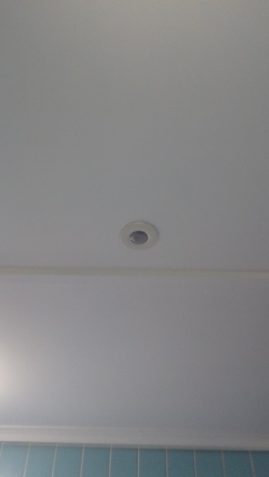 | 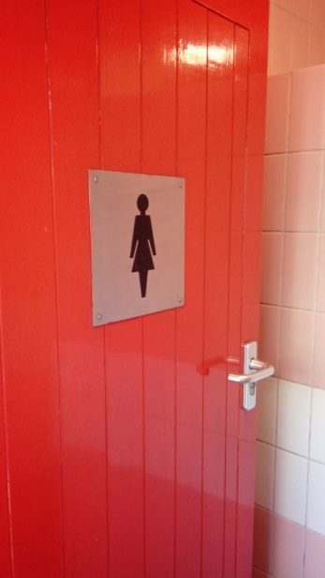 | 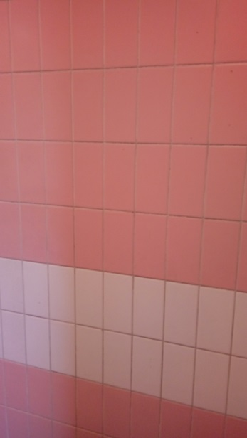 | 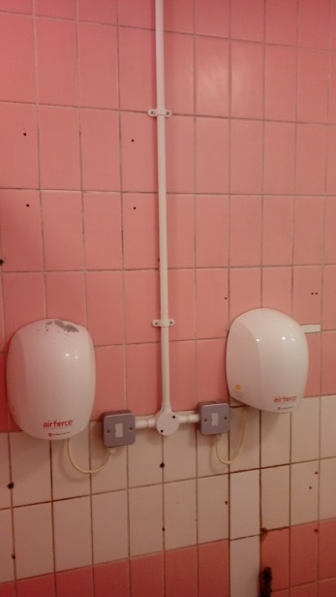
Gents toilet PIR | Entrance to ladies’ toilet | Ladies decoration | Ladies hand dryers
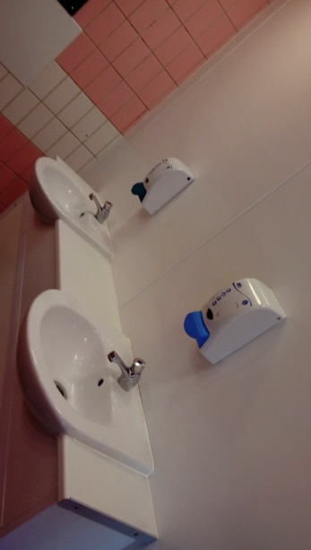 | 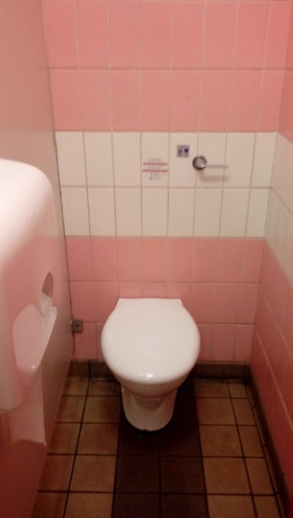 | 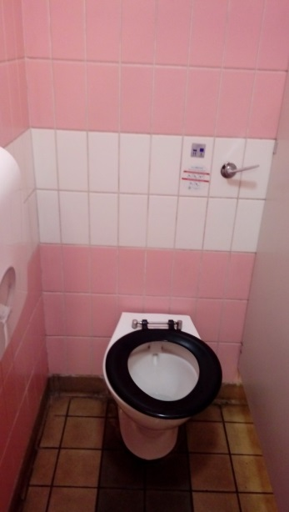 | 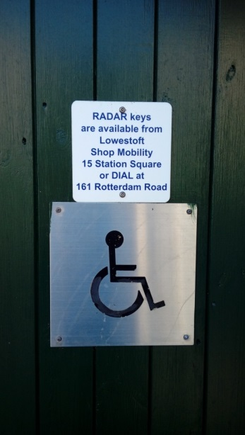
Ladies cold only wash basins and soap dispensers | Ladies toilet and paper dispenser | Ladies toilet | Disabled toilet entrance.
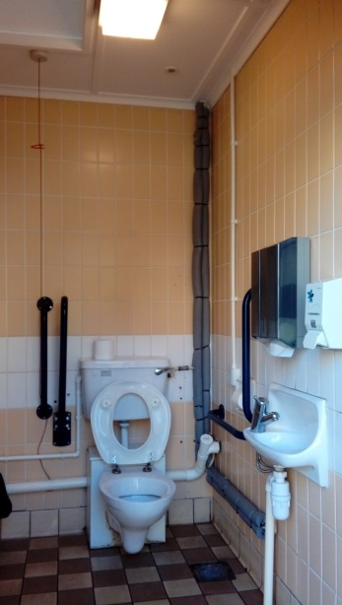 | 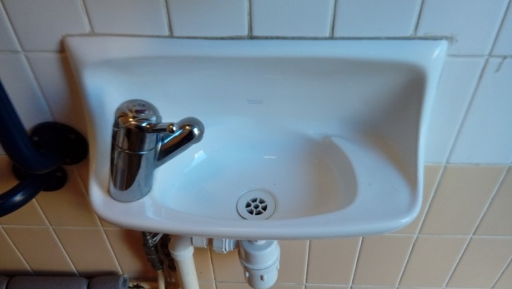 | 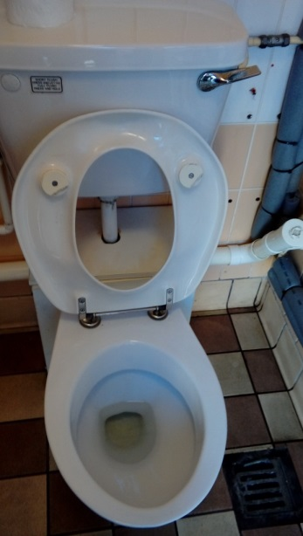 | 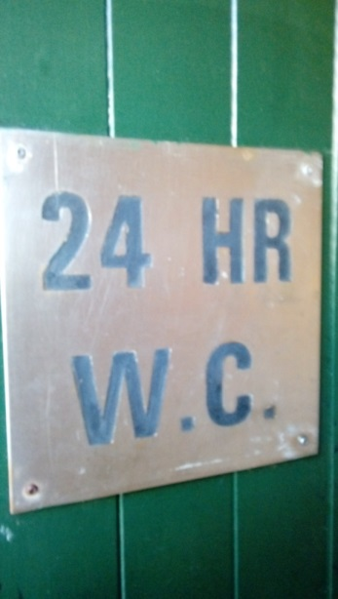
Disabled toilet, basin, lagged pipes, hand rails | Disabled wash basin. NOTE: Thermal Mixing Valve (TMV) tap. | Disabled toilet | Entrance to 24Hr toilet
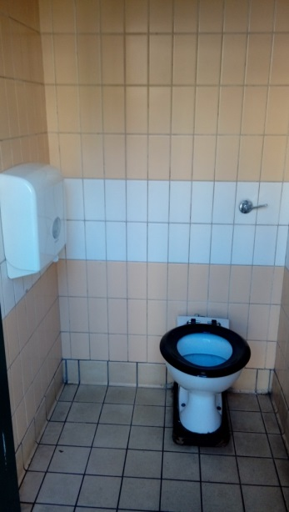 | 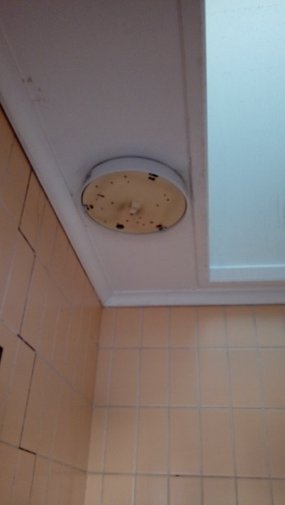 | 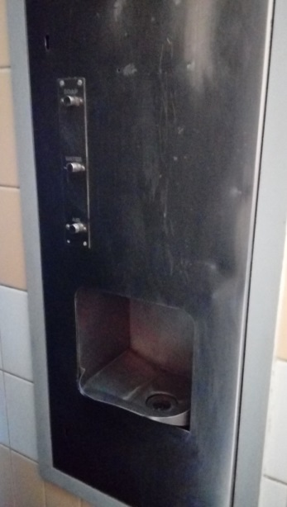
24 Hr toilet and soap dispenser. | 24 Hr toilet (without night light!) | 24 Hr toilet Wallgate unit.

Kensington Gardens Toilets.
These toilets are the most recently refurbished. Norse upgraded them as the toilets needed attention and WDC did not have a budget for the purpose. They are modern, non-gender stereotyped toilets. They have a few issues such as the Wallgates but on the whole are our nicest set of toilets. The is a two cubicle Ladies toilet and a single cubicle and urinal Gents toilet. There is no Disable toilet or baby-changing facilities which is probably historic to the building of the premises and could be considered “acceptable” as there are disabled facilities in the Kirkley Cliff toilets. These toilets are also in the South Lowestoft conservation area.

There has been a request for the bowls pavilion to be extended, if this were to happen it might give a chance to incorporate these facilities within the build.

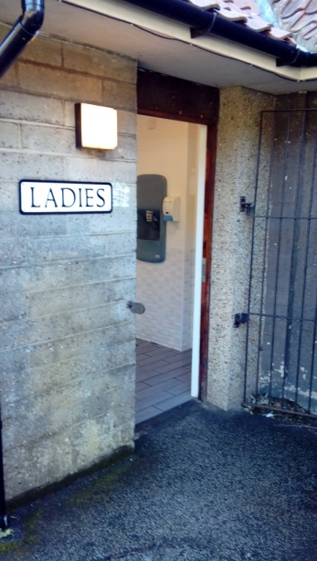 | 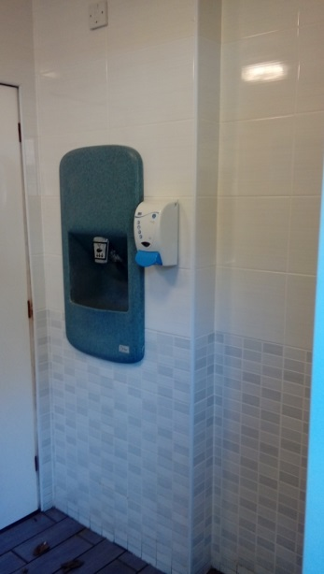 | 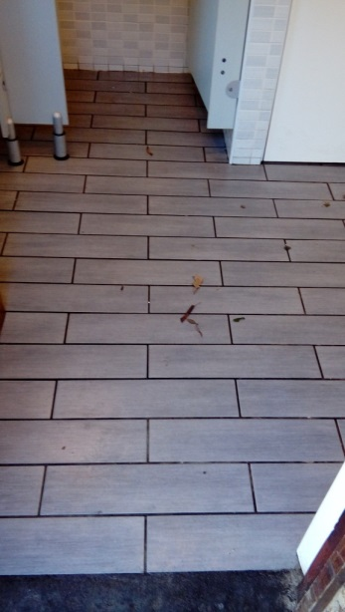 | 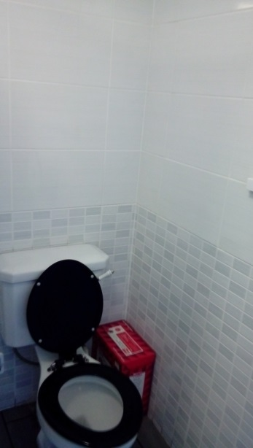
Ladies toilet entrance | Ladies decoration, soap dispenser and composite wallgate unit. | Ladies floor tiles | Ladies toilet and feminine hygiene unit
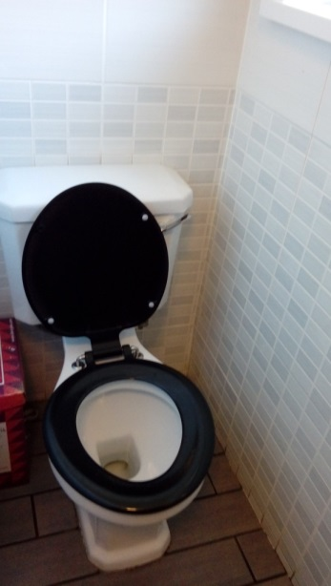 | 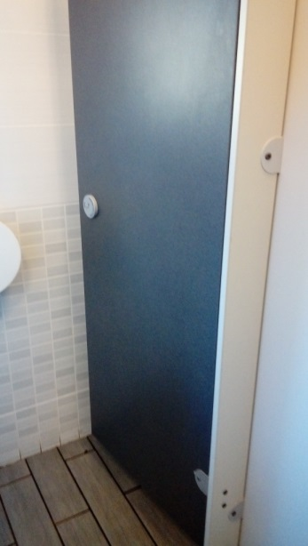 | 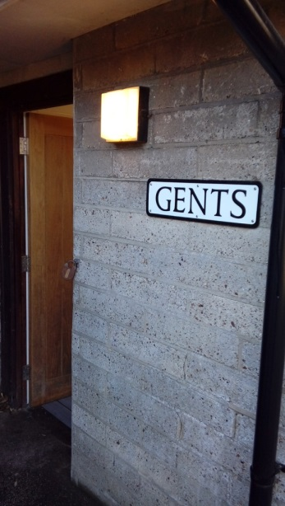 | 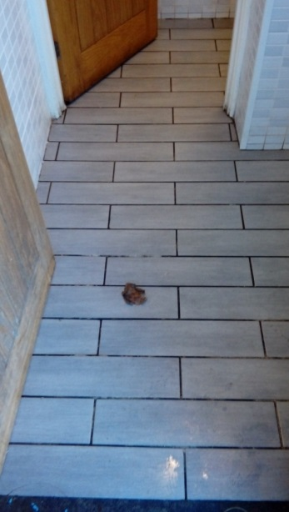
Ladies toilet | Ladies cubicle door | Entrance to gents’ toilet | Gents floor tiles
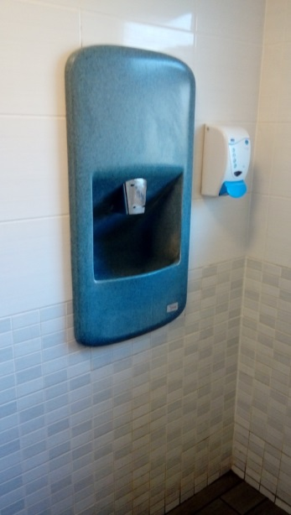 | 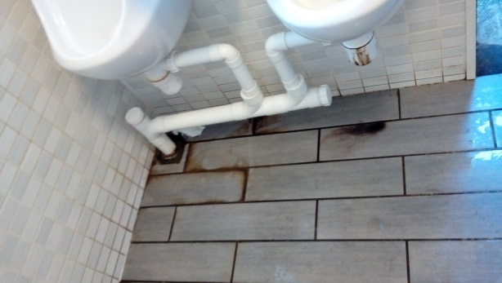 | 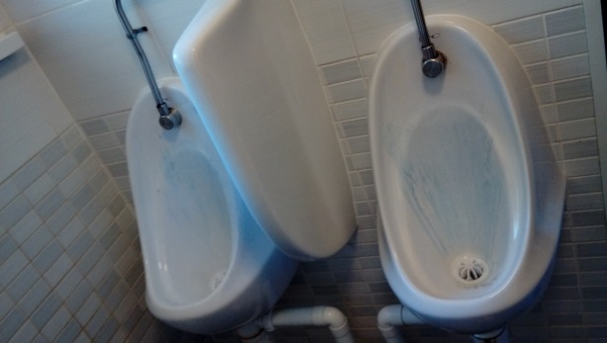 | 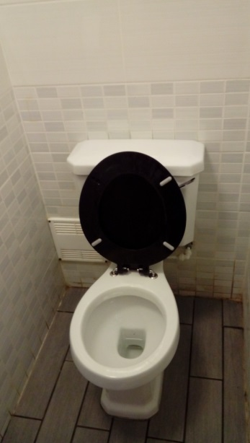
Gents decoration, soap dispenser and composite wallgate unit. | Gents urinal waste traps leaking | Gents ceramic urinals | Gents toilet
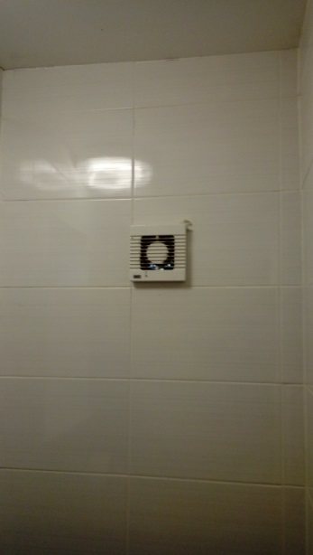
Broken vent

Pakefield Street Toilets.
These toilets are tucked out of the way on Pakefield St, close to the junction with London Road South. They consist of a block containing gents and ladies toilets with a separate more recently built disabled toilet. They have a pleasant planted area around them but do have an issue with overgrown ivy which may be responsible for the mould and a historic leak in the roof. In addition, the soil to the Pakefield Street side of the toilet block was above the damp-proof level. Both these issues have been notified to Norse. During our visit it appeared as if tree cuttings had been tipped in the area.

This is probably the most sexually graffitied set of toilets and this could be due to their out of the way location. These toilets have Wallgates in the original block and a basin in the Disabled toilet and some fittings were broken.

According to Norse statistics this is our least frequently used set of toilets and therefore may be lower on the priority list for total refurbishment although repairing and redecorating with a fresh cost of paint may improve them in the short term.

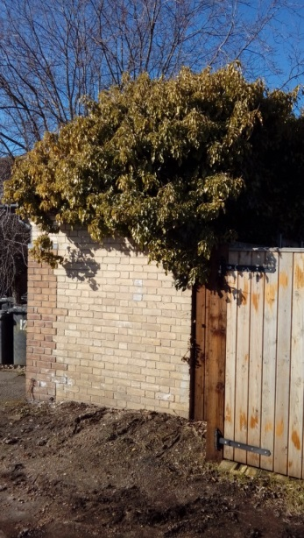 | 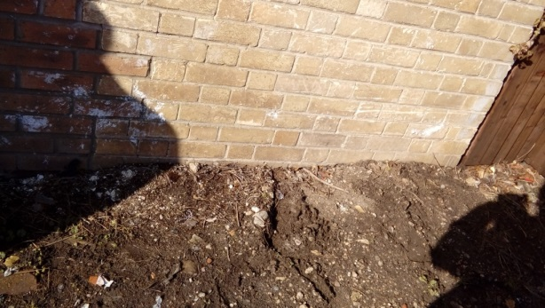 | 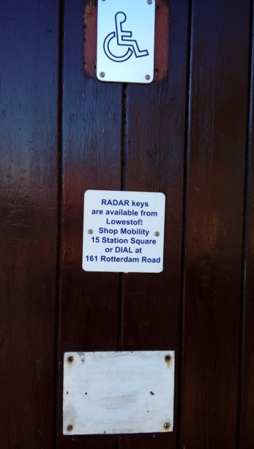 | 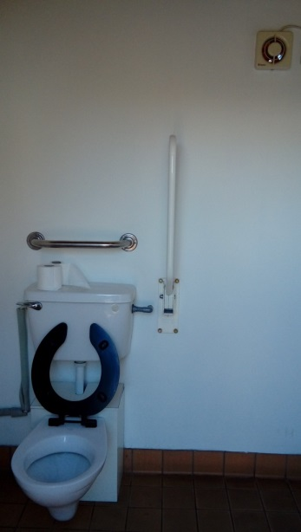
Ivy overgrown roof tiles. Note: Asbestos soffits | Soil level above damp course | Entrance to separate disabled toilet | Disabled toilet and handrails
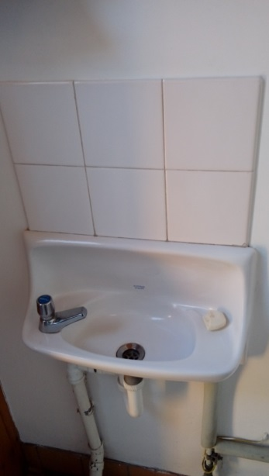 | 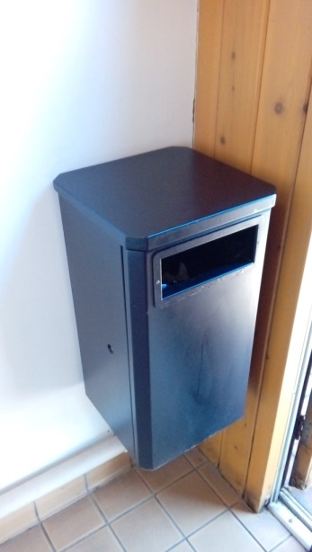 | 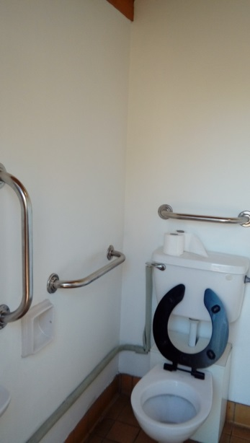 | 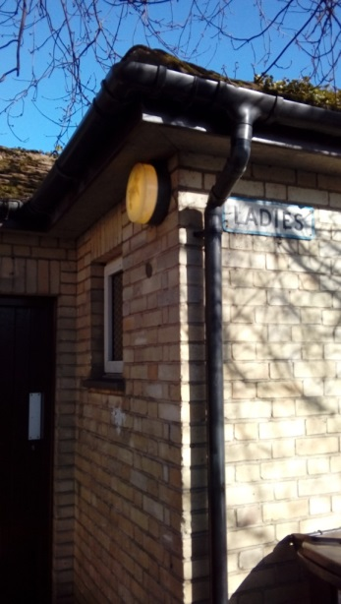
Disabled toilet basin. Cold water only | Disabled toilet bin | Disabled toilet | Entrance to ladies’ toilet
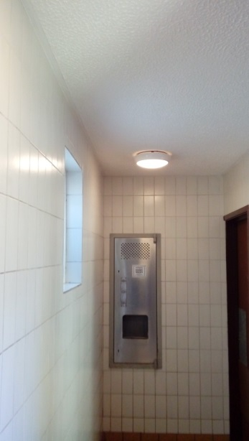 | 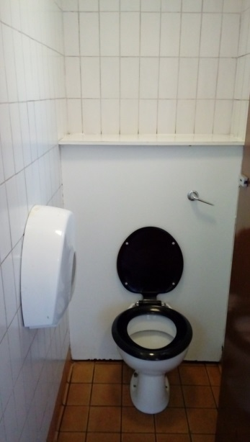 | 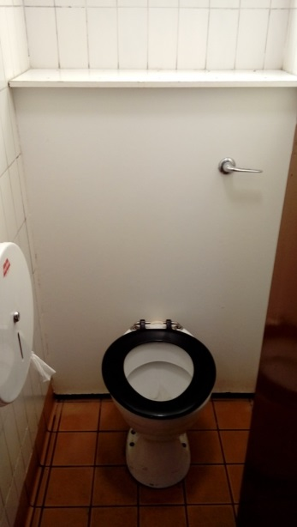 | 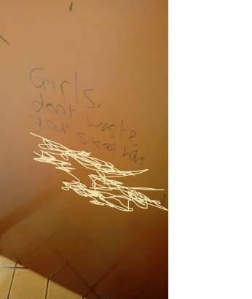
Ladies decoration and wallgate unit. | Ladies toilet and paper dispenser | Ladies toilet | Ladies vandalised cubicle door
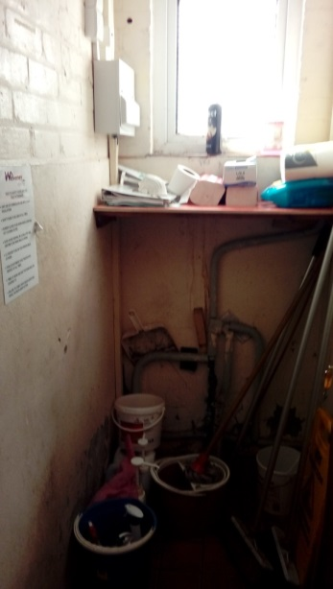 | 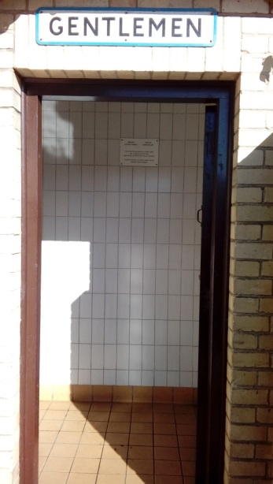 | 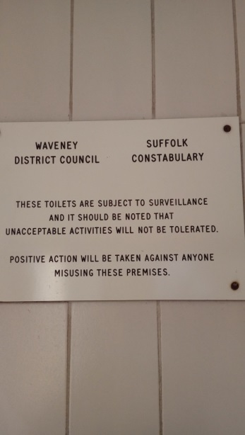 | 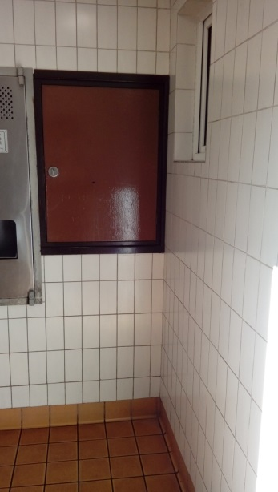
Cleaners cupboard in ladies’ toilet | Entrance to gents’ toilet | Sign in gents’ toilet | Gents utilities void
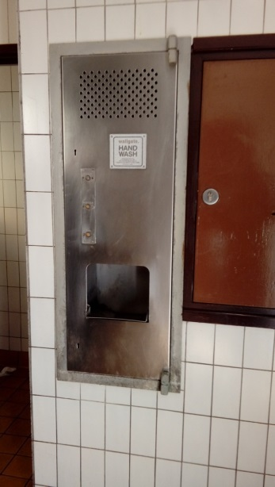 | 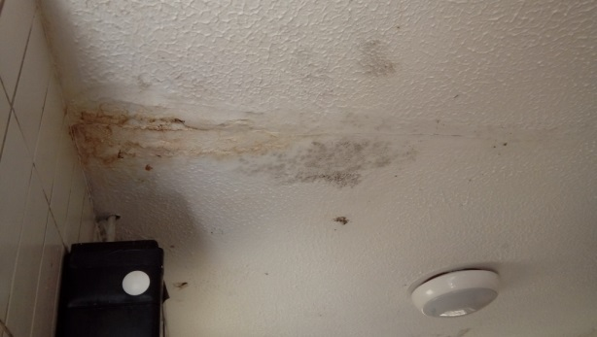 | 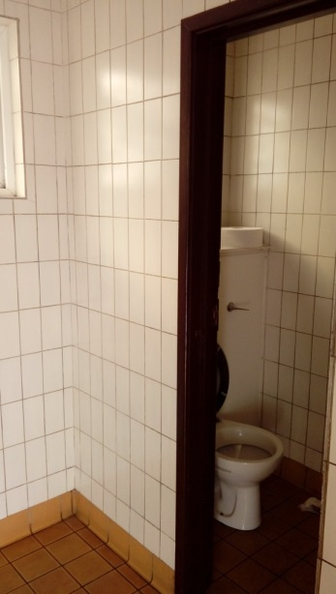 | 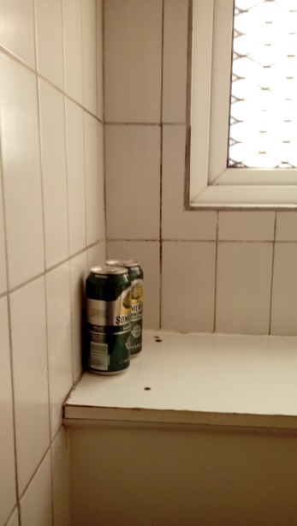
Gents wallgate unit | Gents ceiling damage | Entrance to gent cubicle | Rubbish left in gents’ cubicle
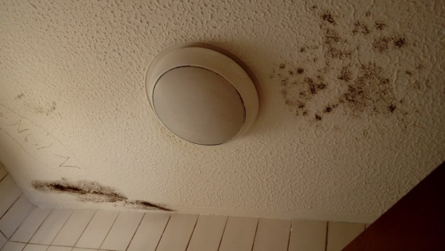 | 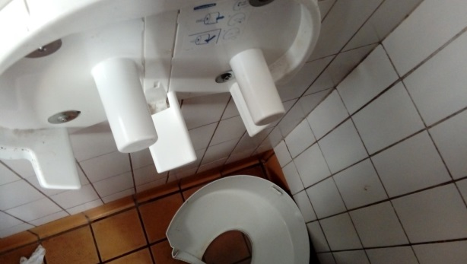 | 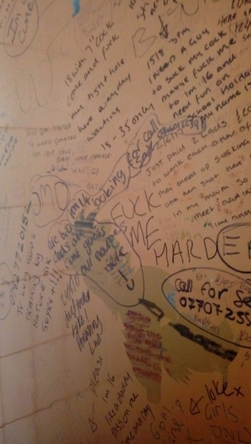 | 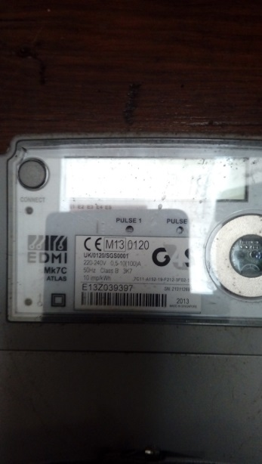
Gents cubicle ceiling damage. | Gents broken toilet paper dispenser | Gents toilet door vandalised | Electric meter in service void.

Fen Park Toilets.
This toilet block was passed to the town council in a derelict state. WDC had apparently decided not to demolish them as it would cost too much (about £15,000 we have been informed). Since passing them to the town council WDC Building Control have now declared them unsafe.
This is a small toilet block consisting of two small toilets one male and one female. The local park users would like the toilets repaired/replaced and there are options which could allow us to do so. We have budgeted for maintenance of these toilets for 2018/19 if they are repaired. The toilets are close to the entrance of the park and therefore in probably the best location as they are close to the play area and in view of the road. It would seem sensible to replace them with a similar sized structure.

Bearing in mind the recommendations noted in this document it would seem sensible to replace the existing toilets with two multifunctional toilets, each a single cubicle with disabled access and facilities as well as pull down changing facilities. This would enable either gender to be able to use the facilities or take their children into the facilities. These could also be fitted with radar keys so that they can be general access during the day but when locked in the evenings they could still be accessible by individuals with a radar key. It may be possible to reuse the current structure (i.e. walls) if they have not been damaged by exposure to the elements without a viable roof. However, it may be worth starting from scratch using the existing foundations as this may provide a more functional layout and be cheaper. It should have a pitched roof constructed with zinc or similar rather than tile which would hopefully be more vandal proof and deter climbing.

It is the working party’s recommendation that we should prioritise the work on these toilets and look at what funding is available from CIL/S106 or external bodies as well as approach Waveney District Council for a contribution as it was under their management that these toilets fell into disrepair. At the very least a contribution of the £15,000 it would have cost to demolish the toilets would seem a reasonable gesture.

Belle Vue Park Toilets.
These toilets have not been in use for many years, indeed no-one is certain what condition the interior is in. They would need a complete overhaul and possibly enhanced access however they would be a benefit to the park and for people travelling north out of the town along the Yarmouth Road. The nearest toilets are either at Sparrows Nest or the Triangle, neither of which is feasible if you have any mobility issues. If we are enhancing the park under the HAZ this may be a chance to reinstate this facility.

Other Public Toilets in Lowestoft
There are additional public toilets in the town that are not managed by the Town Council. These are at Gordon Road, the East Point Pavilion and on the South Beach Lower Promenade/Jubilee Parade which have been retained by WDC although we understand this is under review. There are additionally toilets at the Britten Centre bus station and also one at the train station. The toilets in Gordon Road are the most used public toilets in the town (Waveney Norse figures) and are key to the future of the town centre. Those along the South Beach are obviously key to our tourist economy and for beach users. There is a possibility that WDC may seek to close or transfer these toilets. Whilst the cost for maintaining these toilets would place additional burden on the town council, we would recommend that rather than lose those facilities the town council should take them on and then look to negotiate a separate maintenance contract for toilet provision, at least for those toilets not maintained by onsite staff.

With regard to the toilets at the bus and train station we should work with the organisations involved to ensure that these facilities continue to be available and are well maintained and, if possible, improved. The last Government paper on public toilets were noted the strong links between public transport and public toilet provision, whilst those at the bus station are adequate the single toilet at the train station seems minimal. Perhaps, with the planned regeneration of the train station we could encourage them to add in further unisex public toilets especially if it is to be a public space/hall/café.

Additionally, the location and need for public toilets should be considered as part of our Neighbourhood Plan.

RECOMMENDED SCHEDULE OF RENOVATION
Some toilets need greater planning or are dependent on other work taking place which takes them out of the toilet renovation schedule. This would include the Triangle toilets and those at Normanston, Fen Park and Belle Vue. Those at the Triangle would be better dealt with when looking at options for the area where the toilets and sails are currently.

Normanston needs a major review and consideration of use of the space and facilities as well as looking for external funding. Fen Park can be dealt with as a stand alone build and funding could be drawn from CIL/S106 and possible other external funding. Belle Vue should be considered separately, along with talking to the HAZ about options.

The suggested priority for our other toilets is (starting with the highest):
- Sparrow’s Nest – this state of these toilets lets down our cultural park and could be refurbished without major structural work.

- Kirkley Cliff – one of our busiest sets of toilets and as such more of a priority

- Cemetery – These could do with refurbishment but they are less used than Sparrow’s Nest and Kirkley Cliff.

- Pakefield – these are our least used toilets and, as such, probably a lower priority. Despite their low usage there is little other use that this space could be used for.

- Denes Oval – this is a single toilet and very basic. There may be options to do something with the current building if we look at replacing the hole in the wall to the north east of the cricket pitch with a stand/club area for the cricket ground.

- Kensington Gardens – recently renovated, the only change may be to remove the Wallgates and hopefully replace tiling or place in a floor to ceiling vanity unit.

- Normanston – See above

- Fen Park – See above

- Belle Vue – See above

- Triangle – See above

STRATEGIC RECOMMENDATIONS
General - We should look at long term options when it comes to hardware, i.e. not the latest fashion. We should choose items that will remain available for a long period of time and standardise across all public conveniences so that all toilet paper holders take the same toilet rolls and all lights take the same bulbs etc. This will require less of a stock of replacements to be held. Additionally, choose items that can be repaired/replaced in house rather than needing specialist maintenance.

Air Fresheners – these are no longer recommended for public conveniences as they can have negative effects on a wide range of health conditions. Good ventilation and regular cleaning are considered preferable.

Baby Changing Facilities – these shouldn’t only be provided in Ladies Toilets and should be available at all our toilet facilities.

Business Rates – Business rates on public toilets are discretionary unless you are the charging authority (i.e. District Council). WDC had to charge itself business rates on the toilets however it can waive those charges for a parish council especially if there is either no charge or minimal charge for using the toilets. This is probably an area which we need to clarify with the district council.

Charging – we would recommend that the council does not charge for using public conveniences at this time. This should be reviewed during the four-year term of the Council. In their current condition it would be against the Council’s interests to charge.

Cleaning Regime – The minimum recommended cleaning regimen is twice a day. This does not mean a major clean twice a day but rather a morning clean followed by a check later in the day to ensure that there are no issues etc and a second clean if required. This may vary dependent on the usage of the facilities; a busy toilet may require additional visits whilst one that is quiet may need less attention although at least two visits per day are recommended. At present, as far as we are aware, we have little in the way of SLA’s/KPIs for toilet maintenance and this is something which the Council should address in the near future especially if we are to look to either take toilet maintenance in house or go out to competitive tender for it at any time in the future. There should also be a process where the cleaning staff advise of any maintenance issues and a timeline for dealing with these issues which should tie in with a planned maintenance schedule.

Closure of Public Toilets – No closure of public toilets should take place unless there has been a full investigation into the options and a public consultation has taken place (This is a national recommendation).

Decoration/Tiling – an historic trend has been to use blue in men’s’ toilets and pink in women’s’ toilets, this should be avoided and instead aim for gender neutral colours. Trendy decoration will date more quickly than neutral decoration. Our toilets look more dated generally due to the terracotta floor tiles which have often been left in place when the other tiling has been replaced. Simply updating this in some of our toilets would make them seem more modern. Another issue is the use of white grout which discolours and ages the decoration, using a contrast darker grout can prevent this. Options could include alternative flooring tiles or durable vinyl anti-slip floors and anti-vandalism over-cladding on walls.

Disabled Facilities – We have disabled toilet facilities and most of our locations although not at all of WDC’s. Should they ever want us to take on those toilets then we would require either that disabled provision was provided prior to handover or that capital to carry out the upgrades was provided at the time of transfer.

Although we have regular disabled facilities we do not have a single public toilet in the town which meets the guidelines of the Changing Places Consortium. It is recommended that we should aim to provide at least one of these facilities within the Parish. These are specific facilities which include items such as a hoist etc. Possibly the best location for a toilet of this type may be at the Kirkley Cliff toilets as they are close to the seafront but are also one of the easiest sets of toilets to access and park in close vicinity.

An area that our toilets do fail in with regard to disabilities are provision for those with impaired vision and issues with dementia/mental health. There are various options available and prior to any renovation/build of toilets it would be wise to get professional advice regarding meeting the needs of these individuals. This could be as simple as having bright colours showing exits and facilities and using colour to differentiate areas/fittings etc.

Gender Specific/Unisex toilets – This is a deeply divisive issue which mainly falls along generational lines. This is an issue which should be considered taking into account at each location when renovation work is planned. Where possible the Council should follow society as well as legal obligations and look to provide non-gender specific/unisex toilets specifically in new builds wherever possible as direct-entry, single cubicle provision. Single cubicle options such as the Triangle and proposed at Fen Park need not have gender specifications.

Existing premises may preclude this however due thought should be taken for each site.

Multiple user toilets may have to be more sensitively handled and standard cubicle partitions may not make mixed gender usage comfortable for some people. If we do go down this route then it would be wise to follow our lead at Hamilton House and have full-height, solid-walled cubicles with proper doors which cannot be looked over or under. This type of toilet may be more difficult to “police” but as it would be used by all genders it would be busier and therefore potentially less likely to suffer from antisocial behaviour.

If we do go down the route of unisex toilets then the Council could consider maintaining urinal only facilities as part of a toilet block to reduce the waiting time for cubicles.

The national norm for provision stands around a 1:1 ratio between toilet provision for men to women. Taking into account urinals this reduces and generally public provision of toilets for men are higher than women. Government recommendations are that a 2:1 ratio women to men should be the norm. Obviously where there are unisex toilets then this ratio is negated.

Graffiti – The majority of graffiti in public toilets is on doors or painted walls in done in black ink. Doors could be painted black to prevent this. An alternative would be to use an anti-graffiti paint or sealer. Norse have concerns over using anti-graffiti paint as, if it needs repainting, it needs to be removed/heavily sanded prior to a new coat being put on top. It may be practical to try these methods at different sites to see whether it has an effect.

Hand driers – Cold air hand driers are preferable as although they use more energy than paper towels, they also produce less waste and therefore need less cleaning time. Although combination units of basins/soap dispenser/drier appear more compact and beneficial, they can be costly both in capital and maintenance. The units we have in some of our toilets have to be maintained under contract and if one part of the system breaks then the whole system is flawed. In some toilets these have already been removed and replaced with basins, soap dispensers and hand driers. We would recommend replacing the combination units either when then toilets are updated or if units become obsolete.

Lighting – When replacing we should move to a standard LED light fitting. We do need to verify that these are of a good quality as poor LED can strobe which can lead to fits in some individuals. These should also be connected to PIR systems so that they are more energy efficient. Blue anti-drug lighting (as in the Triangle toilets) are now advised against as they do not prevent individuals injecting. They may slow down the process however and experienced addict can find a vein by feel and an inexperienced one might cause themselves more serious damage. Indeed, comments from paramedics refer to the blue lighting just making it weird when they deal with an overdose in a toilet.

Maintenance and Refurbishment – Council should determine a schedule for refurbishment of our toilets. This should be two-fold, initially we should determine which toilets need refurbishment and in what order; a proposal is outlined in this strategy. Council should then decide what the lifetime of the refurbished toilet is; this may vary by the amount of usage but a generic period could be determined such as 10, 15, 20 or 25 years before a complete refurbishment is needed again. Obviously the less trendy the décor/fittings then the less it will date. This is not to say that during that time individual fittings may need replacement as necessary. Having determined the “life” of the toilets a schedule could be drawn up i.e. if lifetime is 10 years and we had 10 toilets then we would look to renovate one toilet every year, if it is 20 years then it is one every two years and the capital budget required per year could be halved although this may need to be countered by an increase in the maintenance budget. Once these decisions are made then we can draw up a capital budget and a maintenance budget for the toilets which could sit within the capital reserve and the Repairs and Maintenance budget/reserve. We could then have a rotating schedule which can be administered by our staff and would only need referral to Council if issues arose outside of that schedule. Where toilets are to be refurbished, the council should publicise the plans prior to starting the refurbishment in order to allow the public the opportunity to comment on the refurbishment. A draft schedule is included in this d

New Toilets – The Council will consider the options if there is a demand to any new toilets and will check public interest and long-term costs. This would also be the case should the Council be offered any existing toilets. The existing condition of the toilets and the future costs would have to be considered as well as the benefits to the residents and economy of Lowestoft.

Other Fittings – these should be standard across all our toilets and should be durable in order to prevent vandalism and ensure a longer period between replacement.

Ownership options – the possibility of setting up a not for profit or charity to run the toilets has been raised. This would need to be fully investigated and the benefits considered. We would recommend that this needs to be checked out with other authorities that have gone down this route along with legal advice. One reason to consider this could be Business Rates however as noted previously this should not be an issue and indeed a charity would not get exempted from all the rates and would still need the charging authority to apply discretion to some of the rates payable. There may be access to funds for a charity that may not be accessible for a council.

Signage/information – This is not something that we can fully control however toilets need to be clearly signposted. We can manage this within our own premises but directions to toilets from external locations is something we have little input or influence over. Where we cannot provide signage, it is recommended that we have a map of public toilets on our website as well as research apps/websites which offer locations of toilets. There are apps which identify where the nearest public toilet to you are and we should ensure that our toilets are included on those apps depending on the costs involved. There is a recommendation in the public sphere that there should be a universal sign for public toilets however there seems to be no agreement what that should be. The general view seems to be that an image/symbol is better than words due to language issues. We recommend that the council has a single style of sign and that there should be an emergency telephone number within each toilet.

Toilets/Basins etc – When replacing the recommendation would be to use either “resan” or stainless-steel fixtures and fittings as these are more vandal proof. It might also be wise to move to either push button flush units or infra-red sensor flush units (re avoid vandalism) and modern cisterns to reduce water use. We should also look to install urinal systemisers as needed. Individual urinals can also be fitted with infra-red sensors for flushing purposes.

Taps – Push down, time limited non-concussive taps are an environmental and cost saving preference. Another cost-effective option could be to consider infra-red sensor taps. These can be cold water only as it is just as hygienic, saves energy and reduces H&S risks. Hot water facilities should be provided in the cleaner’s areas and should be serviced by small wall mounted heater units.

Waste – A key discussion should be what type of waste provision we have in public toilets. As far as we are aware some toilets have waste bins whilst others may not. None of our toilets seem to have sanitary towel dispensers or disposal bins nor do we have sharps bins. We have to assume that this is a WDC/Norse policy however it is suggested that council consider doing research on our legal position regarding provision and what cost and social implications may arise should council decide to change this position.

WEBSITES OF INTEREST:

http://www.btaloos.co.uk/
http://www.btaloos.co.uk/wp-content/uploads/2014/01/BTABestPracticeAdvice.pdf
http://www.btaloos.co.uk/wp-content/uploads/2014/01/BTACleaningGuidance.pdf
http://www.waterfund.go.ke/sanitation/Downloads/5.%20A%20Code%20of%20Practice%20for%20Public%20Toilets%20in%20Britain.pdf
https://www.nymas.co.uk/blog/what-bs8300
http://www.dudleyresan.co.uk/
https://www.danfo.com/en/products/public-toilet-buildings/
http://www.cleveland-sitesafe.ltd.uk/public-toilets/p51
https://www.lanservicesltd.co.uk/specialities/vandal-proof
https://www.healeyandlord.com/product/stainless-steel-toilet-back-to-wall-anti-vandal
https://www.commercialwashroomsltd.co.uk/products/commercial-sanitary-ware/vandal-resistant-sanitary-ware/vandal-proof-toilets

HISTORIC RESEARCH ON TOILETS PRIOR TO TRANSFER TO LTC

Recorded Usage 2015/16

Toilet | All Year | Summer Only | Disabled | Summer Count 1/4-31/10 | Winter Count 1/11-31/3 | Total annual Count
Triangle Market | Yes |  | Yes | 1112 | 1082 | 57164
Sparrows Nest | Yes |  | Yes | 574 | 383 | 25646
Gordon Road | Yes |  | Yes | 2681 | 1964 | 123638
Royal Plain | Yes |  | Yes | 1028 | 829 | 49078
Jubilee North |  | Yes | Yes | 1708 | N/A | 51240
Jubilee South |  | Yes |  | 889 | N/A | 26670
Kensington Gardens | Yes |  |  | 0 | 971 | 61742
Kirkley Cliff Road | Yes |  | Yes | 0 | 828 | 52626
Pakefield Street | Yes |  | Yes | 0 | 201 | 10632
Normanston Park | Yes |  | Yes | 0 | 240 | 15270
Lowestoft Cemetery | Yes |  | Yes | 0 | 139 | 7348

Costs per user using recorded usage against allocated costs

Toilet | running costs p/user | Total annual Count | running costs
Triangle Market | 0.14 | 57164 | 7803.28
Sparrows Nest | 0.21 | 25646 | 5391.96
Kensington Gardens | 0.10 | 61742 | 6221.31
Kirkley Cliff Road | 0.28 | 52626 | 14956.41
Pakefield Street | 0.82 | 10632 | 8760.2
Normanston Park | 0.39 | 15270 | 5926.59
Lowestoft Cemetery | 0.83 | 7348 | 6094.16

Potential income from levying a charge

Toilet | All Year | Disabled | Total annual Count | Reduction in usage if charge levied Prime -35% Remainder -40% | Takings at 20p
Triangle Market | Yes | Yes | 57164 | 34298 | £6,859.60
Sparrows Nest | Yes |  | 25646 | 15387 | £3,077.40
Kensington Gardens | Yes |  | 61742 | 37045 | £7,409.00
Kirkley Cliff Road | Yes | Yes | 52626 | 31576 | £6,315.20
Pakefield Street | Yes | Yes | 10632 | 6379 | £1,275.80
Normanston Park | Yes |  | 15270 | 9162 | £1,832.40
Lowestoft Cemetery | Yes | Yes | 7348 | 4409 | £881.80

Revisions
Date | Amendment

