MEETING PAPER
Subject: Memorial Plaque at Lowestoft Train Station
Meeting: Events and Communications Sub-Committee
Date: 17.12.2020

NON CONFIDENTIAL

Background/Introduction
The memorial plaque at Lowestoft Station, noting, ‘In December 1938, Lowestoft Station was the arrival point of a Kindertransport train. The train transported mainly Jewish children as refugees, escaping persecution prior to the outbreak of World War II.’
Details
This memorial is not currently listed on the National Heritage List for England.

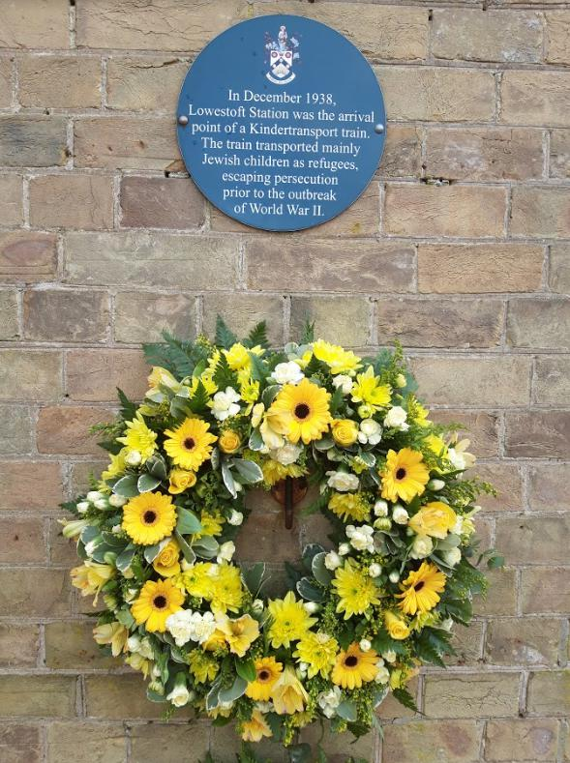

https://www.iwm.org.uk/memorials/item/memorial/85442

Recommendations/Decision
To consider listing the Memorial plaque at Lowestoft train station

