Lowestoft Town Council

Notes on Draft Cycling Strategy
Following closure of the Ravine on 9th December because of an unstable balustrade on the bridge to Belle Vue Park, it was suggested tongue-in-cheek that the roadway itself should also be repaired because of multiple hazards to cyclists, particularly near the junction at the bottom of the hill.
If the Town Council is serious about promoting cycling, advocating good road surfaces must be a priority. Instead of descending the Ravine, just pedal on along Yarmouth Road to the High Street, a designated cycle route, where one has to grit one’s teeth to avoid losing one’s fillings before reaching the Triangle. Norwich Road is another boneshaking experience.
Lowestoft ought to be ideal for commuting and leisure cycling, excepting the obvious pinch points at the bascule bridge and Oulton Broad. I have been pedalling around the town since the 1970’s, cycling 12 miles to and fro every day to Brooke Marine shipyard, along with hundreds of other workers. I still cycle most days now.
Over the years there have been several consultations and strategies for improving provisions for cycling in Lowestoft. There have been some new cycle tracks, but few meaningful and comprehensive measures to advance cycling as a primary means of transport.
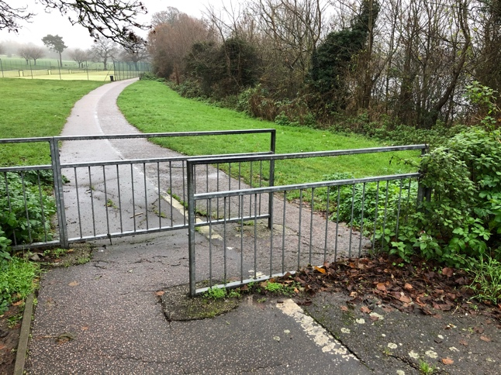
For instance, in the last consultation by Waveney District Council, the authors themselves illustrated some examples of hindrances to cycling. One in particular was the barrier between Lakeland Drive and Normanston Park. The obstacle is still there.

When Tom Crisp Way was built, there was an ideal opportunity to create a direct cycle track along its full length, but from the fire station, riders have to cross back and forth over the main A12 road three times to reach the bascule bridge. Cycling commuters need the shortest and quickest route to work.
It should be noted that Suffolk County Council grits the roads in winter, but not the cycle paths. Furrowed slabs are treacherous on frosty mornings because rime forms in the grooves.
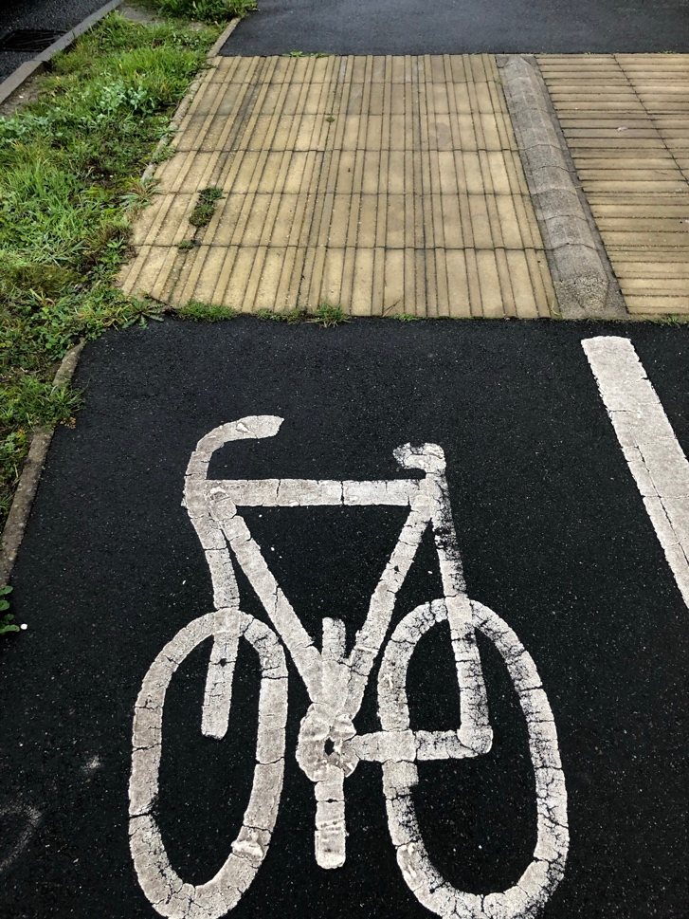

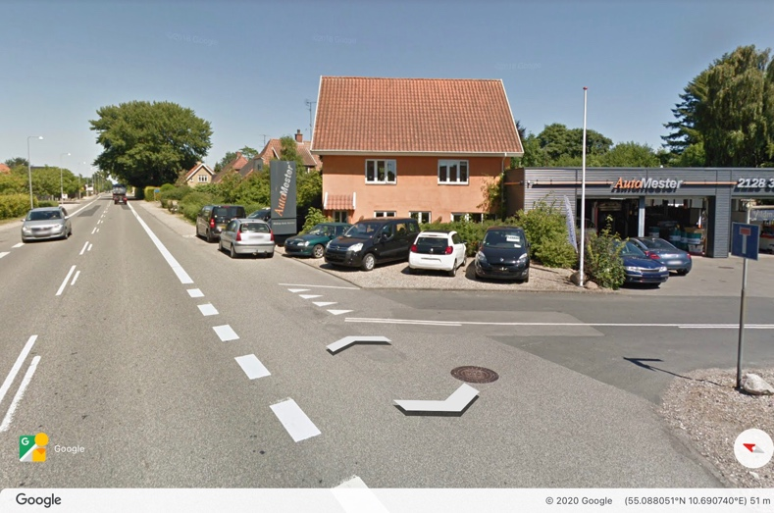
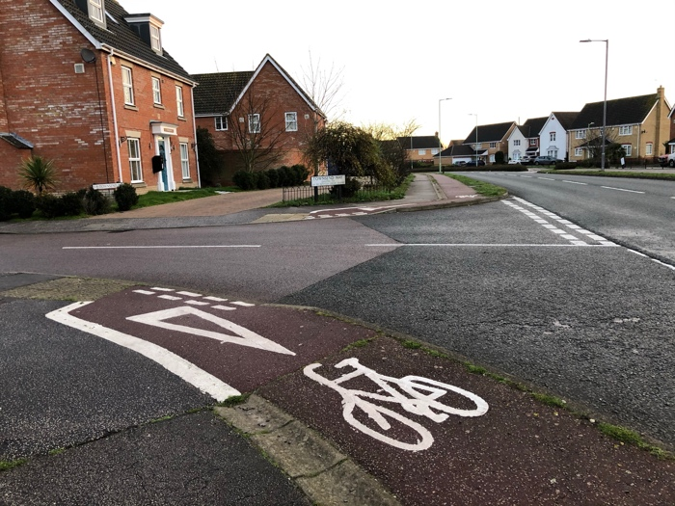
It can be seen from the first following photograph that in this country, cyclists have to give way to cars. In this example in Bentley Drive, a cyclist has to slow and make an awkward double turn in order to cross the side road. Also, from this direction it is difficult to look over the shoulder to see if a vehicle is approaching from the rear to turn left into the side road.

Contrast this to the next photo of the main Svendborg-Nyborg road passing through a village where my son lives on the island of Fyn in Denmark. The ‘give way’ markings on the minor road from the right are placed before the bicycle lane, so that vehicles have give precedence to cyclists before pulling forward to give way to traffic on the main road.
The position of the village in relation to the town of Svendborg is roughly equivalent to Hopton and Lowestoft. In the open country, pedestrians, cyclists and moped riders have a separate, properly engineered, mini-road. From Hopton to Lowestoft, rather than use the A47 dual-carriageway, cyclists are directed to use the narrow, twisting coastal road to Corton, in competition with traffic from the holiday camps, and double-decker buses on the 1/1A route.
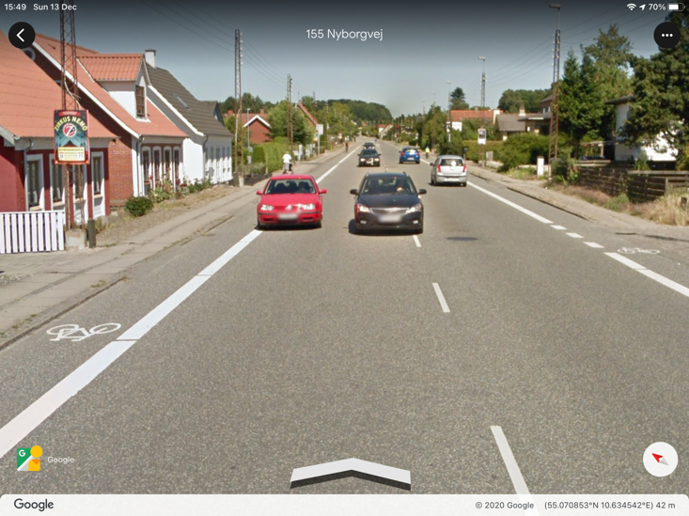
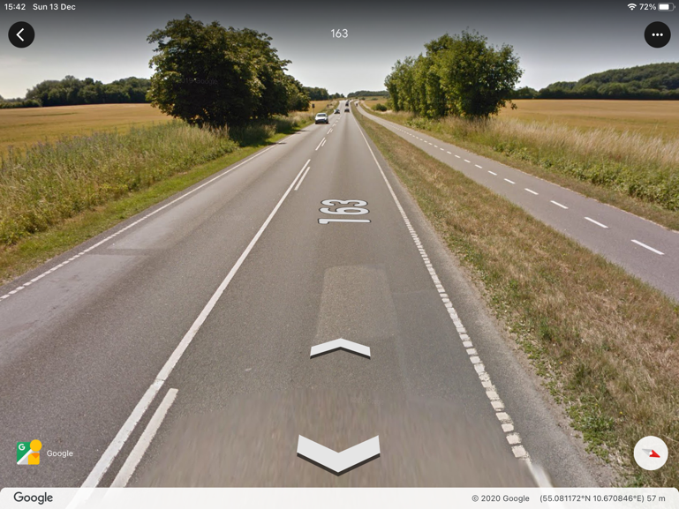

Within the town boundary of Svendborg, on the equivalent of Yarmouth Road, it can be seen that the cycle lanes on either side are defined by solid white lines. Note that the red car is parked by law outside of the cycle lane, allowing cyclists free passage without having to swerve out into traffic as in the UK.
Contrast Svendborg with the short section of pink pavement cycle track along Yarmouth Road between Sussex Road and Harris Avenue. Cars entering and leaving Denes Academy have precedence over cyclists. At end of school in the afternoons, the cycle track is impassable. Two days ago there were thirteen cars parked with two wheels on the cycle path, plus two more on the grass verge near the pedestrian crossing. Cyclists have no option but to swerve out around these parked cars on this busy trunk road.
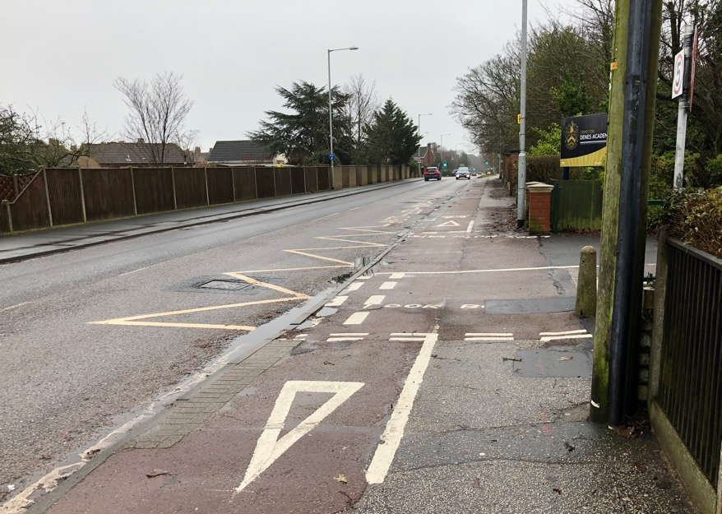
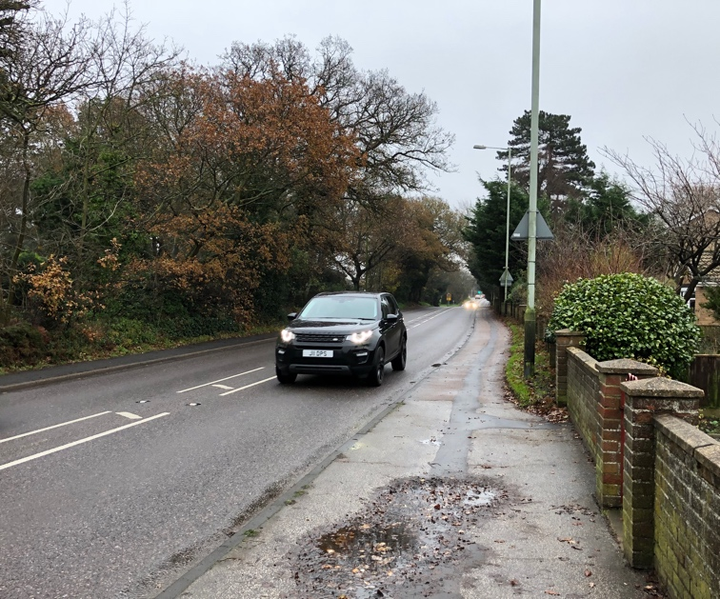
When Yarmouth Road last received major attention from Highways England, separation markings were painted in the centre of the carriageway. These have had the effect of car drivers subconsciously squeezing the amount of room given to cyclists. Many people now cycle on the narrow pavements for fear of the heavy traffic on Yarmouth Road. However, one lady who cycles to work in town every day, was knocked into the roadway by a car emerging from the driveway of a house, fortunately without serious injury.
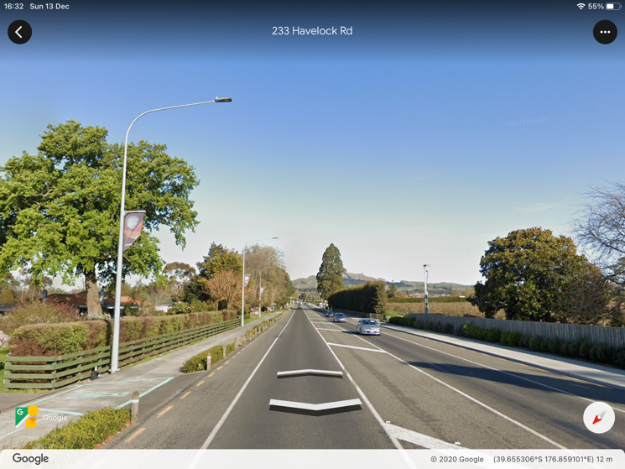
My daughter, who was once Town Manager in Lowestoft, emigrated to New Zealand as an assistant to the mayor of Hastings, on North Island. An early project was construction of a cycle track from an outlying village, equivalent as Kessingland is to Lowestoft.
Now there is a well-surfaced, shared cycle/footpath on both sides of the main road to Hastings, infinitely better than the bumpy pavement alongside the A12 towards Pakefield. Look closely to the bottom left of the above photograph, where a green box has been painted on the path to warn drivers leaving the driveway to beware of cyclists.
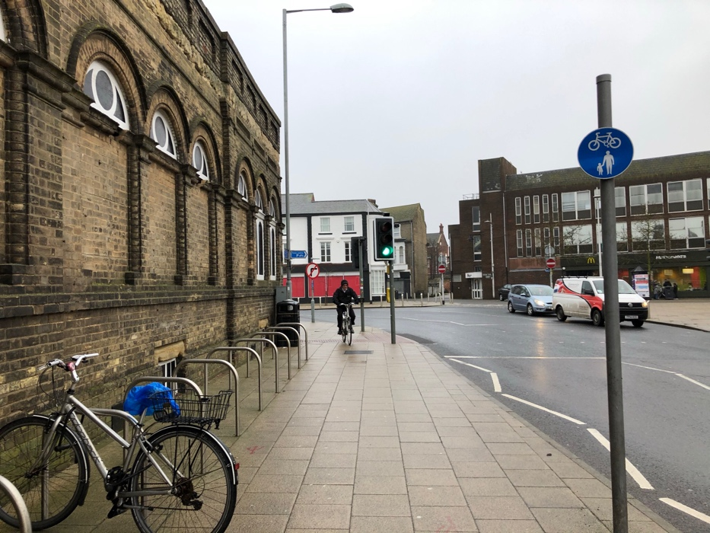
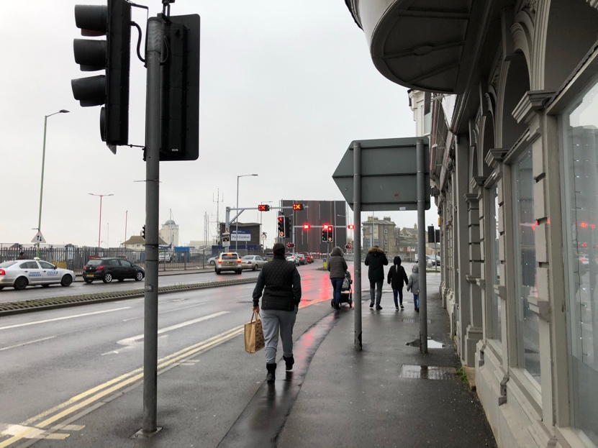
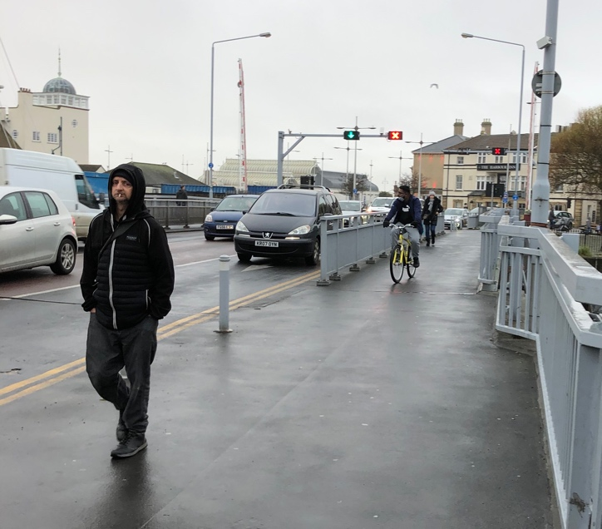
Last year LTC was given a presentation about the new Third Crossing. It was said that the design of the Gull Wing bridge had been reduced in scope and cost, eliminating the dedicated cycle path from the original concept. On the existing bascule bridge, there is the silly situation where cyclists are directed to share the often crowded footpaths. When the Third Crossing is finished, traffic on the bascule bridge should be reduced to two lanes in the centre, with a cycle lane on both sides of the road.
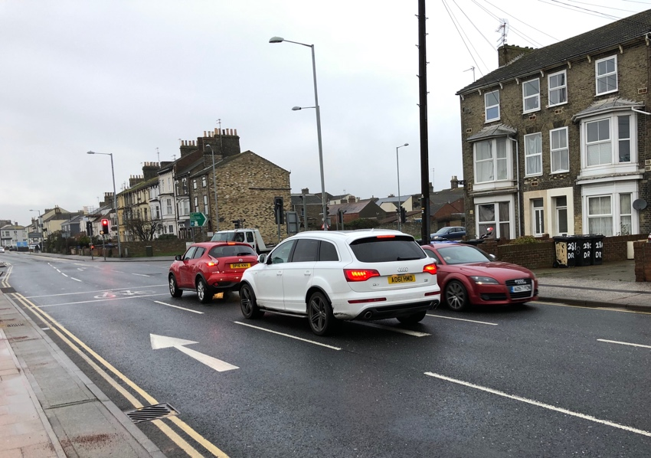
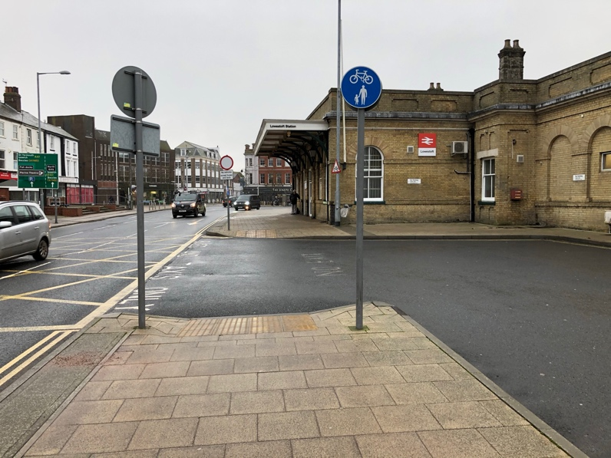
One aspect mentioned by the authors of the previous WDC cycling consultation was signposts that obstruct cycle paths. The two other photographs above illustrate the shared pavement between Station Square and Commercial Road. Whoever directed that cyclists should try to pass through the narrow passage where people queue at the pedestrian crossing, and then ride past the doorway of the station, where travellers enter and exit trailing suitcases behind? It should also be noted that for those of us who persist in riding on the road past the station, turning right into Katwijk Way involves an unpleasant wait for the green filter light whilst sandwiched between traffic passing either side.

The cycle route along Denmark Road finishes abruptly at the end of the station car park, where riders have to swerve on to the road. The route signpost and a litter bin are buried in the brambles. Having rejoined the narrow and bumpy cycle path, opposite Clemence Street where the useful old iron bridge over the railway used to be, is another of WDC’s obstacles. Finally, as illustrated below, the cycle path expires again before reaching the Rotterdam Road roundabout, which is, of course, where the Third Crossing will land.
If small countries such as Denmark and New Zealand can provide civilized facilities for cyclists of all ages and abilities, surely the sixth largest economy in the world ought to be able to build a comprehensive infrastructure for cycling in the future, rather than the inadequate and piecemeal offerings that are endured today.
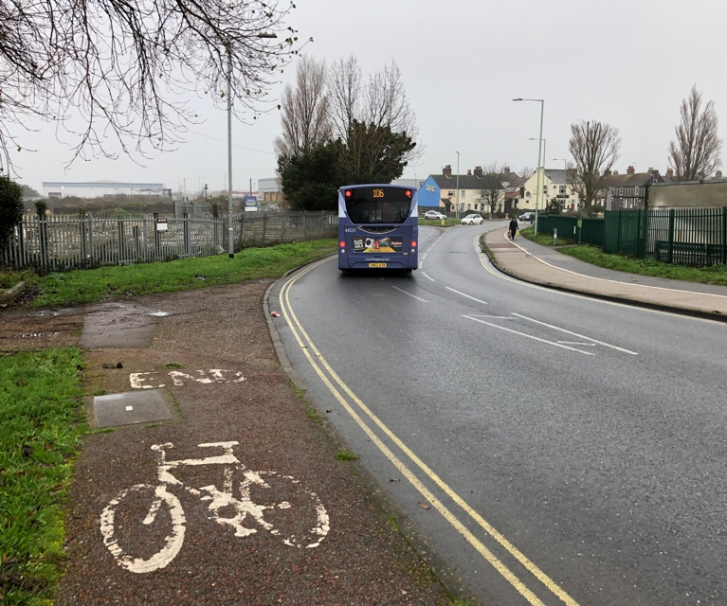
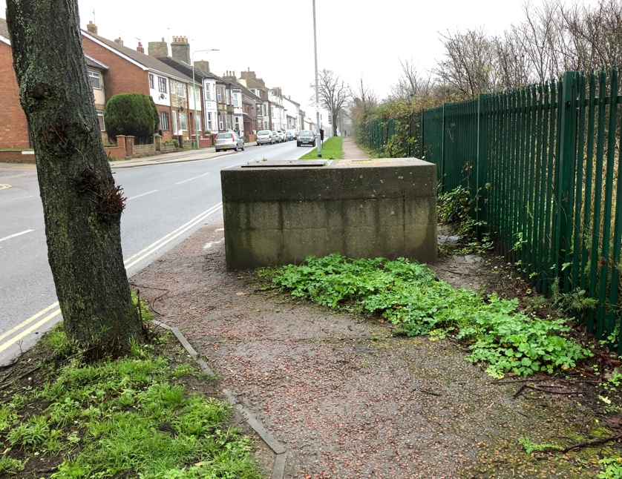
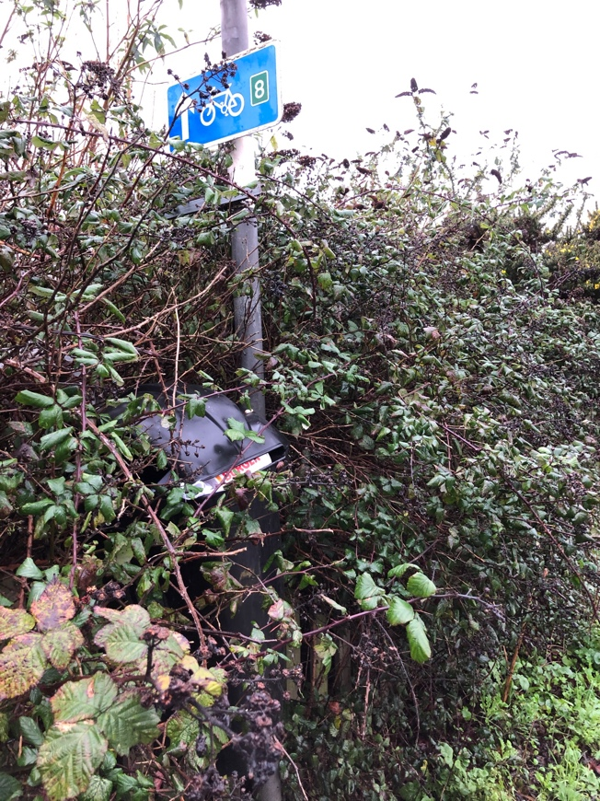
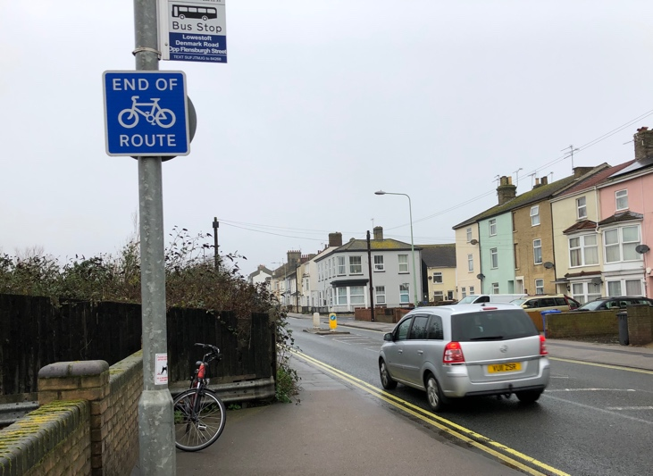
Cllr Colin Butler,
Lowestoft St Margaret’s East Ward,
16th December 2020

