Planning notes 10/3/2020

Burger King, North Quay Retail Park
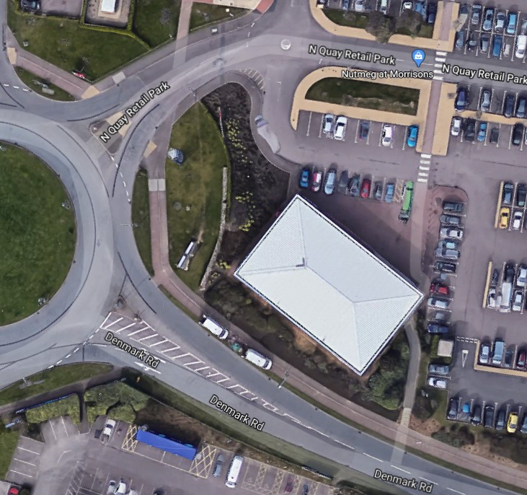
Signage for drive through restaurant.
Burger King North Quay Retail Park Peto Way Lowestoft Suffolk NR32 2ED  Illuminated Advertisement Consent - New Drive Thru site to have a combination of illuminated and non-illuminated freestanding and wall mounted signage.  Date Description Information 1 Information 2  05/03/2020 Consultee Responses SCC Highways  26/02/2020 Consultee Responses Highways  24/02/2020 Proposed Block / Layout Plan 10158 A  24/02/2020 Site / Location Plan 10158  12/02/2020 Application Form & Certificate  12/02/2020 Plans P-6544-1 1/14 Specification  12/02/2020 Plans P-6544-1 10/14 specifications  12/02/2020 Plans P-6544-1 11/14 specifications  12/02/2020 Plans P-6544-1 12/14 specifications  12/02/2020 Plans P-6544-1 13/14 specifications  12/02/2020 Plans P-6544-1 14/14 specifications  12/02/2020 Plans P-6544-1 2/14 specifications  12/02/2020 Plans P-6544-1 3/14 specifications  12/02/2020 Plans P-6544-1 4/14 specifications  12/02/2020 Plans P-6544-1 5/14 specifications  12/02/2020 Plans P-6544-1 6/14 specifications  12/02/2020 Plans P-6544-1 7/14 specifications  12/02/2020 Plans P-6544-1 8/14 specifications  12/02/2020 Plans P-6544-1 9/14 specifications  12/02/2020 Site / Location Plan 10158 PLA L04 A | DC/20/0581/ADI  Public comments  Constraints  Related cases  Documents  Map

127 London Road North and 1 Regent Road
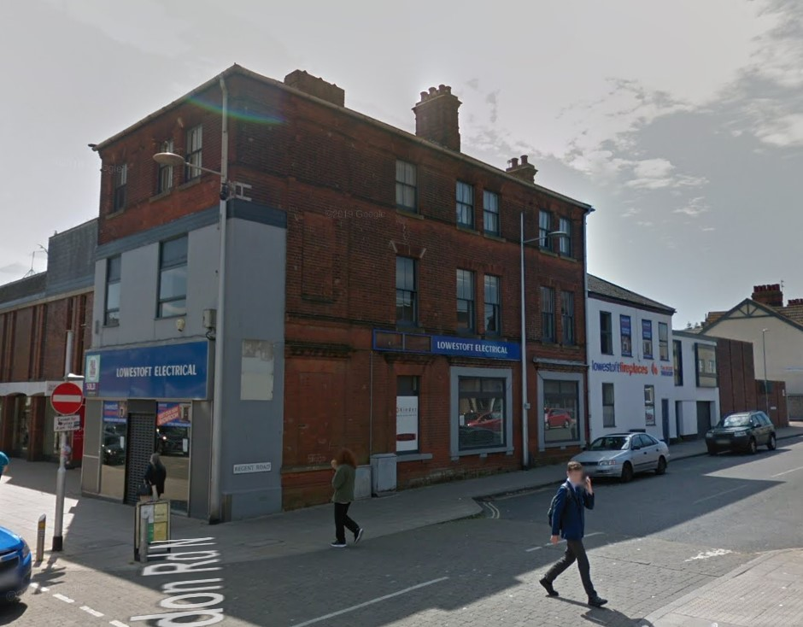
Conversion of block to 3 retail + 1 flat on ground floor, 7 flats on floors above.
127 London Road North And 1 Regent Road Lowestoft Suffolk NR32 1LZ  Conversion of retail unit into 3 smaller retail units and 8 Flats, 2 no in extension  Date Description Information 1 Information 2  25/02/2020 Consultee Responses Essex & Suffolk Water  21/02/2020 Contaminated Land Assessment  21/02/2020 Site Notice & Neighbourhood Notification SNOTQR  19/02/2020 Plans Existing Elevations, Floor Plan, Site & Block  13/02/2020 Application Form & Certificate  13/02/2020 Contaminated Land Assessment Landmark Sitecheck assess  13/02/2020 Contaminated Land Assessment Questionaire  13/02/2020 Design & Access Statement  13/02/2020 Plans Proposed Elevations, Floor Plan, Site & Block | DC/20/0607/FUL  Public comments  Constraints  Related cases  Documents  Map

Post Office, 51 London Road
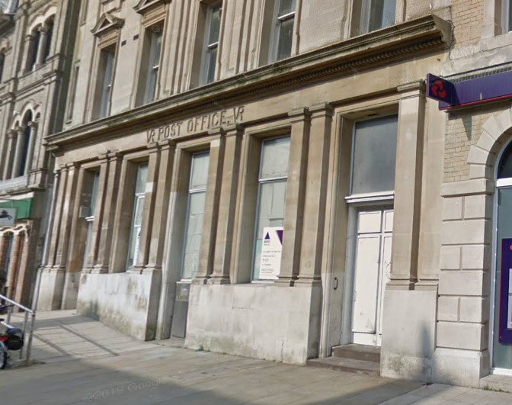
One objection, Brooks: Poor design. Demolition of building contributes to climate emergency. There is a surplus of flats in the area already. Area liable for flooding.
Highways recommends refusal due to inadequate parking provision. 5 proposed, but guidelines recommend 18. Highways recommend 9 spaces as a minimum.
Post Office 51 London Road North Lowestoft Suffolk NR32 1AA  Demolition of existing shed buildings and 3/4 storey brick building to rear of Post Office, including adjoining structures to rear of Post Office. Making essential repairs to Post Office building and modifications (thermal and watertight) to rear wall of Post Office building at ground floor level. Erection of flats and houses comprising 9 dwellings, with associated landscaping works.  Date Description Information 1 Information 2  05/03/2020 Consultee Responses SCC Highways  04/03/2020 Neighbour Responses Brooks 40 Melbourne Road  19/02/2020 Site Notice & Neighbourhood Notification SNOTQR  17/02/2020 Design & Access Statement  17/02/2020 Existing Elevations EX-200 ELEVATIONS 2 & 3  17/02/2020 Existing Elevations EX-200 EXISTING ELEVATION 1  17/02/2020 Plans DM-001 SITE PLAN DEMOLITIONS  17/02/2020 Proposed Block / Layout Plan PL-002  17/02/2020 Site / Location Plan EX-001 Existing Location plan  17/02/2020 Site / Location Plan EX-100 AS EXISTING SITE GROUND FLOOR PLAN  17/02/2020 Supporting Documents Planning Supporting Statement  17/02/2020 Supporting Documents Sequential Assessment Report  17/02/2020 Supporting Documents Site Investigation Report  14/02/2020 Application Form & Certificate  14/02/2020 CIL Additional Questions form  14/02/2020 Flood Risk Assessment  14/02/2020 Flood Risk Assessment Part 2 of 3  14/02/2020 Flood Risk Assessment Part 2 of 3 - Part 1  14/02/2020 Flood Risk Assessment Part 2 of 3 - Part 2  14/02/2020 Flood Risk Assessment Part 2 of 3 - Part 3  14/02/2020 Flood Risk Assessment Part 2 of 3 - Part 4  14/02/2020 Flood Risk Assessment Part 2 of 3 - Part 5  14/02/2020 Flood Risk Assessment Part 3 of 3  14/02/2020 Heritage Statement  14/02/2020 Plans PL-009 AS PROPOSED SITE LOWER GROUND FLOOR PLAN  14/02/2020 Plans PL-300 AS PROPOSED PROPOSED SITE SECTION A  14/02/2020 Plans PL-301 AS PROPOSED PROPOSED SITE SECTIONS B & C  14/02/2020 Plans PL-400 AS PROPOSED PROPOSED FLAT PLANS  14/02/2020 Plans PL-401 AS PROPOSED PROPOSED HOUSE PLANS  14/02/2020 Plans PL-450 AS PROPOSED PROPOSED LANDSCAPING  14/02/2020 Proposed Elevations PL- 200 AS PROPOSED PROPOSED ELEVATION 1  14/02/2020 Proposed Elevations PL- 201 AS PROPOSED PROPOSED SITE ELEVATION 2 & 3  14/02/2020 Proposed Elevations PL-402 AS PROPOSED PROPOSED FLAT ELEVATIONS 1  14/02/2020 Proposed Elevations PL-403 AS PROPOSED PROPOSED FLAT ELEVATIONS 2  14/02/2020 Proposed Elevations PL-404 AS PROPOSED PROPOSED HOUSE ELEVATIONS  14/02/2020 Proposed Elevations PL-405 AS PROPOSED PROPOSED HOUSE ELEVATIONS  14/02/2020 Proposed Elevations PL-406 AS PROPOSED PROPOSED HOUSE ELEVATIONS  14/02/2020 Proposed Elevations PL-407 AS PROPOSED PROPOSED HOUSE ELEVATIONS  14/02/2020 Proposed Floor Plan PL-100 AS PROPOSED SITE GROUND FLOOR PLAN  14/02/2020 Proposed Floor Plan PL-101 AS PROPOSED SITE FIRST FLOOR PLAN  14/02/2020 Proposed Floor Plan PL-102 AS PROPOSED SITE SECOND FLOOR PLAN  14/02/2020 Proposed Floor Plan PL-103 AS PROPOSED SITE THIRD FLOOR PLAN  14/02/2020 Proposed Floor Plan PL-104 AS PROPOSED SITE ROOF PLAN  14/02/2020 Supporting Documents  14/02/2020 Supporting Documents Asbestos Report Pre-Refurbishment Survey | DC/20/0653/FUL  Public comments  Constraints  Related cases  Documents  Map

54 London Road North
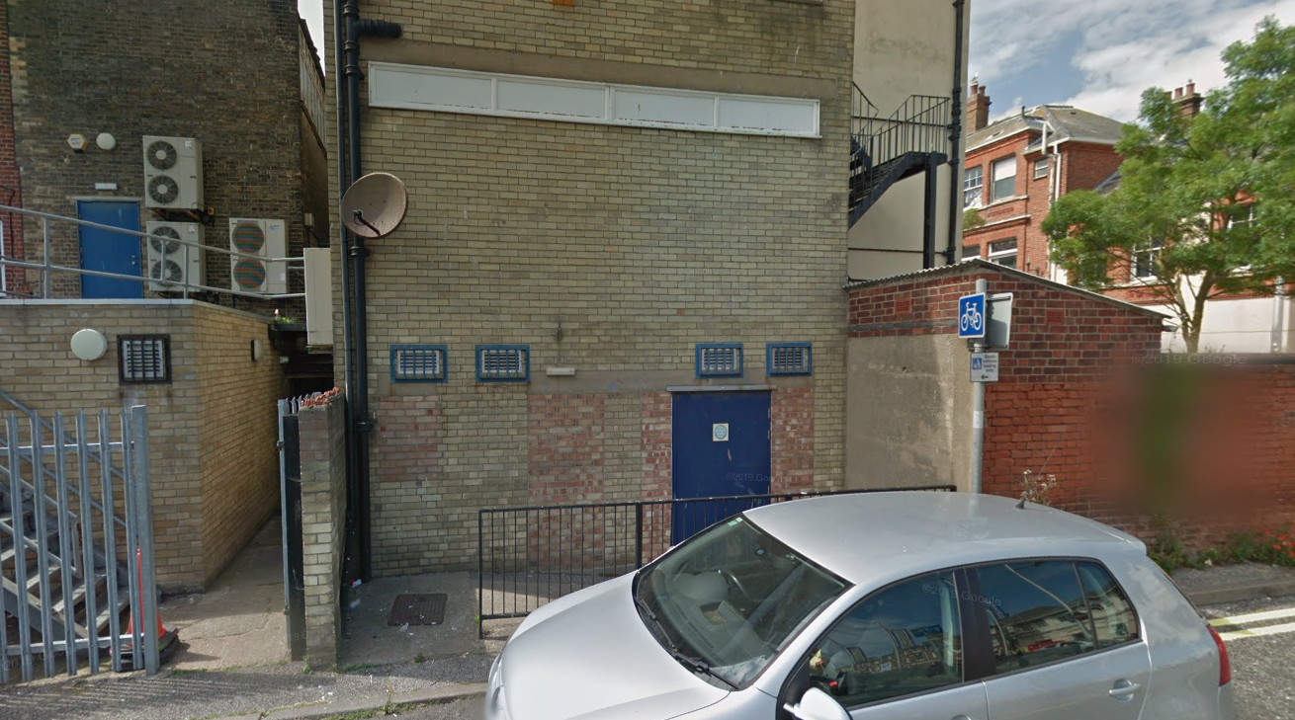
Application for a rear entrance to Cashino. Concern was raised at a previous meeting that the rear of the building may not be suitable for customer entrance/exit without further improvements.
54 London Road North Lowestoft Suffolk NR32 1EP  Planning permission to replace a solid metal rear fire door with a new aluminium framed glazed door  Date Description Information 1 Information 2  19/02/2020 Site Notice & Neighbourhood Notification SNOTQR  17/02/2020 Application Form & Certificate  17/02/2020 Plans Elevations & Floors 115-ADVERT-2  17/02/2020 Site / Location Plan | DC/20/0646/FUL  Public comments  Constraints  Related cases  Documents  Map

4 Bramfield Road
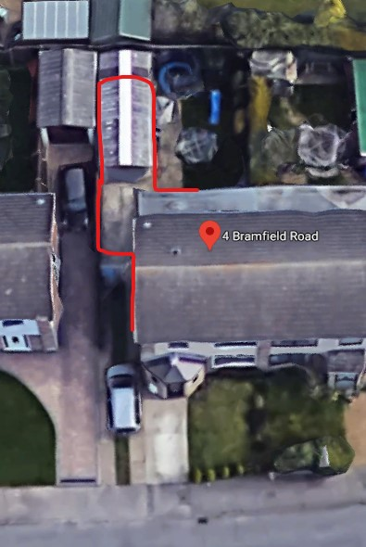
An extension in place of existing outbuilding.
4 Bramfield Road Lowestoft Suffolk NR32 3DT  Construction of a side extension  Date Description Information 1 Information 2  27/02/2020 Site Notice & Neighbourhood Notification SNOTQR  26/02/2020 Plans Existing plans  26/02/2020 Plans Proposed plans  20/12/2019 Application Form & Certificate  20/12/2019 Existing Floor Plans  20/12/2019 Site / Location Plan | DC/19/4902/FUL  Public comments  Constraints  Related cases  Documents  Map

76 Oulton Road
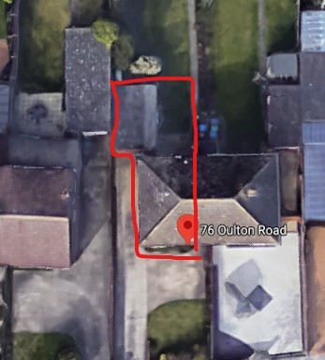
76 Oulton Road Lowestoft Suffolk NR32 4QR  Rear extension, raise & pitch garage roof  Date Description Information 1 Information 2  25/02/2020 Site Notice & Neighbourhood Notification SNOTQR  19/02/2020 Application Form & Certificate  19/02/2020 Plans 2575.20.1 Existing & Proposed - Floor, Elevations, site and block  19/02/2020 Supporting Documents Covering Letter | DC/20/0724/FUL  Public comments  Constraints  Related cases  Documents  Map

81 Gunton Drive
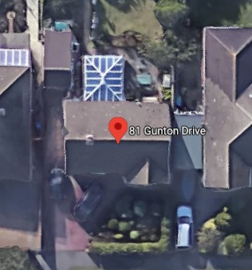
Converting existing conservatory into a single storey extension with same footprint.
81 Gunton Drive Lowestoft Suffolk NR32 4QA  Construction of single storey rear extension  Date Description Information 1 Information 2  04/03/2020 Neighbour Responses Crisp and Purdom 83 Gunton Drive  21/02/2020 Site Notice & Neighbourhood Notification SNOTQR  20/02/2020 Application Form & Certificate  20/02/2020 Plans 180220 1 Proposed Floor and Elevations  20/02/2020 Site / Location Plan 180220 1 Existing Floor and Elevations  20/02/2020 Site / Location Plan 180220 3 Plus Proposed Block plan | DC/20/0753/FUL  Public comments  Constraints  Related cases  Documents  Map

Pathways Care Farm
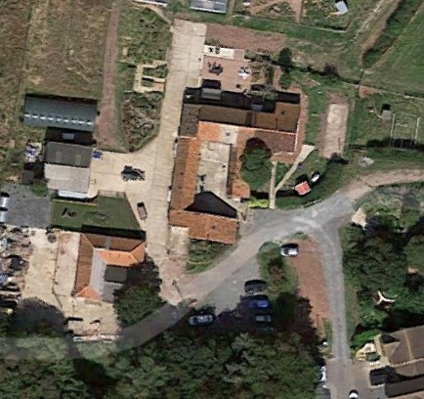
Pathways Care Farm Leonard Drive Lowestoft Suffolk NR32 4WB  Erect Produce Store and Office  Date Description Information 1 Information 2  03/03/2020 Consultee Responses SCC Fire and Rescue  20/02/2020 Application Form & Certificate  20/02/2020 Proposed Block / Layout Plan 895 01B  20/02/2020 Proposed Block / Layout Plan 895 03A  20/02/2020 Proposed Elevations 895 08  20/02/2020 Proposed Floor Plan 895 07  20/02/2020 Site / Location Plan 895 04  20/02/2020 Site Notice & Neighbourhood Notification SNOTQR  20/02/2020 Supporting Documents Cover Letter | DC/20/0747/FUL  Public comments  Constraints  Related cases  Documents  Map

Arlington, North Parade
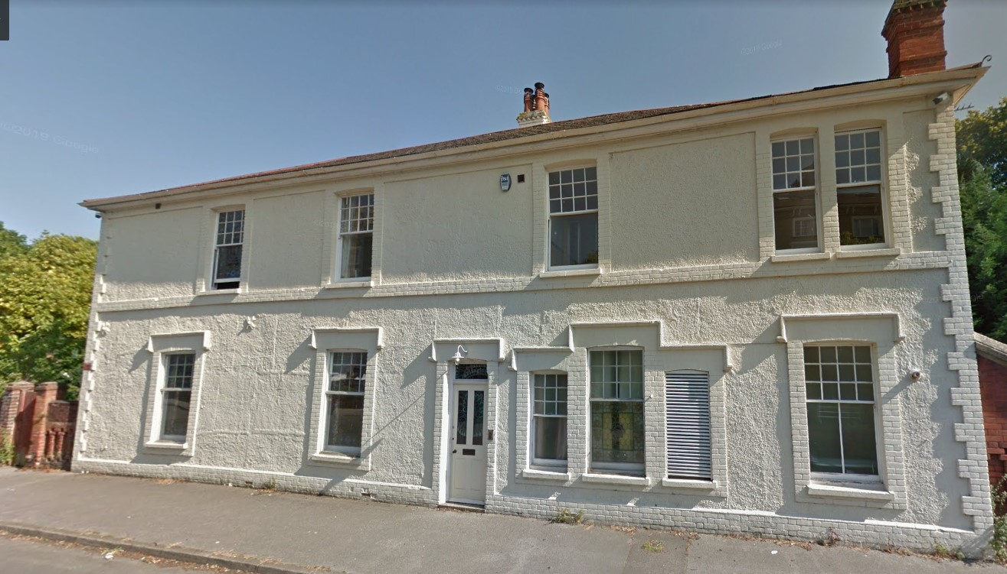
Arlington North Parade Lowestoft Suffolk NR32 4PB  Inserting two small conservation roof lights to existing first floor bathroom  Date Description Information 1 Information 2  19/02/2020 Application Form & Certificate  19/02/2020 Heritage Statement plus Design and access statement  19/02/2020 Plans 238.01 existing floor, elevations, site and block plan  19/02/2020 Plans 238.02 proposed floor, elevations, site and block plan  19/02/2020 Site Notice & Neighbourhood Notification SNOTQR | DC/20/0706/FUL  Public comments  Constraints  Related cases  Documents  Map

38 Monckton Avenue
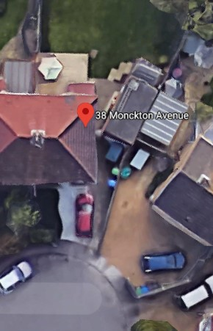
Extension in place of existing patio.
38 Monckton Avenue Lowestoft Suffolk NR32 3EG  Extension and alterations  Date Description Information 1 Information 2  21/02/2020 Site Notice & Neighbourhood Notification SNOTQR  20/02/2020 Application Form & Certificate  20/02/2020 Existing Elevations 467-3  20/02/2020 Existing Floor Plans 467-2 Ground floor  20/02/2020 Plans 467-6 Proposed section  20/02/2020 Plans 467-7 Existing and proposed block plan  20/02/2020 Proposed Elevations 467-5  20/02/2020 Proposed Floor Plan 467-4 Ground floor  20/02/2020 Site / Location Plan | DC/20/0750/FUL  Public comments  Constraints  Related cases  Documents  Map

20 Cedar Drive
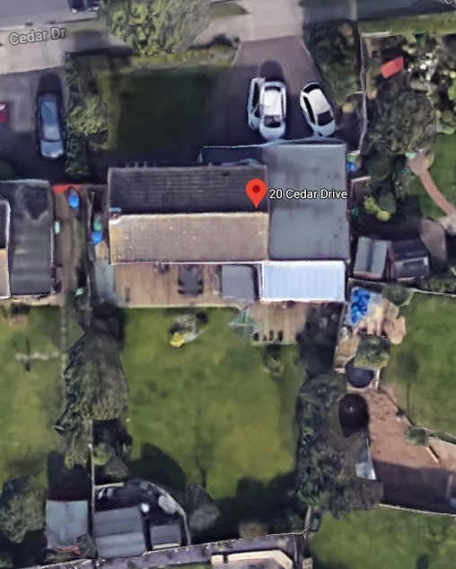
One neighbour objection:
Overpowering development. Loss of light to garden. Cladding to rear would not be in keeping with area. Out of scale development.

20 Cedar Drive Lowestoft Suffolk NR33 9HA  Construction of a rear extension, gardenroom/summer room.  Date Description Information 1 Information 2  06/03/2020 Neighbour Responses Horton 38 Fleetdyke Drive  28/02/2020 Site Notice & Neighbourhood Notification SNOTQR  26/02/2020 Application Form & Certificate  26/02/2020 Plans Elevations, Plan View & Boundary Side Drawing No 1  26/02/2020 Plans Plan View, Block Plan & Elevations Drawing No 1  26/02/2020 Plans Roof Plan & Proposed Front Elevations Drawing No 1  26/02/2020 Plans Structural Calculations Drawing No 3  26/02/2020 Site / Location Plan | DC/20/0847/FUL  Public comments  Constraints  Related cases  Documents  Map

4 Langley Gardens
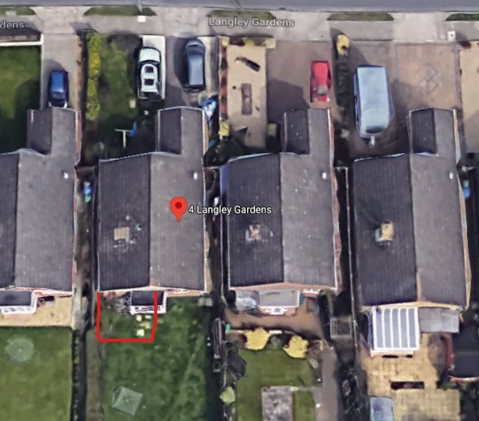
Rear extension of a similar size to conservatory two houses right.
4 Langley Gardens Lowestoft Suffolk NR33 9JE  Construction of a rear extension  Date Description Information 1 Information 2  26/02/2020 Site Notice & Neighbourhood Notification SNOTQR  14/01/2020 Application Form & Certificate  14/01/2020 Plans 2542-19.1A existing/proposed - elevations,floor,block,site | DC/20/0124/FUL  Public comments  Constraints  Related cases  Documents  Map

2 Speedwell Close
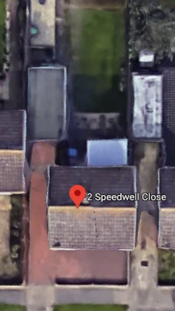
2 Speedwell Close Lowestoft Suffolk NR33 7DU  Replacement garage rebuilt further down the garden in brick, with a pitched tiled roof.  Date Description Information 1 Information 2  26/02/2020 Proposed Block / Layout Plan  26/02/2020 Site Notice & Neighbourhood Notification SNOTQR  24/02/2020 Application Form & Certificate  24/02/2020 Plans Existing and Proposed Elevations  24/02/2020 Plans Existing and Proposed Floor Plan  24/02/2020 Proposed Block / Layout Plan  24/02/2020 Site / Location Plan | DC/20/0780/FUL  Public comments  Constraints  Related cases  Documents  Map

Friends Meeting House, 39 Pakefield Street
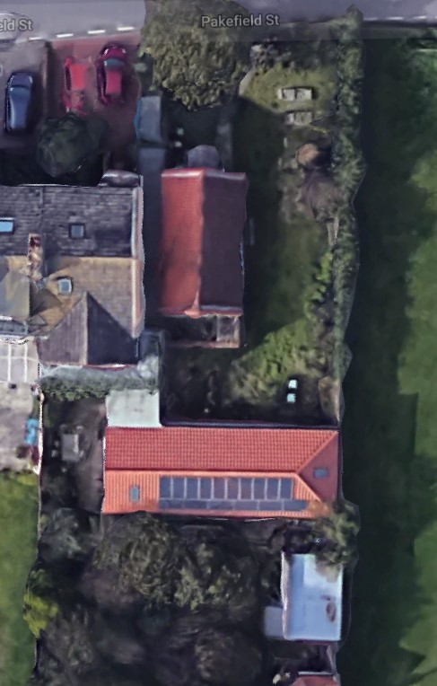
Friends Meeting House 39 Pakefield Street Lowestoft Suffolk  Extension to create Toilet, Lobby and Childrens Room  Date Description Information 1 Information 2  20/02/2020 Application Form & Certificate  20/02/2020 Plans 2500.19.1B Proposed and Existing Floor and Elevations Plus Site Plan and Proposed and Existing Block Plan  20/02/2020 Site Notice & Neighbourhood Notification SNOTQR  20/02/2020 Supporting Documents cover email  20/02/2020 Supporting Documents Cover Letter  20/02/2020 Supporting Documents Statement of Significance  03/02/2020 Consultee Responses SCC Fire and Rescue | DC/20/0744/FUL  Public comments  Constraints  Related cases  Documents  Map

Stella Maris, 93A Saxon Road
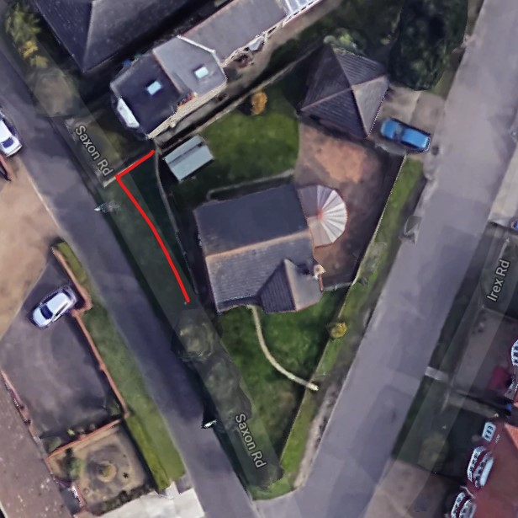
Replace fence with new boundary parallel to Saxon Road.
Stella Maris 93A Saxon Road Lowestoft Suffolk NR33 7BT  Erection of new boundary fence  Date Description Information 1 Information 2  02/03/2020 Neighbour Responses Stimpson 93 Saxon Road  28/02/2020 Site / Location Plan  28/02/2020 Site Notice & Neighbourhood Notification SNOTQR  25/02/2020 Plans 2012-001 Existing & Proposed Block Plan | DC/20/0820/FUL  Public comments  Constraints  Related cases  Documents  Map

