MEETING PAPER
Subject: 35.2 Specification for tablets for Councillors
Meeting: Full Council
Date: 28 May 2019

CONFIDENTIAL/NON CONFIDENTIAL

Background/Introduction
Full Council previously set a maximum budget of £7,000 to provide each Councillor with a tablet for Town Council purposes.

Details
Cllr Taylor and the Clerk recently met with a member of East Coast Community Healthcare’s IT Department to discuss a suitable specification for the Town Council’s requirements. We are assured that the following model will provide us with a good capacity to deliver functionality for Town Council purposes:

Samsung Galaxy Tab A Android Tablet
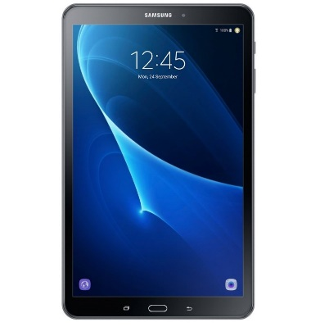
- £3,800 for the product, including setup and software. Email facility etc will be set up for Councillors.
- £200 for security (total per year)
- £320 total for cases
Training will be provided. Terms of use will need to be signed up to, e.g. use for Town Council purposes only, no illegal purposes, due care and return on cessation of office.
Recommendations/Decision
- That the Council approves the purchase of 20 Samsung Galaxy Tab A Android Tablets, appropriate security software and cases as detailed above, with delegated authority to the Clerk to progress this.
- That Terms of Use are drawn up by the Clerk to be signed by each Councillor, prior to them receiving their tablet.
- That the purchase of the tablets will only be progressed subject to all Councillors agreeing that they are happy to use one.

